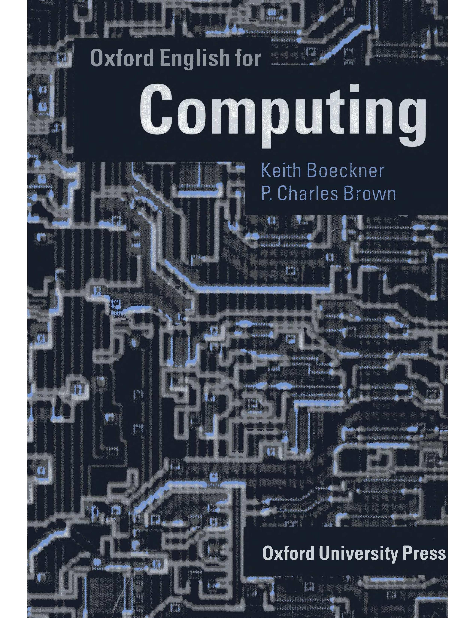

Oxford English for

Computing
Keith Boeckner
P. Charles Brown

Oxford University Press


Page Page
Unit 1 4 Unit 9 100
Personal computing 4 Computers in education 100
The processor 8 CALL 103
Language focus A 11 Language focus I 108
Contextual reference Giving examples
Unit 2 13 Unit 10 110
Portable computers 13 Computers in medicine 110
Operating systems 20 Data storage and management 115
Language focus B 24 Language focus J 120
Word formation prefixes Explanations and definitions
Unit 3 28 Unit 11 123
Online services 28 Robotics 123
Data transmission 32 Robot characteristics 128
Language focus C 36 Language focus K 131
Word formation suffixes Compound nouns
Unit 4 39 Unit 12 134
Programming and languages 39 Virtual reality 134
C language 44 VR input devices 139
Language focus D 49 Language focus L 142
Organizing information Classifying
Unit 5 52 Unit 13 145
Computer software 52 Machine translation 145
Comparing software packages 57 Al and expert systems 148
Language focus E 61 Language focus M 152
Making comparisons Cause and effect
Unit 6 66 Unit 14 155
Computer networks 66 Multimedia 155
Network configurations 70 Computer-to-video conversion 160
Language focus F 75 Language focus N 164
Time sequence Making predictions
Unit 7 78 Unit 15 167
Computer viruses 78 Computer graphics 167
Computer security 81 24-bit colour 172
Language focus G 86 Appendix 1 176
Listing Letter writing
Unit 8 88 Appendix 2 197
Computers in the office 88 Glossary of terms
Information systems 94
Language focus H 97
The passive

Personal computing
4
Start-up

Task 1 a | Name these devices. What are they used for?

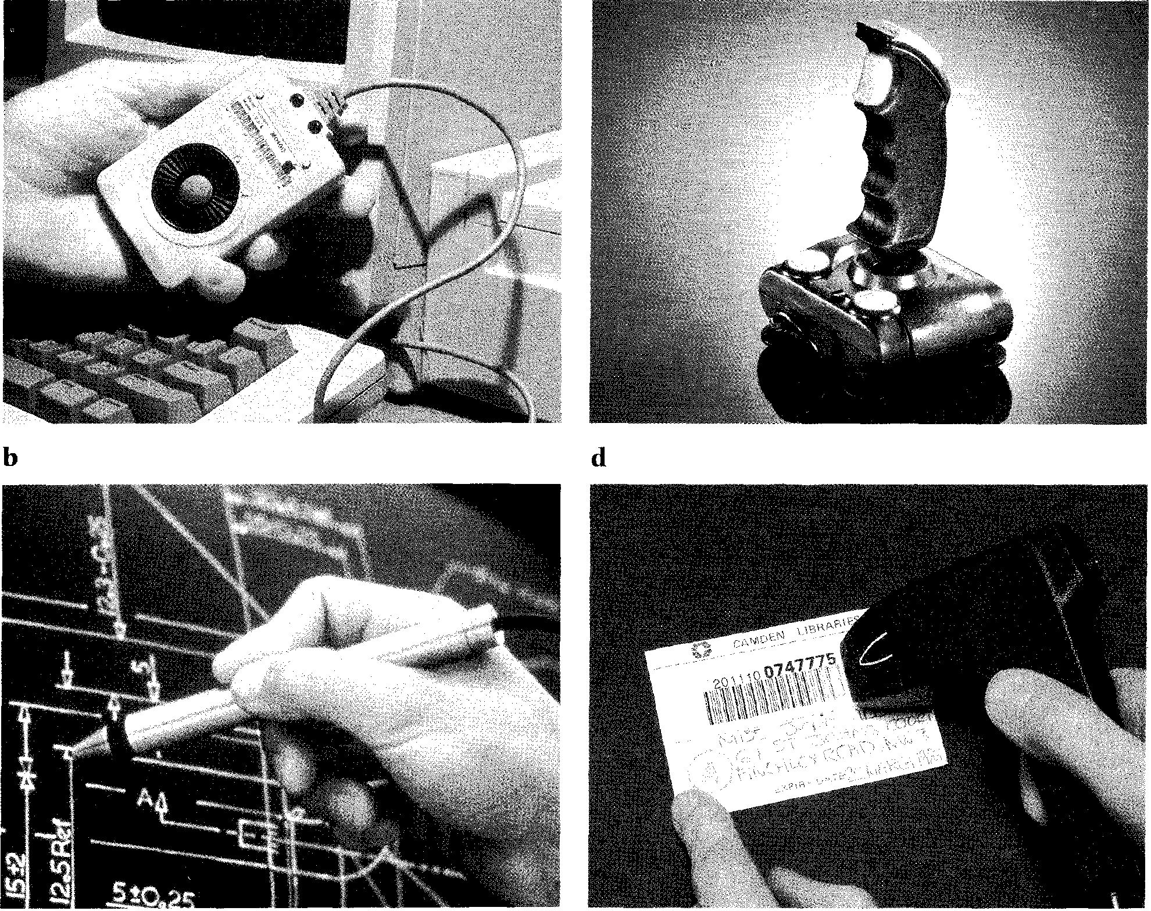
Listening

Task 2 | You will hear two interviews between a market researcher and visitors to a computer exhibition. As you listen, fill in the missing information in the table opposite.

Interview 1 Interview 2
Name:
Occupation:
Type of PC used:
Reasons for choice: 1
2
3
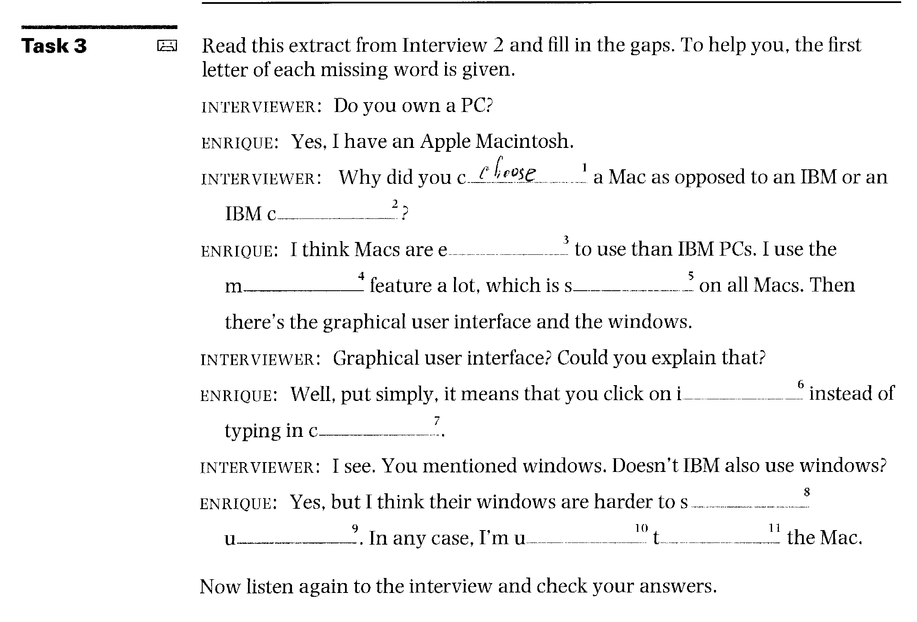

Reading
Task 4
5
Before reading the text on the following page, match each word with the correct definition:
the set of software that controls a computer system a very small piece of silicon carrying a complex electrical circuit
1 | mainframe | a
2 | mouse | b
3 | icon | c
4 | operating system | d
5 | software | e
6 | hardware | f
7 | microchip | g

a big computer system used for large-scale operations the physical portion of a computer system
a device moved by 'hand to indicate position on the screen
a visual symbol used in a menu instead of natural language
data, programs, etc., not forming part of a computer, but used when operating it.

Task 5 Now read the text and decide on a suitable title for it.

I n 1952, a major computing company took a decision to get out of the business of making mainframe computers. They
5 believed that there was only a market for four mainframes in the whole world. That company was IBM. The following year they reversed their decision.
1() In 1980, IBM decided that there
was a market for 250,000 PCs, so they set up a special team to develop the first IBM PC. It went on sale in 1981 and set a world-wide
15 standard for IBM-compatibility which, over the next ten years, was only seriously challenged by one other company, Apple Computers. Since then, over seventy million
20 PCs made by IBM and other
manufacturers have been sold. Over this period, PCs have become commodity items. Since IBM made the design non-proprietary, anyone
25 can make them.
The history of the multi-billion dollar PC industry has been one of mistakes. Xerox Corporation funded the initial research on
30 personal computers in their Palo Alto laboratory in California. However, the company failed to capitalize on this work, and the ideas that they put together went
35 into the operating system developed for Apple's computers. This was a graphical interface: using a mouse, the user clicks on icons which represent the function
40 to be performed.
The first IBM PC was developed using existing available electrical components. With IBM's badge on the box it became the standard
45 machine for large corporations to purchase. When IBM were looking for an operating system, they went
initially to Digital Research, who were market leaders in command-
50 based operating systems (these are operating systems in which the users type in commands to perform a function). When the collaboration between IBM and Digital Research
55 failed, IBM turned to Bill Gates, then
25 years old, to write their operating system.
Bill Gates founded Microsoft
on the basis of the development
60 of MS/DOS, the initial operating system for the IBM PC. Digital Research have continued to develop their operating system, DR/DOS, and it is considered by
65 many people to be a better product than Microsoft's. However, without an endorsement from IBM, it has
become a minor player in the
70 market. Novell, the leaders in PC networking, now own Digital Research, so things may
change.
The original IBM PC had a
75 minimum of 16K of memory, but this could be upgraded to 512K if necessary, and ran with a processor speed of 4.77MHz. Ten
years later, in 1991, IBM were
so making PCs with 16Mb of memory, expandable to 64Mb, running with a processor speed of 33MHz. The cost of buying the hardware has come down
85 considerably as the machines have become commodity items. Large companies are
considering running major applications on PCs, something
90 which, ten years ago, no one would have believed possible of a PC. In contrast, many
computers in people's homes are just used to play computer 95 games.
The widespread availability of computers has in all probability changed the world for ever. The microchip technology which
loo made the PC possible has put chips not only into computers, but also into washing-machines and cars. Some books may never be published in paper form, but
105 may only be made available as
part of public databases.
Networks of computers are already being used to make information available on a world-
110 wide scale.

Vocabulary
6
commodity items (1. 2 3) — items which can be produced and traded freely non-proprietary (I. 24) — not belonging to any single company
capitalize on (I. 3 3) — profit from, turn to one's advantage

read the text slowly and try to understand every word?
Task 6 When you read the text to decide on a title, which of the following did you do?
Did you:
7
Fl read quickly and try to understand the main theme?
underline or mark sentences that you thought were important? make notes about important points?
Which of these reading strategies do you think is most appropriate for this kind of task? Which do you think is least appropriate?
Task 7 Answer these questions about the text.
1 How many mainframes did IBM think it was possible to sell in 1952?
2 How many PCs have now been sold?
3 Who paid for the initial research into PCs?
4 Which company later used the results of this research to develop their operating system?
5 What are command-based operating systems?
6 DR/DOS is an acronym. What does it stand for?
7 Since the invention of the IBM PC, many of its features have been improved. Which of the following features does the text not mention in this respect?
a memory
b speed
c size
d cost
8 Give three examples from the text of how the availability of computers has 'in all probability changed the world for ever'.
Task 8  Task 9 | Using the line references given, look back in the text and find words that have a similar meaning to:  1 international (lines 10-15)  2 contested (lines 15-20)  3 errors (lines 25-30)  4 paid for (lines 25-30)  5 buy (lines 45-50)  6 first (lines 60-65)  7 recommendation (lines 65-70)  8 improved (lines 75-80)  Writing  Translate the sixth paragraph (starting 'The original IBM PC...') into your own language. Look carefully at the tenses before you start.

Task 10 | Speaking  The article states that 'many computers in people's homes are just used to play computer games'.  Discuss the following questions:  1 In what other ways are computers used at home, or outside work?  2 If you already have a PC, how do you use it? (If not, how would you use one?)

The processor
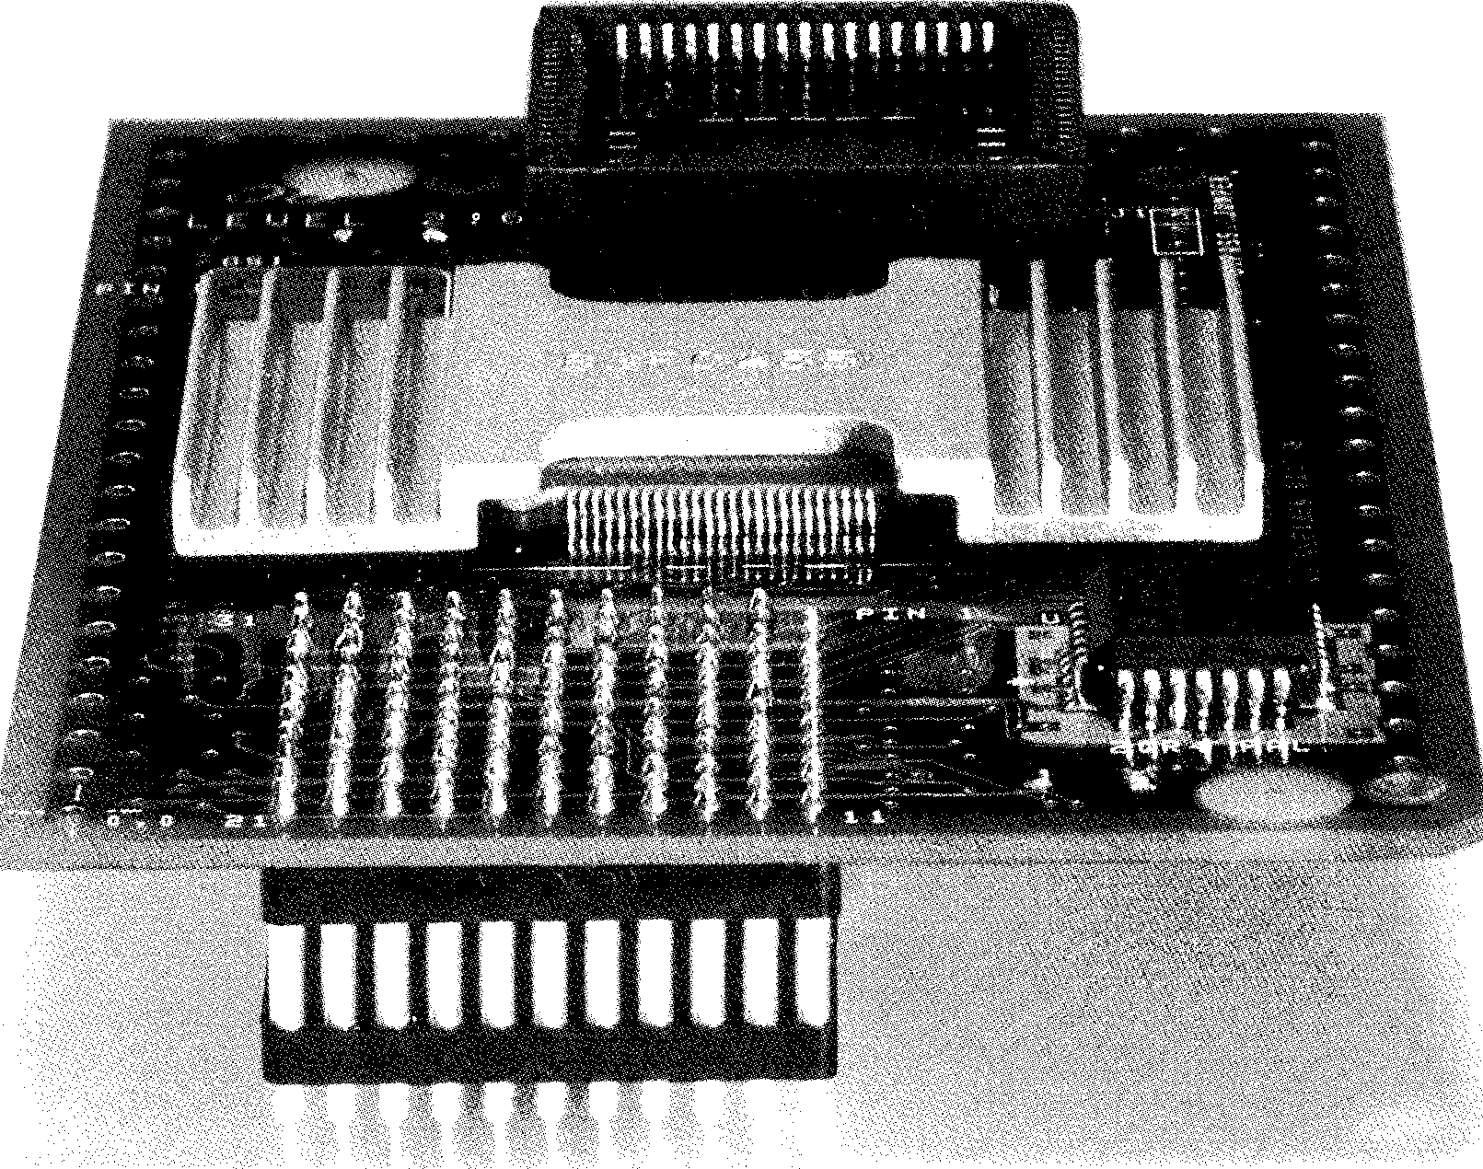
Reading
Read this passage about the structure of the processor and fill in the gaps using the words below.
Task 11
8
Structure of the processor The processor consists of a'  which are mounted ²  components linked together by ³ form of control, address, and data ⁴ | , which is a circuit board on chips, memory chips, and other  lines or channels in the  . In addition, a processor

has , which are electronic circuits providing specialized
functions such as graphics, or which connect a system board to
6 . The system board also consists of electronic devices, such
as an electronic for controlling the speed of operation;
8 , which store numeric data during the course of processing;
and various ⁹ _, including sequence control register, address
register, and function register.
adaptor boards registers microprocessor
clock conductive buses
system board accumulators input or output devices
Reading
Use the information in the reading passage and the diagram to help you match the terms below with the appropriate explanation or definition.
Task 12

A processor consists of many different electronic circuits and devices for performing control functions, arithmetic and logic operations, and data transfers. Data may be transferred from backing storage to the internal memory or from the internal memory to the arithmetic unit by means of
5 conductive channels known as buses. The part of the processor which controls data transfers between the various input and output devices is called the control unit.
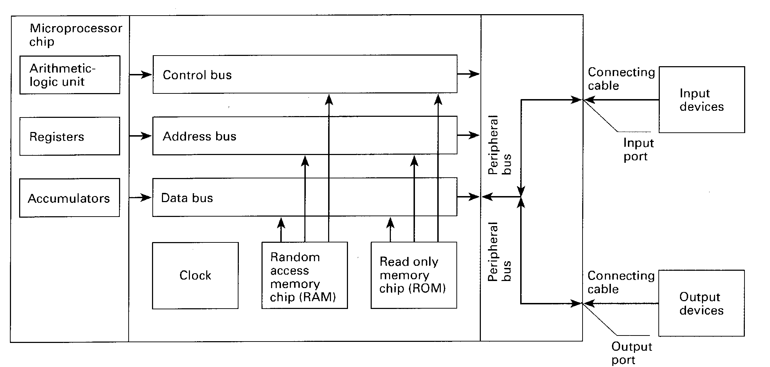

used to send address details between the memory and the address register
consists of an arithmetic-logic unit, one or more working registers to store data being processed, and accumulators for storing the results of calculations a group of signal lines used to transmit data in parallel from one element of a computer to another groups of bistable devices used to store information in a computer system for high-speed access
an electronic circuit, usually a quartz crystal, that generates electronic pulses at fixed time intervals to control the timing of all operations in the processor used for storing part of the operating system and application software known as 'firmware'; can only be read; cannot be written to or altered in any way used to store numeric data during processing
a group of signal lines dedicated to the passing of control signals
used for the temporary storage of application programs and data; can be written to and read from
9
1 | microprocessor chip a
2 | registers | b
3 | accumulators | c
4 | control bus | d
5 | address bus | e
6 | data bus | f
7 | clock | g
8 | RAM | h
9 | ROM | i

 | Speaking
Task 13 | Work in pairs. Write down the list of terms (1-9) in Task 12 on a piece of paper. Without referring to your book, take turns to ask and answer questions about their functions.  1⁰' Useful expressions  What is/are . . .?  What does/do . . . do%

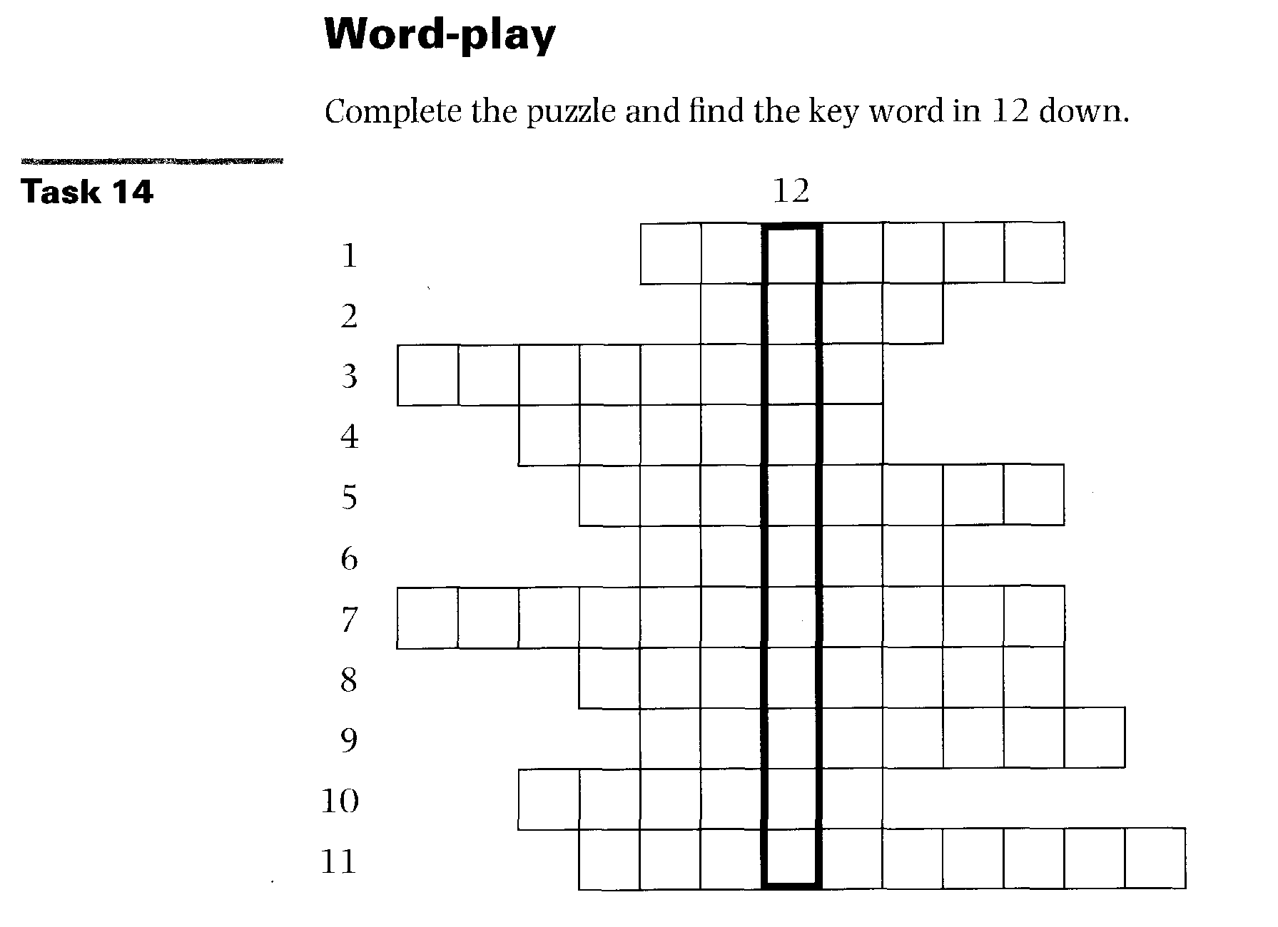
Across
1 A conductive line such as a data bus. (7)
2 A visual symbol used in a menu to represent a file or program. (4)
3 An input device used in computer games. (7)
4 An device converts the electrical signals inside a computer into a form
that can exist outside the computer. (6)
S The name given to system software that is held in ROM. (8)
6 A device with one or more buttons used to point at locations on a computer screen. (5)
7 The part of the CPU that transmits co-ordinating control signals and commands to the computer. (7,4)
8 1,048,576 bytes. (8)
9 A large store of computerized data. (8)
10 The system was first used commercially on the Apple Macintosh
computer, but is now widely used on IBM machines. (7)
11 A signal route dedicated to sending information about locations within a computer. (7,3)
Down
12 A register containing the results of an operation performed by the arithmetic-logic unit. (11)
10
Language focus A
Contextual reference
Transitional markers are words used to link ideas together so that the text is easier to read. When pronouns such as it, they, them, I, he, she, which, who, whose, that, such, one, and demonstrative adjectives such as this, that, these and those, are used as transitional markers, they refer to a word, or words, mentioned earlier in the sentence or paragraph. Their function is to take your thoughts back to something that has already been mentioned. Other words which are often used to refer backwards are the former, the latter, the first, second, etc., the last.

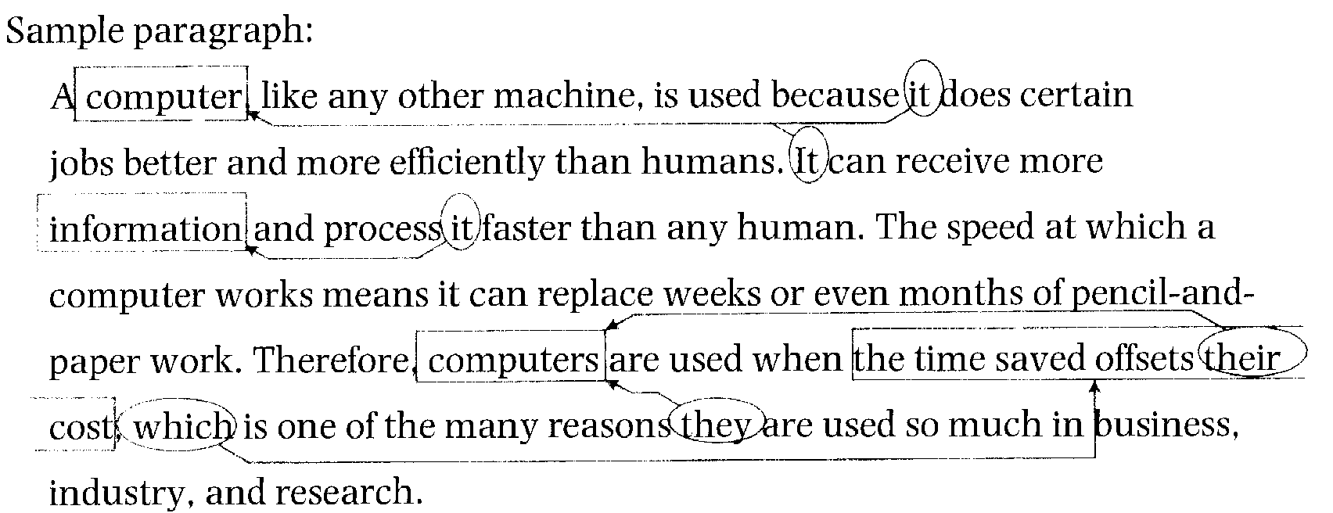
Using the sample paragraph as a model, draw a rectangle around the word, or words, that the circled words refer to. Then join the CD and the =with arrows.
Exercise 1
11
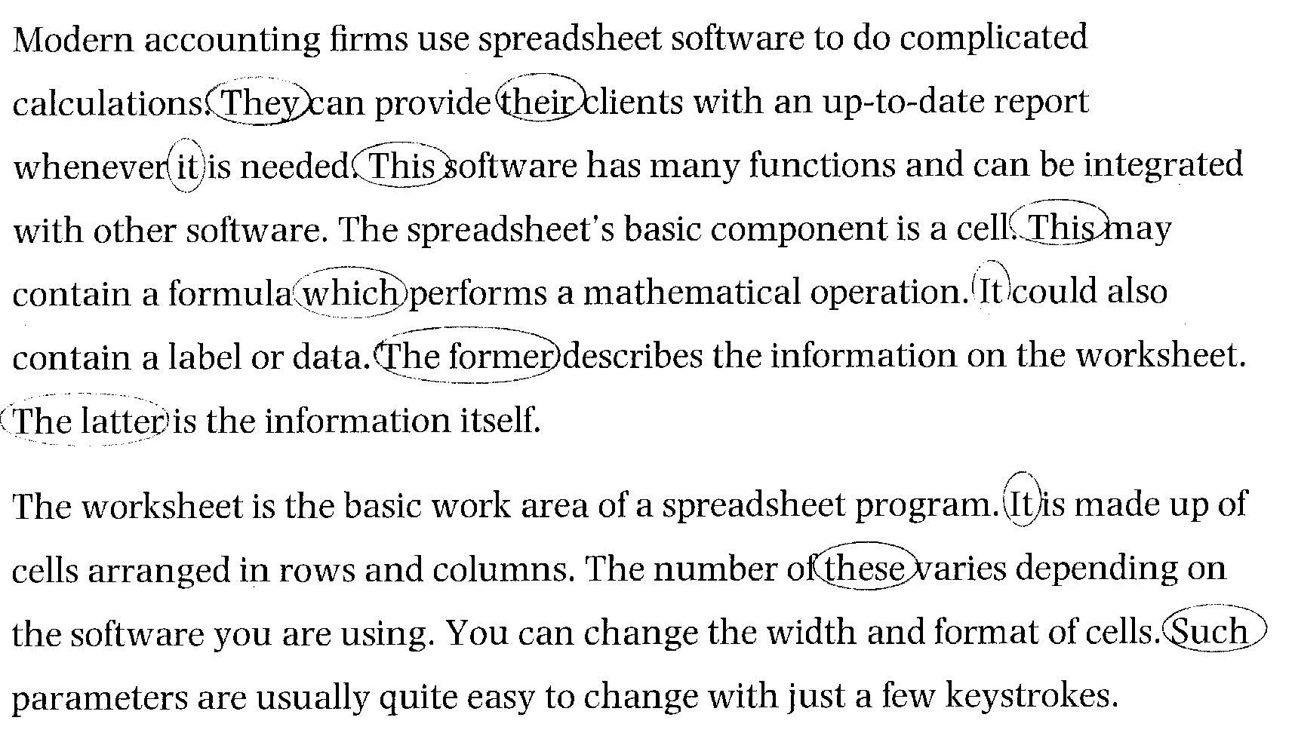

12
Exercise 2 | Using the line reference given, look back at the reading passage in Unit 1, page 6, and find the reference for the words in italics.  1 anyone can make them (line 25)  2 the ideas that they put (line 34)  3 This was a graphical interface (line 37)  4 it became the standard machine (line 44)  5 these are operating systems (line 50)  6 it has become a minor player (line 68)  7 this could be upgraded (line 76)


Portable computers
13
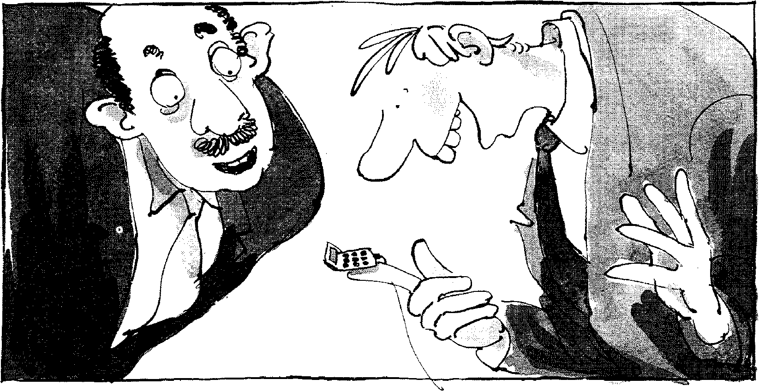
`This is the smallest, most powerful computer in the world.'
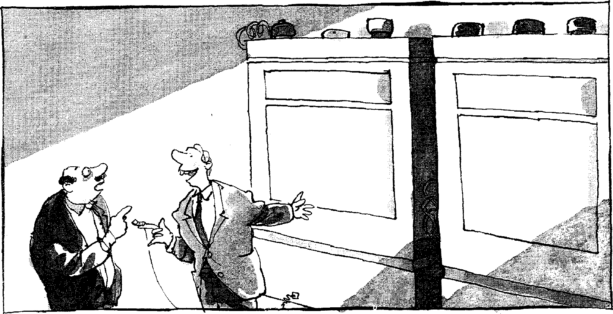
`Those? Those are the batteries.'
Start-up
Task 1 Discuss the following questions:
1 How small do you think computers can usefully become?
2 To what extent does the size of a computer influence what it can be used for? Think of examples to illustrate your answer.
Listening
14
Task 2 Listen to the following extract from a radio talk show called Computerworks in
which the host talks with Sandra Cavanah, a writer with a computer magazine. As you listen, fill in the missing information about the various portable computers.
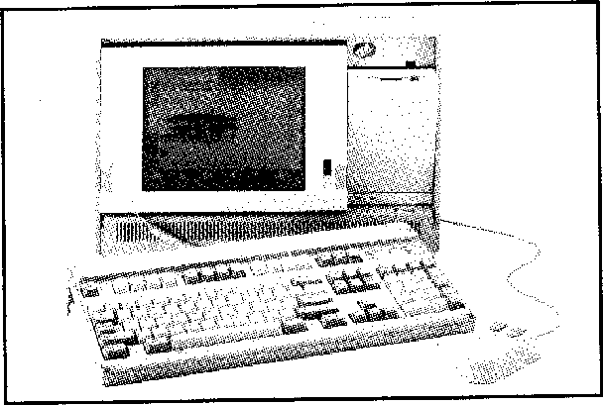 | Portable Power:  Weight:  Screen size: Inplnputvice: | runs on  between 15 and  about ten inches diagonally keyboard | pounds

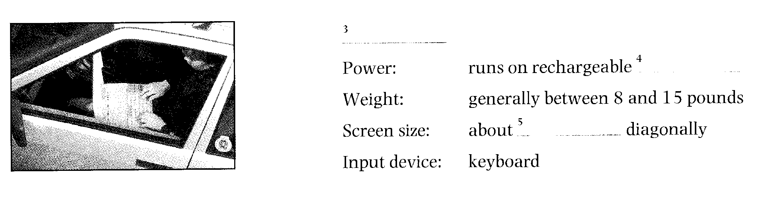
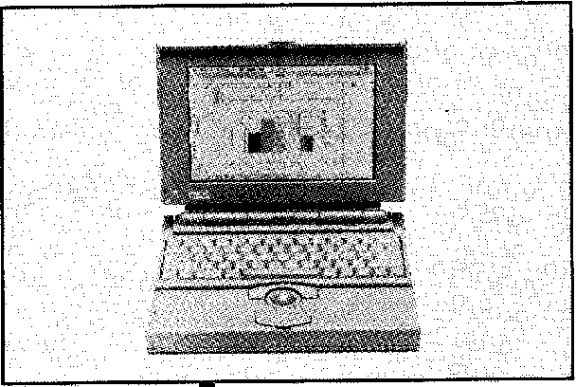 | Notebook  Power: batteries  Weight: as little as  Screen size: as small as _  Input device: keyboard | pounds inches

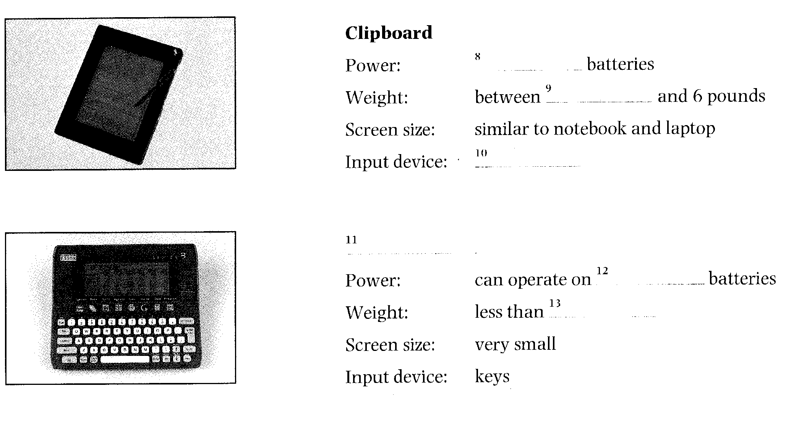
Reading
Task 3 Before reading the text, match these words with their definitions:

a clipboard
b stylus
c screen
d grid
e voltage
f pixel
g template
1 surface on which pictures or data are shown
2 electrical force
3 pattern used as a guide for creating letters or characters
4 individual dot on a computer screen
5 network of lines crossing at right angles
6 pointed implement for drawing or writing
7 portable board with a clip at the top for holding papers

Task 4 Read the text and decide why the author chose the title Delete Keys. Can you
suggest a better title?
Delete Keys - Clipboard Technology

FOR THE LAST GENERATION, Silicon Valley and Tokyo have
been working to design computers
that are ever easier to use. There is
5 one thing, however, that has prevented the machines from becoming their user-friendliest: you still have to input data with a keyboard, and that can require you
10 to do a lot of typing and to memorize a lot of elaborate commands.
Enter the clipboard computer, a technology that has been in
15 development for the last 20 years but took hold in the mass market only this year. Clipboard PCs —which, as their name suggests, are not much bigger than an actual
20 clipboard — replace the keyboard with a liquid crystal display (LCD) screen and an electronic stylus. Users input data by printing individual letters directly on the
25 screen.
There are two technologies at
work in a clipboard PC: one allows
raw data to get into the computer
and the other allows the computer
30 to figure out what that data means. The first technology relies principally on hardware and varies depending on the particular computer. In one system, marketed
35 under the name GRIDPad, the computer's LCD screen is covered by a sheet of glass with a transparent conductive coating. Voltage is sent
across the glass in horizontal and
15
40 vertical lines forming a fine grid; at any point on the grid, the voltage is slightly different. When the stylus — which is essentially a voltmeter — touches
45 the screen, it informs the
computer of the voltage at that point. The computer uses this information to determine where the stylus is and causes a liquid
so crystal pixel to appear at those
coordinates. The position of the stylus is monitored several hundred times a second, so as the stylus moves across the glass,
55 whole strings of pixels are activated.
`What we do is sort of connect
the dots,' says Jeff Hawkins, the creator of GRIDPad. 'Users can
60 then write whatever they want on the screen with a kind of electronic ink.'
Making that writing comprehensible to the computer,
65 however, requires the help of some powerful software. When the stylus is being used, the computer is programmed to look for moments when the tip does
70 not touch the screen for a third of a second or more. Every time this happens — and it happens a lot when somebody is printing —the software assumes that one
75 letter or number has been
written. The pixel positions of 1⁰.-

41 this fresh character are then passed on to the computer's pattern recognition software, which
so instantly identifies the letter or number written.
The software does this by first cleaning up the character —smoothing out crooked lines and
85 removing errant dots. The remaining lines and curves are then compared with a series of templates in the computer's memory that represent hundreds of thousands of
90 different versions of every letter in the English alphabet and all ten numerals. When the computer finds the closest match, it encodes the character in memory and displays it
95 on the screen as if it had been typed. The entire process takes just a fraction of a second. To delete a word, you simply draw a line through it. To move to the next
too page, you flick the stylus at the bottom of the screen as if you're flicking the page of a book.
There are a handful of clipboard
computers now on the market,
105 including GRIDPad, which is sold in the US; Penvision, manufactured by NCR and sold around the world;
and Sony's Palmtop and Canon's Al Note, both sold only in Japan.
1() IBM and Apple are also pouring millions of dollars into the technology.
In addition to this hardware, a variety of software is also
115 making its way to the market. Depending on the power of the computer and the sophistication of the software, clipboard
systems can be programmed to
120 understand the particular quirks of a particular user's printing; this is an especially useful
feature in Japan, where
elaborate kanji characters make
125 up most of the written language. Improvements in software may soon allow machines sold in the US to understand not only printing but continuous script as
130 well.
Given such flexibility, the designers of clipboard computers are predicting big things — and a big market — for their products.
135 'There's no doubt about it,' says an optimistic Hawkins. 'You're going to own one of these things in the not-too-distant future.' ■

1

► Vocabulary
printing (1. 73) — (in this case) writing separated letters or numbers by hand kanji (1. 124) — Japanese script which uses Chinese characters


Decide whether the following statements are true (T) or false (F) in relation to the information in the text. lf you think a statement is false, change it to make it true.
Task 5
16
The Americans and the Japanese are working together to produce user-friendlier computers.
The clipboard computer was first sold twenty years ago.
1
On a clipboard, an electronic pen replaces the traditional keyboard.
ln the GRlDPad system, when the pen touches the screen, it informs the computer and a liquid crystal pixel appears at that point.
The software decides that one character or number is complete if the tip of the stylus is not in contact with the screen for more than half a second. The whole process of recognizing letters or numbers and printing them on the screen takes very little time.
There are many clipboard computers sold today which are all available everywhere in the world.
Clipboard systems can be made to understand any kind of writing.

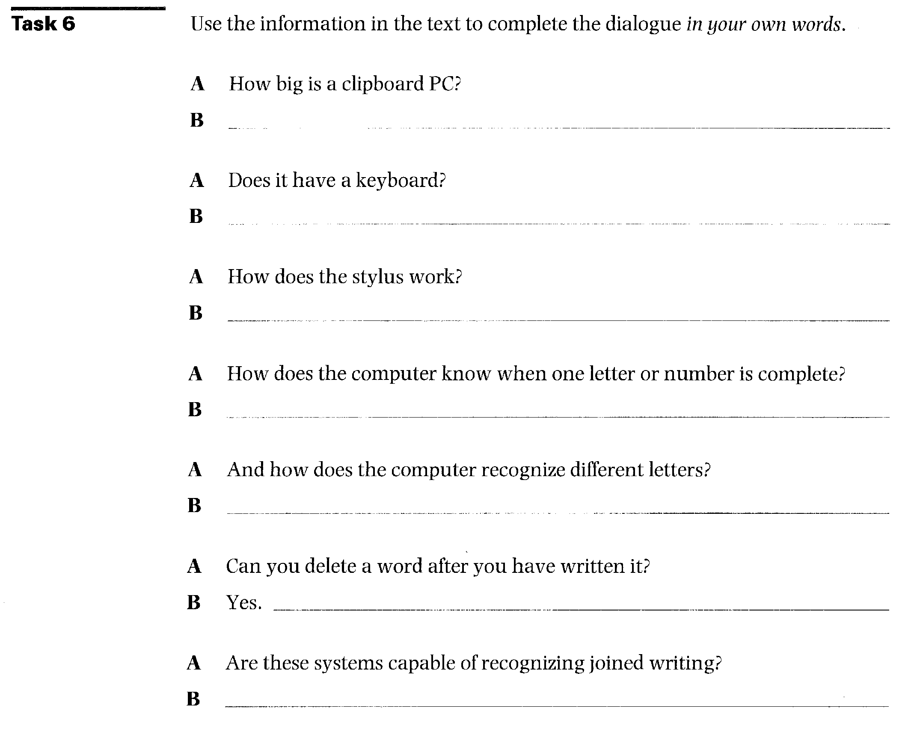
17
Task 7 | Using the line reference given, look back in the text and find the reference for the words in italics.  1 from becoming their user-friendliest (line 7)  2 one allows raw data to get (line 27)  3 it informs the computer (line 45)  4 Every time this happens (line 72)  5 which instantly identifies (line 79)  6 it encodes the character in memory (line 93)  7 this is an especially (line 122)  8 for their products (line 134)

Task 8 | Using the line references given, look back in the text and find words or phrases that have a similar meaning to:  1 understand (lines 2 5-30)  2 sold (lines 30-35)  3 covering (lines 35-40)  4 points (lines 50-55)  5 join (lines 55-60)  6 making even (lines 80-85)  7 not straight (lines 80-85)  8 made by mistake (lines 85-90)  9 move quickly and sharply (lines 95-100)  10 unique features (lines 115-120)

Task 9 | Choose the correct word to complete each sentence. You may have to change  some words slightly. •

1 electron, electronic, electronics, electronically
a An pen is one example of an input device.
b A computer solves problems
c Many students go on to work as engineers.
2 technology, technological, technologically, technologist
a The computer is the greatest invention of the twentieth
century.
b There are two involved in a clipboard PC.
c Today's computers are far superior to those used a few years ago.
3 identify, identifying, identifiable, identity
a The clipboard's pattern recognition software immediately the letters and numbers written by the stylus.
b Most computer companies will not allow people without an card to enter their premises.
c A password is a mechanism for the computer-user and
allowing access.
4 compute, computing, computation, computerize, computerization
a The of the manufacturing division will be expensive in the
short term, but cost-effective in the long term.
b We should be able to  with the new program.  c I could tell from all the in progress. |  | our profit for next year fairly accurately  on the board that a maths lesson was

 | Writing
Tas 10 | Translate the third paragraph (starting 'There are two technologies...' ) into your language. Check the meaning of any unfamiliar technical words in the glossary at the back of this book.

Speaking

Task 11 Discuss the following questions:
18
1 What are the limitations of portable computers?
2 Do you think students should be allowed to use portable computers in class?

Writing
Task 12

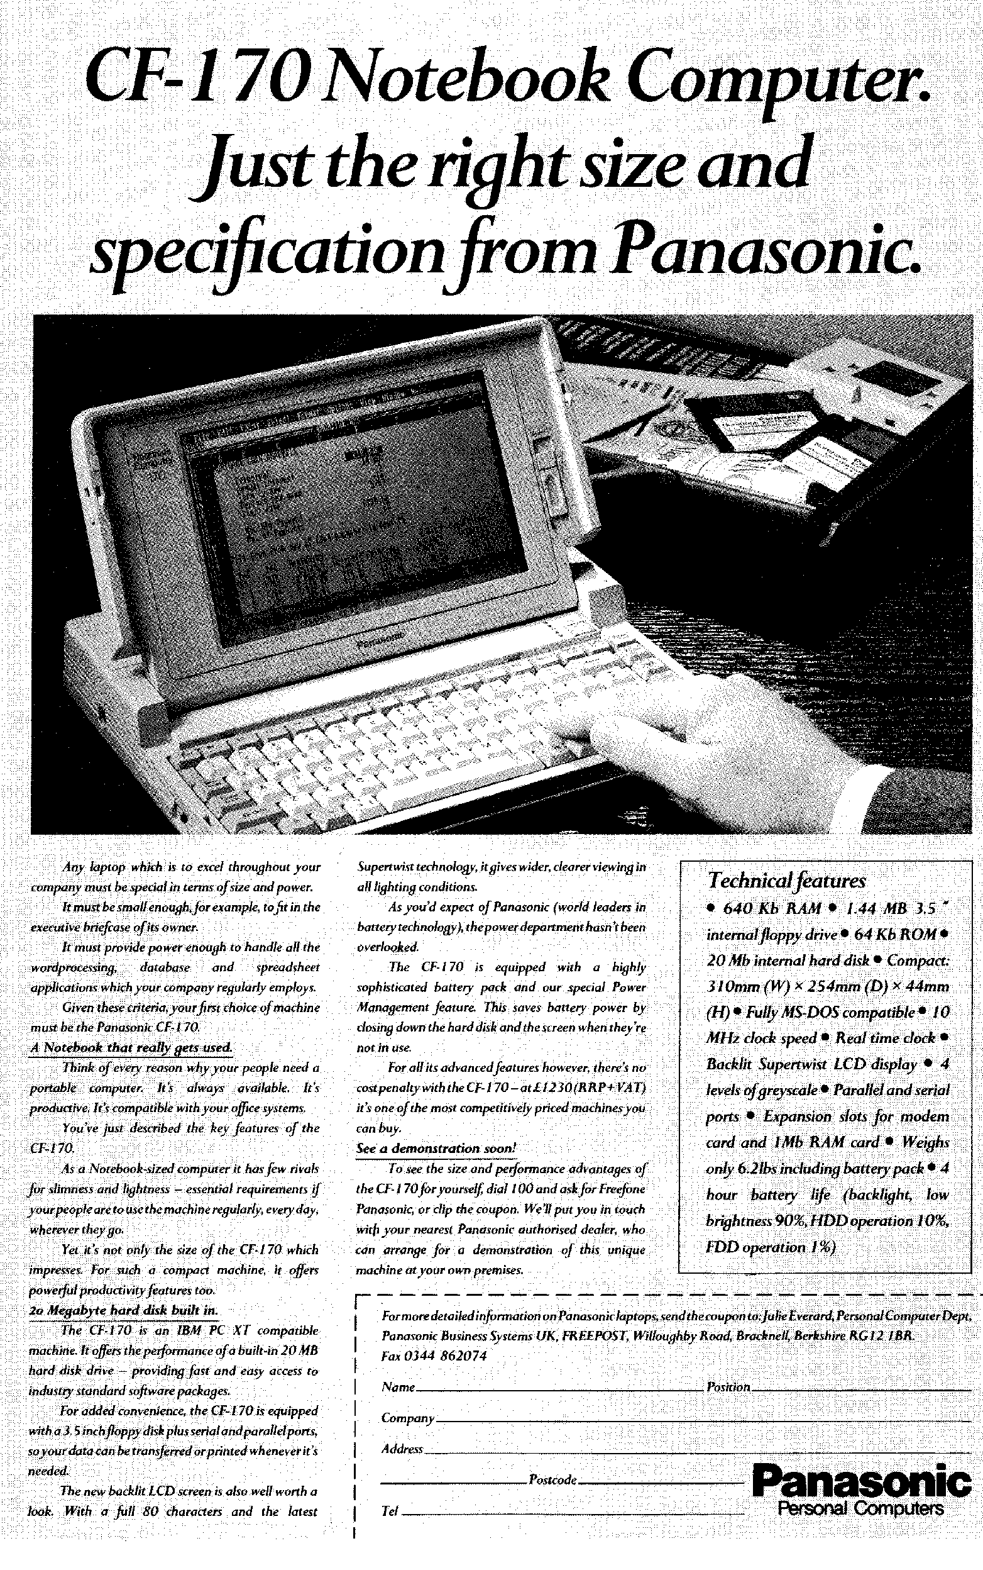
Write an advertisement for a real or imaginary notebook computer. Your material should include its name and type, its size, price, and capacity, and the features that make it superior to other models.
19
You may base your material on the advertisement above, but do not copy straight from the text.

Speaking
20
Task 13 Work in pairs.
Student A: You are a sales representative trying to sell your company's notebook computer. You are presenting your product to the Sales Director of a manufacturing company which is thinking of buying 30 notebook computers for the sales staff. Decide on the specifications and complete the table below. Then try to persuade the Sales Director to buy your product.
Name
Type (size)
Processor type Operating speed Memory
Display
Power supply Cost
Other features
- Useful expressions It costs...
It runs/operates on... It weighs...
Student B: You are the Sales Director of a manufacturing company. You are considering buying 30 notebook computers for your sales staff. Find out about all the specifications of the model on offer. Decide whether it is suitable for your needs.
- Useful expressions
How much does it cost?
What power source does it use? How big/heavy is it?
Operating systems
Reading
Task 14 Before you read the text, try to answer the following questions:
1 What is an operating system and what is its purpose?
2 Where is an operating system stored and how is it transferred to internal memory?
3 List some of the tasks typically performed by an operating system.
Now read the text and check your answers.
General features of operating systems
21
An operating system is a master control program which controls the functions of the computer system as a whole and the running of
application programs. All computers do not use the same operating systems. It is therefore important to assess the operating system used on a
5 particular model before initial commitment because some software is only
designed to run under the control of specific operating systems. Some operating systems are adopted as 'industry standards' and these are the ones which should be evaluated because they normally have a good software base. The reason for this is that software houses are willing to
1() expand resources on the development of application packages for machines functioning under the control of an operating system which is widely used. The cost of software is likely to be lower in such circumstances as the development costs are spread over a greater number of users, both actual and potential.
15 Mainframe computers usually process several application programs concurrently, switching from one to the other, for the purpose of increasing processing productivity. This is known as multiprogramming (multi-tasking in the context of microcomputers), which requires a powerful operating system incorporating work scheduling facilities to
20 control the switching between programs. This entails reading in data for one program while the processor is performing computations on another and printing out results on yet another.
In multi-user environments an operating system is required to control terminal operations on a shared access basis as only one user can access
25 the system at any moment of time. The operating system allocates control
to each terminal in turn. Such systems also require a system for record
locking and unlocking, to prevent one user attempting to read a record
whilst another user is updating it, for instance. The first user is allocated
control to write to a record (or file in some instances) and other users are
30 denied access until the record is updated and unlocked.
Some environments operate in concurrent batch and real-time mode. This means that a 'background' job deals with routine batch processing whilst the 'foreground' job deals with real-time operations such as airline seat reservations, on-line booking of hotel accommodation, or control of
35 warehouse stocks, etc. The real-time operation has priority, and the operating system interrupts batch processing operations to deal with real-time enquiries or file updates. The stage of batch processing attained at the time of the interrupt is temporarily transferred to backing storage. After the real-time operation has been dealt with, the interrupted program is
40 transferred back to internal memory from backing storage, and processing recommences from a 'restart' point. The operating system also copies to disk backing storage the state of the real-time system every few minutes (periodic check points) to provide a means of 'recovering' the system in the event of a malfunction.
45 An operating system is stored on disk and has to be booted into the internal memory (RAM) where it must reside throughout processing so that commands are instantly available. The operating system commands may exceed the internal memory capacity of the computer in which case only that portion of the OS which is frequently used is retained internally,
50 other modules being read in from disk as required. Many microcomputers
function under the control of a disk operating system known as DOS.

Task 15 | Answer these questions about the text.  1 Why is it important to assess the operating system on a computer before buying it?  2 What is multiprogramming?  3 The text gives some examples of real-time processing. Can you think of some examples of batch-processing?

Task 16 | Here is a list of typical tasks performed by an operating system. In each case the main verb has been omitted. Fill in the blanks from the words given. Sometimes more than one may apply.  A typical operating system will:  1 input and output devices.  2 the status of hardware devices.  3 hardware interrupts.  4 new disks.  5 disk directories.  6 _ disk reading and writing operations.  7 disk errors.  8 disk commands relating to the deletion, copying,  renaming, and dumping of files.

execute monitor format
diagnose
Task 17 | Match these common DOS commands with the appropriate explanation.

1 | BACKUP | a
2 | CHDIR or CD | b
3 | CHKDSK | c
4 | CLS | d
5 | DEL | e
6 | DIR:SORT | f
7 | REN | g
8 | TYPE | h
9 | FIND | i
10 | DISKCOPY | j
searches for a specific string of text in a file. allows a text file from the current directory to be displayed on screen.
allows the user to change the name of a file.
22
saves the contents of the hard disk to a floppy disk for security purposes.
is used when it is necessary to change the current directory.
clears data from the screen.
alphabetically sors and lists a disk directory. makes back-up copies of the contents of one disk to another.
deletes a specified file from the current directory, specified drive, or specified path.
produces a status report of the currently logged-on disk, indicating the amount of disk space used, the available capacity (in bytes), and the number of files on disk.

23
 | Word-play
Task 18 | Find the hidden words in this square. Some appear vertically, some horizontally, and some diagonally. They may be upside-down or back to front. Use the clues below to help you. The number of letters in each word and the first letter of the word appear in brackets after the clue. The first one has been done for you.

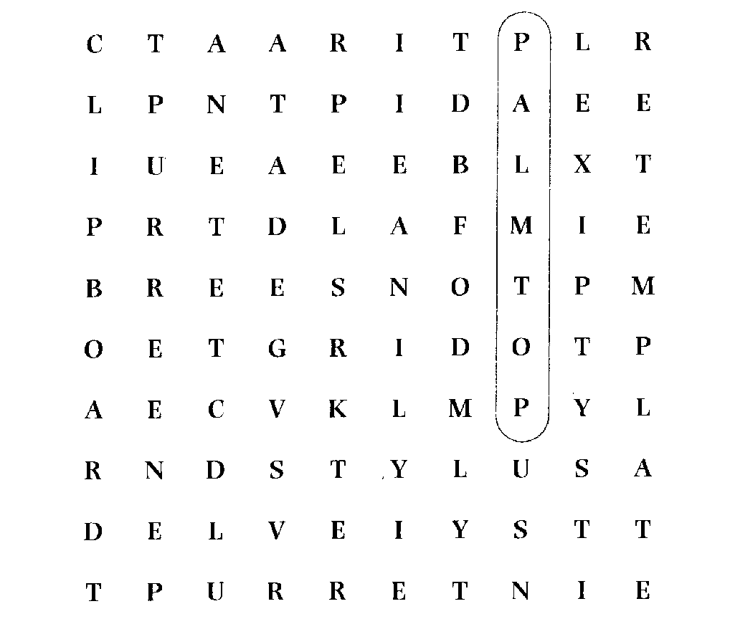
Find words which mean:
1 a computer that is small enough to hold in the hand. (7, P)
2 an electronic pen. (6, S)
3 to erase or omit. (6, D)
4 one type of portable computer which operates with an electronic pen. (9, C)
5 the information that the computer processes. (4, D)
6 a network of lines crossing at right angles. (4, G)
7 a signal to a processor to suspend temporarily the current sequence of instructions. (9, I)
8 a pattern used as a guide for creating letters or characters. (8, T)
9 an individual dot on a computer screen. (5, P)
Language focus B
24
Word formation: prefixes
When you are reading, you will come across unfamiliar words. lt is often possible to guess the meanings of these words if you understand the way words in English are generally formed.

An English word can be divided into three parts: a prefix, a stem, and a suffix. Pre-means 'before'. A prefix, therefore, is what comes before the stem. Consider, as an example, the prefix de- (meaning 'reduce' or 'reverse') in a word like demagnetize (meaning 'to deprive of magnetism'). A suffix is what is attached to the end of the stem. Consider, as an example, the suffix -er (meaning `someone who') in programmer Ca person who programs').
Suffixes change the word from one part of speech to another. For example, -ly added to the adjective quick gives the adverb quickly. Prefixes, on the other hand, usually change the meaning of the word. For example, un- changes a word to the negative. Unmagnetizable means 'not capable of being magnetized'.
Let us now consider some prefixes, their usual meanings, and how they change the meanings of English words.
 |  | Prefixes
Negative and positive | Size | Location | Time and order | Number
un- | semi- | inter- | pre- | mono-
non- | mini- | super- | ante- | bi-
in- | micro- | trans- | fore- | hex-
dis- |  | ex- | post- | oct-
re- |  | extra- peri- |  | multi-

Exercise 1 Study these tables. Try to find additional examples, using your dictionary if
25
necessary.
1 Negative and positive prefixes:
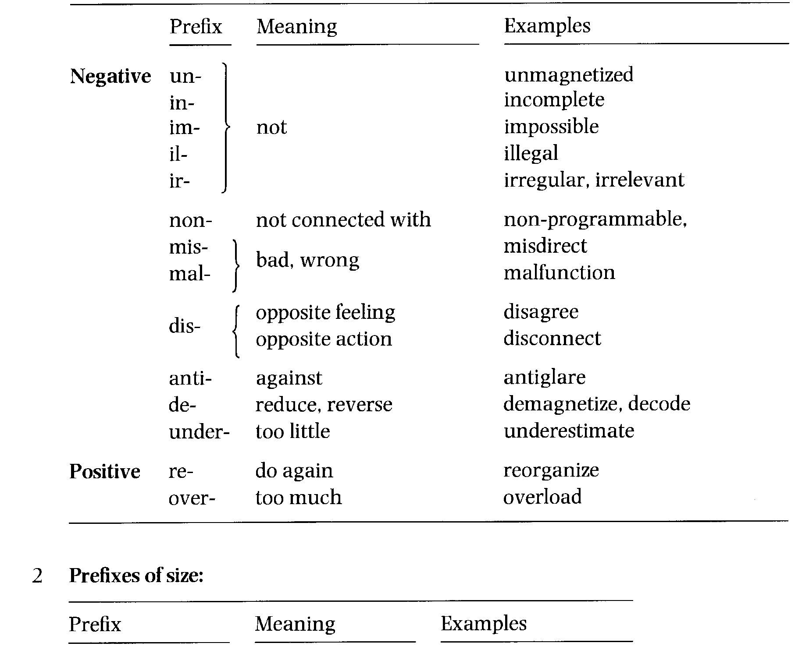
semi- half, partly semiconductor
equi- equal equidistant
mini- small minicomputer
micro- very small microcomputer
^{macro-}large, great 1 macroeconomics
mega- megabyte
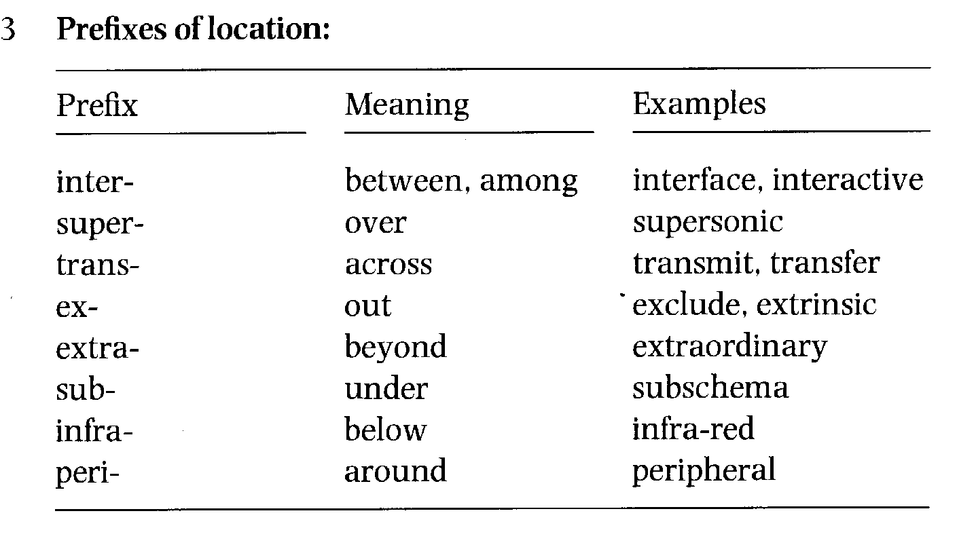
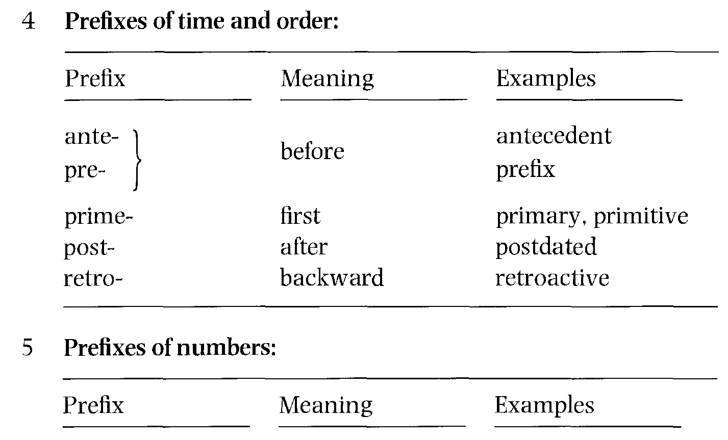
semi- half semicircle
26
mono- one monochromatic
bi- two binary
tri- three triangle
quad- four quadruple
penta- five pentagon
hex- six hexadecimal
sept(em)- seven September
oct- eight octal
dec- ten decimal
multi- many multiplexor
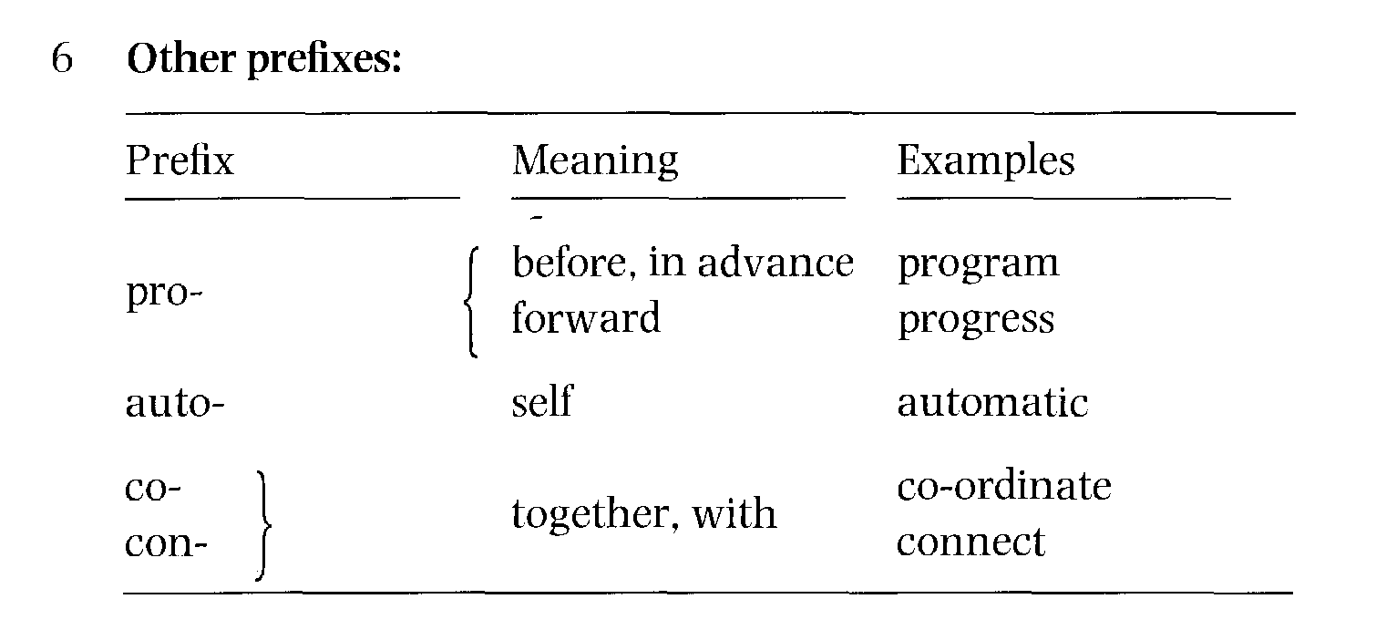

Exercise 2 | Read the following sentences and circle the prefixes. For each word that has a prefix, try to decide what the prefix means. Refer back to the table if you need help.  1 Floppy disks are inexpensive and reuseable.  2 If a printer malfunctions, you should check the interface cable.  3 The multiplexor was not working because someone had disconnected it by mistake.  4 Improper installation of the antiglare shield will make it impossible to read what is on the screen.  5 After you transfer text using the 'cut and paste' feature, you may have to reformat the text you have inserted.  6 You can maximize your chances of finding a job if you are bilingual or even trilingual.

7 Peripheral devices can be either input devices (such as keyboards) or output devices (such as printers).
27
8 Your pay rise is retroactive to the beginning of June and you will receive a biannual bonus.
9 The octal and hexadecimal systems are number systems used as a form of shorthand in reading groups of four binary digits.
10 As the results are irregular, the program will have to be rewritten.
Exercise 3 Fill in the gaps with the correct prefix from the following list.
auto de dec inter
maxi mega micro mini
mono multi semi sub
1 Most people prefer a colour screen to a chrome screen.
2 _script is a character or symbol written below and to the right of a
number or letter, often used in science.
3 A byte equals approximately one million bytes.
4 Once you finish your program, you will have to test it and bug it to
remove all the mistakes.
5 The introduction of conductor technology revolutionized the computer
industry.
6 If a computer system has two or more central processors which are under common control, it is called a processor system.
7 The imal system is a number system with a base of 10.
8 When the user and the computer are in active communication on a graphics system, we refer to this as active graphics.

Online services
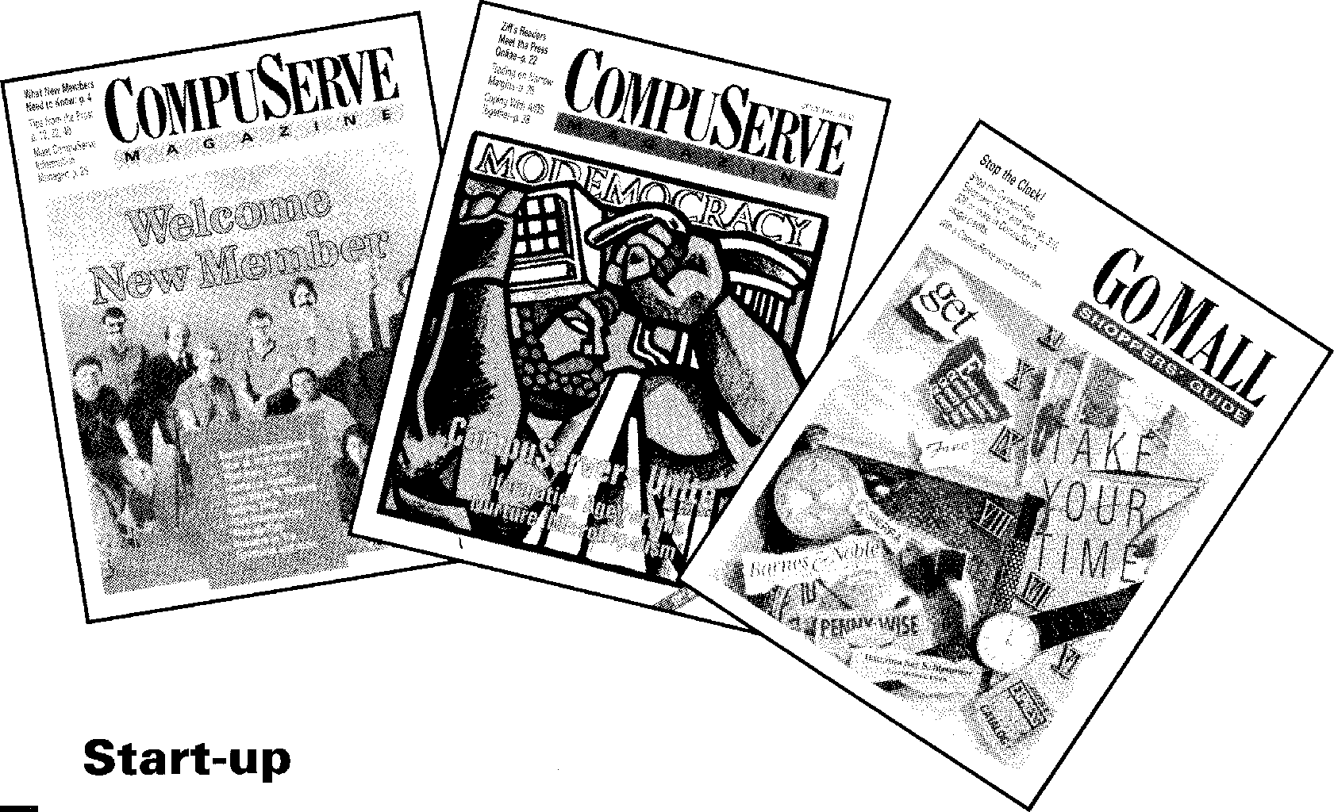
Task 1 Discuss the following questions:
1 What online services are available in your country?
2 What kind of facilities do online services provide?
Reading
Decide whether the following statements are true (T) or false (F) in relation to the information in the text which follows. If you think a statement is false, change it to make it true.
Task 2

Most people choose an online service because of the price or the number of available files.

28
Everybody has one service which he/she likes more than all the others. You should judge each BlX.ice according to whether it is better or wBlXe overall than the service you are currently using.
Eventually, all services will be accessible from the service you are using.
McGraw-Hill is owned byDELPHl'S
Tammy Ray and Jeanette Shearer think the BIX service is average. French Minitel users have free access to an English-language version of CompuServe, although they cannot use the e-mail facility.
DELPHI'S Hobby Shop now has two special-interest areas: onlfon classic vehicles, and one on new cars and technology.

Online Services
What's new on-line
BIX
TAB Book Clubs Online: You've
probably seen magazine ads for The 50 Computer Book Club and The
Computer Professionals' Book Society.
These are sponsored by TAB Books. This division of McGraw-Hill (BIX's parent company) is now online on
55 BIX, taking orders and answering
questions from members and
prospective members. The club
conference is moderated by Tammy Ray and Jeanette Shearer. You can
60 check them out by typing JOIN TAB.BOOK.CLUBS.
CompuServe
Dell Computer Forum: Dell Computer Corporation has opened a product support area on CompuServe. The Dell
65 area is part of the PC Vendor D Forum. Type GO DELL or GO PCVEND to take a look.
Minitel Link to CompuServe
CompuServe bolstered its position in Europe by making some of its services
70 available via France's national Minitel system in July. French Minitel users have access to an extra-cost service that is essentially a 'limited edition', English-language version of
75 CompuServe. Among the services
available are software and database downloads. E-mail and message-base posting are not available to Minitel users.
DELPHI
80 Hobby Group Expands: DELPHI's Hobby Shop specia40interest group continues to expand its areas of
interest. The most recent additions to the database and group topics are
85 Antique Auto, which focuses on
classic vehicles, and Autotech, where you can learn about new cars and technology. Type Go GROUP.
'I'm frequently asked which online service is 'best', but the answer is there is no best. Rating a particular service over another is entirely
5 subjective. Price is important to some people, while the number of files available for download is important to others. Because of these and so many other different judgments, there can be
10 no absolute. It all comes down to individual needs and preferences.
Still, users tend to be fiercely loyal to their 'home' online service-which is usually the first online service they
15 ever used. They tend to judge all other online services based on this first service - often preventing themselves from seeing the advantages of a specific service. For my part, I like all
20 the services I use and I'm on two dozen.
Each offers one or more products or features that either do not exist elsewhere or are superior to the same
25 features on other services. And I've a really subjective reason for being on one service - I use it to send monthly articles to magazines in Japan.
So, the real answer to the question
30 is simple: the best online service is the service that has what you want and is easy for you to use. The point? Keep an open mind when checking out an online service. Judge it based on what
35 it offers and how it meets your needs -not in comparison to what you're used to using. (It takes a couple of sessions to shake preconceived notions of what an online service 'should' be.)
ao Eventually, we're all going to be interlinked, no matter which service we use, in what DIALOG's Richard Ream calls a 'network of networks'.
Until then, most of us have to go
45 to more than one service to find everything we need.
And now, the news ...

IN. Vocabulary
29
It all comes down to (1. 10) — It is a question of two dozen (1. 20) — about twenty-four checking out (1. 33) — examining
is moderated by (1. 58) — is run by
bolstered (1. 68) — strengthened

Task 3 Fill in the gaps in this summary of the first part of the text. Each clue is an
anagram. The first and last letters are correct.
Task
In my opinion, there is no single 'best' online service. The choice depends on
your (prltacuair) needs and preferences. Most users have their
own ² (ftrvaioue), but this can prevent them from seeing the
3
(agtvndaaes) of other services. Each one offers something which
is either ⁴ (uqinue) to that service, or which is ⁵
(bteetr) than the same features on other services. So, when considering an
online service, decide whether its features ⁶_ (cosrernopd) to what
you need. Until all services are' (iilktneernd), most of us will need
to (cunoitne) using more than one.
Task 4 1 Do you think the English in the text is:
a formal?
b neutral?
c informal?
2 Do you think this article originally appeared in:
a a computer magazine?
b a general magazine for young people?
c a general magazine for adults?
d an online bulletin board?
e the science page of a newspaper?
Give reasons for your choices.
Task 5 Make these words negative by adding the appropriate prefix from those given
30
below. The first one has been done for you.
in- un- im- dis-
1 infrequently
2 loyal
3 advantages
4 specific
5 like
6 real
7 probably
8 available
Task 6 Match each word or expression in the first column with a synonym in the
second column.
1 but (line 2) a ultimately
Task
2 while (line 6) b however
3 still (line 12) c whereas
4 for my part (line 19) d nevertheless
5 eventually (line 40) e personally
6 until then (line 44) f meanwhile
Listening
Task 7 ri Listen to Jean-Yves Martin, a sales representative of France Telecom,
explaining the Minitel online service to Paul Burgess, an English reporter. Complete Paul's notes.
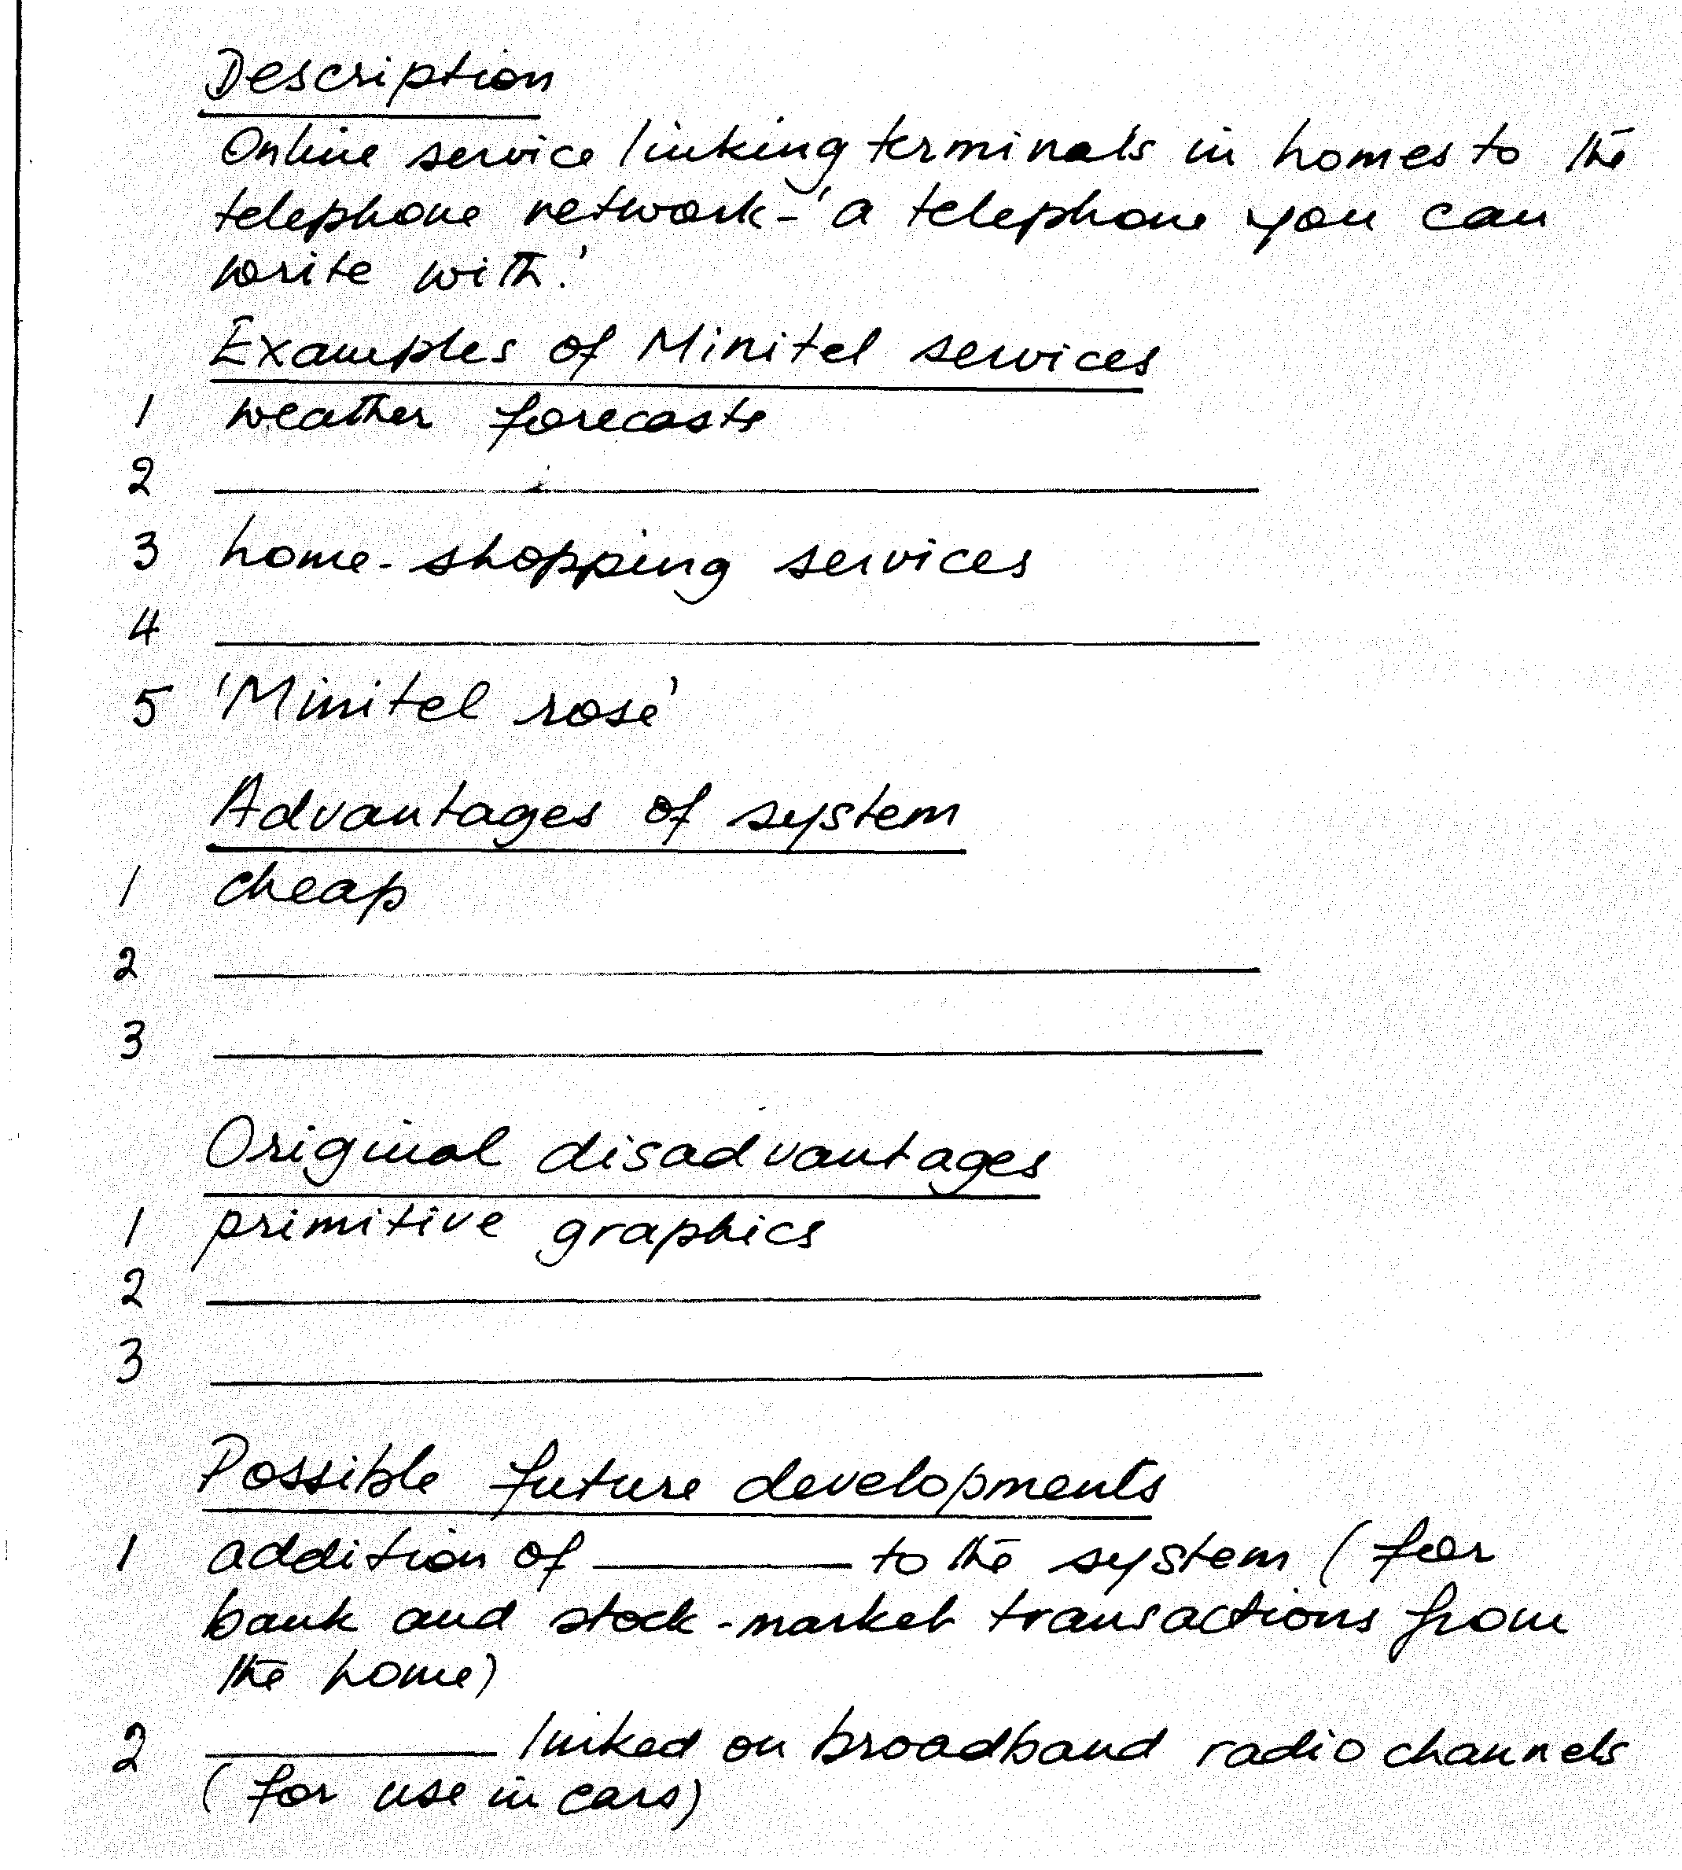
Task 8 r Answer these questions about the interview.
1 What is 'Minitel rose'?
2 When did the system start?
3 How many Minitel terminals did the PTT install originally?
4 Did the first users have to pay?
Data transmission

Reading
32
Match up the jigsaw pieces to complete the definitions. One has been done for
Task 9
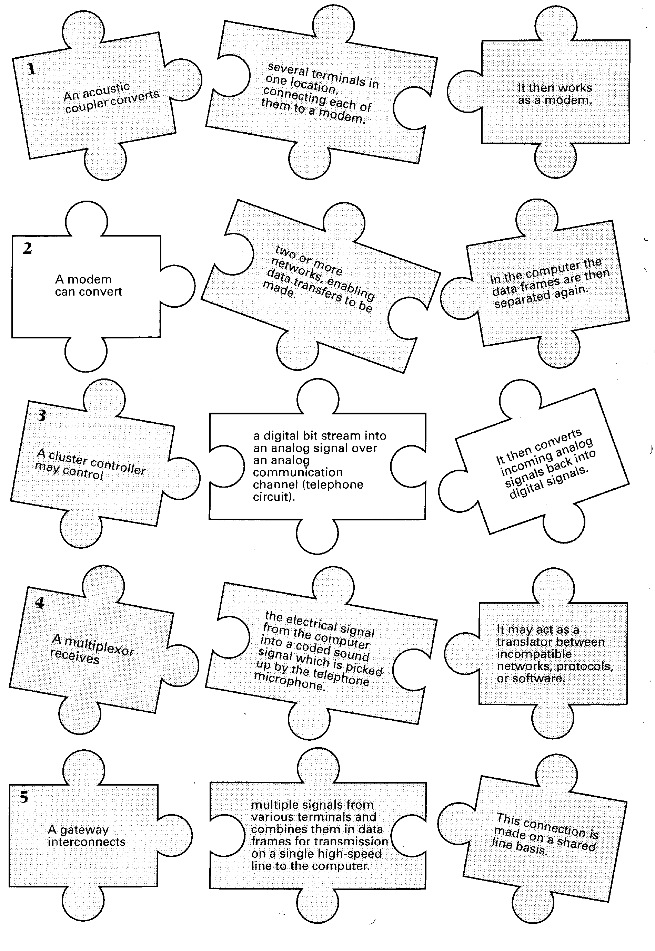

Task 10 Using the completed definitions from Task 9 and the information in the text
33
below, fill in the gaps in this diagram.
Accounts
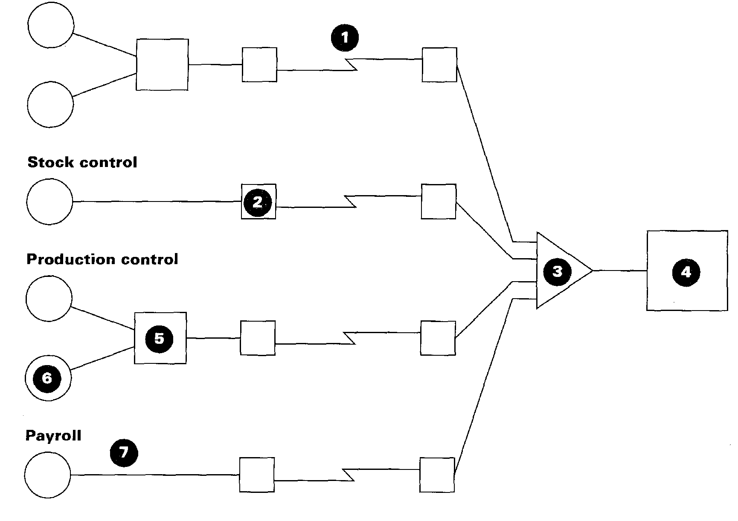
1  2  3  4  5  6  7 |  |  | signals  signals
Analog transmission
The older telephone systems function on the basis of analog signals representing voice modulation patterns which are represented by variations in wave forms. When using telephone lines for transmitting data by terminal to a computer, the digital signals from the terminal need
5 to be converted to analog signals by an acoustic coupler or modem prior to
transmission. A modem is a device which serves a dual purpose because it acts as a MOdulator (digital to analog) and DEModulator (analog to digital), hence the name MODEM. An analog communication system requires a modem at either end of the communication line. When the
1() signals are received by the distant computer, the signals are reconverted to digital form prior to being input for processing.

Reading
34
Task 11 Before reading the text below, answer these questions.
1 What are the advantages of digital transmission?
2 How does digital transmission differ from analog transmission?
3 What information does the code supply?
Now read the text to check your answers.
Digital transmission
Analog transmission has been in use for many years as the basis of telephone technology and is very effective for this purpose, but it is not so suitable for high-speed transmission of information. Digital transmission consists of electrical pulses representing data in binary code as a series of
5 on/off pulses. A number of different codes exist, some of which are based on a 6-, 7-, or 8-bit structure. ASCII is a 7-bit code and EBCDIC is an 8-bit code. The codes represent characters, transmission control signals, information separators, and device control. Digital technology has a number of advantages compared to analog, including higher transmission
1() speed, lower incidence of errors, and the facility for mixing data consisting of voice, image, and text on the same circuit. It is for this reason that data transmissions will be increasingly digital in the future. A network structure known as Integrated Services Digital Network (ISDN) facilitates these aspects.
Speaking
Task 12 Work in pairs, A and B. Use the information in this unit to describe the
diagrams below. You may make notes first.
Student A: Describe diagram 1 to your partner.
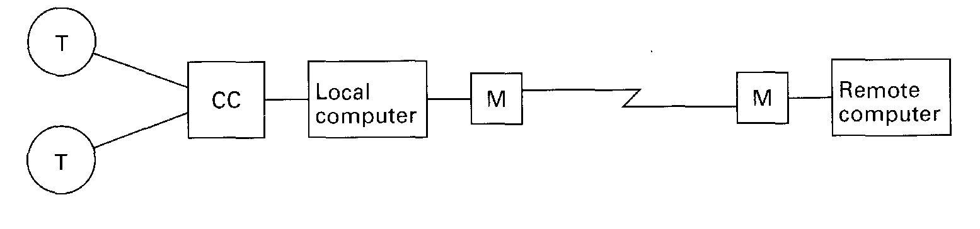
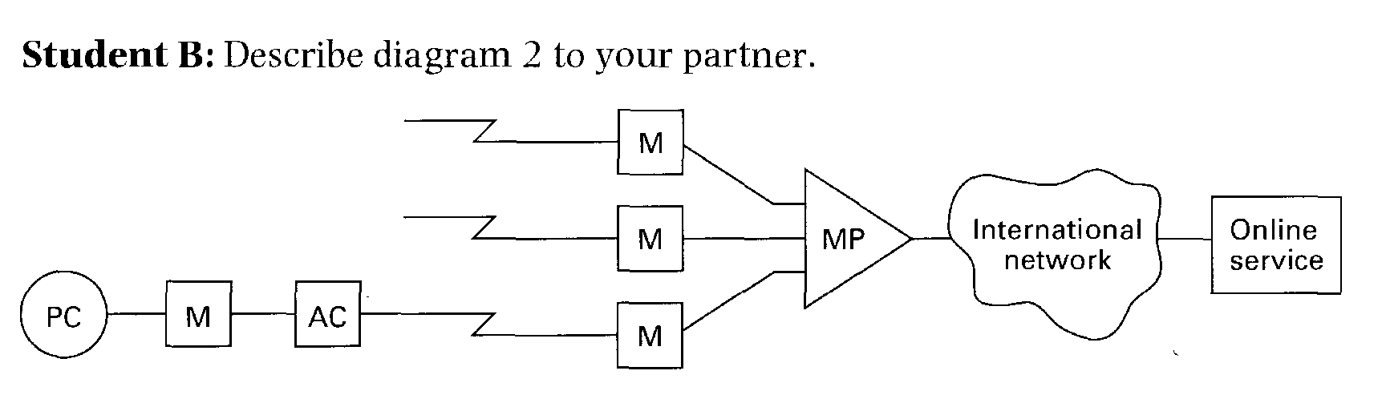
AC — Acoustic coupler CC — Cluster controller M — Modem
MP — Multiplexor
PC — Personal computer T — Terminal
Writing
35
Task 13 Write a paragraph to show the difference between analog and digital
transmission.
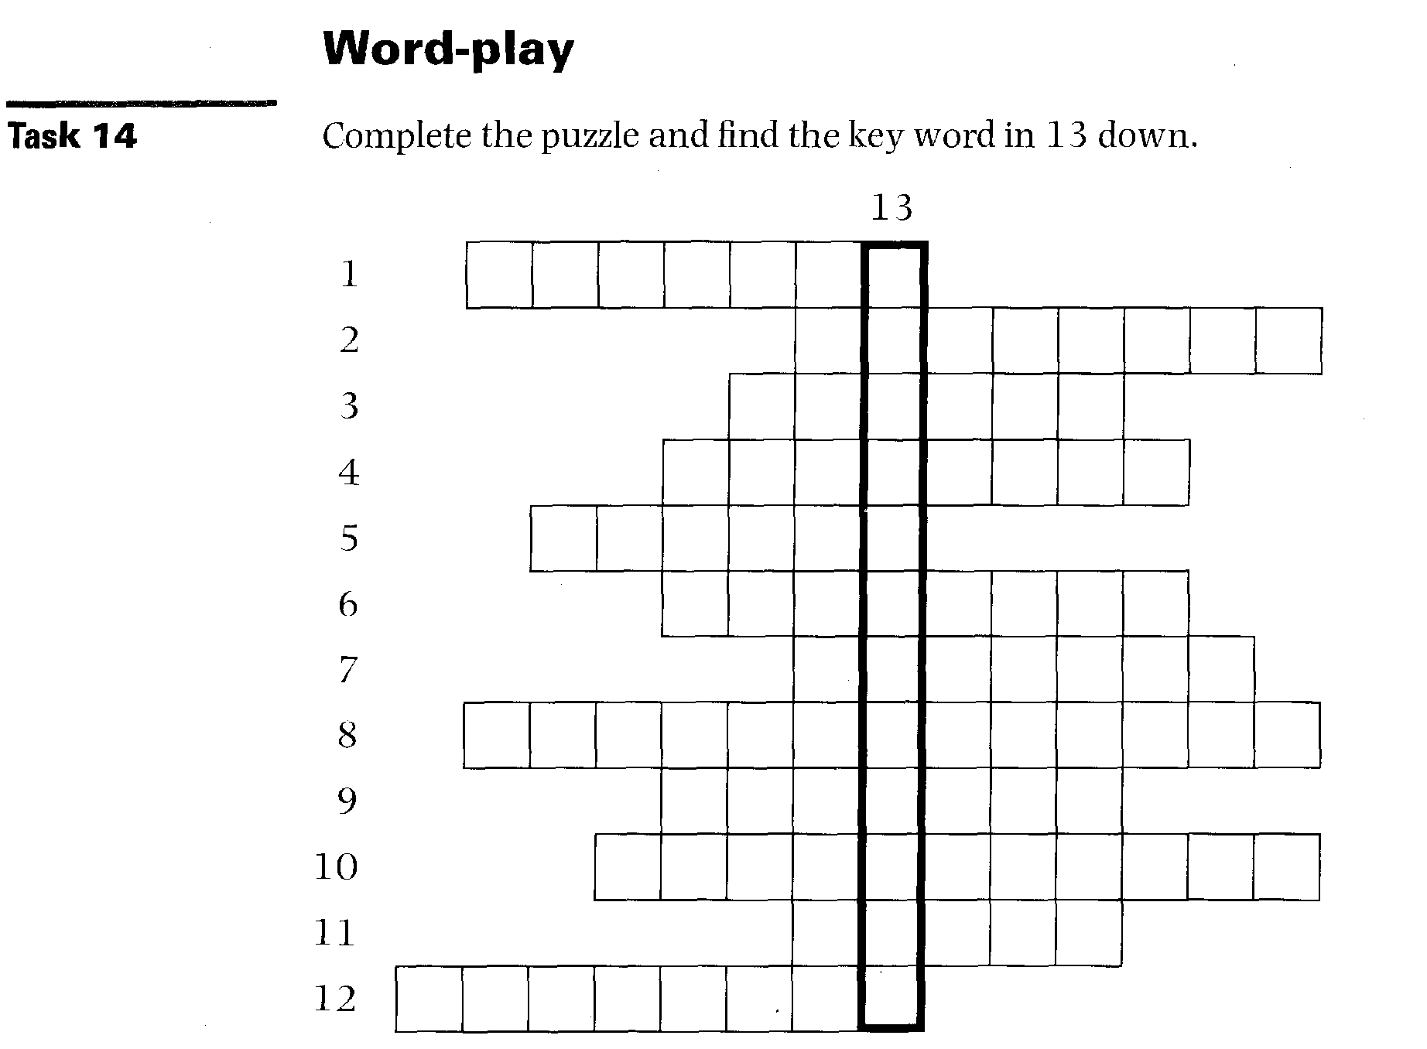
Across
1 A combination of electronic devices and conductors that form a conducting path. (7)
2 An agreement that covers the procedures used to exchange information between co-operating computers. (8)
3 This kind of transmission has been the basis for telephone technology for many years, though it is gradually being replaced. (6)
4 To send programs or data from a central computer to a remote PC. (8)
5 Single vibrations of electric current. (7)
6 A VDU screen and keyboard used to interact with a computer, usually with no computing capacity of its own. (8)
7 This kind of transmission consists of electrical signals representing data in binary code. (7)
8 A public database, for example, that can be accessed over a computer or telephone network. (6, 7)
9 A controller controls a number of similar peripheral device such as
terminals and links them to the main computer. (7)
10 This merges information from several channels into one channel. (11)
11 A device that converts the computer's digital bit stream into an analog signal for transmission over a telephone line. (5)
12 A board is a public teleconferencing system that allows users to read and
write messages. (8)
Down
13 The process of sending signals electronically. (1-2)
Language focus C
Word formation: suffixes
We have already seen how prefixes can change the meaning of a word. Let us now consider some suffixes, their usual meanings, and how they change the meanings of English words.
Suffixes

Nouns
-ance
-ence
-or
-er
-1st
- ness
Verbs
-ize -ate
- fy
- en
- ify
Adjectives
- able -ible -less -ic
- ical -ish
- lye
Adverbs
-ly

Study these tables and try to make additional examples. Use your dictionary if necessary.
Exercise 1
1 Noun-forming suffixes:

state quality of
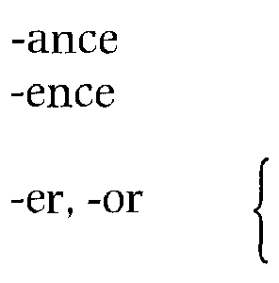
- ist, -yst
- ian -tion, -ation -ness
-ion
-ing
- ment
- ity
- ism
- dom
- ship
a person who a thing which
a person who pertaining to the act of condition of action/state activity
state, action state, quality condition/state
domain/condition condition/state
performance independence
programmer, operator compiler, accumulator
analyst, typist electrician
compilation readiness
conversion multiplexing measurement electricity
magnetism
freedom
relationship, partnership

36

2 Verb-forming suffixes:

Examples

Suffix
- ize/-ise
- ate
- ify
- en
Meaning
to make
computerize automate, activate,
calculate
simplify harden, widen

Adverb-forming suffix:

Suffix |  | Meaning |  | Examples

- ly in the manner of electronically,
logically, comparably, helpfully
4 Adjective-forming suffixes:

Suffix |  | Meaning |  | Examples

computational, logical
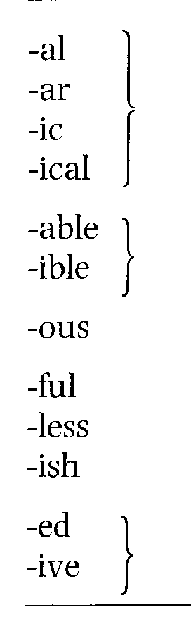
having the quality circular
of magnetic, automatic
electrical
capable of being comparable
divisible
like, full of dangerous
characterized by helpful
without careless
like yellowish
having the quality computed
of interactive

Note: Words ending in -ing are formed from verbs. The -ing form may be used as a noun, part of a noun phrase, or part of a verb.
37
Examples:
1 Programming is an interesting job. (noun)
2 Programming in C is interesting. (part of noun phrase)
3 He is working as a programmer. (part of verb)

Exercise 2 | Read the following sentences and circle the suffixes. Underline the stem if it can be used on its own. The first one has been done for you.  1 A programmes designs, writes, and tests programs for perperformingrious tasks on a comcomputer  2 A systems analyst studies organizational systems and decides what action needs to be taken to maximize efficiency.

3 Laser printers are preferable to other types of printing devices because of their speed and quietness.
38
4 The microcomputer we have purchased does not have a FORTRAN compiler. It is programmable in BASIC only.
5 We have found that operators who have the freedom to take short breaks during the day greatly improve their performance.
6 The number of shipments will increase over the coming months.
7 We decided to computerize the entire plant to give each division more independence.
8 Spooling is a way of storing data temporarily on disk or tape until it can be processed by another part of the system.
9 Turning your office into a paperless environment may be expensive at the beginning but can produce big savings in the long run.
10 Software developers are producing increasingly sophisticated applications for a growing global market.
Now, for each word that has a suffix, indicate what part of speech the word is (e.g. noun, verb, etc.).

Programming and languages
39
Start-up
Task 1 Can you identify these programming languages?
a
/* this program finds the minimum of two integers #-^{i}nclude <stdio.h>
main()
int j,k,m;
printf("Input two integers: scanf("%d%d",&j.&k);
m=min(j,k);
printf("\n%d is the minimum of %d and %d\n\n" m,j,k);
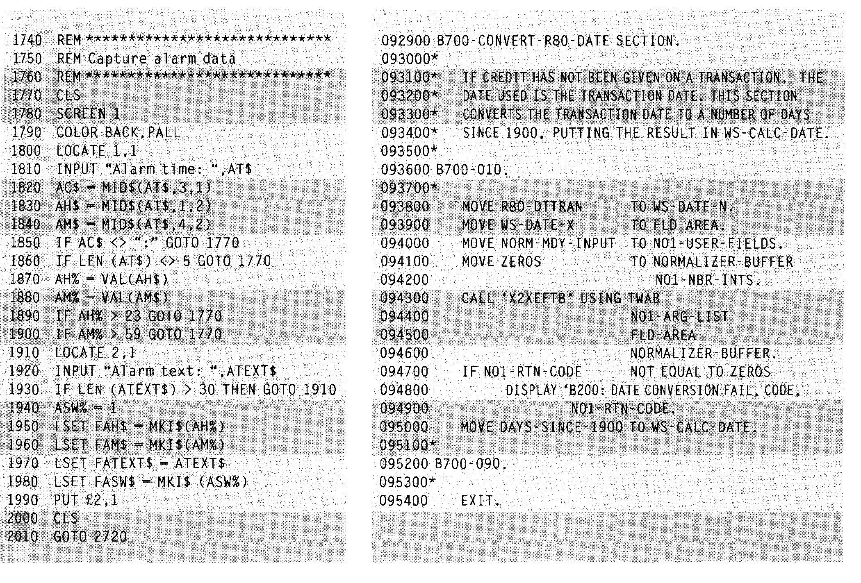
Reading
40
Task 2 Before reading the text, try to fill in the gaps in these sentences.
1 A is a program written in one of the high-level
languages.
2 A program written in a high-level language must be interpreted into
before the computer will read and process it.
3 A program designed to perform a specific task is called an
4 The or is the program
produced when the original program has been converted into machine code.
5 A is a program that converts a high-level language into machine
code.
6 The systems program which fetches required systems routines and links them to the object module is known as the
7 The is the program directly executable by the
computer.
Now read the text to check your answers.
Programs and programming languages
Computers can deal with different kinds of problems if they are given the right instructions for what to do. Instructions are first written in one of the high-level languages, e.g. FORTRAN, COBOL, ALGOL, PL/I, PASCAL, BASIC, or C, depending on the type of problem to be solved. A program
5 written in one of these languages is often called a source program, and it cannot be directly processed by the computer until it has been compiled, which means interpreted into machine code. Usually a single instruction written in a high-level language, when transformed into machine code, results in several instructions. Here is a brief description of some of the
io many high-level languages:
FORTRAN acronym for FORmula TRANslation. This language
is used for solving scientific and mathematical problems. It consists of algebraic formulae and English phrases. It was first introduced in the United States in 1954.
15 COBOL acronym for COmmon Business-Oriented Language. This language is used for commercial purposes. COBOL, which is written using English statements, deals with problems that do not involve a lot of mathematical calculations. It was first introduced in 1959.
ALGOL acronym for ALGOrithmic Language. Originally called IAL,
zo which means International Algebraic Language. It is used for mathematical and scientific purposes. ALGOL was first introduced in Europe in 1960.
PL/I Programming Language I. Developed in 1964 to combine
41
features of COBOL and ALGOL. Consequently, it is used for data processing 25 as well as scientific applications.
BASIC acronym for Beginner's All-purpose Symbolic Instruction
Code. Developed in 1965 at Dartmouth College in the United States for use
by students who require a simple language to begin programming.
C developed in the 19 70s to support the UNIX operating system. C is a 30 highly portable general-purpose language.
Other such languages are APL (developed in 1962), PASCAL (named after Blaise Pascal and developed in 1971), and LISP and PROLOG, both of which are used for work in artificial intelligence. LOGO is a development of LISP which has been used to develop computer-based training (CBT)
35 packages.
When a program written in one of these high-level languages is designed to do a specific type of work such as calculate a company's payroll or calculate the stress factor on a roof, it is called an applications program. Institutions either purchase these programs as packages or commission
40 their own programmers to write them to meet the specifications of the users.
The program produced after the source program has been converted into machine code is referred to as an object program or object module. This is done by a computer program called the compiler, which is unique for each
45 computer. Consequently, a computer needs its own compiler for the various high-level languages if it is expected to accept programs written in those languages. For example, in order that an IBM RS/6000 may process a program in FORTRAN, it needs to have a compiler that would understand that particular model and the FORTRAN language as well.
50 The compiler is a systems program which may be written in any language, but the computer's operating system is a true systems program which controls the central processing unit (CPU), the input, the output, and the
secondary memory devices. Another systems program is the linkage editor, which fetches required systems routines and links them to the
55 object module (the source program in machine code). The resulting program is then called the load module, which is the program directly executable by the computer. Although systems programs are part of the software, they are usually provided by the manufacturer of the machine.
Unlike systems programs, software packages are sold by various vendors
60 and not necessarily by the computer manufacturer. They are a set of programs designed to perform certain applications which conform to the
particular specifications of the user. Payroll is an example of such a package which allows the user to input data — hours worked, pay rates, special deductions, names of employees — and get salary calculations as
65 output. These packages are coded in machine language (Os and 1s) on magnetic tapes or disks which can be purchased, leased, or rented by users who choose the package that most closely corresponds to their needs. ■
■ Vocabulary
payroll (1. 62) — list of employees and the amount of money to be paid to each of them
Task 3 These are answers to questions about the text. Write the questions.
42
1 No, it is quite wordy so it is used for commercial purposes.
2 To support the UNIX operating system.
3 An applications program.
4 It is done by the compiler.
5 It fetches required systems routines and links them to the object module.
6 No, they are also sold by other vendors.
Task 4 Summarize the information on different high-level computer languages by
completing the table below.
Language | Developed | Function | Characteristic
FORTRAN
 | 1959
 |  | mathematical and scientific purposes
 |  |  | combines features of COBOL and ALGOL
BASIC
 |  | to support Unix operating system
 | 1962

Find the passages in the text where the following ideas are expressed. Give the line references.
line
Task 5
1 | 1.  _ | Systems programs control the work of the computer system.
2 | 1. | Software packages are not always sold by the manufacturer.
3 |  | Usually, every high-level instruction translates into many more in machine code.
4 | 1. | Systems programs are usually provided by the manufacturer.
5 | 1. | Programmers may be required to write software for their employers.

43
Task 6 | Using the line reference given, look back in the text and find the reference for the words in italics.  1 if they are given the right (line 1)  2 it cannot be directly processed (line 5)  3 it is called an applications program (line 38)  4 commission their own programmers (line 40)  5 to write them to meet (line 40)  6 that would understand (line 48)  7 which controls the central (line 51)  8 links them to the object (line 54)  9 They are a set of programs (line 60)  10 which can be purchased (line 66)

Task 7 | Using the line references given, refer back to the text and find words or phrases that have a similar meaning to:  1 converted (lines 5-10)  2 give the responsibility to (lines 35-40)  3 brings (lines 50-55)  4 are compatible with (lines 60-65)  5 matches (lines 65-67)

Task 8 Choose the correct word to complete each sentence. You may have to change
some words slightly.
1 instruction, instruct, instructed, instructor
a Our maths arithmetic.  b We were  c Both |  |  |  |  | explained to us the principles of binary
a Our maths arithmetic.  b We were  c Both |  |  |  | to document our programs very carefully.  and data have to be changed to machine code before

the computer can operate on them.
2 compilation, compiler, compile, compiled
a Our university computer does not have a PASCAL
b Usually, a programmer his program before he puts in the
data.
c A source program cannot be directly processed by the computer until it has been
3 result, results, resulting
a The linkage editor links systems routines to the object module. The
program, referred to as the load module, is directly
executable by the computer.
b The of these mathematical operations were obtained from
the university mainframe and not from my micro.
4 specification, specify, specific, specified, specifically
44
a Our company bought three packages with very applications:
payroll, accounts receivable, and accounts payable.
b An applications program is designed to do a type of work,
such as calculating the stress factor of a roof.
c Did the analyst give the new programmer the necessary to
start on the project?
C language
Listening
Listen this terview with David Wendt, an expert on C. Are the following

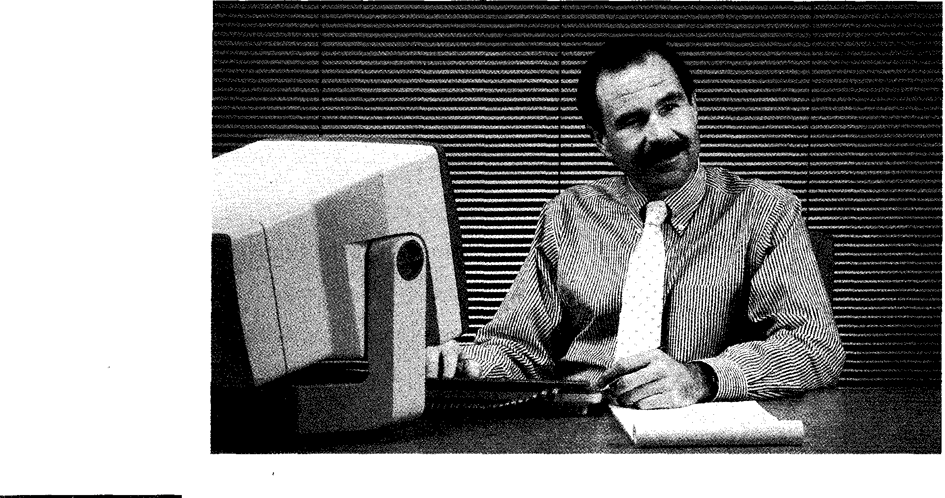
#tt#M#M111
EIM
sentences true (T) or false (F)?
C was written to support the development of the MS/DOS operating system.

C was based directly on a language called BCPL.
UNIX was rewritten in C in 1973.
C is rarely used for systems programming now.
C's main disadvantage is that it has a small set of operators. C is more powerful than Assembler.
C can be used to access memory addresses directly. Pascal and C produce equally fast and efficient code. C is the ideal language for everyone.
A language called D is expected to replace C.
Listen again. Change the sentences that are false to make them true.
Task 10 Listen again to the cassette and fill in the gaps in the tapescript below.
45
INTERVIEWER: Could you give some examples of how it does that?
DAVID WENDT: Yes. With C, the programmer can access the underlying hardware. He can access memory addresses directly, he can perform operations on values stored as , and he can store variables in
registers, just as in Assembler. This produces faster and more
code than is produced by high-level languages like PASCAL. At the same time, it provides the fundamental ³ constructs required
for well-structured programs: decision-making, loops, and
These features combined together provide a very powerful tool for the programmer.
INTERVIEWER: You make it sound like the ideal language for everyone.
DAVID WENDT: Well, no, I'm not saying that. But if you need to write programs
that are ⁶ , fast in execution, and yet ⁷ from one
computer to another, then C is the language you should be using.
Reading
Task 11 Read the program below and the text on the next page, then complete the
sentences which follow.
/* CALCULATE AVERAGES */ main()
f
float a,b,c,d,average; printf("Enter three numbers:");
scanf("%f %f %f",&a,&b,&c); d=a+b+c;
average=d/3.0;
printf("The average is %f", average);
1
Comment Lines
46
A C source program consists of statements and comment lines. Comment lines are enclosed by the characters /* (at the start of the comment) and */ (at the end of the comment).
The Function main{ }
Every C program must have a function called main which must appear
5 only once in a program. The parentheses following the word main must be present, but there must be no parameters included. The main part of the program is enclosed within braces {} , and consists of declaration statements, assignment statements, and other C functions. In the above
program there are six statements within the braces: a declaration
10 statement (the first statement of the main program starting with the word float), two assignment statements (the fourth and fifth statements starting with the variable names d and average), and three function statements, two to print information on the screen and one to scan the keyboard for input.
15 As C is a free form language, the semicolon (;) at the end of each line is a
must. It acts as a statement terminator, telling the compiler where an instruction ends. Free form means that statements can be identified and
blank lines inserted in the source file to improve readability, and statements can span several lines. However, each statement must be
20 terminated with a semicolon. If you forget to include the semicolon, the compiler will produce an error, indicating the next line as the source of the error. This can cause some confusion, as the statement objected to can be correct, yet as a syntax error is produced.
Variables and the Declaration Statement
A variable is a quantity that is referred to by name, such as a, b, c; d, and
25 average in the above program. A variable can take on many values during program execution, but you must make sure that they are given an initial value, as C does not do so automatically. However, before variables can be used in a program, they must be declared in a type declaration statement.
1 The Function must appear only once in a program.
2 /* CALCULATE AVERAGES */ is a line.
3 The statement float a,b,c,d,average; is a statement.
4 The program below contains function statements.
5 The assignment statements are on lines and
6 The main part of the program is enclosed within
7 Each line of any C program must end with a , which acts as a
statement
8 If you forget to include the correct punctuation, the will produce
a error.
9 A quantity referred to by name is known as a
10 A statement must be used to declare variables.
Task 12 Find words in the text which mean:
47
1 brackets (lines 5-10)
2 not fixed (lines 10-15)
3 systematically check (lines 10-15)
4 recognized (lines 15-20)
5 completed (lines 20-25)
6 starting (lines 25-29)
Task 13 The table below shows C's relational operators. Fill the gaps in the table.
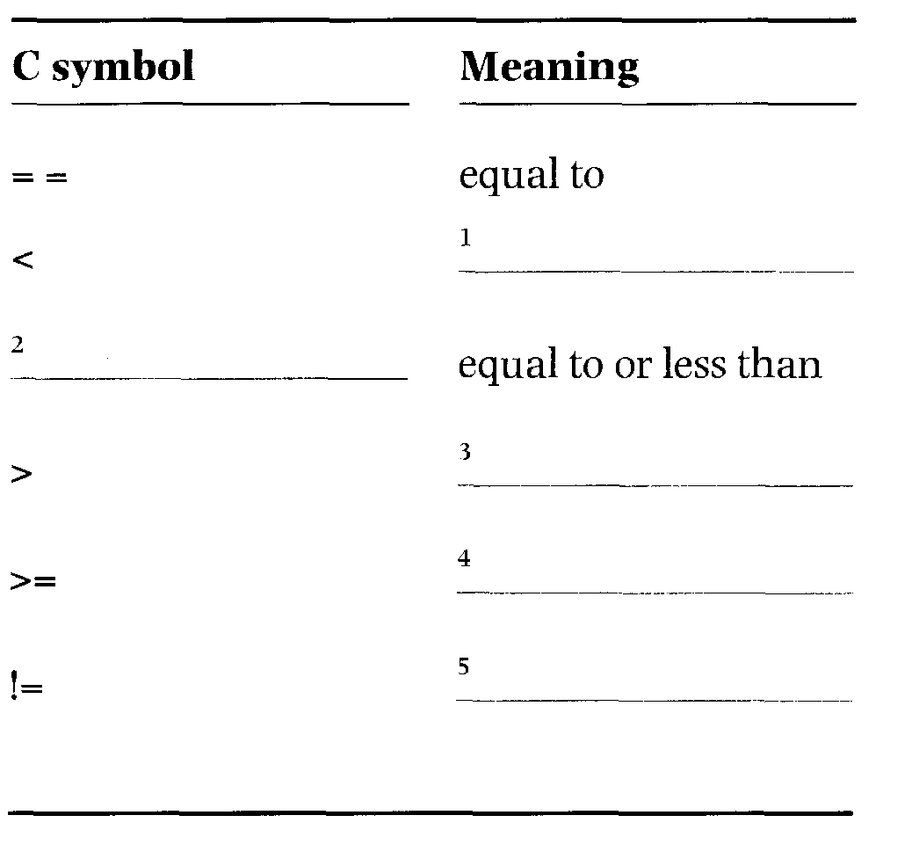
Writing
Using the completed table above, write sentences to illustrate the following:
1 a != b
Task 14
2 a > b
3 a <= b
4 a >, b
5 a < b
6 a = = b

Speaking
Task 15 Read the statements below. Which do you agree with more? Why?
`Learning a programming language is like learning any natural language. The only difference is that you are communicating with a machine instead of another person.'
`I get annoyed when I hear people comparing programming languages with
natural languages. They have almost >=thing in common.'
48
 | Word-play
Task 16 | Solve the anagrams in the right-hand column and match them with the words in the left-hand column to complete the phrases. The first one has been done for you.

1 | high-level | a | mestnttae
2 | machine | b | thirmacite
3 | systems | c | peat
4 | object | d | taporeor
5 | linkage | e | omelud
6 | magnetic | f | egguanal | language
7 | binary | g | trodite
8 | declaration | h | deco
9 | comment | i | enil
10 | relational | i | nituroe

Language focus D
49
Organizing information
A paragraph is a group of related sentences that develop an idea. In nearly every paragraph, there is one idea that is more important than all the others. The main idea of the paragraph is usually found at the beginning.
Sample paragraph 1:
All computers, whether large or small, have the same basic capabilities. They have circuits for performing arithmetic operations. They all have a way of communicating with the person(s) using them. They also have circuits for making decisions.
In sample paragraph 1, the first sentence, All computers, whether large or small, have the same basic capabilities. expresses the main idea of the paragraph.
All main idea sentences have a topic and say something about the topic.
Example:
All computers [topic], whether large or small, have the same basic capabilities [about the topic].
In some of your reading, finding main ideas may serve your needs but, in much of your studying, you need to understand details. It is sometimes more difficult to understand details than main ideas. You will find it helpful if you think of details as growing out of the main idea. In sample paragraph 1, there are three major details growing out of the main idea. These are the major details:
1 They have circuits for performing arithmetic operations.
2 They all have a way of communicating with the person(s) using them.
3 They also have circuits for making decisions.
A major detail often has minor details growing out of it. These minor details tell more about a major detail, just as major details tell more about a main idea. In studying, you often find a paragraph that has many small details that you must understand and remember. Breaking up a paragraph of this kind into its three components: the main idea, major details, and minor details will help you to understand and remember what it is about.
Sample paragraph 2:
It is the incredible speed of computers, along with their memory capacity, which makes them so useful and valuable. Computers can solve problems in a fraction of the time it takes man. For this reason, businesses use them to keep their accounts, and airline, railway, and bus companies use them to control ticket sales. As for memory, modern computers can store information with high accuracy and reliability. A computer can put data into its memory and retrieve it again in a few millionths of a second. It also has a storage capacity for as many as a million items.
If you were to organize this paragraph into its three components, it would look like this:

Main idea
It is the incredible speed of computers, along with their memory capacity, which makes them so useful and valuable.
Major details
Computers can solve problems much faster than humans.
Modern computers can store information with high accuracy and reliability.

It also has a storage capacity
for as many as a million items.
Minor details | Businesses | Transport |  | A computer
 | use them | companies |  | can put
 | to keep | use them |  | data into
 | accounts. | to keep track of ticket  sales. |  | its memory and  retrieve it again in  a few millionths  of a second.

In making a block diagram you don't have to write every word in the main idea sentence or in each of the detail sentences.
Exercise 1 | Practise finding the main idea, major details, and minor details by completing the block diagram after reading the following paragraph.  The computer has changed the production of copy in the newspaper industry. There are three steps involved in the process: input, correction, and output. First, the computer numbers each story, counts words, and gives a listing of the length of each story, Then, a page is made up, advertisements are placed in, the copy is shifted or deleted, and corrections are made.⁾Finally, the computer hyphenates words, and the result of all this is a newspaper page.

Main idea
The computer has changed the production of copy in the newspaper industry.
50
Major details
Minor details

Main idea
Major details
Minor details
Exercise 2 | Practise finding the main idea, major details, and minor details by completing the diagram after reading the following paragraph.  Railway companies use large computer systems to control ticket reservations and to give immediate information on the status of their trains. The computer system is connected by private telephone lines to terminals in major train stations, and ticket reservations for customers are made through these phone lines. The passenger's name, type of accommodation, and the train schedule is put into the computer's memory. On a typical day, a railway's computer system gets thousands of telephone calls about reservations, space on other railways, and requests for arrivals and departures. A big advantage of the railway computer ticket reservation system is its rapidity because a cancelled booking can be sold anywhere in the system just a few seconds later. Railway computer systems are not used for reservations alone. They are used for a variety of other jobs including train schedules, planning, freight and cargo loading, meal planning, personnel availability, accounting, and stock control.

Terminals for ticket reservations
51
Thousands of calls for reservations, space, arrivals, and departures


Computer software
 |  | .AMMNYNIMU.ia• | Start-up  Make a list of software products that you use (e.g. word processing, spreadsheets, etc.). Are there some features of the products you never use? Are there any features missing?
Task 1 |  | .AMMNYNIMU.ia•

Reading
In the magazine article which follows, a number of software developers expnions on the future of software technology. Read the article and tick
( V ) the relevant boxes to show which opinions are expressed by the speakers.
Task 2

Opinions
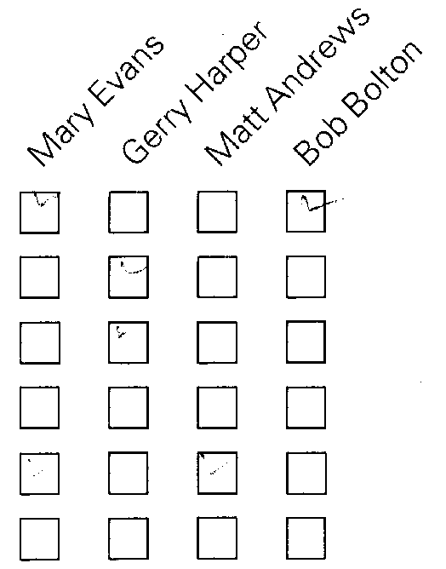
In general, customers are getting what they want.
In general, customers are not getting what they want. Software is too complex.
Software is not complex enough.
Software developers know what users want.
Software developers don't know what users want.

c)

Catherine Bull investigate s

This week: software
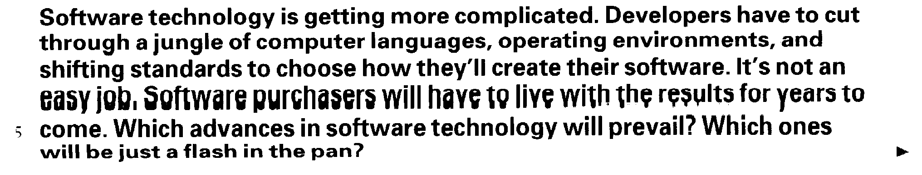

⁴ I chose four well-known software developers and asked each to talk about current and future trends in software technology. Their comments reveal some common and diverse themes.
53
10 I began by asking them if they thought that software purchasers are getting what they need? What should developers be doing differently to give purchasers a better product?
Mary Evans In general, I think people are getting what they want —there are a lot of creative things being done with paint software, word

15 processing, DTP (desktop publishing) systems, and the like. Do users want more? Of course! Users will always want more. The computer is an incredibly powerful tool, and any software that makes it easier, faster, more creative, or more cost-effective will inevitably be in demand. But I'm generally optimistic about the way things are going
20 at the moment. I think most of the major software manufacturers are able to read the market quite well.'
Gerry Harper 'I'm afraid I completely disagree with Mary. I just don't think that software purchasers are getting the technical support they need. While the products are getting more and more complex, and
25 more and more expensive, it seems that support is starting to be thought of as an additional business opportunity. More generally, I've thought for some time that applications are getting too big, and that they're trying to do too much. Yes, they're versatile and powerful, but they're also often overwhelming. I think what we need are simple little
30 programs that are easy to understand and use, and that work together to accomplish more complex tasks.'
Matt Andrews 'I really can't agree with that. To imagine we can just go back to "simple little programs" just ignores the complex needs of many of today's software users. No, I'm sure that you can't stop
35 progress. Suppliers know what their customers want — they just can't supply it quickly enough. I've studied the market very closely, and I've found that purchasers' needs seem always to exceed the capability of the available software by a constant time-frame of about six to twelve months.'
40 Bob Bolton 'I think users are getting what they want, provided that their needs fit the off-the-shelf application. Specialized software is usually so specific that it should be written in-house for businesses. Developers should add features that the customer needs, not what they think customers want. Some effort should be made to get
45 feedback from the users before making an upgrade so that the proper features are added.'
Vocabulary
a flash in the pan (1. 6) — a success that lasts only a short time and is not repeated
off-the-shelf (1. 41) — mass-produced: not made according to the individual needs of the customer
1 'Developers have to cut through a jungle of computer languages, operating environments, and shifting standards...' (line 1)
Task 3 Each of the following comments from the text is followed by two paraphrases.
Decide which paraphrase (a or b) is closer in meaning to the original comment. Remember to look at the comments in their original context.
54
a The huge number of languages, environments, and standards makes life difficult for software developers.
b Software developers have to act to reduce the number of languages, environments, and standards which currently exist.
`Their comments reveal some common and diverse themes.' (line 8)
a They talk about ordinary and wide-ranging topics.
b They agree about some issues, but disagree about others.
3 'I think most of the major software manufacturers are able to read the market quite well.' (line 20)
a Most software manufacturers understand what consumers want.
b Most software manufacturers know how to influence users to buy more of their products.
4 `...it seems that support is starting to be thought of as an additional business opportunity.' (line 25)
a Increased technical support is a means of making software more attractive to businesses.
b Software manufacturers are using the fact their products are complex to
start selling technical support to their customers.
5 `... purchasers' needs seem always to exceed the capability of the available software by a constant time-frame of about six to twelve months.' (line 37)
a It takes about six to twelve months for purchasers to understand fully the software they buy.
b The software customers want now what will only become available in about six to twelve months.
Task 4 Which of the four speakers do you most agree with? Why?
Task 5 | Using the line references given, look back in the text and find words or phrases in the text that have a similar meaning to:  1 penetrate (lines 1-5)  2 changing (lines 1-5)  3 win, survive (lines 5-10)  4 buyers (lines 10-15)  5 understand (lines 20-25)  6 flexible (lines 25-30)  7 too big/complex to manage (lines 25-30)  8 achieve (lines 30-35)  9 go beyond (lines 35-40)  10 information about a product/service (lines 40-45)

Writing
Task 6 Translate Mary Evans's comments (the paragraph beginning 'In general, I
think people...') into your own language.
Listening
55
Task 7
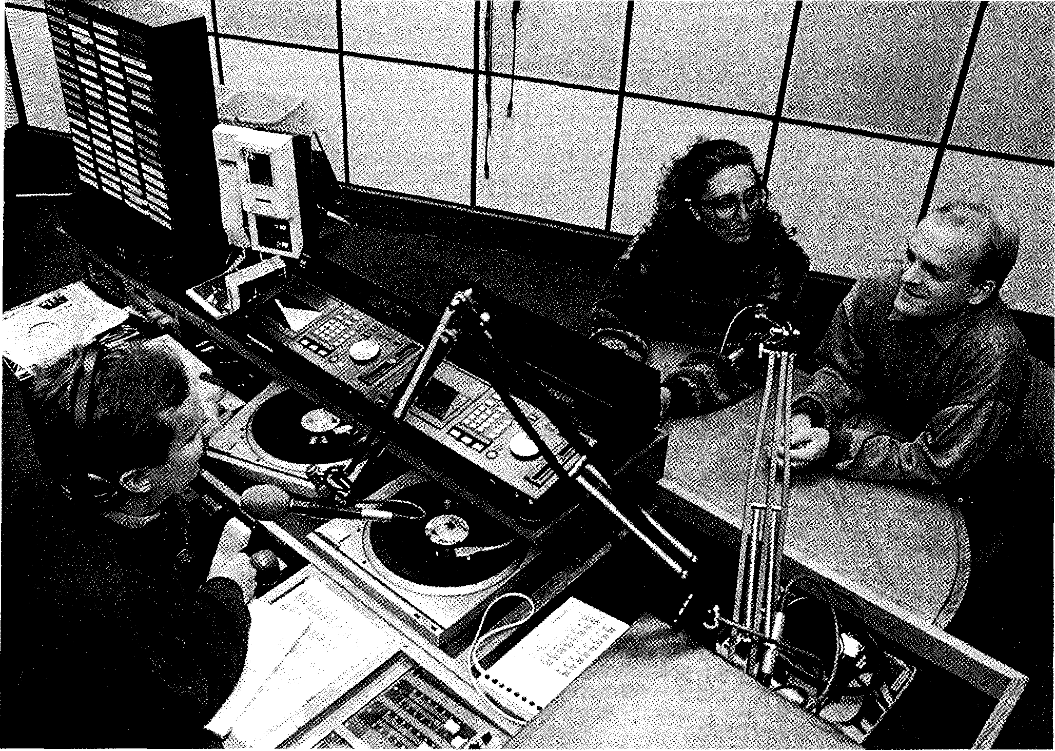
Listen to the following radio talk show called Computer Forecast, in which Barry Harris, the host, is discussing the future of software technology with his two guests. Are the following sentences true (T) or false (F)?
1 Liz thinks that most PC users are too tolerant of design faults.
2 Liz thinks that only ten per cent of software users really know what they are doing.
3 Liz thinks that the increased sophistication of software will make the problem of lack of expertise among users even worse in the future.
4 Sam agrees that the vast majority of users of a single PC are inexperienced.
5 Sam estimates that the number of experienced users and first-time buyers among his customers is about the same.
6 Liz thinks that multimedia isn't having a big impact on the software
market because of its high price and the lack of appropriate technology.
7 Sam disagrees with Liz about multimedia, and believes that it will replace conventional desktop publishing.
8 Both Liz and Sam agree that, in future, new software products will all have to be network-compatible.
Listen again. Change the sentences that are false to make them true.
Task 8 F-⁻1, Read this extract from the tapescript of the conversation and fill in the gaps. To
56
help you, the first letter of each missing word is given, and each gap is followed by a synonym for the missing word.
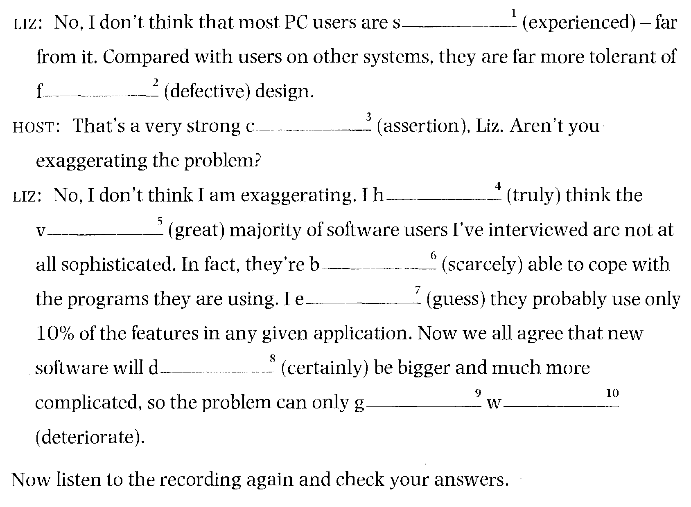
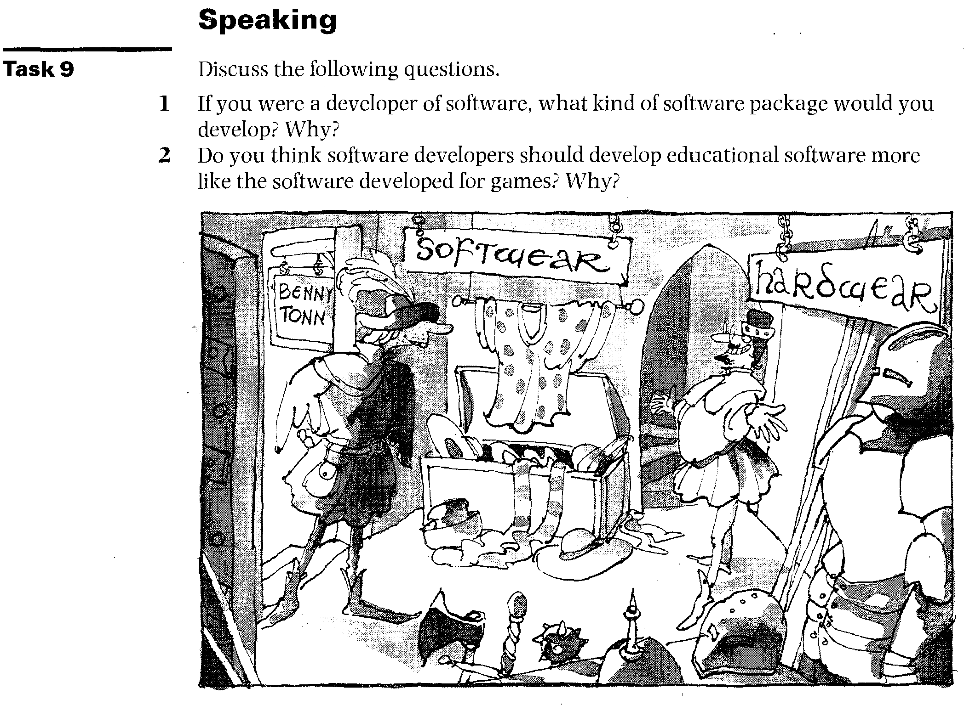
Comparing software packages
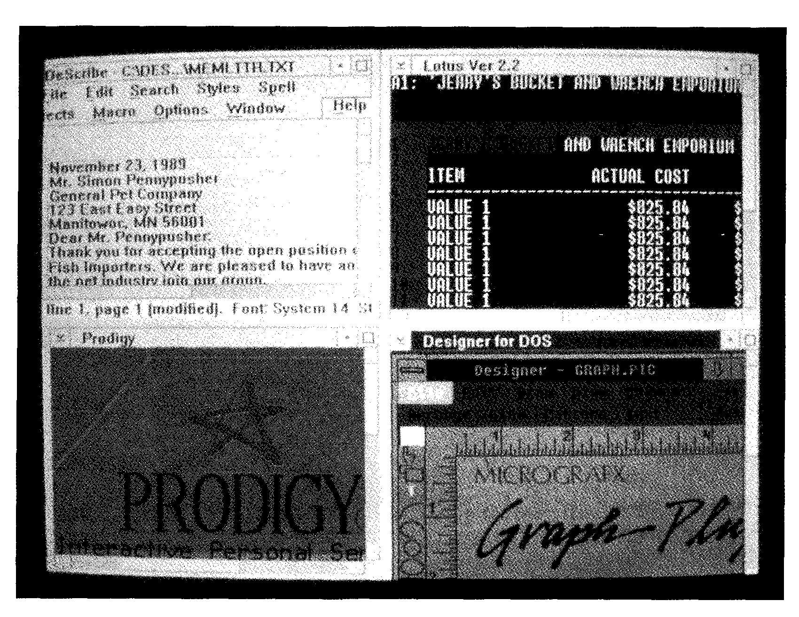
Reading

Task 10 | The features below are common in commercially available word-processing and desktop publishing packages. Match each feature with the correct definition. The first one has been done for you.

can automatically generate a table of contents for a document
1 auto-kerning a
2 mail merge b
3 style sheets
4 input tagging
5 maths functions e
6 table of contents f
7 auto numbering g
8 outliner
9 index generation
10 multiple rulers
57
can carry out simple calculations within a document such as totalling columns, etc.
a single text file can contain several 'rulers' with different margins and tab settings
automatic numbering of figures, paragraphs, etc.
can adjust the space between successive characters to produce a 'best fit'
program can read in names and addresses from a database and create personalized letters for mail-shots can automatically generate a sorted alphabetical index for a document
text from word processors and databases can be precoded with tags to allow the correct format to be applied automatically
these help to ensure uniform style throughout a document
a writing aid enabling the structure of the document to be worked out beforehand and used as a guide when doing the detailed writing

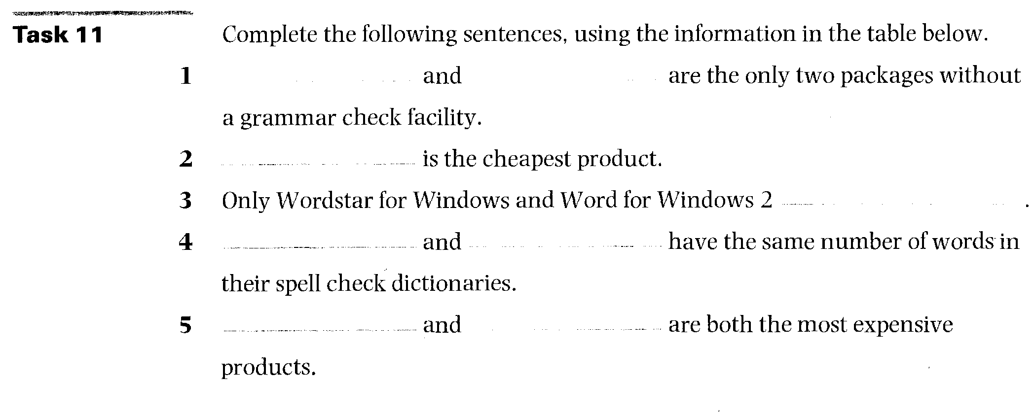
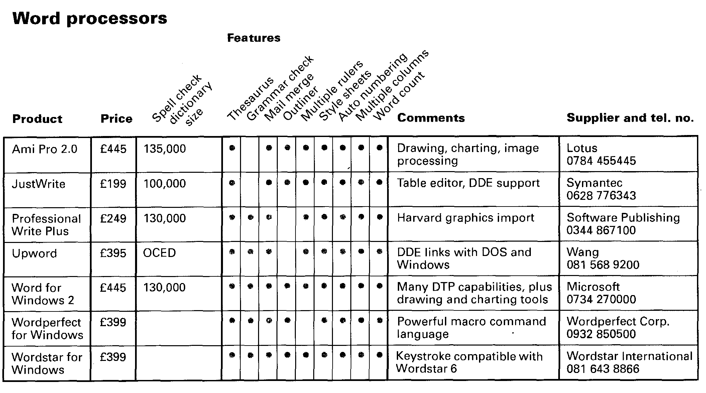
58
Task 12 | a  b  d | The table on the following page contains information about five DTP products (a—ea-eUsing the hints below, identify the products.  1 PageMaker 4.0 and Ventura Publisher Windows 4.0 are both the same price.  2 PageMaker 3.01 has the fewest features.  3 Ventura Publisher Windows 4.0 has a spell check and an auto numbering facility.  4 Legacy is cheaper than Ami Pro for Windows 2.0.

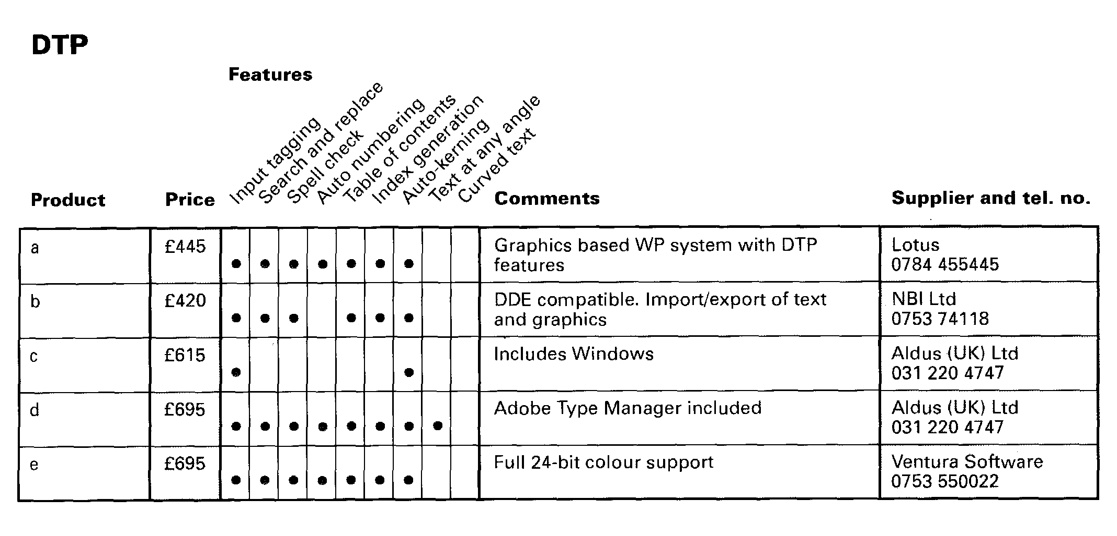
59
Writing
Imagine that you are the product reviewer for a PC magazine. Decide which word-processing product in Table 1 is the best, then write a paragraph explaining your choice.
Task 13
Speaking
Work individually, then in pairs, using the information in the table on word processors in Task 11.
1 Individually, list the word-processing packages in order of merit (1 = best; 7 = worst).
2 In pairs, compare your lists. Explain the reasons for the order you chose. Try to persuade your partner to change his/her list to match yours.
You may use the space below to write your lists.
Task 14
10- Useful expressions
I agree with you about...
I'm afraid I can't agree with you about... I think...
I don't think...
Xis too expensive.
Y has more/fewer features.

Word-play
60
Task 15 Complete the puzzle and find the key word in 11 down.
11
1
2
3
4
5
6
7
8
9
10
Across
1 A program designed to perform a specifid function. (11)
2 A general term for programs which do not form part of a computer but are used when operating it. (8)
3 A facility which allows the user to read in a file of names and create `personalized' letters. (4,5)
4 A sequence of instructions that is repeated until a desired condition is reached. (4)
5 A program that manipulates rows and columns of figures, used especially for accounting. (11)
6 The combined use on computer of text, graphics, video, animation, and sound. (10)
7 The editor is a systems program that fetches required systems routines
and links them to the object module. (7)
8 The business of preparing, printing, and distributing books or magazines, etc. to the public. (10)
9 Someone who creates new software products. (9)
10 A program or series of programs directed at some generic application (e.g. word processing) that can be tailored by the user to match his individual needs. (7)
Down
11 An IBM- computer is one which can be used with other IBM hardware.
(10)
Language focus E
Making comparisons
Formation
The regular comparative and superlative forms of descriptive words (adjectives and adverbs) are shown below:
1 Words of one syllable add the ending -er and -est, Examples:

 | Absolute  new  old  big  soon late |  |  | Comparative |  | Superlative
Adjectives  Adverbs | Absolute  new  old  big  soon late |  |  | newer older  bigger  sooner later |  | newest oldest  biggest  soonest latest

2 Words with three or more syllables are preceded by more and most. Examples:

Absolute Comparative |  |  |  | Superlative

Adjectives  Adverbs | interesting convenient beautiful  easily carefully | more interesting more convenient more beautiful  more easily more carefully | most interesting most convenient most beautiful  most easily most carefully

3 Adjectives with two syllables may be like 1 or 2 above in that they will add the ending -er and -est if they end in -y or -ly, -ow, -le and -er.
Examples:

-y | Absolute | Comparative | Superlative
-y | tiny | tinier | tiniest
 | speedy | speedier | speediest
-ly | early | earlier | earliest
 | friendly | friendlier | friendliest
-ow | shallow | shallower | shallowest
 | narrow | narrower | narrowest
-er | clever | cleverer | cleverest
61
4 Most of the remaining two-syllable adjectives take more and most in front of them.
62
Examples:
Absolute Comparative Superlative
careful more careful most careful
careless more careless most careless
boring more boring most boring
awful more awful most awful
complex more complex most complex
5 Some common two-syllable adjectives can have either type of formation. Examples:

Absolute |  | Comparative Superlative

common commoner/ commonest/
more common most common
gentle gentler/ gentlest
more gentle most gentle
quiet quieter/ quietest/
more quiet most quiet
6 Two-syllable adverbs ending in -ly take more and most. Examples:

Absolute |  | Comparative Superlative

quickly more quickly most quickly
slowly more slowly most slowly
badly more badly most badly
7 A small number of adjectives and adverbs have an irregular comparative and superlative form.
Examples:
Absolute Comparative Superlative

Adjectives  Adverbs | bad worse worst  far further/farther furthest/farthest  good better best  many more most  badly worse worst  far further/farther furthest/farthest  little less least  much more most  well better best

Use in sentences
63
Comparisons may show equivalence, non-equivalence, the highest degree of something, and parallel increase.
1 Equivalence: the following words or constructions are used to show that things or people are similar in some way.

as ... as  as many ... as as much ... as the same ... as similar to  the same | are similar  equal to  is like  similar/ly  equal/ly  compared to/with | each either all  both alike

Examples:
1 Here, the term 'processor' is equivalent to the central processing unit.
2 Laptops are as powerful as microcomputers.
3 Some companies have as many computers as employees.
4 Some companies use both disks and conventional filing systems for storing data.
5 A computer virus is like a virus in the human body. It can do a lot of damage.
6 Many word-processing programs are similar in that thother,re certain common functions.
2 Non-equivalence: the following words and constructions are used to compare or contrast things or people that are separate from each other.

not as ... as ...-er than more ... than fewer ... than less ... than | greater than  not as many ... as not as much ... as not equal to | unequal(ly) unlike  not the same as not all

Examples:
1 A mainframe is larger and more expensive than a microcomputer.
2 Learning to use a computer is not as difficult as learning to program.
3 A fax board costs less tha(superlative),e.
4 Unlike factory-sealed software, pirated versions may contain viruses.
5 Desktop publishing is the same as electronic publishing.
6 You can save money with a network because you will need fewer printers.
3 The highest degree: the following words and constructions are used to compare one member of a group with the whole group (superlative).
the ...-est the most ... the least ...
Examples:
1 This is the most popular package on the market today.
2 BASIC is probably the least difficult programming language to learn.
3 The best programs are those adapted specifically to your own needs.
4 Parallel increase: the following words and constructions are used to show parallel increase (two comparatives).
64
the ...-er, the more ... the more ..., the ...-er the ...-er, the less ...
Examples:
1 The more memory your computer has, the more data it can store.
2 The bigger your computer system, the less time you spend waiting.
3 The more training you give to your employees, the better they will perform.

Exercise 1 | The following sentences express computer capabilities and limitations. Decide whether the sentences express equivalence, non-equivalence, or the superlative, then underline the words expressing the comparison. The first one has been done for you.  1 equivalence Speeds for performing decision-making operations are  comparable to those for arithmetic operations.  2 Even the most sophisticated computer, no matter how good it is,  must be told what to do.  3 A computer can perform similar operations thousands of times,  without becoming bored, tired, or careless.  4 For example, modern computers can solve certain classes of  arithmetic problems millions of times faster than a skilled mathematician.  5 One of the most important reasons why computers are used so  widely today is that almost every big problem can be solved by solving a number of little problems.  6 Finally, a computer, unlike a human being, has no intuition.

Exercise 2 | Read the following sentences taken from previous units. Decide whether the  sentences express equivalence, non-equivalence, or the superlative, then underline the words expressing the comparison.  1 Digital Research have continued to develop their operating system, DR/DOS, and it is considered by many people to be a better product than Microsoft's. (Unit 1)  2 For the last generation, Silicon Valley and Tokyo have been working to design computers that are ever easier to use. (Unit 2)  3 There is one thing, however, that has prevented the machines  from becoming their user-friendliest: ... (Unit 2)  4 Clipboard PCs — which, as their name suggests, are not much  bigger than an actual clipboard — replace the keyboard with a liquid crystal display (LCD) screen and an electronic stylus. (Unit 2)  5 When the computer finds the closest match, it encodes the  character in memory and displays it on the screen as if it had been typed. (Unit 2)  6 There are a handful of clipboard computers now on the market,  including GRIDPad, which is sold in the US; Penvision, manufactured by NCR and sold around the world; and Sony's Palmtop and Canon's Al Note, both sold only in Japan. (Unit 2)  7 I'm frequently asked which online service is 'best' but, the  answer is, there is no best. (Unit 3)

8 They tend to judge all other online services based on this first service — often preventing themselves from seeing the advantages of a specific service. (Unit 3)
65
9 Each offers one or more products or features that either do not exist elsewhere or are superior to the same features on other services. (Unit 3)
10 Judge it based on what it offers and how it meets your needs —not in comparison to what you're used to using. (Unit 3)

Exercise 3 | Refer back to the table of word-processing packages (Unit 5, page 58) and write ten sentences comparing the products advertised.  Examples:  Upword is more expensive than JustWrite.  Ami Pro 2.0 has the largest spell check dictionary.


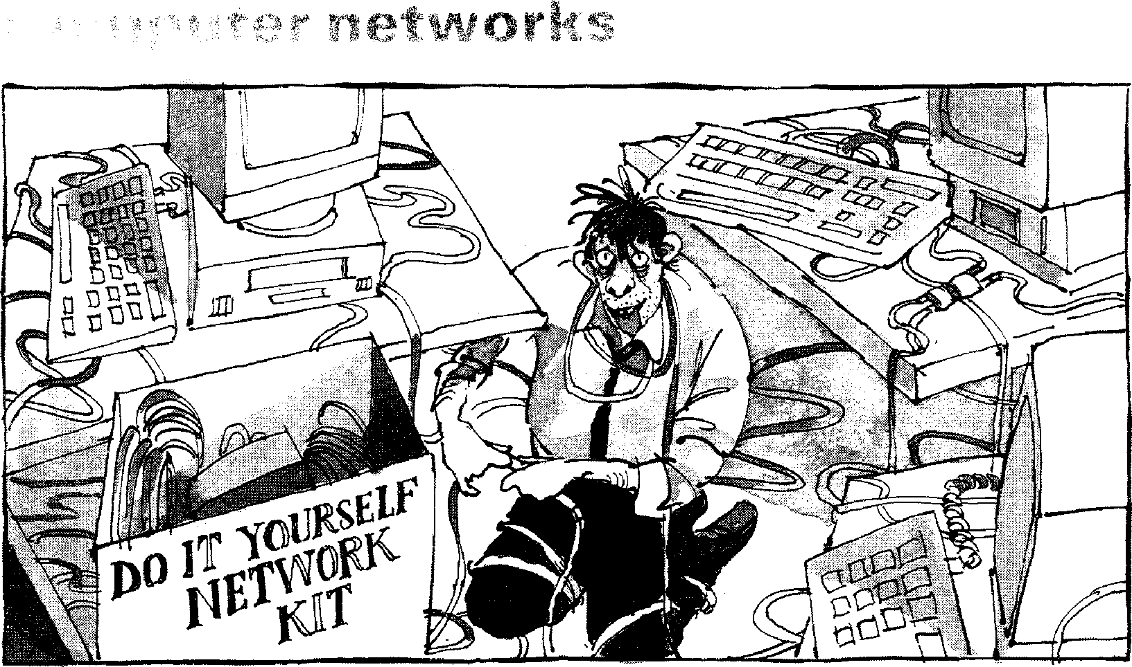
`There! That should make life easier!'
Start-up

Try to answer these questions.
Task 1
1 What is a LAN?
2 What is a WAN?
3 What is a distributed system?

the text opposite, match these words and phrases with their
Reading
Task 2 Before reading
definitions.
1 protocol
2 bulletin board
3 user interface
66
a analyse the syntax of a string of input symbols
b a teleconferencing system allowing users to read messages left by other users
c agreement governing the procedures used to exchange information between co-operating computers
d means of communication between a human user and a computer system
4 make a query
5 parse
6 synchronous
e taking place at exactly the same time as something else
f request a search

Read quickly through the text below, then match each paragraph with the appropriate summary.
Task 3
Network uses, past and present
a
b
d
e
L]
How distributed systems work
Networks and the future
What networks are and how they operate n The growth of networks, past and present

Computer networks

Computer networks link computers by communication lines and
software protocols, allowing data
central database. The PC passes
the query, written in a special
50 language (e.g. Structured Query Language — SQL), to the
mainframe, which then parses the query, returning to the user only
the data requested. The user
55 might then use his PC to draw
graphs based on the data. By passing back to the user's PC only the specific information
requested, network traffic is
so reduced. If the whole file were transmitted, the PC would then have to perform the query itself, reducing the efficiency of both network and PC.
65 In the 1980s, at least 100,000 4
LANs were set up in laboratories
2 and offices around the world.
During the early part of this decade, synchronous orbit
70 satellites lowered the price of long-distance telephone calls, enabling computer data and television signals to be
distributed more cheaply around
75 the world. Since then, fibre-optic cable has been installed on a large scale, enabling vast amounts of data to be transmitted
3 at a very high speed using light
so signals.
The impact of fibre optics will 5
be considerably to reduce the price of network access. Global communication and computer
85 networks will become more and more a part of professional and personal lives as the price of
microcomputers and network access drops. At the same time,
90 distributed computer networks should improve our work environments and technical abilities.
67
5 to be exchanged rapidly and reliably. Traditionally, networks have been split between wide area networks (WANs) and local area networks (LANs). A WAN is a
io network connected over long-distance telephone lines, and a LAN is a localized network usually in one building or a group of buildings close together. The
15 distinction, however, is becoming blurred. It is now possible to connect up LANs remotely over telephone links so that they look as though they are a single LAN.
20 Originally, networks were used
to provide terminal access to another computer and to transfer files between computers. Today, networks carry e-mail, provide
25 access to public databases and bulletin boards, and are
beginning to be used for distributed systems. Networks also allow users in one locality to
30 share expensive resources, such
as printers and disk-systems.
Distributed computer systems are built using networked computers that co-operate to
35 perform tasks. In this environment each part of the networked system does what it is
best at. The high-quality bit-mapped graphics screen of a
40 personal computer or workstation
provides a good user interface.
The mainframe, on the other hand, can handle large numbers of queries and return the results
45 to the users. In a distributed environment, a user might use his
PC to make a query against a

Computer networks link computers locally or by external communication lines and software allowing data to be exchanged rapidly and
Task 4
Read this summary of the text and fill in the gaps using the list of words below.
68
reliably. The ² between local area and wide area networks is,
however, becoming unclear. Networks are being used to perform increasingly diverse tasks, such as carrying e-mail, providing access to public databases,
and for ³ . Networks also allow users in one locality to share
resources.
Distributed systems use networked computers. PCs or ⁴
provide the user . Mainframes process ⁶
and return the results to the users. A user at his PC might make a query against a central database. The PC passes the query, written in a special language, to the mainframe, which then' the query,
returning to the user only the data requested. This allows both the network and the individual PC to operate efficiently.
In the 1980s, at least 100,000 ⁸ were set up world-wide. As
9
orbit satellites have lowered the price of long-distance telephone calls, data can be transmitted more cheaply. In addition,
10 cable has been installed on a large scale, enabling vast
amounts of data to be transmitted at a very high speed using light signals. This will considerably reduce the price of network access, making global networks more and more a part of our professional and personal lives. Networks should
also improve our work!' and technical abilities.
distinction fibre-optic protocols synchronous
distributed systems LANs queries workstations
environments parses screen handling
Task 5  Task 6 | Using the line references given, look back in the text and find words that have a similar meaning to:  1 unclear (lines 15-20  2 place (lines 25-30)  3 carry out (lines 35-40)  4 cost (lines 70-75)  5 world-wide (lines 80-85)  Now look back in the text and find words that have an opposite meaning to:  1 disparate (lines 10-15)  2 conflict v (lines 30-35)  3 preventing (lines 70-75)  4 tiny (lines 75-80)  5 increase (lines 80-85)

Writing
69
Task 7 Translate the third paragraph, beginning 'Distributed computer systems...' into
your own language.
Listening
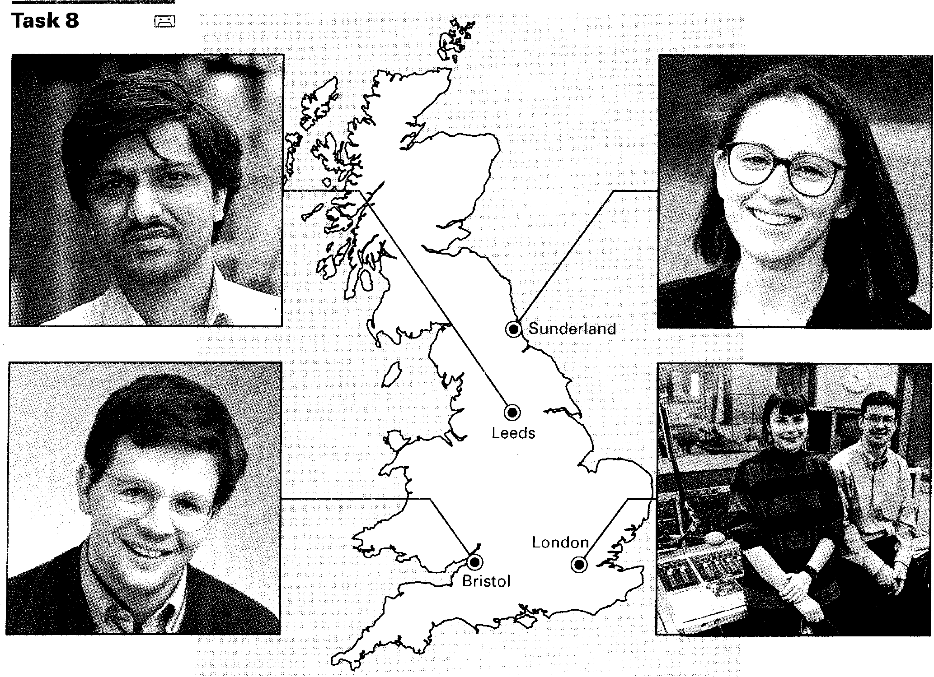
Listen to this extract from the radio programme Computerworks about LANs. Indicate whether the following items are mentioned ( ✓ ) or not mentioned (x).
1 LANs are equally useful to large and small companies.
2 Companies can install their own LANs, provided they are not too big.
3 Whether or not a company builds a 'do-it-yourself' LAN depends on the
amount of space available for the installation.
4 It is sometimes still possible to install part of a LAN if you don't have the
computer knowledge or time to do the whole job yourself.
5 You need at least three years' computer maintenance experience before
you should attempt to install a LAN.
6 In order to install your own LAN, you need to be used to opening up
computers, adding and removing expansion boards, and consulting computer documentation.
7 When installing your own LAN you should expect to have to repeat the
same process several times.
8 The installation process often causes computers to break down.
70
Task 9 | Read this extract from the tapescript and try to fill in each gap with an appropriate word.  When you're installing a LAN, you may be __ your computers for  as much as a day or so. A lot depends on how ² the installation  proceeds, and that depends on your own . Professional installers  can have each of your machines ⁴ of _ for only a few  minutes at a time. If you can't live without your computers for a while, you

might want to ⁶ doing it yourself.
Installing a LAN involves running cable to several' . This may
require you to install junction boxes in walls, do the wiring, and maybe install electrical as well. If you aren't ⁹ with these skills,
and if you aren't a ^{1°} _ electrician, you will need to hire someone for
this part, at least. Of course, if you're installing your LAN in one room, then you might not need to hire ¹¹
Now listen again to the last part of the recording. Check to see whether your answers match those used by the speaker.
Network configurations
Reading
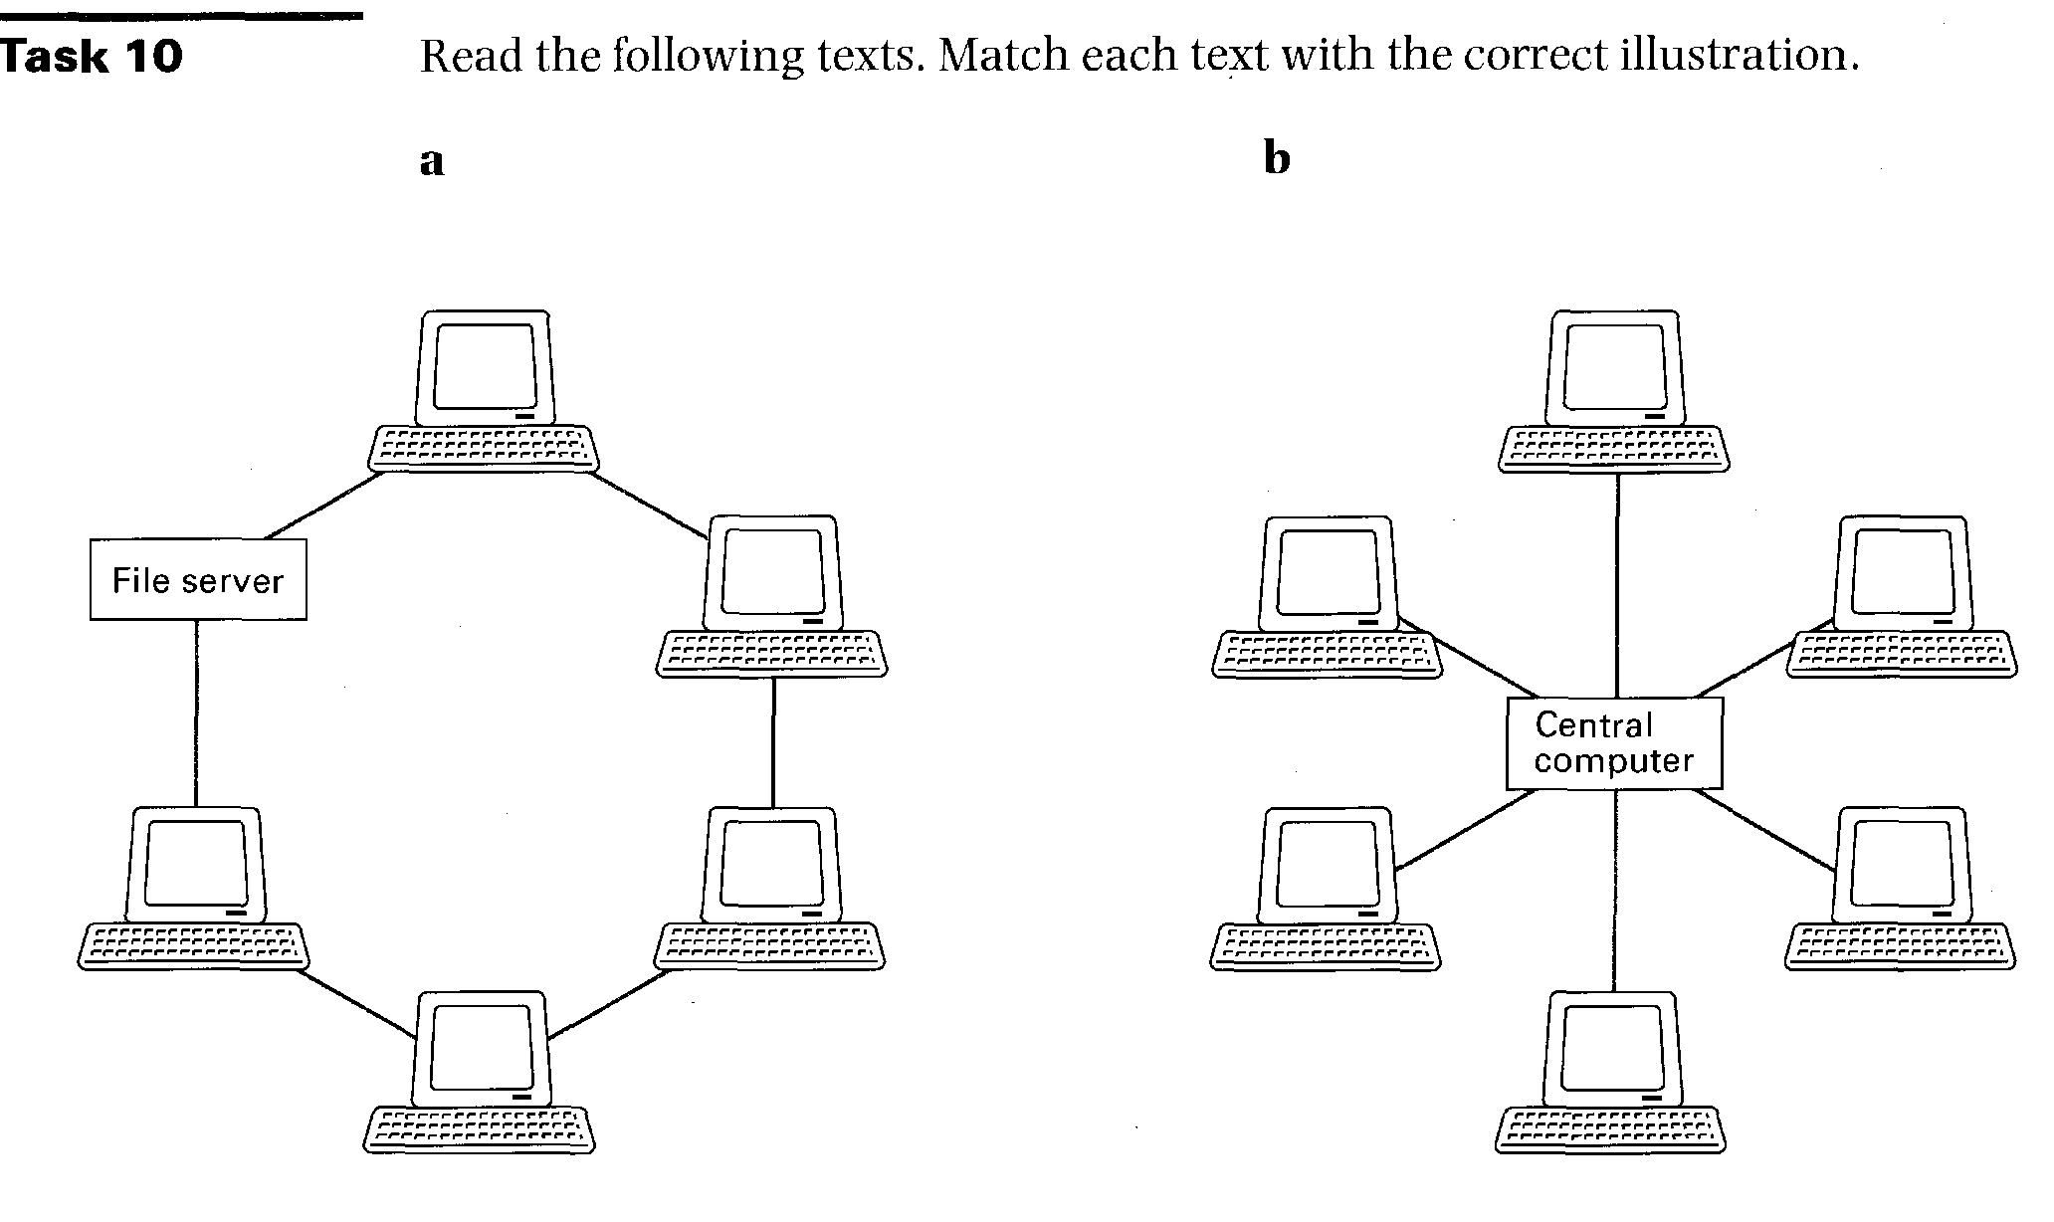
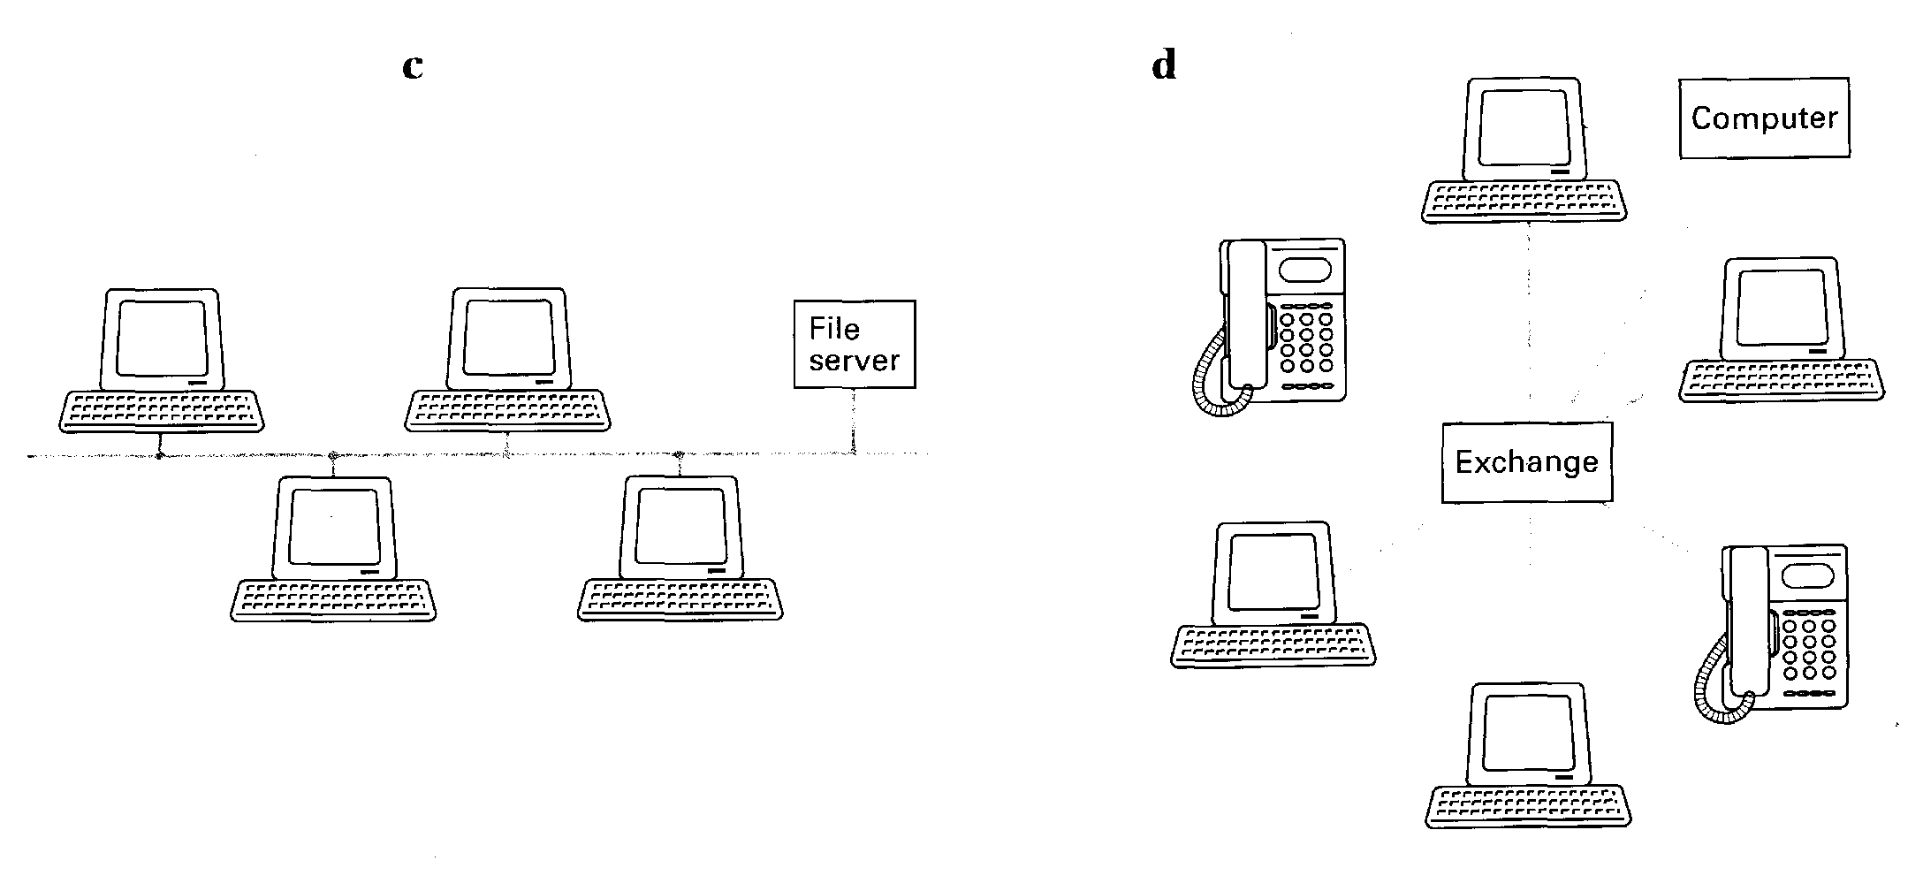
1 Star
71
In the star configuration, the central computer performs all processing and control functions. All access devices are linked directly to the central computer. The star configuration has two major limitations. First of all, the remote devices are unable to communicate directly. Instead, they must communicate via the central computer only. Secondly, the star network is very susceptible to failure, either in the central computer or the transmission links.
2 Switched
The central switch, which could be a telephone exchange, is used to connect different devices on the network directly. Once the link is established, the two devices communicate as though they were directly linked without interference from any other device. At the end of the session, the connection is closed, freeing capacity for other users and allowing access to other devices. Multiple switches can be used to create alternative transmission routes.
3 Ring
Each device is attached to a network shaped as a continuous loop. Data proceeds in only one direction and at a constant speed round the loop. Devices may send information only when they are in control of the 'token'. The token is a package of data which indicates which device has control. The receiving device picks up the token, then clears it for another's use once it has received the message. Only one device may send data at any given moment,
and each device must be working for the network to function.
4 Bus/Ethernet
A bus network consists of one piece of cable terminated at each end to which all devices are connected. In a bus-based network, each device is able to broadcast a message when it has detected silence for a fixed period of time. All devices receive the broadcast and determine from the content of the message whether it was intended for them. The only problem occurs when two devices try to send at the same time. When a sending device detects another's transmission, it aborts its own.
Task 11 These are answers to questions about the texts. Write the questions.
72
1 To connect different devices on the network directly.
2 No, it goes in only one direction round the loop.
3 No, only one device may send data at any given moment.
4 From the content of the message.
5 It cancels its own transmission.
Task 12 Which of the network configurations on page 71 does this flowchart refer to?
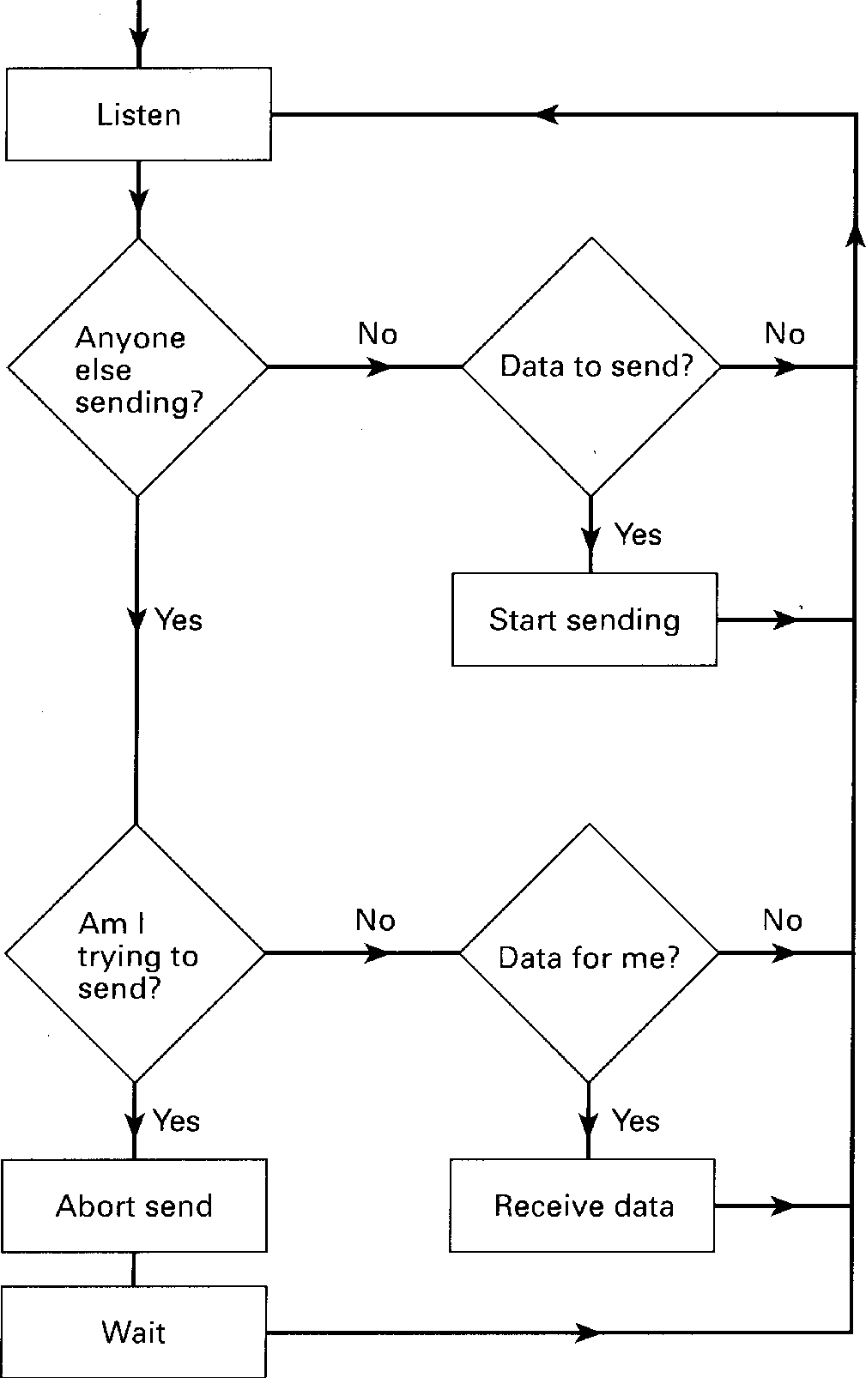
Task 13 The columns below describe characteristics of the bus and ring configurations.
Which column refers to which configuration? How did you decide?
a
varied time response calculable time response
easy expansion difficult reconfiguration
fault-tolerant fault-intolerant
simple more complex
Speaking

Task 14 | Work in pairs, A and B, using the information in the advertisement opposite.  Prepare the role-play in advance and try not to refer to the advertisement during the activity.

Student A: You are a customer interested in the Netplan Eazy Kit. Before deciding whether to buy it, ask questions to find out:
73
1 what you need in order to use the Netplan Eazy Kit.
2 the total number of PCs you can run on it.
3 the cost of adding additional PCs.
4 how difficult it is to install.
5 what software it runs.
6 the other features offered.
Student B: You represent the makers of the Netplan Eazy Kit. Make notes about the features of the product. Answer any questions and try to encourage the customer to buy it.
Netplan Eazy Kit
from as little as £215
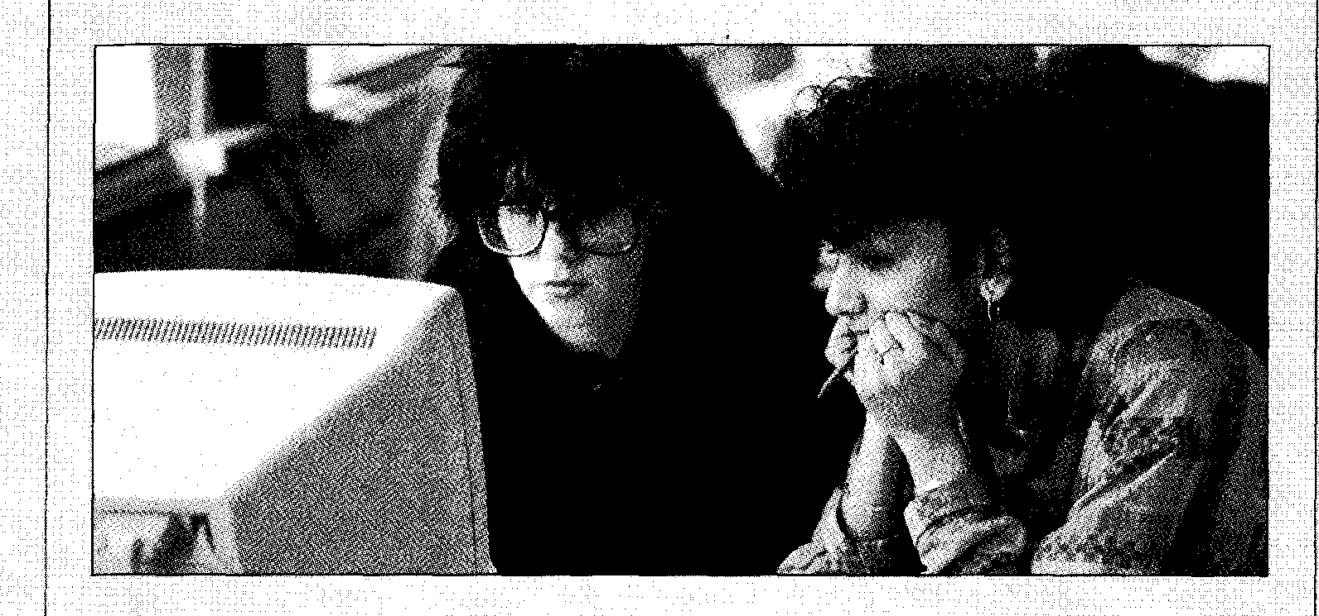
This is not the only way to share software.
If your idea of sharing software is looking over a colleague's shoulder, then Netplan may have the ideal solution. To benefit from a network you only need two PCs.
The Netplan Eazy Kit costs just £215 and gives you all the hardware, software, and cabling you need to link two PCs. And for £100 per PC you can extend the network to up to six users. With Netplan Eazy even the smallest business can save time, money, and effort.
 | Extra efficiency  The Netplan Eazy Kit allows PCs to share the same data and software without having to copy and  transfer disks. So whether you're dealing with customer enquiries or updating accounts, you can do it from the same machine. You can even send messages from one PC to another by e-mail.  Netplan Eazy will also save you money on expensive resources like printers. | It's so Eazy  If you can use a screwdriver, you can install Netplan Eazy yourself. That's all it takes. And once  installed, it runs on all popular software.  We also offer our customers unlimited access to our Freephone Helpline as part of the package. So why wait? Contact  your nearest Netplan dealer today. Details are on the back  cover of this magazine.

Word-play
74
Task 15 Solve the crossword puzzle using the clues below.
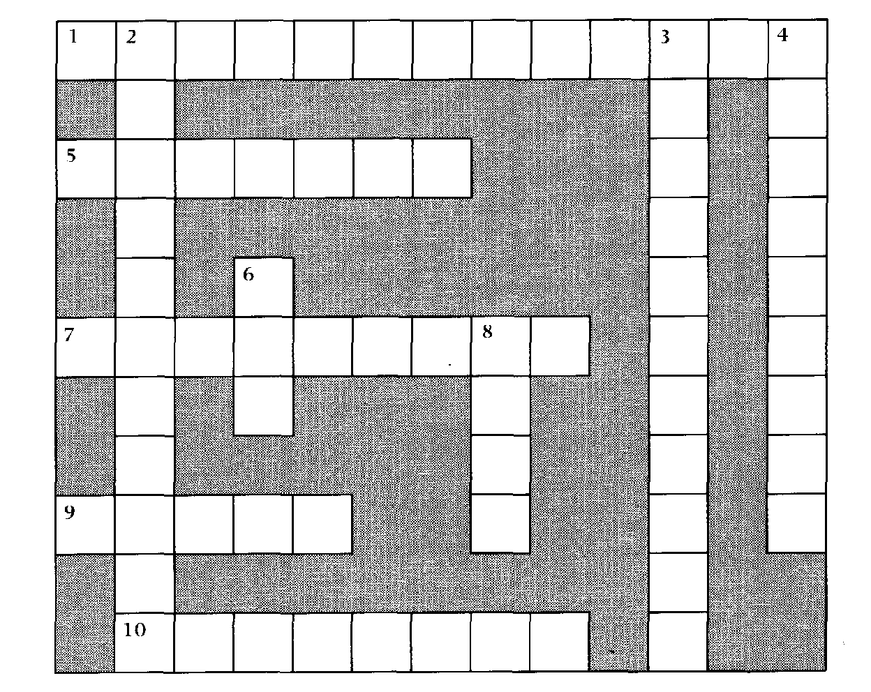
Across
1 The means of communication between a human and a computer. (4,9)
5 To load software on to a computer, ready for use. (7)
7 To transmit a message to all nodes on a network. (9)
9 and 3 down Usually found in one building or a group of buildings close together. ( 5 ,4, 7)
10 This kind of network often uses a telephone exchange to connect different devices directly. (8)
Down
2 Taking place at exactly the same time as something else. (11)
3 See 9 across.
4 An board may be inserted into a computer to give it added features. (9)
6 The opposite of 9 across and 3 down. (3)
8 The network configuration in which all devices are linked through the central computer. (4)
Language focus
Time sequence
In activities such as scheduling, doing routine activities, and conducting and describing experiments, it is important to recognize the sequence of events. As we know, events do not simply occur in isolation, they occur either before, during, or after other events. This time sequence may be chronological, logical, or causal. The following tables show examples of time relaters.
1 Before given time-references:
Time relaters

Adjectives Adverbials | earlier former  already prior  before  before that before then | preceding previous  earlier  first  formerly originally  up to now/then until now/then | previously so far  yet  in the beginning (long) ago

Examples:
1 The memory storage capacity of earlier computers was not as large as those of today.
2 When the first digital computer was developed, the first analog computer had already been in use for some time.
3 Up to now, voice recognition technology has not been developed for mass marketing.
2 Simultaneous with given time-references:
Time relaters

contemporary simultaneous

at present
Adjectives Adverbials
at this point now/then
today
for the time being at the moment
at that time
meantime meanwhile
in the meantime when
at the same time

75

Examples:
76
1 At that time many new computer programs were being developed for use in businesses.
2 Computers may soon take over many daily tasks, but in the meantime ordinary people must continue to do them themselves.
3 Computer magazines keep us informed about contemporary issues in the computing world.
3 After given time-references:
Adjectives Adverbials | Time relaters
Adjectives Adverbials | following  afterwards after that  eventually | later  since  by the time | next  by the end  soon next
Examples:
1 Since the development of the chip, computers have become cheaper and more compact.
2 You should have a good idea of the various applications of computer software by the time you finish reading this book.
3 Although initial versions of word-processing programs were not very complex, later versions were much more sophisticated.
Sample paragraph:
Computers, as we know them today, have not been around for a long time. It was not until the mid-1940s that the first working digital computer was completed. But since then, computers have evolved tremendously. Vacuum tubes were used in the first-generation computers only to be replaced by transistors in the second-generation computers at the beginning of the early1960s. By the end of the 1960s, transistors themselves were replaced by tiny integrated circuit boards and, consequently, a new generation of computers was on the market. Fourth-generation computers are now produced with circuits that are much smaller than before and can fit on a single chip. Even now, new technologies are being developed to make even better machines.

Exercise 1 | Read the following paragraph and, as you read, underline the time relaters.  During the seventeenth and eighteenth centuries, many easy ways of calculating were devised. Logarithm tables, calculus, and the basis for the modern slide rule were invented during this period. It was not until the early 1800s that the first calculating machine appeared and, not too long after, Charles Babbage designed a machine which became the basis for building today's computers. A hundred years later, the first analog computer was built, but the first digital computer was not completed until 1944. Since then, computers have gone through four generations: digital computers using vacuum tubes in the 1950s, transistors in the early 1960s, integrated circuits in the mid-60s, and a single chip in the 1970s. In the 1980s, we saw computers become smaller, faster, and cheaper. Earlier this decade, computers became portable, from laptops to palmtops. At the rate computer technology is growing now, we can expect further dramatic developments before the end of the century.

Read the following sentences which come from previous units. Underline the time relaters and indicate whether they refer to before, during, or after the given time reference. The first one has been done for you.
Exercise 2
1 after Since then, over seventy million PCs made by IBM and other
manufacturers have been sold. (Unit 1)
2 Over this period, PCs have become commodity items. Since IBM
made the design non-proprietary, anyone can make them. (Unit 1)
3 _ Ten years later, in 1991, IBM were making PCs with 16Mb of
memory, expandable to 64Mb, running with a processor speed of 33MHz.
(Unit 1)
4 Large companies are considering running major applications on PCs, something which, ten years ago, no one would have believed possible of a PC. (Unit 1)
5 When the computer finds the closest match, it encodes the
character in memory and displays it on the screen as if it has been typed.
(Unit 2)
6 Enter the clipboard computer, a technology that has been in development for the last 20 years but took hold in the mass market only this year. (Unit 2)
7 Eventually, we're all going to be interlinked, no matter which
service we use, in what DIALOG's Richard Ream calls a 'network of networks'. (Unit 3)
8 Until then, most of us have to go to more than one service to
find everything we need. (Unit 3)

77
Exercise 3 | Now refer back to paragraphs 1, 2, 4, and 5 of the text entitled Computer networks (page 67, Unit 6). Underline all the time relaters and indicate whether they refer to before, during, or after the given time reference.


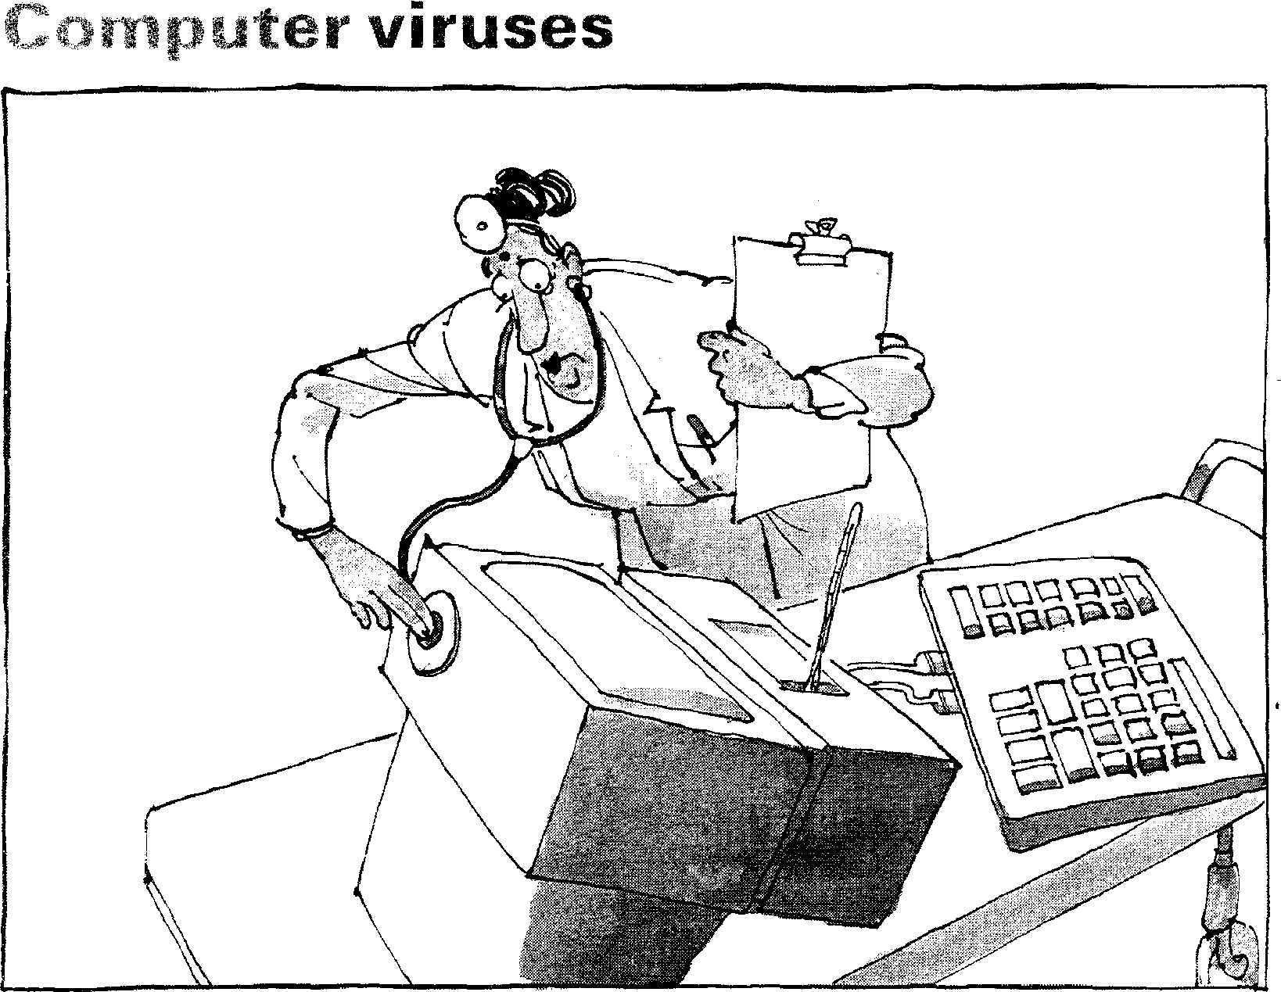
Start-up
Task 1 Try to answer these questions.
1 What is a computer virus?
2 How does a virus work?
Reading
Task 2 Before reading the text, match the words and definitions listed below.

1 a detonator
2 an infector
3 to boot
4 to trigger
5 to erase
6 pirated
7 a shield
8 to detect
a a protective device
b to remove all traces of something
78
c a device used to set off an explosion or other destructive process
- to discover or recognize that something is present
e to set a process in motion
f something which transmits a disease or virus
- stolen, obtained without the owner's consent
- to load the operating system into memory

Task 3 Now read the text to check your answers to Task 1.
How computer viruses work

Acomputer virus — an unwanted program that has entered your system without you knowing about
5 it— has two parts, which I'll
call the infector and the
detonator. They have two
very different jobs. One of
the features of a computer
10 virus that separates it from other kinds of computer program is that it replicates itself, so that it can spread
(via floppies transported
15 from computer to computer, or networks) to other computers.
After the infector has
copied the virus elsewhere,
20 the detonator performs the virus's main work. Generally, that work is either damaging data on your disks, altering what you see on your
25 computer display, or doing something else that interferes with the normal use of your computer.
Here's an example of a
30 simple virus, the Lehigh virus. The infector portion of Lehigh replicates by attaching a copy of itself to COMMAND.COM (an
35 important part of DOS), enlarging it by about 1000 bytes.
So let's say you put a floppy containing
40 COMMAND.COM into an infected PC at your office —that is, a PC that is running the Lehigh program. The infector portion of Lehigh
45 looks over DOS's shoulder, monitoring all floppy accesses. The first time you tell the infected PC to access your floppy drive, the Lehigh
50 infector notices the copy of
COMMAND.COM on the
floppy and adds a copy of
itself to that file.
Then you take the floppy 105
55 home to your PC and boot
from the floppy. (In this case, you've got to boot from the
floppy in order for the virus
to take effect, since you may
so have many copies of COMMAND.COM on your
hard and floppy disks, but
DOS only uses the COMMAND.COM on the 115
65 boot drive.)
Now the virus has silently
and instantly been installed
in your PC's memory. Every
time you access a hard disk 120
70 subdirectory or a floppy disk containing COMMAND.COM, the virus sees that file and
infects it, in the hope that this particular COMMAND.COM 125
75 will be used on a boot disk on
some computer someday.
Meanwhile, Lehigh keeps a count of infections. Once it
has infected four copies of 130
80 COMMAND.COM, the
detonator is triggered. The detonator in Lehigh is a
simple one. It erases a vital
part of your hard disk, 135
85 making the files on that part
of the disk no longer
accessible. You grumble and set about rebuilding your
work, unaware that Lehigh is 140 90 waiting to infect other unsuspecting computers if
you boot from one of those
four infected floppies.
Don't worry too much 145
95 about viruses. You may
never see one. There are just a few ways to become
infected that you should be
aware of. The sources seem 150
100 to be service people, pirated games, putting floppies in
publicly available PCs
without write-protect tabs, commercial software (rarely), and software distributed over computer bulletin board systems (also quite rarely,
despite media misinformation).
Many viruses have spread through pirated — illegally copied or broken — games. This is easy to avoid. Pay for your games, fair and square.
If you use a shared PC or a PC that has public access, such as one in a college PC lab or a library, be very careful about putting
floppies into that PC's drives without a write-protect tab. Carry a virus-checking
program and scan the PC before letting it write data onto floppies.
Despite the low incidence of actual viruses, it can't hurt to run a virus checking
program now and then. There are actually two kinds of antivirus programs: virus shields, which detect viruses as they are infecting your PC, and virus scanners, which detect viruses once they've infected you.
Viruses are something to worry about, but not a lot. A little common sense and the occasional virus scan will keep you virus-free.
Remember these four points: Viruses can't infect a data or text file.
Before running an antivirus program, be sure to cold-boot from a write-
protected floppy.
Don't boot from floppies except reliable DOS disks or your original production disks.
Stay away from pirated software.

Vocabulary
79
fair and square (1. 113) — honestly
it can't hurt (1. 126) — it's probably a good idea

80
Task 4 | Decide whether the following statements are true (T) or false (F) in relation to the information in the text. If you feel a statement is false, change it to make it true.  1 Viruses cannot be spread through a computer network, only via floppies transported from computer to computer.  2 The virus will spread as soon as you put the infected floppy in your PC.  3 The infector works by interfering in some way with the normal use of  your computer.  4 The detonator in Lehigh works by altering what you see on your screen.  5 Most viruses spread through pirated games.  6 You should run an antivirus program every time you use your computer.  7 There are not very many viruses in circulation.  8 I Virus shields are more effective than virus scanners.

Task 5 Indicate the line reference where the following ideas are found in the text.
line
1 1. The Lehigh virus must infect four copies of COMMAND. COM before
damage is done to data.
2 1 _ _ Always boot your computer from dependable DOS disks or your original disk.
3 1. The infector part of a virus must first copy itself somewhere before the
detonator part damages the data on your disks.
4 1_ Virus scanners discover viruses after the infection and virus shields
discover viruses during the infection process.
Task 6 These are answers to questions about the text. Write the questions.
1 Two, one that infects and one that does the damage.
2 By interfering in some way with the normal use of the computer.
3 After it has infected four copies of COMMAND.COM.
4 Every time you access a hard disk subdirectory or a floppy disk containing COMMAND.COM.
5 Yes, by using your common sense and by occasionally scanning for them.

Task 7 | Using the line reference given, look back in the text and find the reference for the words in italics.  1 They have two very (line 7)  2 is that it replicates itself (line 12)  3 enlarging it by about (line 36)  4 of itself to that file (line 53)  5 and infects it (line 73)  6 This is easy to (line 112)  7 which detect viruses (line 131)  8 once they've infected (line 134)

Task 8 | Using the line references given, look back in the text and find words or phrases with a similar meaning to:  1 reproduces (lines 10-15)  2 infect (lines 12-17)  3 changing (lines 20-25)  4 immediately (lines 65-70)  5 complain (lines 85-90)  Using the line references given, look back in the text and find words or phrases that have an opposite meaning to:  6 reducing (lines 35-40)  7 removed from (lines 65-70)  8 records (lines 80-85)  9 ignorant (lines 9 5-100)  10 frequently (lines 100-105)

Computer security
Security breach blamed on hacker'

12 year-old
hacks into
bank's database
Hacker causes
chaos in
city hospital

Computer fraud on the increase
81
Speaking
Task 9 In pairs, try to answer these questions:
1 Who or what is a 'hacker'?
2 How many ways can you think of to make the data in a computer secure?
Listening
Task 10 Listen to Steve, a computer technician, and Richard, the office manager at a
language institute, talking about computer security.
As you listen to the conversation, answer the following questions.
1 What is the problem with the computer system at the language institute?
2 What would someone need to connect his/her PC to the office network?
3 What are the disadvantages of security passwords, according to Steve and Richard?
4 How does the 'smart' card work? Is it safe?
5 How much do you think Steve and Richard know about security systems?

 | Speaking
Task 11 | Steve and Richard must decide what to do. What advice would you give them? In groups or pairs, note down the advantages and disadvantages of the possible solutions. Think about safety, cost, and ease of use. Try to decide on the best solution.

Reading
Task 12 |  | 

The combined threat of viruses y,reakii.g havoc on y ,ir PC and probing meddlers gaining access to sensitive dai can strike fear into the hearts of even the most mild-mannered PC managers. Relax XTree Company has the ultimate in PC protection. AllSafe teams superior vims prevention with aura, 0,11701 and security reporting.
And while most ant-virus produc_, simply scan or known virus signatures, AitSafe actually looks for the signs of viruses attempting to replicate. Once a virus is spotted, AllSafe isolates it, preventing the virus from infecting your PC. If the virus is known, AllSafe quickly removes it. Even it the virus is unknown, AllSafe studies it and learns its signature immediately, letting you automafically update the virus signature database Then you can use AllSale to scan other disks or
systems right away before
an infection can spread,
without waiting for a new AUSAFE
signature from the
are publisher. So, if you use a,gandalone PC, fear not Its over for the evil virus.
Just as scary as the viruses are those characters that attempt to invade your computer files without authorization. AllSafe's flexible password options let you share or limit acces to as much of your hard disk as you wish. AllSafe keeps out the evil invaders!
When you need a complete solution - protection against both viruses xi(' unauthorized entry - choose AllSafe. And like all XTree Company products, they're easy to install and use. For more information or to find out where you can buy AilSafe, call one of our distributors:
Softsel UK (081) 588-8866 P&P (0706)217-744
Ingram Micro UK (0908)260460 Frontline (0256)27890
XTREE
COMP

qc 01191 LleMS■iteffe, ram
82
FREE FACTS 091
The flowchart on the following page represents the steps in the process by which AliSafe removes viruses from PCs. Using the information in the advertisement, match each step with the corresponding letter in the flowchart.

1 Virus signature database is updated.

a
b
d
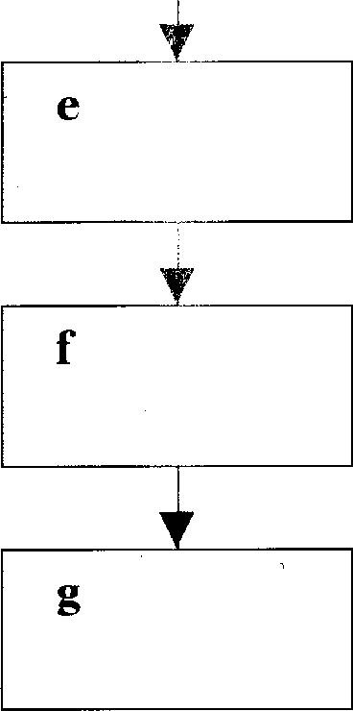
2 Is virus known?
3 AllSafe scans other disks or systems in order to prevent further infection immediately.
4 AllSafe searches for indications that viruses are
attempting to copy themselves.
5 AllSafe identifies and isolates the virus.
6 AllSafe eliminates the known virus.
7 AllSafe analyses the virus and learns its signature straight away.

Task 13 Find words or phrases in the text which mean:
83
1 wickedness, badness, danger
2 hides (while waiting to attack)
3 causing a lot of damage
4 people who interfere without authorization
5 terrify, make very afraid
6 combines
7 identified, recognized
8 frightening
9 choices
10 attackers
Speaking
Task 14 Discuss the following questions:
1 What technique does the advertisement use to persuade people to buy the product?
2 Do you think the advertisement is successful? Give reasons for your opinion.
3 What other techniques could be used to sell this kind of software?

Task 15  Task 16 | Writing  Design an advertisement for a PC protection package. Your advertisement should mention all the features listed below, but you may add others. Choose a name, and decide on the best way to present your product.  Features  Password protection — system manager controls what each user is permitted to do  File encryption — plain text messages are converted into cipher (code) so that only authorized recipients can read them  Keyboard lock — screen is cleared and keyboard is locked after pre-set period of inactivity  Reading  Read this news report and discuss the questions that follow.

NSA consultant's son is
computer saboteur
`Worm' came from graduate student

Acourt heard today how a Cornell University graduate student,
Robert T. Morris Jr. (25), infected a host of government and educational computer centres with a computer virus, known as a 'worm', which literally brought all computational activity to a halt in over 6,000 installations. Morris, the son of a prominent National Security Agency computer consultant, was sentenced for his offences yesterday. As punishment, he was required to spend no time in prison but, instead, serve three years' probation, contribute 400 hours of community service, and to pay a $10,000 fine along with associated court and probation costs.


1 How serious do you think Robert Morris's crime was?
84
2 Do you think the punishment was
a too severe?
b about right?
c not severe enough?
3 Do you know of any similar incidents of computer hacking?

Word-play
85
The words and phrases below are taken from this unit. In pairs or groups, decide if they have a 'protective' or a 'destructive' meaning as they are used in the unit, then put them under the correct heading.
detonator | infector | erase | pirated
infect | write-protect tab | worm | virus scanner
hacker | password | smart card | shield
signature protective | cipher  destructive | keyboard lock | access control

How many other ways can you think of to classify them?
Language focus G
86
Listing
It is important when reading to recognize and understand the relationship in which sentences and groups of sentences combine to present information. This information may be linked by means of a connective word or marker.
Making a list, for example when enumerating, and giving instructions, indicates a cataloguing of what is being said. It is important to note that most enumerations belong to clearly defined sets. The following table is a list of the markers that can be used to show the order in which things are to be said.
1, 2, 3, etc.
one, two, three, etc.
first(ly), second(ly), third place
another, next, then
furthermore, afterwards, moreover
lastly/finally
to begin/start with, and to conclude
first and foremost} mark the beginning
first and most important(ly) of a descending order
above all mark the end of
last but not least an ascending order
There are many ways of showing sequential relationships. Those given in the table above are not the only ones, they are the most common ones used in listing or enumerating. The -ly forms are usually used when listing.
Sample paragraphs:
More and more police departments are now using sophisticated devices to help control the increasing crime rate. Some of these devices are: firstly, a computer terminal inside a police vehicle to answer an officer's questions, secondly, a computer-controlled display unit for displaying fingerprints, and thirdly, educational systems for police officers such as terminals, enabling them to verify changes in laws, rules, and regulations.
The computer memory of many law enforcement systems contains all kinds of information. First and foremost, it has data on stolen items such as cars, licence plates, and property. Second, it has information on missing persons and wanted fugitives. Last but not least, it contains information on political extremist groups and their activities.
Computers have certainly revolutionized police work by providing access to millions of items of information with the least possible delay and speeding up the process of apprehending suspicious-looking characters.
87
l
Exercise 1 Complete the following paragraph about the various steps in the creation of a
database by filling in the blanks with appropriate listing markers.
When you are creating a new database, you must many fields you will need in your database. ² | decide how , you will have to

provide up to five items of information about each field. , each
field needs to have a name. ⁴ , the field type has to be defined.
Character, numeric, date, and logical are some common types. ^{s}
choice to be made is the width of the field. However, some fields, such as date,
 | have present default values. The ⁶ decimal places if the field is numeric. ⁷ whether the field is to be indexed or not. | step is to set the number of  , you will have to indicate
Exercise 2 Complete the following paragraph by filling in the blanks with appropriate
listing markers.
Computers can do wonders, but they can waste a lot of money unless careful consideration goes into buying them. Businessmen and women thinking of buying a computer system should ^{I} admit they know very little
about computers. ² , they must realize that the computer sales
people don't always know how their business works.
3
, it is essential that buyers should get outside advice, not necessarily from consultants but from other executives who have had recent experience in buying a computer system ⁴ they should try to see
systems similar to ones under consideration in operation. Because their operations will have differences that must be accommodated, they should
5
find out what would be involved in upgrading a system.
6
important thing to know before buying a computer is the
financial situation of the supplier because computer companies come and go and not all are financially stable. ' , the prospective buyer should
demand that every detail be covered in writing, including hardware and software if they are supplied by different companies. There's nothing wrong with computers themselves, it's how and why they are used that can cause problems.

Computers in the office
88
Start-up
What aspects of computer technology are illustrated below: Make a list of any other examples used in the office.
Task 1 a

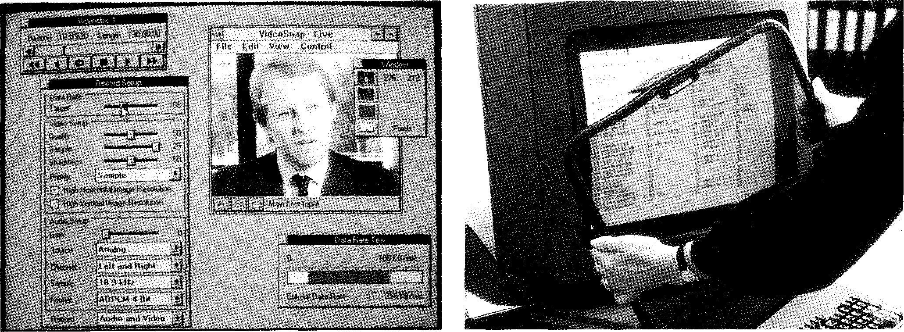
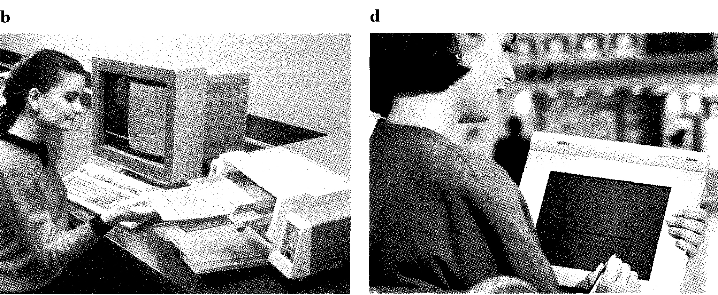
Reading
Task 2 Read the text opposite. How many of the items you listed in Task 1 are
mentioned:
Visions of Tomorrow

Ffirst, safety. Radiation screens are available, and have been for some years. Most of them place an
5 emissions barrier between you and the front of your display, while others encase the entire monitor,
protecting you from side and
io rear emissions as well. Many offices already have these screens available for their workers.
The paperless office is still
15 a dream, but the basic tools are in place. We receive mail in two basic forms: on paper in an envelope, or electronically on our
20 computers. Most of us have access to e-mail in one form
or another. That's half the battle won. The other half is a bit more difficult, but it can
25 be, and is being, done. All mail can be opened in the mail room and scanned into the computer using optical character recognitnn 'OCR).
30 Then a document-imageprocessing program takes over and lets you accomplish electronically what you
would normally do with
35 paper. Various personal computer products are available for this purpose.
Pen-based computing is
coming into its own. Pen-
a() input capabilities are beginning to show up in hardware, applications, and operating systems. You can't take notes that will go
45 directly into your computer, and the technology wouldn't know what to do with your doodles, but it would know that a doodle isn't a valid
50 word. And that's a start — a good one.
Multimedia really needs no explanation. There are many packages that help you
55 create multimedia
presentations, and the tools to create customized multimedia training programs are also plentiful.
so CD-ROM disks, such as ZiffDavis's Computer Select and
Microsoft's Bookshelf, let you access mountains of information with ease.
65 Computers are already
much smaller than they used to be, and you can't go to an industry show these days without finding some
70 company promoting its 'small footprint'. When you start talking about laptops, notebooks, and palmtops, the question becomes, 'How
75 small is too small?' FAX capabilities are already available on boards that you can plug into your computer. When you combine the
so technologies present in internal modems with voice recognition, the basics for having your computer replace your phone-voice
85 line are in place.
Voice recognition is another technology that may appear limited in its present form, but it shows great
so promise for the future.
Current voice-recognition systems can handle speaker-dependent continuous speech or speaker-
95 independent discrete speech.
Speaking to your computer will be a major factor in the office of the future. In some locations, it is already a
loo major factor in the office of today. Stock is traded in some brokerage houses by verbal command from the broker to the computer. So,
105 you ask your computer a question, and it answers you — verbally. Depending on the rate of speech sampling used and the resolution the A/D
110 converter uses for each
sample, we can already create a credible approximation of human speech with digitized
115 sound.
Large display screens? You can get screens of up to 35 inches now, and between Barco and Mitsubishi
120 competing for the honor of having the largest monitor, it's hard to predict just how big they will get in the future. As for color, some
125 companies offer upwards of 16 million. Somewhere in that number must lie the perfect color for reducing eye-strain.
130 The real disaster that most
of us still have to deal with is
the traditional keyboard, which is the cause of much
pain and suffering in the
135 form of carpal tunnel syndrome and other
repetitive-strain injuries. Wrist rests are available to alleviate the problem, and
140 new designs for strange-looking keyboards, Star Trek-style, are moving from the drawing board to the factory.
Enterprise networks are
145 proliferating almost as fast as LANs did just a year or two ago. Public data
networks are ripe for the dialling up and signing on.
150 And the Internet already
exists, with several of the research and educational facilities on its membership rolls.
155 Worldwide connectivity is
already available in the enterprise networks of some
major corporations (e.g. DEC's DECnet and IBM's
160 Systems Network Architecture). Admittedly, these are proprietary networks, but they are living proof that the concept can
165 and does work.

• Vocabulary
89
doodle (1. 49) — meaningless drawing
brokerage houses (1. 102) — companies that buy and sell shares for clients carpal tunnel syndrome (1. 135) — chronic wrist-strain caused by repetitive movement, such as typing
Star Trek (1. 141) — futuristic American television series of the 1970s/1980s.

Task 3 Using the table below, make a summary of the main points of the article in
90
note form.


Task 4 | Each of the following sentences from the text is followed by two paraphrases. Decide which paraphrase (a or b) is closer in meaning to the original comment. Remember to look at the comments in their original context.  1 Pen-based computing is coming into its own. (line 38)  a Pen-based computing is receiving the recognition it merits.  b Pen-based computing is good for tasks where a conventional pen would normally be used.  2 ...you can't go to an industry show these days without finding some company promoting its 'small footprint'. (line 67)  a At every exhibition these days, you will find at least one company advertising its own miniature computer.  b It is impossible to get invited to a computer show these days unless you  have a contact in a company manufacturing miniature computers.

3 Current voice-recognition systems can handle speaker-dependent continuous
91
speech or speaker-independent discrete speech. (line 91)
a Some of today's voice-recognition systems are set up to recognize continuous speech from certain people, while others can recognize specific words from anyone.
b All of today's voice-recognition systems are set up to recognize either continuous speech from certain people or specific words from anyone.
4 Public data networks are ripe for the dialling up and signing on. (line 147)
a There are public data networks waiting to be used.
b Public data networks are now sufficiently developed to be used.
Task 5 1 Do you think the English in the text is:
a very formal?
b quite formal?
c neutral?
- quite informal?
- very informal?
2 Do you think this article originally appeared in:
a a computer magazine?
b a general magazine for young people?
c a general magazine for adults?
- an online bulletin board?
- the science page of a newspaper?
3 Do you think this article is written by:
a a British person
b an Australian
c an American
- a non-native speaker of English
Give reasons for your choices.

Task 6 | Using the line reference given, look back in the text and find the reference for the words in italics.  1 while others encase (line 7)  2 The other half is a bit more difficult (line 23)  3 but it can be (line 24)  4 but it would know (line 48)  5 in its present form (line 88)  6 it is already a major factor (line 99)  7 which is the cause (line 133)  8 on its membership (line 153)

Task 7 | Using the line references given, look back in the text and find words with a similar meaning to:  1 whole (lines 5-10)  2 usually (lines 30-35)  3 acceptable (lines 45-50)  4 seem (lines 85-90)  5 believable (lines 110-115)  6 decreasing (lines 125-130)  7 spreading (lines 140-145)  8 ready (lines 145-150)

Now find words or phrases that mean the opposite of:
9 danger (lines 1-5)
10 destroy (lines 55-60)
11 rare (lines 55-60)
12 separate (lines 75-80)
13 minor (lines 95-100)
14 less than (lines 120-125)
15 enjoyment (lines 130-135)
16 aggravate (lines 135-140)

Choose the correct word to complete each sentence. You may have to change some words slightly.
Task 8
92
1 consider, considered, consideration, considerable, considerably
a We'll have to using another company if they can't provide
the software we need.
b The company has invested a sum of money in ergonomic
workstations.
c The CEO has submitted this proposal for your
- This computer is faster than the old one.
2 apply, applying, applicant, application, applicable
a We have interviewed five for the new position.
b The last part of the form is not to foreign students.
c My student is thinking of for a government grant to continue
his research.
- The new book uses business to teach computer studies.
3 explain, explained, explaining, explanation, explanatory
a The package includes an booklet.
b The instructions are very clear and do not require any further
c It will only take a couple of minutes to how the program
works.
- If you are new to this system, almost everything will have to be
4 depend, depending, dependent, dependence, dependable, dependably
a The company has supplied us for over ten years.
b We have to reduce our on imported goods.
c This is very equipment. We have never had a serious
breakdown.
- Today, many companies more on FAXes than on mail.

connect, connected, connecting, connector, connectivity, connection
93
a is an important concept in global communications.
b He only got that contract because he has in the government.
c Make sure the is not loose before you call a service
technician.
d Once the new telephone lines are , our system should be more
efficient.
 | 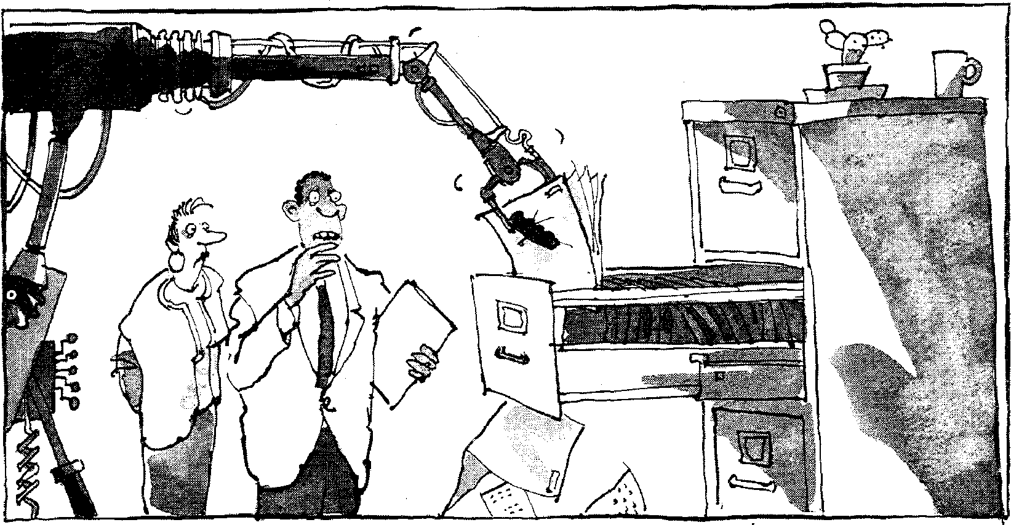
'I know they said they were going to introduce new technology, but this isn't quite what I expected.'
Listening
Task 9 | Listen to this conversation in which Charles, the Information Services Manager in an American insurance company, talks about the steps involved in making a document available to users via document image-processing. Put the steps in the right order.
1 |  |  | Index is stored.
 |  |  | Quality of scan is checked.
3 |  |  | Envelope is opened by a machine.
4 |  |  | Temporary key number is generated and written on the document.
5 |  |  | IMS index transaction and customer name is entered into the computer.
6 |  |  | Mail arrives in the mailroom.
7 |  |  | Temporary document number is entered into the computer to link it with the previously-generated index.
8 |  |  | Document is scanned.
9 |  |  | Document pages are removed and arranged by a clerk.
10 |  |  | Document can be accessed by users.
11 |  |  | Computer supplies routing and indexing data.
12 |  |  | Document pages are transferred to the mail analyst.

94
Task 10 | Now listen again and answer the following questions:  1 How long does it take:  a for an index to be stored and a key number issued?  b for a recent document to be retrieved?  2 Why does it take longer to retrieve a document processed more than a year ago?  3 Note down:  a the number of square feet of office space saved.  b the number of employees freed from file maintenance.  c the approximate net saving per year in pounds.

Speaking
Task 11 We have looked at some of the benefits of replacing people with computers in
the office. What are the negative aspects of this policy?
Writing
Task 12 Write two paragraphs, one listing the benefits, the other listing the negative
aspects of replacing people with computers.
Information systems
Reading

Task 13 | Before reading the text, try to decide which of the following definitions best describes a management information system:  a a system for supplying information to management  b a system for managing information  c a system which supplies information about management

allanla a al a mania..  Task 14 | Decide whether these statements are true (T) or false (F), then read the passage to check your answers.

1 All businesses are interested in more or less the same information,
regardless of the nature of their operations.
2 The managing director of a company needs a lot more detailed information about the day-to-day operations than his executives do.
3 Functional management require up-to-the-minute information so that
they can take action to control events as they happen.
4 Information systems are usually computerized.
5 Transaction processing systems are usually the first systems to be
installed.
Information systems
95
The objective of information systems is to provide information to all levels of management at the most relevant time, at an acceptable level of accuracy, and at an economical cost.
Individual businesses require information according to the nature of their
5 operations. A car manufacturer is particularly interested in the extent of competition from overseas manufacturers in the home market and competition from other home-based manufacturers. A tour operator is concerned about purchasing power and its effect on holiday bookings and the political situation prevailing in the various countries.
10 As a general guide, the detail contained in reports containing information varies according to the position of the recipient in the hierarchical management structure. The chairman and managing director of a company require details of operations which are broad in scope and which concentrate on key factors pinpointing economic and financial trends.
15 Functional management require information relating to the departments they are responsible for in sufficient detail to enable them to apply whatever measures are required to bring situations into line with requirements. They require information relating to events as they occur so that appropriate action can be taken to control them.
20 Information systems are often computerized because of the need to respond quickly and flexibly to queries. At the bottom level in the information hierarchy are the transaction processing systems, which capture and process internal information, such as sales, production, and stock data. These produce the working documents of the business, such as
25 invoices and statements. Typically, these are the first systems which a company will install. Above the transaction-level systems are the decision support systems. These take external information — market trends and other external financial data — and processed internal information, such as sales trends, to produce strategic plans, forecasts, and budgets. Often such
30 systems are put together with PC spreadsheets and other unconnected tools. Management information systems lie at the top of the hierarchy of information needs. The MIS takes the plans and information from the transaction-level systems to monitor the performance of the business as a whole. This provides feedback to aid strategic planning, forecasting,
35 and/or budgeting, which in turn affects what happens at the transactional level.

Task 15 | Draw a diagram to show how information is processed by information systems, as described in the last paragraph. Your diagram should show the hierarchy of systems and should include examples of the kind of information involved at each stage in the process. Use arrows (—.) to indicate the flow of information.

Writing

Task 16 | Using your completed diagram from Task 15, write a paragraph explaining how information is processed by information systems. Do not look back at the text itself.

Word-play
96
Complete the puzzle and find the key word in 10 down.
Task 17
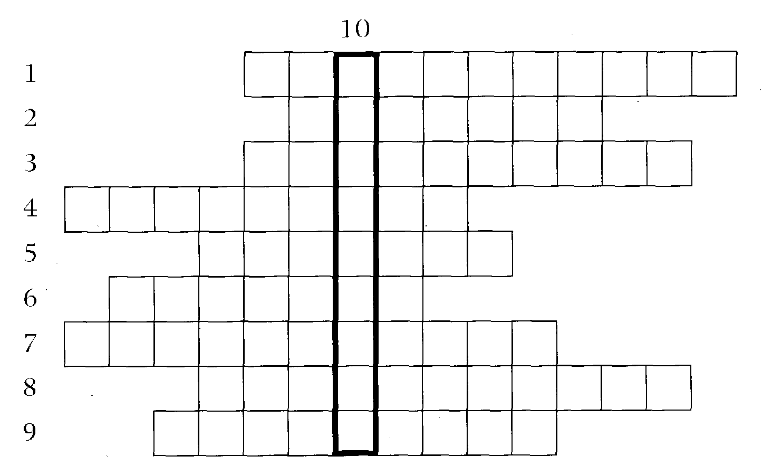
Across
1 The T of MIS. (11)
2 Another term for a VDU. (7)
3 See 8.
4 An A/D changes analog signals into digital signals. (9)
5 The `D' of VDU. (7)
6 The decision systems combine information from outside and inside an
organization to produce strategic plans and forecasts. (7)
7 Voice systems permit people to talk to computers. (11)
8 and 3 systems capture and process information generated within
an organization (e.g. sales and production data). (11,10)
9 Converted from an analog to a digital signal. (9)
Down
10 The amount of deskspace (or floorspace) taken up by a computer. (9)
Language focus H
97
The passive
Passives are very common in technical writing where we are more interested in facts, processes, and events than in people. We form the passive by using the appropriate tenses of the verb to be followed by the past participle of the verb we are using.
Examples:
Active
1 We sell computers. (simple present)
2 Babbage invented The Analytical Engine'. (simple past)
Passive
1 Computers are sold. (simple present)
2 'The Analytical Engine' was invented in 1830. (simple past)
Facts and processes
When we write or talk about facts or processes that occur regularly, we use the present passive.
Examples:
1 Data is transferred from the internal memory to the arithmetic-logical unit along channels known as buses.
2 The other users are automatically denied access to that record.
3 Distributed systems are built using networked computers.
Read the text below, which describes the insurance company's procedure for dealing with PC-users' problems. Fill in the gaps using the correct form of the verb in brackets.
All calls ¹ (register) by the Help Desk staff. Each call
2
(evaluate) and then ³
(allocate) to the relevant support group. If a visit ⁴ (require), the user^{s} (contact) by telephone, and an
appointment ⁶ (arrange). Most calls
(deal with) within one working day. In the event of a
major problem requiring the removal of a user's PC, a replacement can usually
8 | (supply).

98
Exercise 2 | Fill in the gaps in the following sentences using the appropriate form of the verb in brackets.

1 The part of the processor which controls data transfers between the various input and output devices (call) the control unit.
2 The address bus (use) to send address details between the
memory and the address register.
3 The pixel positions (pass on) to the computer's pattern
recognition software.
4 An operating system (store) on disk.
5 Instructions written in a high-level language (transform) into machine code.
6 In the star configuration, all processing and control functions
(perform) by the central computer.
7 When a document arrives in the mail room, the envelope
(open) by a machine.
8 Once the index  document.  Events | (store), a temporary key number (generate) and (write) on the

When we write or talk about past events, we use the past passive. Let us look at some examples.
Examples:
1 COBOL was first introduced in 1959.
2 Microsoft was founded on the basis of the development of MS/DOS.
3 The organization was created to promote the use of computers in education.
Exercise 3 Fill in the gaps in the following sentences using the appropriate form of the
verb in brackets.
1 Microsoft (found) by Bill Gates.
2 C language (develop) in the 1970s.
3 During that period, enormous advances _ (make) in
computer technology.
4 The following year, twice as many PCs (sell).
5 In the 1980s, at least 100,000 LANs laboratories and offices around the world.
(set up) in
(build) by the University of
(launch) than ever
6 The first digital computer Pennsylvania in1946.
7 Last year, more software companies before.

8 IBM's decision not to continue manufacturing mainframes
99
(reverse) the year after it (take).


Computers in education
100
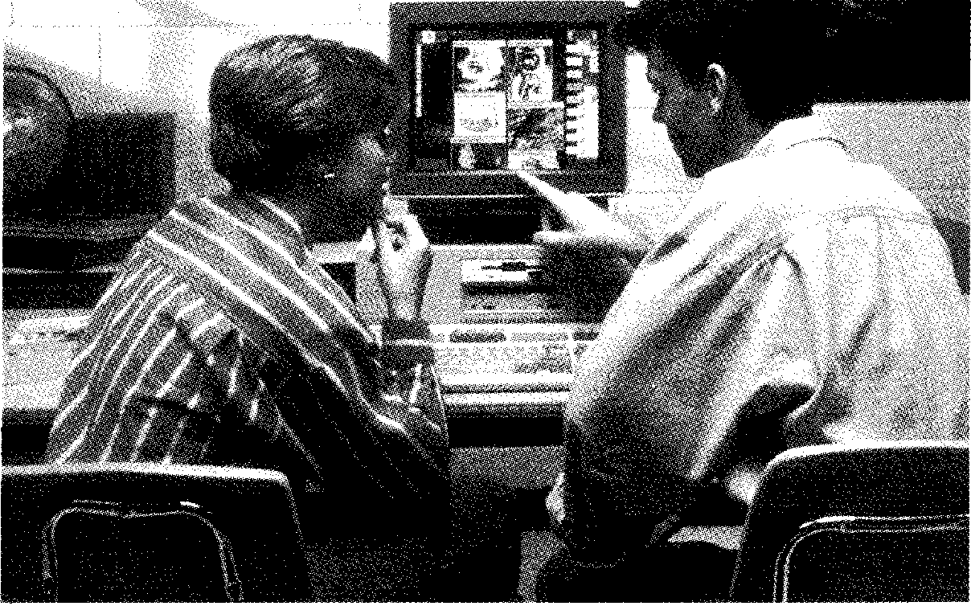
Start-up
Task 1 Make a list of the ways computers are used in education.
Speaking
Task 2 Discuss these questions:
1 How are computers used in your school?
2 What do you think the following terms mean?
a further education
b open learning
c flexible learning
Reading

Task 3 | Read quickly through the text opposite to find:  1 the overall purpose of NCET.  2 another expression meaning 'educational technology'.  3 whether NCET produces learning materials.  4 how many priorities NCET's Schooling Directorate has.  5 three groups of people helped by NCET's Vocational Training programme.  6 three examples of new and developing technologies that the Council gives advice about.

National Council for Educational Technology
101
The Council's purpose is to bring beneficial change to the processes of learning in education and training through the development and application of educational technology.
Educational technology — or learning technology, as it is sometimes known -
5 embraces everything from the way computers, satellites, and interactive video are used in schools, colleges, and industry to issues of copyright and flexible learning. Focusing on the learner, our purpose is to support change in the ways we learn by applying the benefits of educational technology — especially the new information technologies — to the process of learning.
10 We design and produce learning materials in all subjects to support education
and training. We carry out research and manage projects, offer consultancy
on technical matters, support training for trainers and teachers, and offer
expertise in areas such as open and flexible learning, resource management,
and educational software. We provide a comprehensive information and
15 enquiry service.
Information Technology in schools
Through its I.T. in Schools Programme, NCET's Schooling Directorate is pursuing four priorities:
- to identify and promote and spread good practice in the use of new technologies
20 ■ to provide professional guidance to teacher trainers so that they can help teachers and schools in managing I.T. and in applying it to all areas of study
- to develop high-quality curriculum materials and encourage other publishers to do the same
25 ■ to give particular support for those concerned with children and young
adults with special educational needs, including the handicapped.
Learning after school and at work
NCET's Training Directorate focuses on the needs of those wishing to learn after the school-leaving age. Projects under the Vocational Training programme include looking into the training needs of women, older workers,
30 and those who use information technology to work from home. In further education, lecturers and senior managers are being helped to plan for I.T. and changing client needs. For industry, our work has included language training in the run-up to 1992, and the application of artificial intelligence systems to training. This directorate also takes the lead in important trans-sectoral issues
35 such as open and flexible learning, copyright, and the use of computers in careers guidance.
Technical expertise
Keeping abreast of developments in technology and maintaining a national expertise on standards and specifications is the work of NCET's Technical Consultancy Directorate. Through links with other organizations, it identifies
40 issues associated with the adoption of new technologies and, where appropriate, carries out projects to assess or develop their potential in education and training. It has a watching brief and provides consultancy on new and developing technologies such as satellites, CD-ROM, and interactive video. Current projects involve the examination of the use of educational
45 software in schools, the use of massive storage systems, and the use of satellites in education and training. The Directorate also produces guidance to users on a wide range of technology, from desk-top publishing and remote sensing to teleconferencing and audio-visual systems.

Task 4 | Imagine that you represent NCET and that a newspaper reporter is interviewing you. Use the information in the text to complete the dialogue in  your own words.

Reporter What exactly does the term 'educational technology' cover? You
Reporter I see. Apart from offering advice on technical matters, what other services do you provide?
You
Reporter Does the I.T. in Schools Programme help teachers as well as students?
You Yes.
Reporter What about those with special educational needs?
You
Reporter What responsibility does the NCET's Training Directorate have? You
Reporter Does that include helping people in industry?
You Yes.
Reporter One last question. What kind of work is the Technical Consultancy Directorate doing in schools at the moment?
You

Make a list of the 'new information technologies' mentioned in the text. Do you know what all the terms mean?
Task 5
Task 6
102
Using the line references given, look back in the text and find words or phrases in the text which have a similar meaning to:
1 includes (lines 1-5)
2 advantages (lines 5-10)
3 covering everything (lines 10-15)
4 course (lines 20-25)
5 physically or mentally challenged (lines 25-30)
6 approach (lines 30-35)
7 up-to-date with (lines 35-40)
8 instructions to monitor (lines 40-45)
Writing
Translate the last paragraph of the text (beginning 'Keeping abreast of...') into your language.
Task 7

103
 | Speaking
Task 8 | You represent the National Council for Educational Technology. You have been asked to talk to a group of teachers about the work of the Council. Make brief notes from the text, then prepare a short presentation.  In pairs or small groups, take turns to make your presentation. If you are listening to a presentation, check that it is accurate and that it covers the main points mentioned in the text.

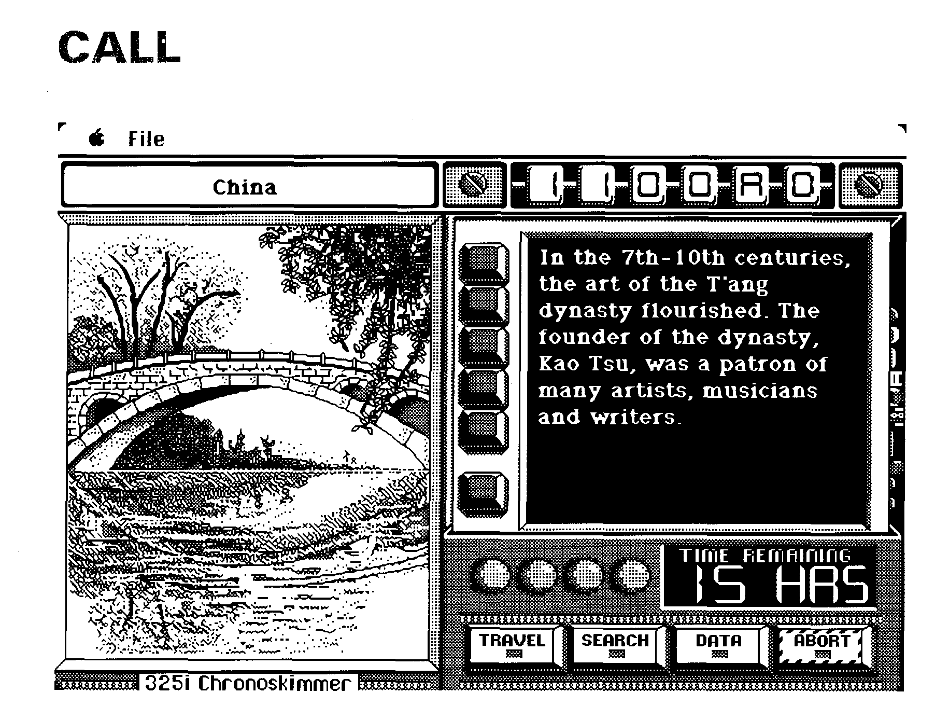
Listening
Task 9 Tony Longstone, an expert on educational technology, is answering questions
from teachers about Computer Assisted Language Learning (CALL). Listen to the discussion and decide whether the following sentences are true (T) or false (F):
1 7 Most uses of computers in language education can be described as CALL.
2 H There is no point in buying a computer for CALL, if there is no commercially available software for that computer or operating system.
3 The number of computers you buy will depend on two factors: the
number of students there are, and the amount of physical space available.
4 It is possible to have CALL using only one computer.
5 The ideal way to organize CALL is to have one computer in each
classroom.
6 1 1 The CALL resource should be free to students if possible.
Listen again. Change the sentences that are false to make them true.
Task 10 Read this extract from the tapescript and try to fill in the missing words.
LQNGSTQNE: Well, given sufficient' , it's a good idea to have some
computers ² for teachers in the teachers' room. Also, it's very
useful to have a self-access for use by students. In both cases,
they — teachers and students — can gain a lot of confidence and
4 5
by having free access to the . Finally, an
excellent idea is to have one computer with a large screen functioning as an electronic ⁶ for messages prepared for students and staff. This
should be located in a public part of the school or college, such as the hall or
7
Now listen to the last part of the recording again and check your answers.

Discuss the following questions:
Task 11
104
1 What do you think are CALL'S main advantages and disadvantages as a way of learning foreign languages?
2 Do you think it is possible that one day language teachers will be completely replaced by computers?
Reading
Task 12
A teacher has been looking at some publicity material for the Adam & Eve program. Read the material and fill in the gaps in the teacher's notes opposite.
Choose your own texts v
ADAM & EVE allows you to create exercises based on any text you want. The text could be from the course-book you are using, from a reader, from a newspaper — whatever your students are interested in.
Analyse your texts v
ADAM & EVE will analyse the vocabulary of the text according to
the database of word frequency contained within the software. From this analysis you get a precise idea of the level of difficulty of a text, you can compare one text with another text, and you can see whether it fits in with the syllabus your students are working to
Generate exercises v
ADAM & EVE will then create a wide variety of exercises based on this analysis. These exercises, which are easily and quickly generated, can be presented to your students either as printed worksheets — you will be provided with the answers on a separate sheet — or can be put on to a floppy disk so that a performance will be automatically evaluated and the score recorded.

Simple to use
105
No previous experience with computers is necessary. If you can type using a word processor (or know someone who can!) you will
have no difficulty in putting your texts into the software. The whole program is 'menu driven' in any one of five languages so you will always know where you are and it will be obvious from the screen where you can go next. There is a full and clearly written manual to help you get started. Once you are familiar with the basic workings, don't forget to go back to the manual to learn about the program's finer points.
Something for the whole school ♦
Up to twenty-five different teachers can work with ADAM & EVE . The program will keep each teacher's texts and the exercises generated on those texts in separate files which are only accessible using that teacher's password. ■
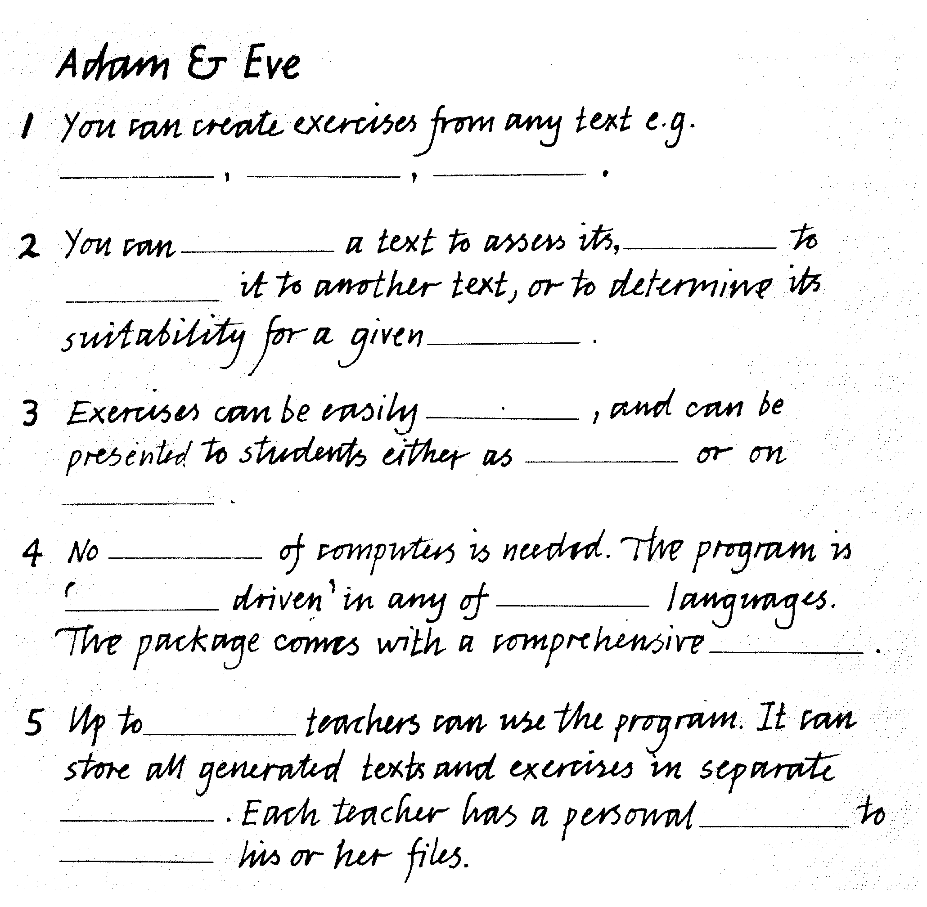
1 create, created, creating, creation, creativity
Task 13
Choose the correct word to complete each sentence. You may have to change some words slightly.
106
a The __ of this database will give us a huge advantage over our
competitors in the long run.
b The procedure for a new file is very simple.
c The new position we are advertising is going to require someone with enormous
2 generate, generated, generative, generation
a Exercises can be quickly using this program.
b Our company is working on a new of software products.
c This development is sure to great interest.
3 access, accessed, accessible, accessibility
a All user requests to a database are handled by the database
management system.
b to the computer room is restricted to authorized personnel.
c Those files are not  4 analyse, analysed, analysis, analyst | unless you know the password.

a When a text is | , all pronouns, prepositions, conjunctions, and

verb forms are automatically identified.
b This shows that most PC users are not aware of the full
potential of the software products they buy.
c The DBMS first receives the request and it for syntax errors.
Task 14 | Writing  Imagine you are in charge of language teaching in an institute. Write a short report to the principal recommending the introduction of CALL.  Organize your report as follows:  Paragraph 1— explain what CALL is.  Paragraph 2 — describe the different options available (e.g. one computer per class; a special classroom with several networked PCs). Paragraph 3 — recommend one of the options you mentioned in paragraph 2.

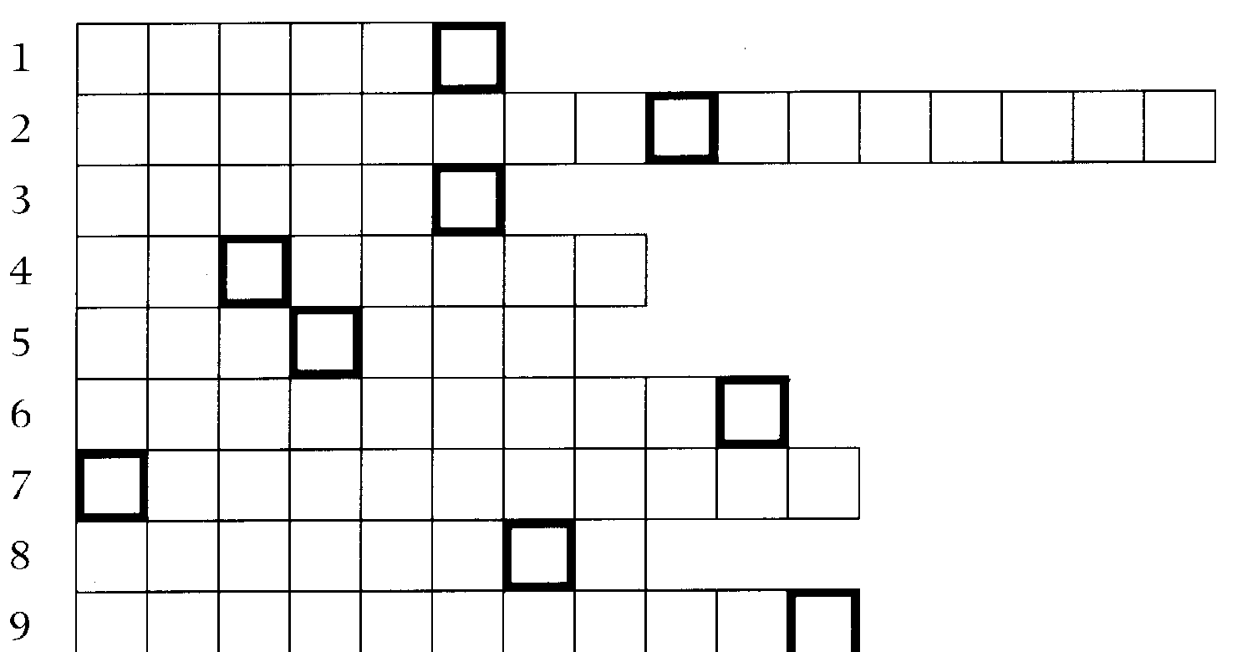
1 To connect to a database. (scaces)
Task 15
Word-play
The clues below contain anagrams of words from this unit. Enter the words in the grid, then solve the anagram in the bold boxes to find the hidden word.
107
2 A technology which allows telephone communication between several people at the same time. (ctoenlfeergcnien)
3 Describing a device connected over a WAN. (emtore)
4 A large store of computerized data. (aaaestdb)
5 Examine carefully. (easnaly)
6 Concerning the qualifications, etc. needed for a trade or profession. (lvaoncoait)
7 Describing a system in which the computer responds to the user's instructions. (vercaitneit)
8 A VDU and keyboard. (lnmrteia)
9 A program that manipulates tables of figures. (steerpandse)
Hidden word clue
Device used for relaying telephone messages or radio and TV signals. (9)
Language focus I
Giving examples
When the main aim of a text is to inform the reader about a subject, the writer will often use examples, either to explain a point or to illustrate an idea or argument. When giving examples, it is important to differentiate between the idea itself and the illustration of the idea.
Some expressions for introducing examples are shown in the table below.

for example (e.g.) for instance  an example (of this) as an example  such as  like  including | examples of instances of cases of illustrations of exemplified by illustrated by seen in | shown by exemplifies shows  illustrates  a second/third example, etc.

Examples:
1 Office workers use many computer applications such as word processing, spreadsheets, and databases.
2 Computers have made radical changes in preparing income tax returns. For example, in some countries you can now send your income tax return on disk.
3 Students can make good use of computer technology at school. Essay writing, for instance, can be done using a word-processing program.
Note: Sometimes the markers follow the example, separated by commas, as in 3 above.
Exercise 1 The list below is made up of five groups of words, consisting of five main
categories and examples of each category. Find the word groups and then write sentences to show the relationship between the groups of words. Use a different marker for each sentence. One has been done for you.

108
trackball  mainframe  microcomputer  network configuration programming language mouse  input device | bus  output device printer  APL  COBOL stylus | PC  star  VDU  C  ring  computer

Example:
Ring, bus, and star are all examples of network configurations.

109
Exercise 2 | Read the following sentences. Circle the marker and underline the main idea for which the example is given. The first one has been done for you.  1 Networks also allow users in one locality to share expensive resources, such as printers and disk-systems. (Unit 6)  2 There are a handful of clipboard computers now on the market, including GRIDPad, which is sold in the US; (Unit 2)  3 The PC passes the query, written in a special language (e.g. Structured Ouery Language — SOL), to the mainframe, which then parses the query, returning to the user only the data requested. (Unit 6)  4 Here's an example of a simple virus, the Lehigh virus. (Unit 7)  5 If you use a shared PC or a PC that has public access, such as one in a college PC lab or a library, be very careful about putting floppies into that PC's drives without a write-protect tab. (Unit 7)

Exercise 3 | Not all texts present examples explicitly. In some cases, markers are not used. Read the paragraph below. Circle the main idea and underline the examples of that idea.  The widespread availability of computers has in all probability changed the world for ever. The microchip technology which made the PC possible has put chips not only into computers, but also into washing-machines and cars. Some books may never be published in paper form, but may only be made available as part of public databases. Networks of computers are already being used to make information available on a world-wide scale. (Unit 1)


Computers in medicine
110
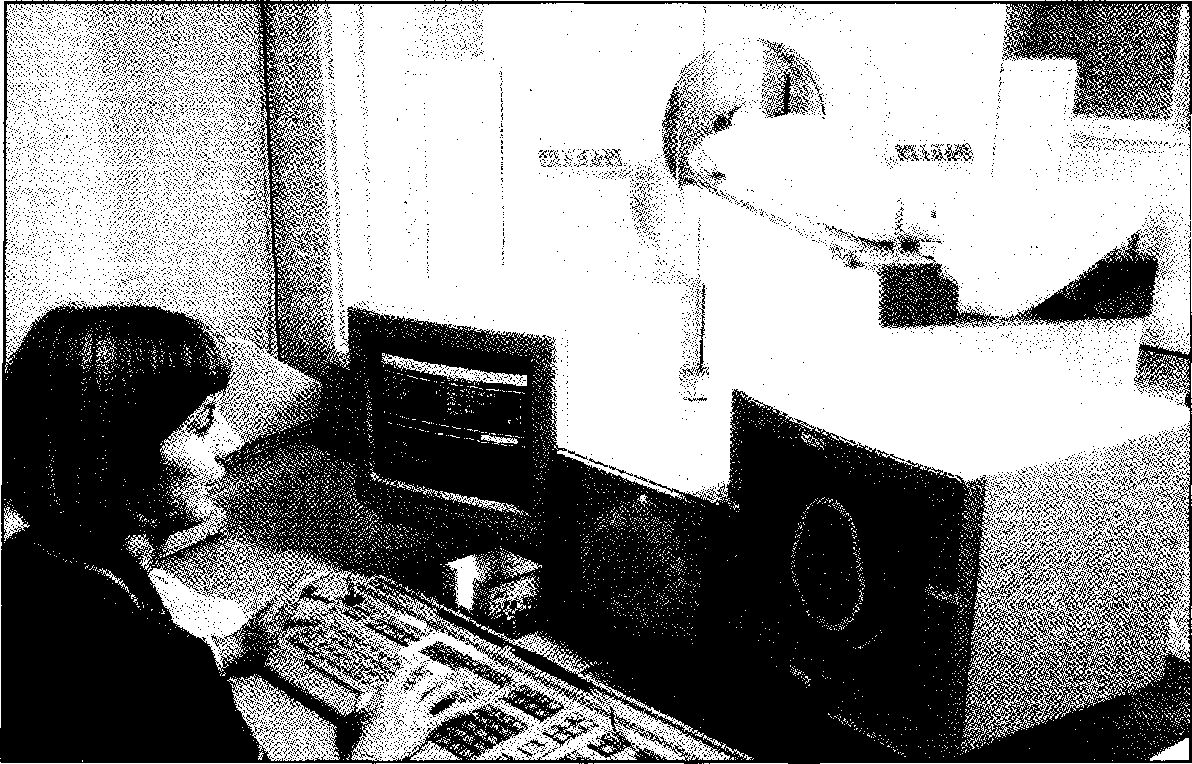
Start-up
Task 1 Make a list of all the applications of computers you can think of which are
related to medicine and patient care.
Reading
Before reading the text opposite, try to answer the following questions:
The cards below contain a message. What do you think it is? Why do you think the message was given in this form?
How could a computer help to convey messages like this?
Task 2 | 1  2  3

Now read the text and check your answers.

EILEEN CARLETON HAS A whimsical talent for hand
signals. When the 65-year-old stroke
victim draws a vertical line in the air,
5 her family knows she is referring to a very slim friend of her son.
But a lexicon of hand gestures —no matter how inventive — and the few dozen words left in Carleton's
10 vocabulary following her stroke are inadequate for conveying even the most basic wishes, observations, or questions to her family. Through a pilot study at the School of
s Medicine, however, Carleton has learned to communicate using a specially designed computer program that has restored not only her ability to express herself, but
20 also, family members and therapists say, her enthusiasm for life.
The stroke that Carleton suffered in 1985 damaged the portion of her brain where words and speech are
25 processed, leaving her with a condition known as aphasia, or the inability to use language. While she is able to comprehend much of what people say to her, she cannot
30 formulate her thoughts into
coherent phrases or sentences.
Using the computer program, she can select from hundreds of pictures that represent people, objects,
35 actions, and descriptive qualities and arrange them in sequence to communicate thought, obviating the need to use words.
`When Eileen first entered the 40 study, she depended on her
husband Steve to figure out what she wanted to say from her gestures and facial expressions. All she could say was, "Come on! You know!",
45 with increasing frustration,' said Dr Cheryl Goodenough Trepagnier, associate professor of rehabilitation medicine.
The computer program used in
50 the Tufts study was developed in conjunction with the Palo Alto, California, Veterans Administration Medical Center and grew out of research in the 1970s at the Boston
55 Veterans Administration Hospital.
`Researchers had found that chimpanzees, whose brains lack
111
specialized language centers, could engage in a kind of
60 communication using plastic tokens that represented different objects and actions,' Dr
Trepagnier said. 'We wondered whether aphasics — whose
65 language processing areas are damaged — could benefit from the same idea.'
On small cards, researchers drew symbols representing
70 different people, objects; and actions and trained aphasic patients to select and arrange the cards to form statements or
questions. By selecting cards
75 showing a woman, a person walking, a store, and a chicken, for example, an aphasic patient
could ask his wife to go to the grocery store to buy some
80 poultry.
`Some patients become quite adept at using the cards,' Dr Trepagnier said. 'But as the
number of cards increased, it
85 became awkward and time-consuming to find the right cards
and then put them back in the right order. Patients found the cards too cumbersome and
90 didn't use them at home.'
In the mid-1980s, however, a computer program was
developed that, like the cards, used pictures to represent ideas,
95 but was easier to use. With the program, aphasic patients could select from hundreds of pictures simply by moving a computer mouse. Dr Trepagnier was
100 among the first researchers to
test the new software on
aphasics.
`At first, there was a great deal of doubt over whether aphasics
105 would be able to use computer,' Dr Trepagnier said. 'But we found that many took to the
computer quite easily. As they became more proficient on the
110 computer, some showed gains 10.-

⁴¹¹ in their overall self-confidence, as well.'
It's hardly an exaggeration to say
that the program transformed
115 Carleton's life. In the aftermath of her stroke, Carleton 'was so despondent she sat on the couch all
day and did nothing,' said her speech therapist, Evelyn Chedekel.
120 But as soon as she learned that she's capable of communicating with the computer, her whole world changed. Now she can introduce topics, rather than hoping that
125 people will guess what's on her mind. When her husband passed
away suddenly, she was able to carry on.'
Encouraged by the results
130 thus far, Dr Trepagnier will study ways of expanding the computer program's capabilities. For unknown reasons, many aphasics have more trouble
135 conceptualizing verbs than nouns. Making the intellectual connection between a picture of
a sailboat and the idea of a sailboat is easier than
140 connecting a picture of a boy
running to the idea of
running. Trepagnier hopes to overcome this difficulty by designing a program that
145 enables patients to see computer images in motion. III

• Vocabulary
112
whimsical (1. 2) — fanciful, highly imaginative
lexicon (1. 7) — vocabulary dozen (1. 9) — about twelve stroke (1. 10) — sudden attack of illness in the brain, causing loss of speech and
movement
took to (1. 107) — developed an ability with
passed away (1. 126) — died

Task 3 | Decide which of these titles best sums up the content of the text.  1 A new way to communicate for stroke victims  2 Stroke victims: computers that care  3 New technology comes to the rescue of stroke victims

Task 4 Read this summary of the text and fill in each gap with an appropriate word.
Eileen Carleton's life has been completely transformed by Dr Trepagnier's computer program. Whereas she used to be entirely ¹ on her
husband to deduce what she wanted to say, now she is able to ²
her own ideas. Before, she had to hope other people would what
she was thinking. Now she is ⁴ of starting a conversation with others.
Dr Trepagnier's program was ' from research on symbolic
communication by chimpanzees, which ⁶ specialized language
areas in their brains. As these language-processing areas are also known to be
7 in human aphasics, the same idea of using visual symbols to
represent different people, objects, and actions was thought likely to be effective.

Using cards to show these symbols proved ⁸ for most patients, but
113
the introduction of computer technology has greatly ⁹ - the use of
the system by aphasics, whose lives have been immeasurably 10
since the invention of this program.

Task 5 | Each of the following sentences from the text is followed by two paraphrases. Decide which paraphrase (a or b) is closer in meaning to the original comment. Remember to look at the comments in their original context.

1 But a lexicon of hand gestures — no matter how inventive — and the few dozen words left in Carleton's vocabulary following her stroke are inadequate for conveying even the most basic wishes, observations, or questions to her family. (line 7)
a Eileen Carleton's hand gestures and words are not clear enough to allow her thoughts to be understood.
b Eileen Carleton does not have enough hand signals and words to express her thoughts.
2 While she is able to comprehend much of what people say to her, she cannot formulate her thoughts into coherent phrases or sentences. (line 27)
a Eileen understands quite a lot of what people are saying to her and knows what she wants to say. However, she cannot translate her thoughts into understandable messages.
b Eileen finds it difficult to choose the right words and sentences to express herself while she is concentrating on what people are saying to her.
3 As they became more proficient on the computer, some showed gains in their overall self-confidence, as well. (line 108)
a Some people found that their growing confidence about using the
computer made them generally more self-confident.
b The more people used their computer, the more self-confident they became.
4 It's hardly an exaggeration to say that the program transformed Carleton's life. (line 113)
a The program changed Carleton's life in some respects.
b The program completely changed Carleton's life.

Task 6 | Match each word in the list on the left with the appropriate synonym on the right.  1 inventive (line 8) a deduce  2 inadequate (line 11) b awkward  3 select (line 33) c take part in  4 obviating (line 37) d depressed  5 figure out (line 41) c insufficient  6 engage in (line 59) f completely changed  7 cumbersome (line 89) skilled  8 proficient (line 109) h creative  9 transformed (line 114) i choose  10 despondent (line 117) j removing

Writing

Task 7 Translate paragraph 6 (beginning 'The computer program used in the Tufts
study...' ) into your own language.
Reading

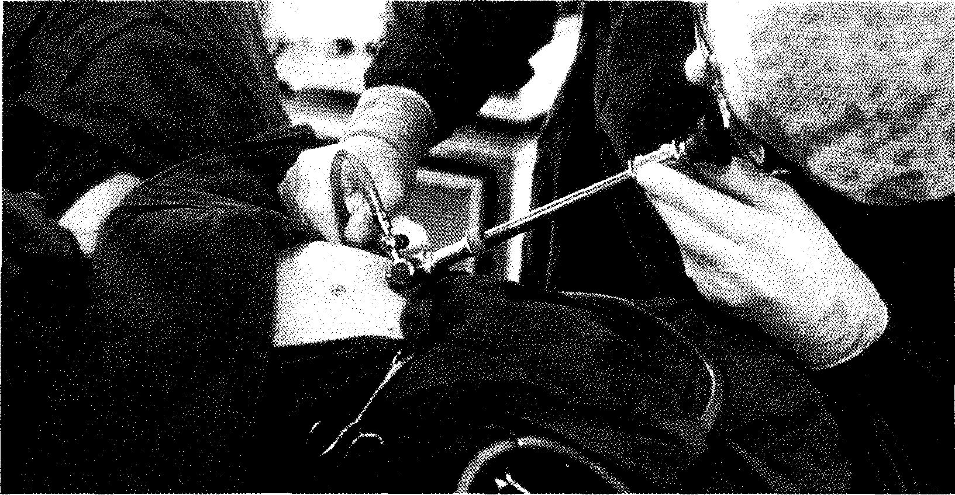

Work in pairs, A and B. Student A should read text I only. Student B should read text 2 only. Without looking at the text you have read, tell your partner about it. Write down what your partner tells you about his/her text, then compare it with the original. How accurate is it?
1 2

Robot eye for surgery
Laparoscopy is a procedure in which a camera is pushed through a small hole in the abdominal wall. It allows a surgeon to operate by television,
5 with instruments inserted through a second hole. The small size of the incisions reduces the trauma for patients and speeds up recovery. Until recently, the procedure has
10 required the presence of a second doctor to guide the camera for the surgeon.
A new development now facili-
tates this procedure. A robot ma-
15 noeuvres the camera in response to
the surgeon's head. Four tiny trans-
mitters, worn on a headband, send
radio signals to a base unit. As the
surgeon moves his head left or right,
20 up or down, forwards or backwards,
the robot causes the camera to track
his movements, enabling him to
view the exact area he wishes to see.
Robot surgery for eye
Techniques derived from virtual reality will soon allow surgeons to feel as well as see the inside of the eye during an operation. During the
114
s operation, the surgeon manipulates a set of controls known as the master. These are connected through high-performance computer to the robot. The robot's 1 imbs move in
10 exactly the same way, except that the movements can be scaled down as much as a thousand times, thus eliminating hand tremor and reducing damage to the eye.
15 The computer also creates a three-
dimensional view of the inside of the eye, which the surgeon can see wearing a virtual reality helmet and 'feel' via a sensory feedback system which
20 emulates the forces generated by cutting with a surgical tool.

Data storage and management
Listening

Task 9 | 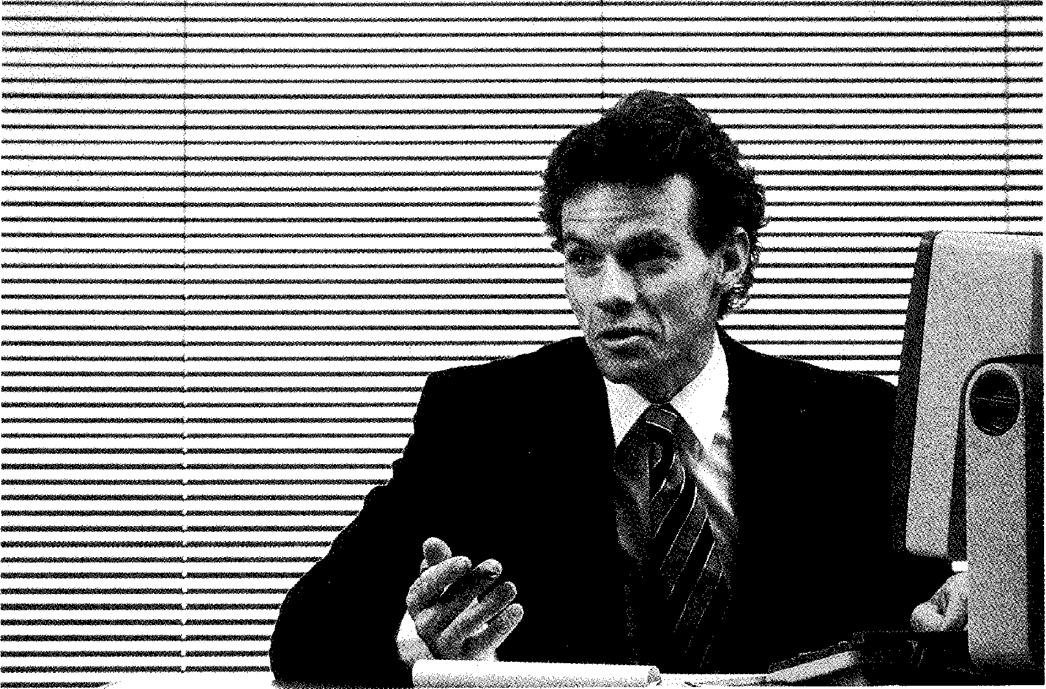

Listen to this extract from a programme called Science Made Simple, in which a hospital administrator answers questions about the hospital database. As you listen, choose the correct answer for each question.
115
1 How many characters of stored information are generated each year by the database at Grovemount Hospital?
a More than 500,000.
b More than 50,000,000.
More than 500,000,000.
More than 500,000,000,000.
2 How is the database organized?
a Like all other databases.
b Like any hospital database.
c Differently from any other database.
3 How is information on patients stored?
a Each patient has a named file.
b Each patient has a record.
c Each patient has a number of records within a personal file.
4 What do fixed-format records contain?
a Types of data that cannot be changed.
b Text only.
c Different types of data stored separately.
5 What happens when two people try to access the same data at the same time?
a The database management system cancels both queries.
b One user has to wait until the other has finished.
c The Database Manager processes both queries at the same time and updates the database accordingly.

Task 10 Read this extract from the tapescript and fill in each gap with an appropriate
word.
INTERVIEWER: I see. Now, can you tell us what happens when the database is
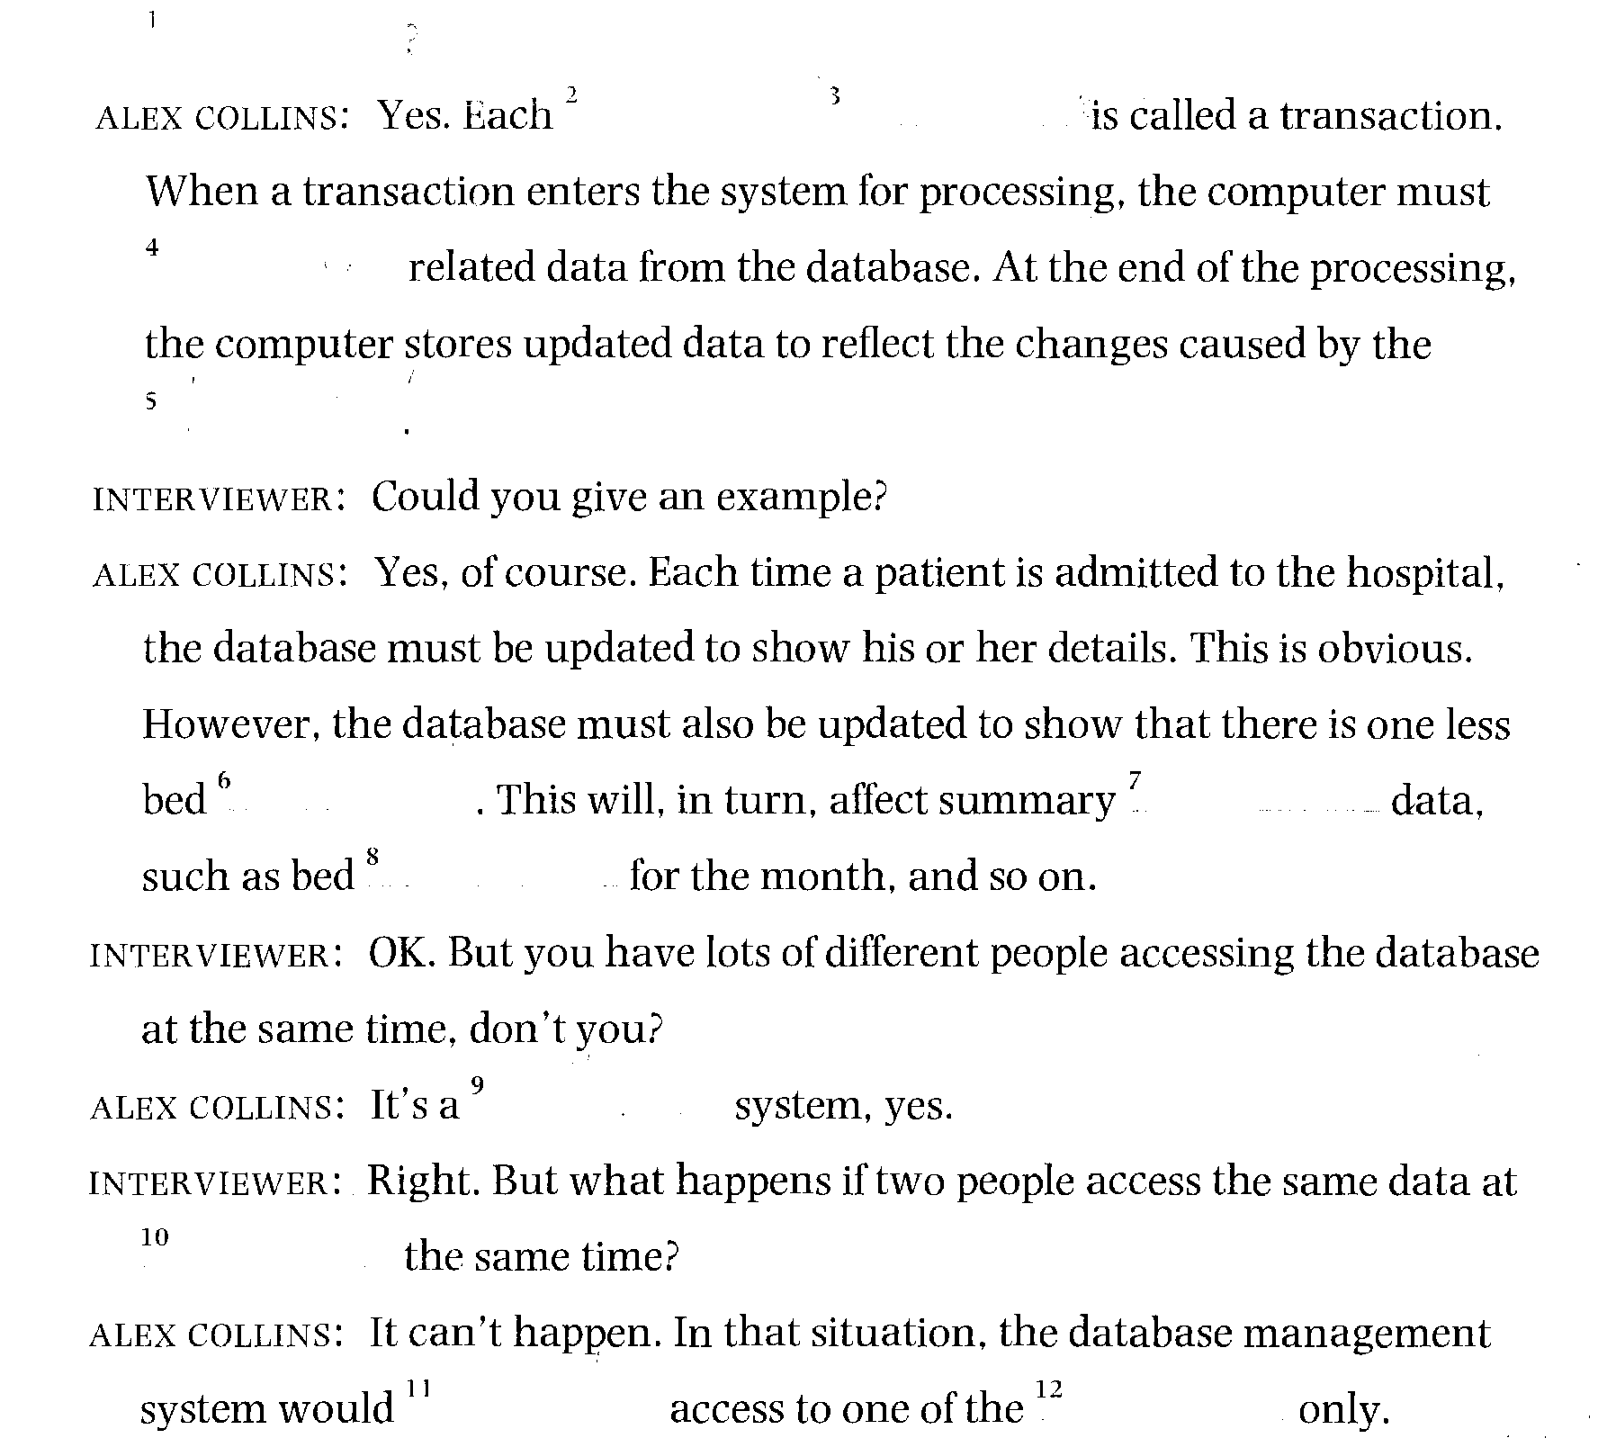
Now listen again to the cassette and compare your answers.
Reading

Before reading the text opposite, match the following words with their definitions:
Task 11
116
1 logical record a the collection of data transferred as a unit
2 field b the user's permitted view of the data
3 physical record c the logical design of the database
4 internal schema d an item of data such as a number, a name, or an
address
5 external schema e the way that the data is physically held
6 conceptual schema f the collection of data relating to one subject
Before reading the text, try to answer these questions in pairs.
Task 12
1 How many medical uses of a database can you think of?
2 What is a DBMS?
3 What is its function?

Now compare your answers with the information in the text.
117
Database management systems
Databases are used within a medical context for many purposes. For example, they are used to hold patient details so they can be accessed from anywhere within a hospital or network of hospitals. With the recent improvements in image compression techniques, X-rays and scan output
5 can also be held in databases and accessed in the same way.
These multi-user databases are managed by a piece of software called a database management system (DBMS). It is this which differentiates a database from an ordinary computer file. Between the physical database itself (i.e. the data as actually stored) and the users of the system is the
10 DBMS. All requests for access to data from users — whether people at terminals or other programs running in batch — are handled by the DBMS.
One general function of the DBMS is the shielding of database users from machine code (in much the same way that COBOL shields programmers from machine code). In other words, the DBMS provides a view of the data
15 that is elevated above the hardware level, and supports user-requests such as 'Get the PATIENT record for patient Smith', written in a higher-level language.
The DBMS also determines the amount and type of information that each user can access from a database. For example, a surgeon and a hospital 20 administrator will require different views of a database.
When a user wishes to access a database, he makes an access request using a particular data-manipulation language understood by the DBMS. The DBMS receives the request, and checks it for syntax errors. The DBMS then inspects, in turn, the external schema, the conceptual schema, and
25 the mapping between the conceptual schema and the internal schema. It then performs the necessary operations on the stored data.
In general, fields may be required from several logical tables of data held in the database. Each logical record occurrence may, in turn, require data from more than one physical record held in the actual database. The
30 DBMS must retrieve each of the required physical records and construct the logical view of the data requested by the user. In this way, users are protected from having to know anything about the physical layout of the database, which may be altered, say, for performance reasons, without the users having their logical view of the data structures altered.

Task 13 | The steps below show how a DBMS deals with an access request. Find the relevant section in the text, then put the steps in the correct order.  The DBMS:  1 inspects the mapping between the conceptual schema and internal schema  2 checks for syntax errors  3 inspects the external schema  4 receives the request  5 performs operations on the stored data  6 inspects the conceptual schema

Task 14 | Speaking  The diagram below represents a simplified database. In pairs, use the diagram to explain to your partner the following:  Student A: what a DBMS is and how it works Student B: how an access request is processed  Try not to refer to the text. Use your own words.
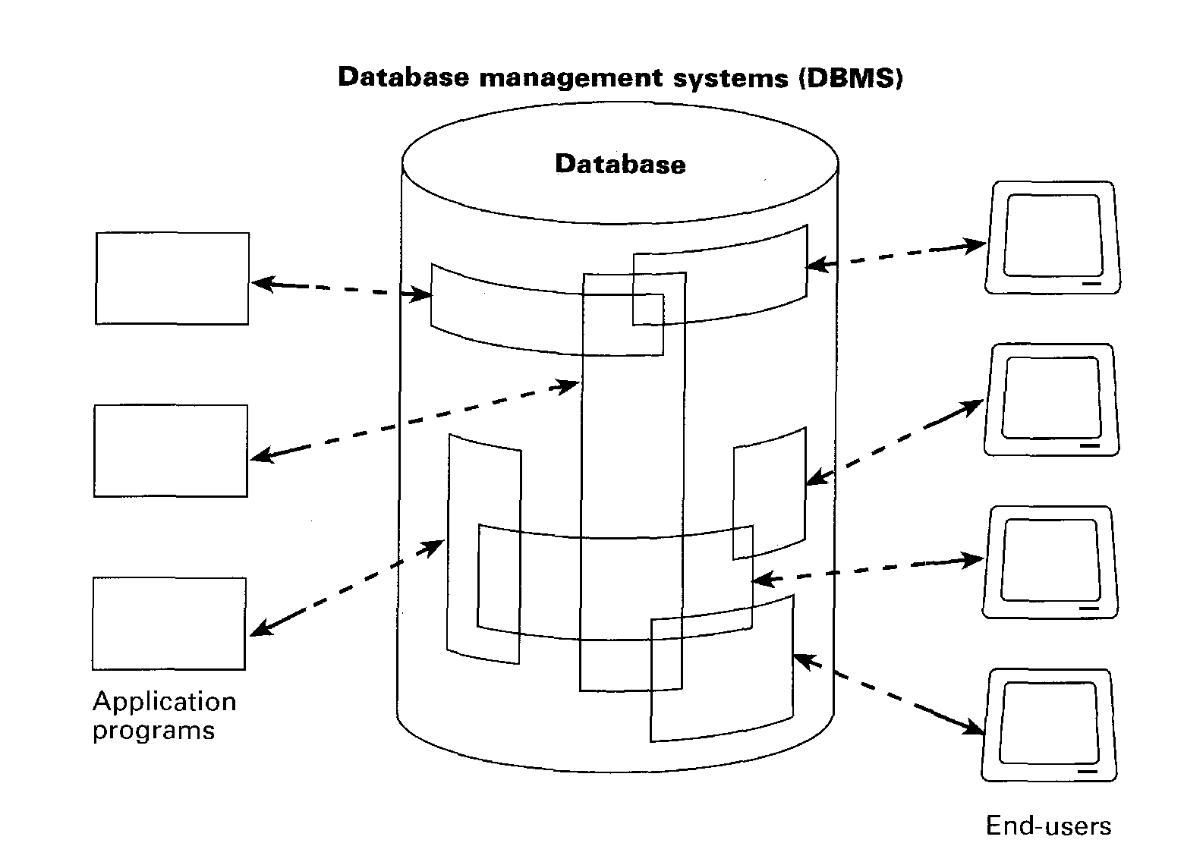

Word-play
Task 15
118
Complete the puzzle and find the key word in 12 down.
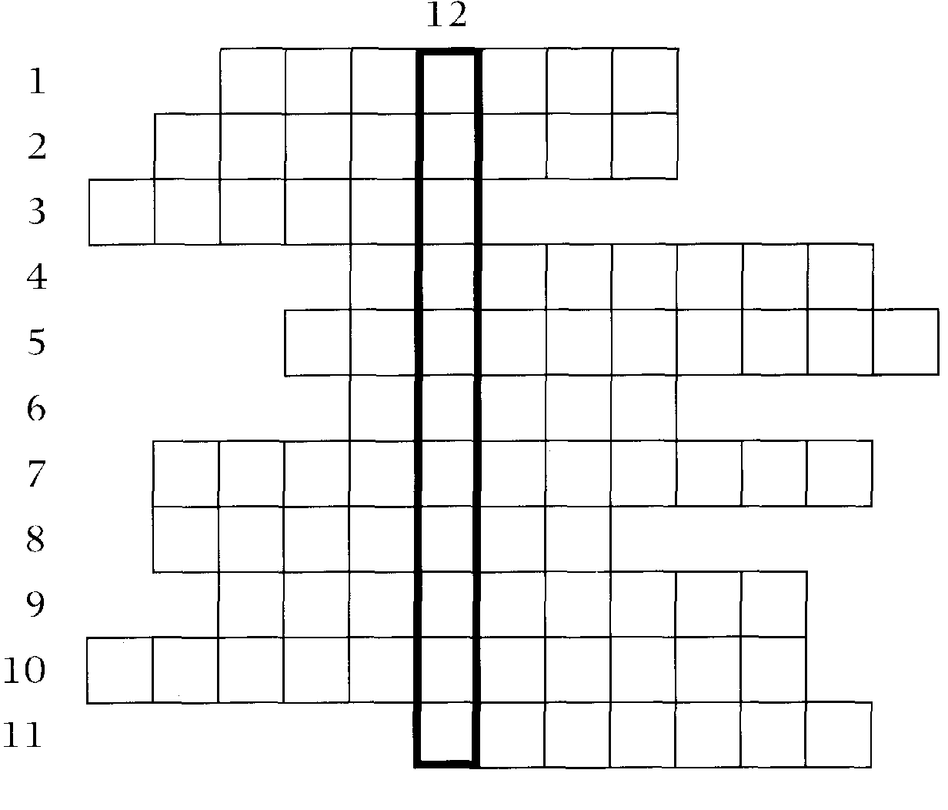

Across
119
1 and 11 The creation of an artificial environment in the memory of a
computer in which the user can apparently exist. (7,7)
2 and 3 The user's permitted view of the data in a database. (8,6)
4 The opposite of 2. (8)
5 A surgical is a tool used for carrying out operations. (10)
6 and 10 A technique for reducing the amount of space that a graphics image will use when stored in computer memory. (5,11)
7 A program must be converted into this before a computer will read and process
it. (7,4)
8 Programs that run do not involve any terminal or user interaction.
(2-5)
9 Used to describe computer systems that allow access by more than one user simultaneously. (5-4)
10 See 6.
11 See 1.
Down
12 A device for sending a radio message. (11)
Language focus J
120
Explanations and definitions
Texts containing technical terminology frequently contain definitions and explanations. This is particularly the case if the text is aimed at non-experts or students of technical subjects, or if the purpose of the text is to inform specialists about new developments.
1 Common words and expressions used in definitions or explanations are listed below.
is/are by ... we mean
means by ... is meant
is taken to be in other words
denotes that is (to say)
is/can be defined as
Examples:
1 A computer is an electronic device.
2 Printers are output devices.
3 The term computer refers to the processor plus the internal memory.
4 A microchip can be defined as a tiny piece of silicon or similar material carrying an integrated circuit.
5 By peripherals we mean those devices attached to the computer.
2 Some definitions and explanations give further distinguishing characteristics by means of a defining relative clause.
Examples:
1 A computer is an electronic device which/that processes information.
2 Tapes and disks are memory devices which/that can be stored away for future use.
3 A programmer is a person who/that prepares programs to solve problems.
4 The arithmetic-logical unit is the part of the CPU where arithmetic and decision-making operations are done.
Note: The relative pronouns used in this type of definition or explanatidn will be who or that for people, when for⁻a period of time, where for a place or location, and that or which for things.
3 Another way of defining or explaining is to use a noun, a noun phrase, or a clause separated from the rest of the sentence by commas or dashes.
121
Examples:
1 Computers — electronic devices for processing information — are now used in practically every aspect of life. (noun phrase)
2 Turnkey systems, complete hardware/software products which are ready for use, are available from many suppliers. (clause)
Exercise 1 |  | Study the following definitions. A definition usually includes three parts: the term to be defined, the group it belongs to, and the characteristics which distinguish it from other members of the group.

Term |  | Group Characteristics

A core is a ferrite ring | which is capable of being either magnetized  or demagnetized.

Silicon is a non-metallic with semiconductor
element characteristics.
Now analyse the following definitions and identify the different parts:
a by circling the term
b by underlining the group once
c by underlining the characteristics twice.
Example: A computer is a machine with an intricate network of electronic circuits that operate switches or magnetize tiny metallic cores.
1 Input is the information presented to the computer.
2 The term 'computer' includes those parts of hardware in which calculations and other data manipulations are performed, and the high-speed interval memory in which data and calculations are stored during actual executions of programs.
3 A 'system' is a mixture of integrated parts working together to form a useful whole.
4 Large computer systems, or mainframes, as they are referred to in the field of computer science, are those computer systems found in computer installations processing immense amounts of data.

Exercise 2 | Now read the following sentences, which have all appeared in previous units, and analyse them in the same way as you did in Exercise 1.  1 The part of the processor which controls data transfers between the various input and output devices is called the control unit. (Unit 1)  2 A modem is a device which serves a dual purpose because it acts as a MOdulator (digital to analog) and a DEModulator (analog to digital) ... (Unit 3)  3 The compiler is a systems program which may be written in any language, but the compiler's operating system is a true systems program which controls the central processing unit (CPU), the input, the output, and the secondary memory devices. (Unit 4)  4 A variable is a quantity that is referred to by name, such as a, b, c, d, and average in the above program. (Unit 4)  5 A WAN is a network connected over long-distance telephone lines. (Unit 6)

6 ...a LAN is a localized network, usually in one building or in a group of buildings close together. (Unit 6)
122
7 A computer virus — an unwanted program that has entered your system without you knowing about it — has two parts, which I'll call the infector and the detonator. (Unit 7)
8 There are actually two kinds of antivirus programs: virus shields, which detect viruses as they are infecting your PC, and virus scanners, which detect viruses once they've infected you. (Unit 7)
11
Robotics
123
Start-up
What function do you think each of these robots performs?
Task 1 a

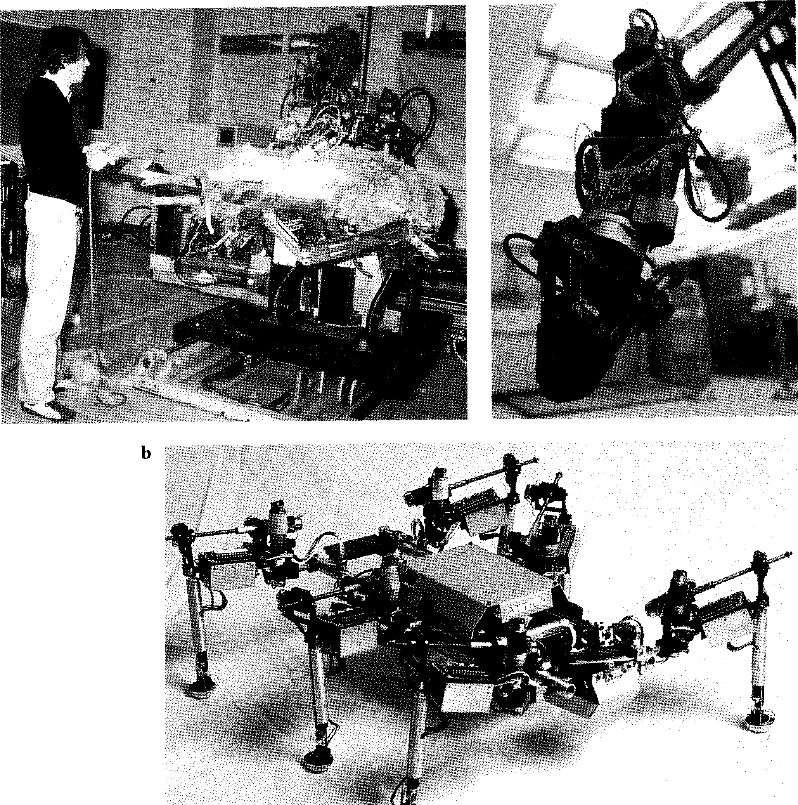
Listening
124
You are going to hear a recorded guide to an exhibition on robotics, which begins with a brief history of robotics. The table below summarizes the history, but the events are in the wrong order. As you listen, match each event with the correct year.
Task 2
Year Event
1 1921 a 'Shakey': mobile robot at Stanford Research Institute
2 1954 b Perambulating vehicle: successful four-legged vehicle at
Tokyo Institute of Technology
3 1967 c Czech playwright, Karel 'Capek, brings his play, RUR
(Rossum's Universal Robots), to London
4 1967-9 d One-legged hopping machine at Carnegie-Mellon University
5 1980 e George Devol develops first programmable robot
6 1983 f Quadruped personnel carrier at General Electric
7 1984 g Odetics Inc. develop a six-legged robot
Listen again and decide whether the following statements are true (T) or false (F) in relation to the information in the recording. If you think a statement is false, change it to make it true.
Task 3
1 I I The history of robotics begins only in the twentieth century.
2 I I In ‘Capek's play, RUR, the robots become the masters and the humans become their servants.
3 I Today's industrial robots developed out of the work done by George Devol.
4 I I Shakey used bump detectors, a sonar range finder, and a video camera to avoid obstacles and move freely.
5 Shakey had a built-in computer which controlled all its movements.
6 The success of GEC's four-legged machine depended on the skill of its
driver.
7 fl The robot developed at the Tokyo Institute of Technology functioned completely automatically, with no human control.
8 Odetics Inc.'s Odex I model did not need to be connected to a separate
power-source.
Reading
Some jobs are suitable for robots, while some must be done by people. Make two lists in the table below.
Task 4
Types of jobs suitable for robots Types of jobs done by humans
Now read this text to see if the author agrees with your ideas.

The robotics revolution

Many of the robots in use today do jobs that are especially difficult for human
workers. These are the types of jobs
5 that require great strength or pose danger. For example, robots are particularly useful in the auto-manufacturing industry where parts of automobiles must be welded
10 together. A welding tool used by a human worker weighs about 100 pounds or more and is difficult to handle. As mechanical supermen, robots may be called upon to do
15 anything from moving heavy components between workstations on a factory floor to carrying bags of cement.
Spray painting is another task
20 suited to robots because robots do not need to breathe. Unlike human painters, they are unaffected by the poisonous fumes. Robots are better at this task, not because they are
25 faster or cheaper than humans, but because they work in a place where humans cannot.
Third in the list of useful jobs for
robots is the assembly of electronic
30 parts. Robots shine at installing chips in printed circuit boards because of a capability that robots have that people don't. A robot, once properly programmed, will not
35 put a chip in the wrong place. This automatic accuracy is particularly valuable in this kind of industry because locating and fixing mistakes is costly.
40 Earlier robots were usually blind
and deaf but newer types of robots are fitted with video cameras and other sensing devices that can detect heat, texture, size, and
45 sound. These robots are used in space projects, nuclear reactor stations, and underwater exploration research.
In their efforts to expand the
50 range of robotic applications, researchers are looking beyond traditional designs to examine a variety of potential models from the biological world. The industrial arm
55 is a classic example. Scientists have
been able to model robots to imitate the vertebrate spine of a snake in order to paint the
interior of automobiles. They
60 have simulated the muscle structure and movement of an elephant's trunk in an attempt to create a robotic arm capable of lifting heavy objects. Scientists
65 have also emulated the flexibility of an octopus where the
tentacles can conform to the fragile objects of any shape and hold them with uniform, gentle
70 pressure. A variation of this
design can be used to handle animals, turn hospital patients in
their beds, or lift a small child.
The challenge of equipping
75 robots with the skills to operate independently, outside of a factory or laboratory, has taxed
the ingenuity and creativity of academic, military, and
so industrial scientists for years.
Simply put, robot hands — like robot legs, or eyes, or reasoning powers — have a long way to go before they can approach what
85 biological evolution has
achieved over the course of hundreds of millions of years. Much more will have to happen in laboratories around the world
so before robots can be compared to nature's handiwork.
In the meantime, the robotics revolution is already beginning to change the kind of work that
95 people do. The boring and
dangerous jobs are now
assumed by robots. By the turn of the century, more and more humans will be required for tasks
loo that machines cannot do. There are some industrialists who hope
that by the year 2000 all their employees will be knowledge workers, no longer standing on
105 assembly lines but rather sitting at desks and computer terminals to deal with information. These changes are already under way, and their pace accelerates every
no year.

Vocabulary
125
welded (1. 9) — (of pieces of metal) joined together by heating shine at (1. 30) — do very well at
octopus (1. 66) — sea-animal with eight arms (tentacles) has taxed (1. 77) — has made heavy demands on

126
moms
Task 5
moms  Task 5 |  |  | Summarize the reasons that certain jobs and environments are suitable for robots by completing the table below.
 |  |  | Job or environment Reason
Welding
Carrying components, etc.
 |  | Spray painting Assembling components
 |  | In nuclear reactors, underwater, etc.

Task 6 These are answers to questions about the text. Write the questions.
1 About 100 pounds.
2 Because locating and fixing mistakes is costly.
3 In space projects, for example.
4 They are examining the potential of certain biological models.
5 No, they cannot be compared yet.
6 They will be doing intellectual rather than manual work.
Task 7 Fill in this table with details of the animals mentioned in the text.
1 2 3
Animal
Aspect being emulated
Reason

Task 8 | Using the line references given, look back in the text and find words in the text which have a similar meaning to:  1 manipulate (lines 10-15)  2 correcting (lines 35-40)  3 expensive (lines 35-40)  4 increase (lines 45-50)  5 copy (lines 55-60)  6 reproduced artificially (lines 60-65)  7 easily damaged (lines 65-70)  8 gets faster (lines 105-110)

Writing

Task 9 Translate the sixth paragraph (beginning 'The challenge of equipping
robots...') into your own language.
Speaking

Look carefully at the table below showing past, present, and future applications of robotic systems, then discuss the following questions:
Task 10
127
1 Do you agree with the predictions made?
2 What are the implications for society if these predictions become reality?
Applications of robotic systems
Domain Pre-1990 1990s Post-2000
Industry
Production (welding, etc) Materials handling
Assembly
Inspection
Office
Mail handler
Clerk Cleaning
Professional
Home
Tutor
Housekeeper Companion
Military
Automatic pilot Scout
Soldier
Ocean
Explorer Constructor
Space
Stationary observer (on Mars) Rover (on Mars)
Laborer (space station & moon)
= Laboratory prototypes
= First commercial applications
= Widespread commercial applications

Reading

Task 11 Read this short text, then match each robot type with the appropriate
definition.
Classification of types of robot
One way of classifying robots is in terms of their similarity to humans. An automaton is any machine capable of operating independently, such as a clothes dryer. A flexible machine is a special case of an automaton with different capabilities, that can be programmed as the need arises. An
5 example is a welding robot on the factory floor that can be programmed to participate in other production operations. A mobile robot is a flexible machine capable of moving freely in its own environment. It can partly select its own goals and communicates with other agents, including humans. An android or humanoid is a mobile robot whose structure
10 approximately resembles a human structure. Finally, a cyborg is a humanoid with organic structures. Cyborgs have some physiological structures similar to those of humans.
Machine capable of independent operation following a predetermined series of behaviours, e.g. a cuckoo clock

Mobile robot a
Cyborg b
Automaton c
Flexible machine d
Android/ e
Humanoid


Flexible machine capable of moving and communicating with humans, e.g. a sentry robot
Humanoid having both organic and inorganic structures, with some physiological similarity to humans
Mobile robot of human proportions
Versatile, programmable automaton, e.g. an assembly robot
Now renumber the robot types, 1-5 (1 = the most similar to humans; 5 = the simplest).

Reading
128
Using the diagram to help you, fill in the gaps in the text with the words given.
Task 12
Co-ordination of control in robots
The diagram shows a' system for the force required to
2
an object. The desired level of force is fed into the control module, which' it with the actual amount of force as indicated by the
feedback signal. The discrepancy enters the command generator, which

determines the ⁴ and extent of adjustment necessary. The
129
resulting command passes into an amplifier which produces power
⁵ to the level of the input signal. The power drives a motor
to some linkage such as a set of gears.The mechanical linkage in the robotic hand ultimately' the initial command signal into
displacement at the fingertips.
proportional grasp attached closed-loop
compares direction converts
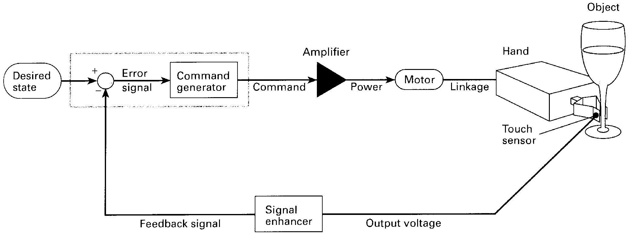
Speaking
Task 13 | In pairs, design a simple robotic wrist and hand. Your device should have the three degrees of rotational freedom illustrated below and should be capable of grasping objects. Describe your invention to another pair.

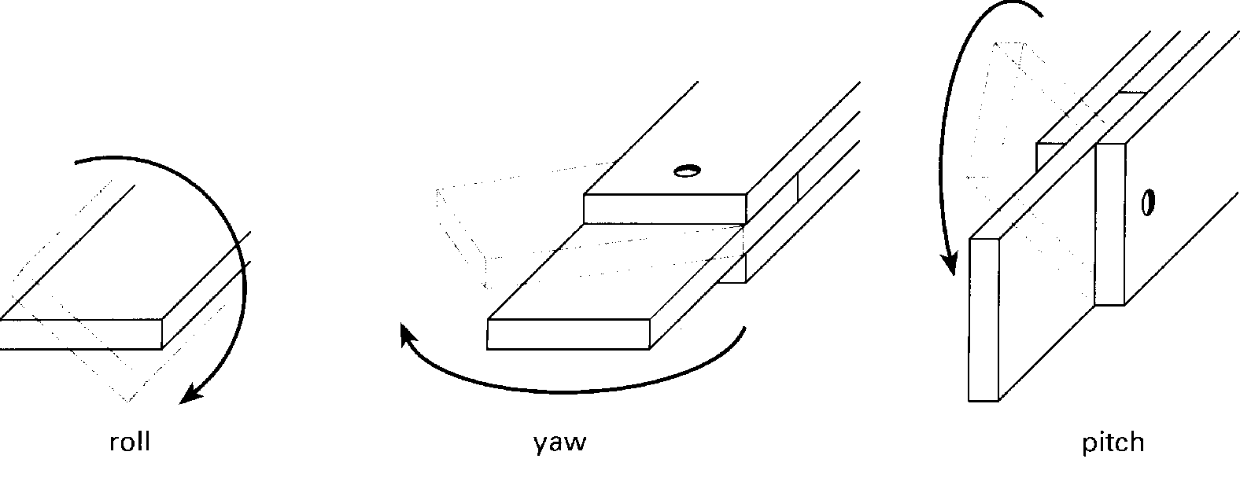
Task 14 | Writing  Label the parts of your robotic wrist with letters or numbers, then write a paragraph explaining how it works.

Word-play
130
Look at the lists and circle the word that is different from the others. Then explain why. The first one has been done for you.
Task 15

1 | mouse keyboard  A printer is an output device. |  | printer | OCR scanner
2 | palmtop | notebook | clipboard | briefcase | laptop
3 | accumulator | register | address | bus | monitor
4 | drive | floppy | hard | compact
5 | FORTRAN | COBOL | PASCAL | ASSEMBLER
6 | ring | loop | bus switched | star
7 | cyborg | automaton | sentry | android
8 | virtual | internal | external | conceptual

Language focus K
131
Compound nouns
The language of computing in English contains an ever-increasing number of compound nouns, that is, a group of two or more nouns which act as a single noun.
Examples:  memory capacity information systems | an address bus an arithmetic unit  a bar code scanner

It is important to be able to recognize how such compounds are formed in order to understand what they mean.
The exact relationship between the words depends on the particular expression, but all these expressions have one thing in common: the last word in the chain says what the thing is, while the preceding word or group of words describes the thing. So when we read compound nouns, we have to start with the last word and work backwards.
Examples:
An address bus is a bus dedicated to address information.
The memory capacity of a computer is the capacity of its memory.
A large number of possible meanings can be expressed by compound nouns. For instance, the first noun or group of nouns can tell us what the second noun is made of, what it is for, or what it is part of.
1 Material: the first noun tells us what the second consists of.
Examples:
a silicon chip (a chip made of silicon) a ferrite ring (a ring made of ferrite)
2 Function: the first noun tells us what the second noun is for.
Examples:
an address bus (a bus dedicated to address information) an input device (a device for inputting)
an arithmetic unit (a unit which performs arithmetic functions)
3 Part: the second noun refers to a part of the first noun.
Examples:
a computer keyboard (the keyboard of a computer) a monitor screen (the screen of a monitor)
a program feature (a feature of a program)
4 Activity or person: the second noun refers to an activity or person related to the first noun.
Examples:
computer programming (the programming of computers)
a computer programmer (a person who programs computers)
systems analysis (the analysis of organizational systems)
a systems analyst (a person who analyses organizational systems)
5 Multiple nouns: sometimes a compound noun will join together with one or more other nouns to give an expression that has three or four words. In such cases, it is important to examine the expression very carefully to break it into its constituent parts. The secret, as always, is to read the expression from the back towards the front.
Example:
4 3 2 1
a document-image-processing program (a program which processes images of documents)
Note: some expressions are written separately, while others are joined by hyphens. There are no clear rules for this. Sometimes you will see the same expression written in different ways in different texts.
Example:
document-image-processing program document image-processing program document image processing program
However, it is important to be consistent within a single text.

A device that scans bar codes is called a bar code scanner.
Exercise 1
132
What name is given to :
1 a unit that gives a visual display of information on a screen?
2 a device that reads magnetic cards?
3 a device that plots graphs?
4 a device that prints using a laser as the light source?
5 a unit that holds magnetic disks?
6 a device that prints using a jet of ink?
7 the rate of transmission of data?
8 a package for making presentations using multimedia?
9 a program which processes data in batches?
10 the process for the conversion of disks for computers?
Using the explanations in Exercise 1 as models, write short simple explanations
Exercise 2
of the following items:
1 an input device
2 an optical character reader
3 a graphics stylus
4 a document sorter

5 a fibre optics transmission system
133
6 a sequence control register
7 a liquid crystal display
8 network configuration information
9 a desktop document manager
10 a multimedia editing software package
12
Virtual reality
Task 2
134
Read the text opposite. Note down any applications that are not in your list.
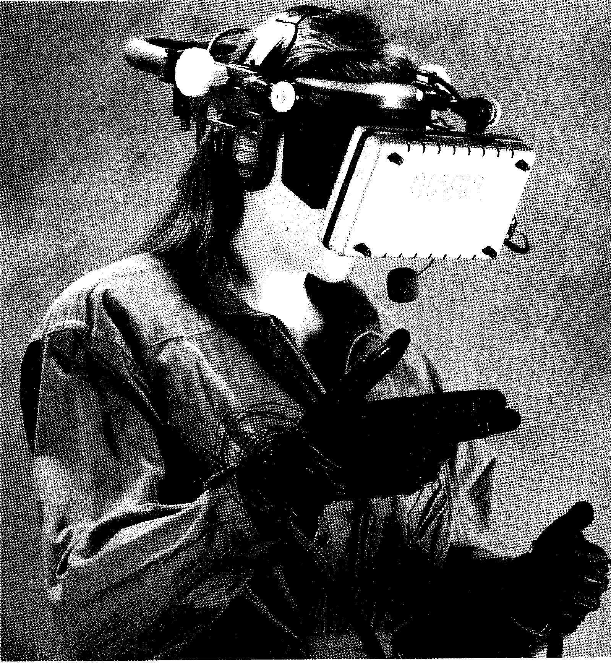
Start-up
Virtual reality is still seen as a toy by most people. Can you think of any
potential applications of VR other than in computer games? Make a list.
Task 1

Reading
Fancy a fantasy
spaceflight?

Computers are about to take people to places they have never been able to visit before, 45
Make a wish and you can go anywhere. That ⁸⁵ is the reality for a new computer invention, Chris Partridge says,
ing them out of the office.
The problem with guiding a robot by looking at a picture from a video camera mounted on it and twiddling the controls is that it is not a natural system, Mr Stone says. The operator spends all his time controlling the robot and none solving the problem. The time lag between seeing the image and sending a
corrective control signal is
another difficulty.
A virtual reality system consists of a helmet with a colour display in front of each eye, and wide-angle lenses to cover the entire field of view and give a stereoscopic effect. The helmet
contains sensors, rather like ¹ electronic compasses, to record
where it is pointing. A computer calculates what the wearer should be seeing in that direc-
tion and displays it on the 115 screen.
In more advanced systems, the
70 operator wears an electronic glove that detects exactly what
the fingers are doing and trans- 120 mits the information to the computer. If the user tries to pick up
75 something, the computer will make the object follow the hand to give the illusion of carrying it. ¹²⁵
Pads in the latest type of gloves
press into the insides of the fin-
80 gers and palm when an object is encountered, to create the illusion of feeling it. Complete `exoskeletons' covering the user and allowing the computer to
including the surface of other
5 planets. Such a trip will be an illusion. but one that comes closer to real life than anything on
stage or screen. Artificial worlds 50 are being built up in a computer
10 memory so that people can walk through at will, look around, and even touch objects.
The system is called virtual 55 reality, so called from the math-
15 concept of an image that has the virtues of a real object without the substance.
Virtual reality systems are 60 being developed throughout the
20 world for a range of uses includ ing enabling people to walk `inside' nuclear power stations,
while controlling a robot that ac- 65 tually goes into an area in which
25 no human could live, and conducting architects through a computer-generated building before it is constructed.
British scientists have a world
30 lead in virtual reality, despite the fortunes being poured into research by Japanese and American companies, which see it as a technology for the next century.
35 In Britain, Robert Stone, of the National Advanced Robotics Research Centre at Manchester University, is developing systems that could put men on Mars
40 without shooting them into space and could plunge divers under the North Sea without tak-
simulate almost anything possible in real life are still in the laboratory.
A fire-fighter in a nuclear pow-
er plant, for example, would
90 move through a computer model wearing an exoskeleton, while a robot would move through the real thing. The computer program will be derived from the
95 data used to design the plant in the first place.
Mr Stone has developed a data glove with air pockets that are inflated to give a sensation of
100 touch in collaboration with Air-muscle, the supplier of the pneumatic systems that made the Spitting Image puppets really spit.
105 The biggest initial market is
likely to he for a new generation
of video games. W Industries, of
Leicester, recently launched a
virtual reality system for video 0 arcades. The system, called Virtuality, consists of a cockpit in which a player sits, wearing the helmet, at a set of controls that can rn lithe a bobsleigh, a spaceship, or whatever the imagination of the games programmer can devise.
The helmet has a pair of liquid-crystal displays with wide-angle lenses giving a stereoscopic image, and a set of magnetic sensors to tell the computer what the helmet is looking at as it moves.
The first game is a fighter
simulation. Another is based on
a sequence in the film, Return of
the Jedi, in which flying motor-
cycles race through a forest. The
130 computer can link and control
several helmets at once for a
group game.

Ivo- Vocabulary
135
time lag (1. 52) — time delay
Spitting Image (1. 103) — satirical British TV programme, using computer-controlled animated puppets
bobsleigh (1. 114) — large vehicle, moving on strips of wood, for travelling fast over ice and snow

Task 3 Answer the following questions about the text:
1 Where does the term 'virtual reality' come from?
2 Which country leads the field in VR research?
3 Why are robots controlled via mounted video cameras less effective than the VR solution?
4 How does Robert Stone's system allow the user to 'feel' objects?
5 What application of VR is expected to be the commonest to start with.

Using the line reference given, look back in the text and find the reference for the words in italics.
Task 4
1 one that comes closer to real life (line 6)
2 which see it as a technology for the next century (line 33)
3 without taking them out of the office (line 43)
4 it is not a natural system (line 48)
5 to record where it is pointing (line 64)
6 and displays it on the screen (line 67)
7 to give the illusion of carrying it (line 77)
8 while a robot would move through the real thing (line 92)
Using the line references given, look back in the text and find words or phrases
Task 5

meaning:
136
1 whenever and however they like (lines 10-15)
2 qualities (lines 15-20)
3 large amounts of money (lines 30-35)
4 immerse (lines 40-45)
5 twisting (lines 45-50)
6 small pockets filled with air (lines 75-80)
7 filled with air (lines 95-100)
8 released on to the market (lines 105-110)
9 imitate (lines 110-115)
10 war plane (lines 125-130)
Task 6 | Choose the appropriate form of the word to fit the meaning of the sentence. Make sure you understand the different forms of the word and their meanings. Use your dictionary to find this information.  1 correct, correctly, correction, corrective, correctness  a If an error occurs, it is important to take action immediately.  b The 'spell check' facility checks the of your spelling  c The data was entered , so the result must be accurate.  2 detect, detection, detectable, detective  a There were traces of radiation in the water sample.  b The analyst could not any errors in the system.  c She tried to escape by disguising herself.  3 sense, sensor, sensation, sensitive  a An infra-red detects the presence of intruders in the building.  b The probe is to heat and light.  c The new system caused a when it was launched last month.

 | Writing
Task 7 | These two paragraphs from the article contain similar information. Write one paragraph combining the information from them to give a short but complete description of the VR visual system.

A virtual reality system consists of a helmet with a colour display in front of each eye, and wide-angle lenses to cover the entire field of view and give a stereoscopic effect. The helmet contains sensors, rather like electronic compasses, to record where it is pointing. A computer calculates what the wearer should be seeing in that direction and displays it on the screen.
The helmet has a pair of liquid-crystal displays with wide-angle lenses giving a stereoscopic image, and a set of magnetic sensors to tell the computer what the helmet is looking at as it moves.
Speaking
Task 8 We asked a number of people to answer the following question:
Do you think the use of virtual reality in computer war games is going to affect young people's attitude to violence?
Here are some responses. Read them and decide which point of view (if any) most closely matches yours. Discuss your opinions.

Rita Harper

137
`Yes, I do. I think anything which portrays violence as fun is going to alter young people's perception of violence in a very dangerous way. Violent crime amongst young people is increasing. I think manufacturers of computer war games must take some of the responsibility.'
Susan Clark
`No, not really. Kids — particularly boys — have been playing with toy guns ever since guns were invented. Surely playing with toy guns in the real world is more dangerous than playing with imaginary guns in an imaginary world.'
Mark Watts
`It's difficult to say. Some of my friends get very aggressive when they play computer war games. But I don't really know if it makes them more violent when they're doing other things. I play a VR jet fighter game, and I don't think it has made me more violent.'

Writing
138
Task 9 Write a paragraph giving your answer to the question asked in Task 8.
Listening
Task 10 Listen to this interview with Michael Emsley, one of the exhibitors at an
exhibition of virtual reality at Olympia in London. As you listen, answer these questions about the interview.
1 Why do people expect far more from VR than it can give them?
2 How does Michael Emsley think VR should be seen?
3 Give two examples of the potential applications mentioned.
4 What problems will VR developers have if the technology does not produce results, according to Emsley?
5 How does the best VR system compare with human vision?
6 Why are there three electromagnetic coils in the headset?
7 How long does it take the computer to calculate each new position of the headset and update the display?
8 In order to make a 'reasonable' visual system, how powerful would the computer have to be?
Task 11 Read this extract from the tapescript and try to fill in the gaps. The first letter of
each missing word is given.
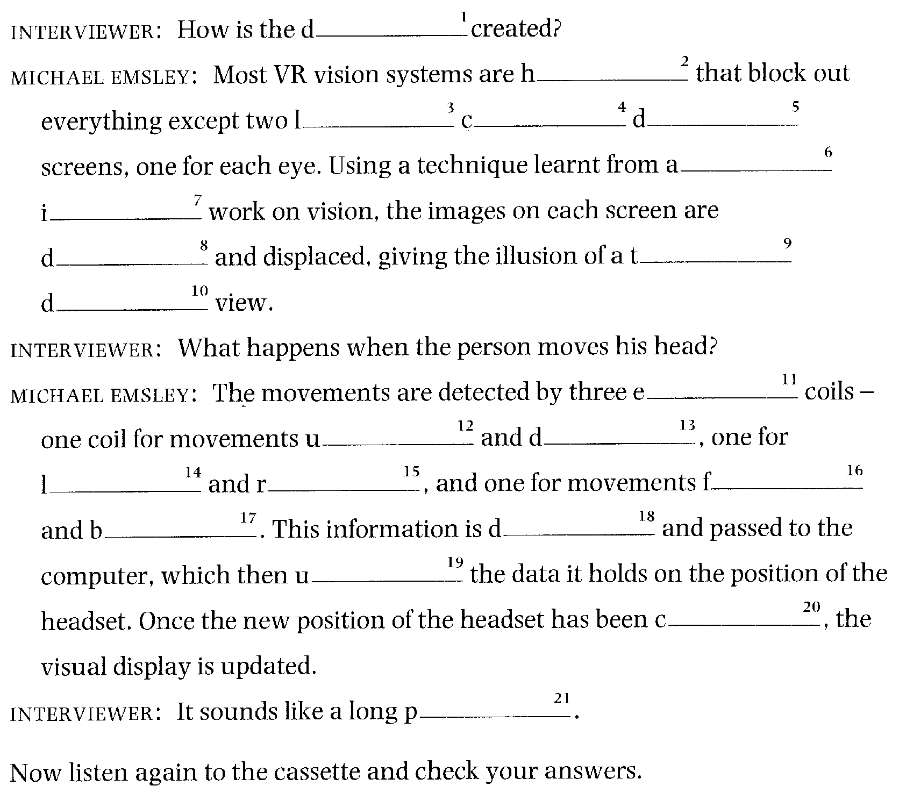
VR input devices
139
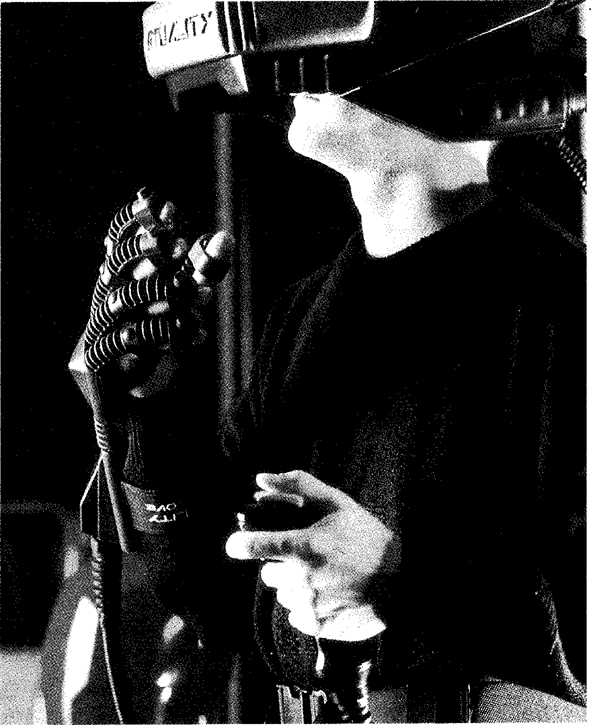
Reading
Read quickly through the text below. Does the text contradict in any way what you already know about VR systems? If so, what is the contradiction and how can it be explained?
Problems with hand-based input/output
The current hand input devices suffer from the same delays that plague the head mount display systems, but the user's over-compensation is even more noticeable. Because there is typically some interaction with the hand and other objects, absolute position control is much more important here
5 than it would be with head positioning, where relative motion is usually sufficient.
These devices are also extremely limited in their ability to generate any kind of tactile force or feedback to the user. Based on our research, even to
perform gross manipulation tasks with a DataGlove is extremely difficult
to without some kind of sensory feedback. Any kind of fine manipulation is impossible. Though tactile feedback of some kind may be possible, the quality of this will very likely be extremely low and the cost extremely high for the foreseeable future. •
Perhaps the major failing of the glove-based system is that it requires the
15 user to keep the hand and arm unsupported. This requires the user to employ both the agonist and antagonist muscle sets of the arm working against each other in order to perform any kind of complex task. The user actually is working harder at this than he would at pushing a real object because, in the case of a real object, at least one muscle group is at rest.
20 Further, because there is no true stable surface for the arm to rest against, any kind of control requires even more force between the muscle groups.. Our experience demonstrated that a user of such a system when faced
with any kind of gross manipulation tasks, could only be expected to use the system for five-minute periods with a large degree of exertion. Any
25 kind of extended activity was precluded.
As a consequence of these drawbacks, it is our expectation that the DataGlove and other similar interface devices will be replaced by more useful devices in the future. ■
OP- Vocabulary
agonist and antagonist muscle sets (1. 16) — two muscle groups which normally act in opposition to each other

Task 13
1
2
3
Read the text again and complete the table in note form.
Problem of hand input device Consequences

Task 14 The following pairs of words are taken from the text. In each case, say whether
140
their meanings are similar (S) or opposite (0).
111 suffer from (1. 1) plague (1. 1) absolute (1. 4) true (1. 20) tactile (1. 8) sensory (1. 10) force (1. 8) exertion (1. 24) gross (1. 9) fine (1. 10)
2
3
4
5
6
7
8
impossible (1. 11) precluded (1. 25) ❑ failing (1. 14) drawback (1. 26) working (1. 18) at rest (1. 19)

Word-play
141
Solve the crossword puzzle using the clues below.
Task 15
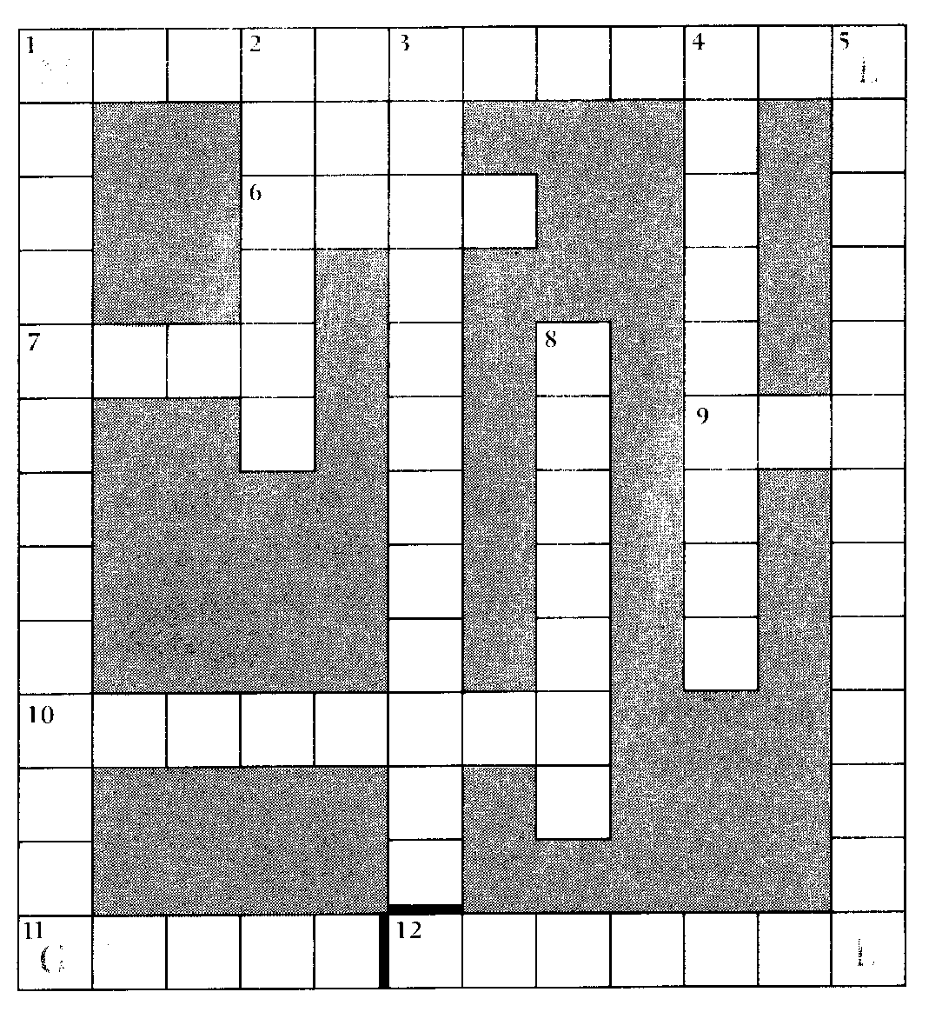
Across
1 The adjectival form of maths. (12)
6 A piece of glass with a curved surface used to make things appear clearer, larger, or smaller. (4)
7 The opposite of gross. (4)
9 Short for 5 down. (3)
10 The study of robots. (8)
11 This is worn on the hand. (5)
12 This sort of reality is not real. (7)
Down
1 Making (goods) on a large scale using machinery. (13)
2 VR device worn on the head. (6)
3 Present VR hand input devices are capable only of gross tasks. (12)
4 To work out or estimate. (9)
5 A kind of display. (6,7)
8 A device for finding direction, with a needle that points to magnetic north. (7)
Language focus L
142
Classifying
The term 'classifying' means arranging objects in classes or groups according to shared characteristics. For example, the Class of 'animals' includes all living things that can feel and move about, such as fish and birds. Each of these subgroups is also a class in its own right, having shared characteristics.
Classifying, then, is a process of bringing order out of confusion by organizing information in a logical fashion. There are often several ways of classifying the same information.
1 From general to specific: focusing on the large or high-level category and talking about its parts, that is from general to specific, the following expressions can be used:
is is made up of
can be divided into is composed of
is of comprises
has consists of
A general-to-specific classification will usually have singular main verbs, unless two or more things are being analysed simultaneously.
Examples:
1 The CPU is divided into three parts: the control unit, the arithmetic-logic unit, and memory.
2 The CPU has three parts: the control unit, the arithmetic-logic unit, and memory.
3 The CPU is made up of three parts: the control unit, the arithmetic-logic unit, and memory.
4 The CPU is composed of three parts: the control unit, the arithmetic-logic unit, and memory.
5 The CPU consists of three parts: the control unit, the arithmetic-logic unit, and memory.
2 From specific to general: what the smaller (or lower-level) components make when they are put together. This kind of classification uses the following expressions:
make up may be
form can be
constitute are classified as
A specific-to-general classification will have plural verbs, because two or more lower-level categories are the focus of classification.
Examples:
1 The control unit, the arithmetic-logic unit, and memory are the three parts that make up the CPU.
2 The control unit, the arithmetic-logic unit, and memory are the three parts that form the CPU.
Exercise 1 Using the diagram below, complete the paragraph on the following page.
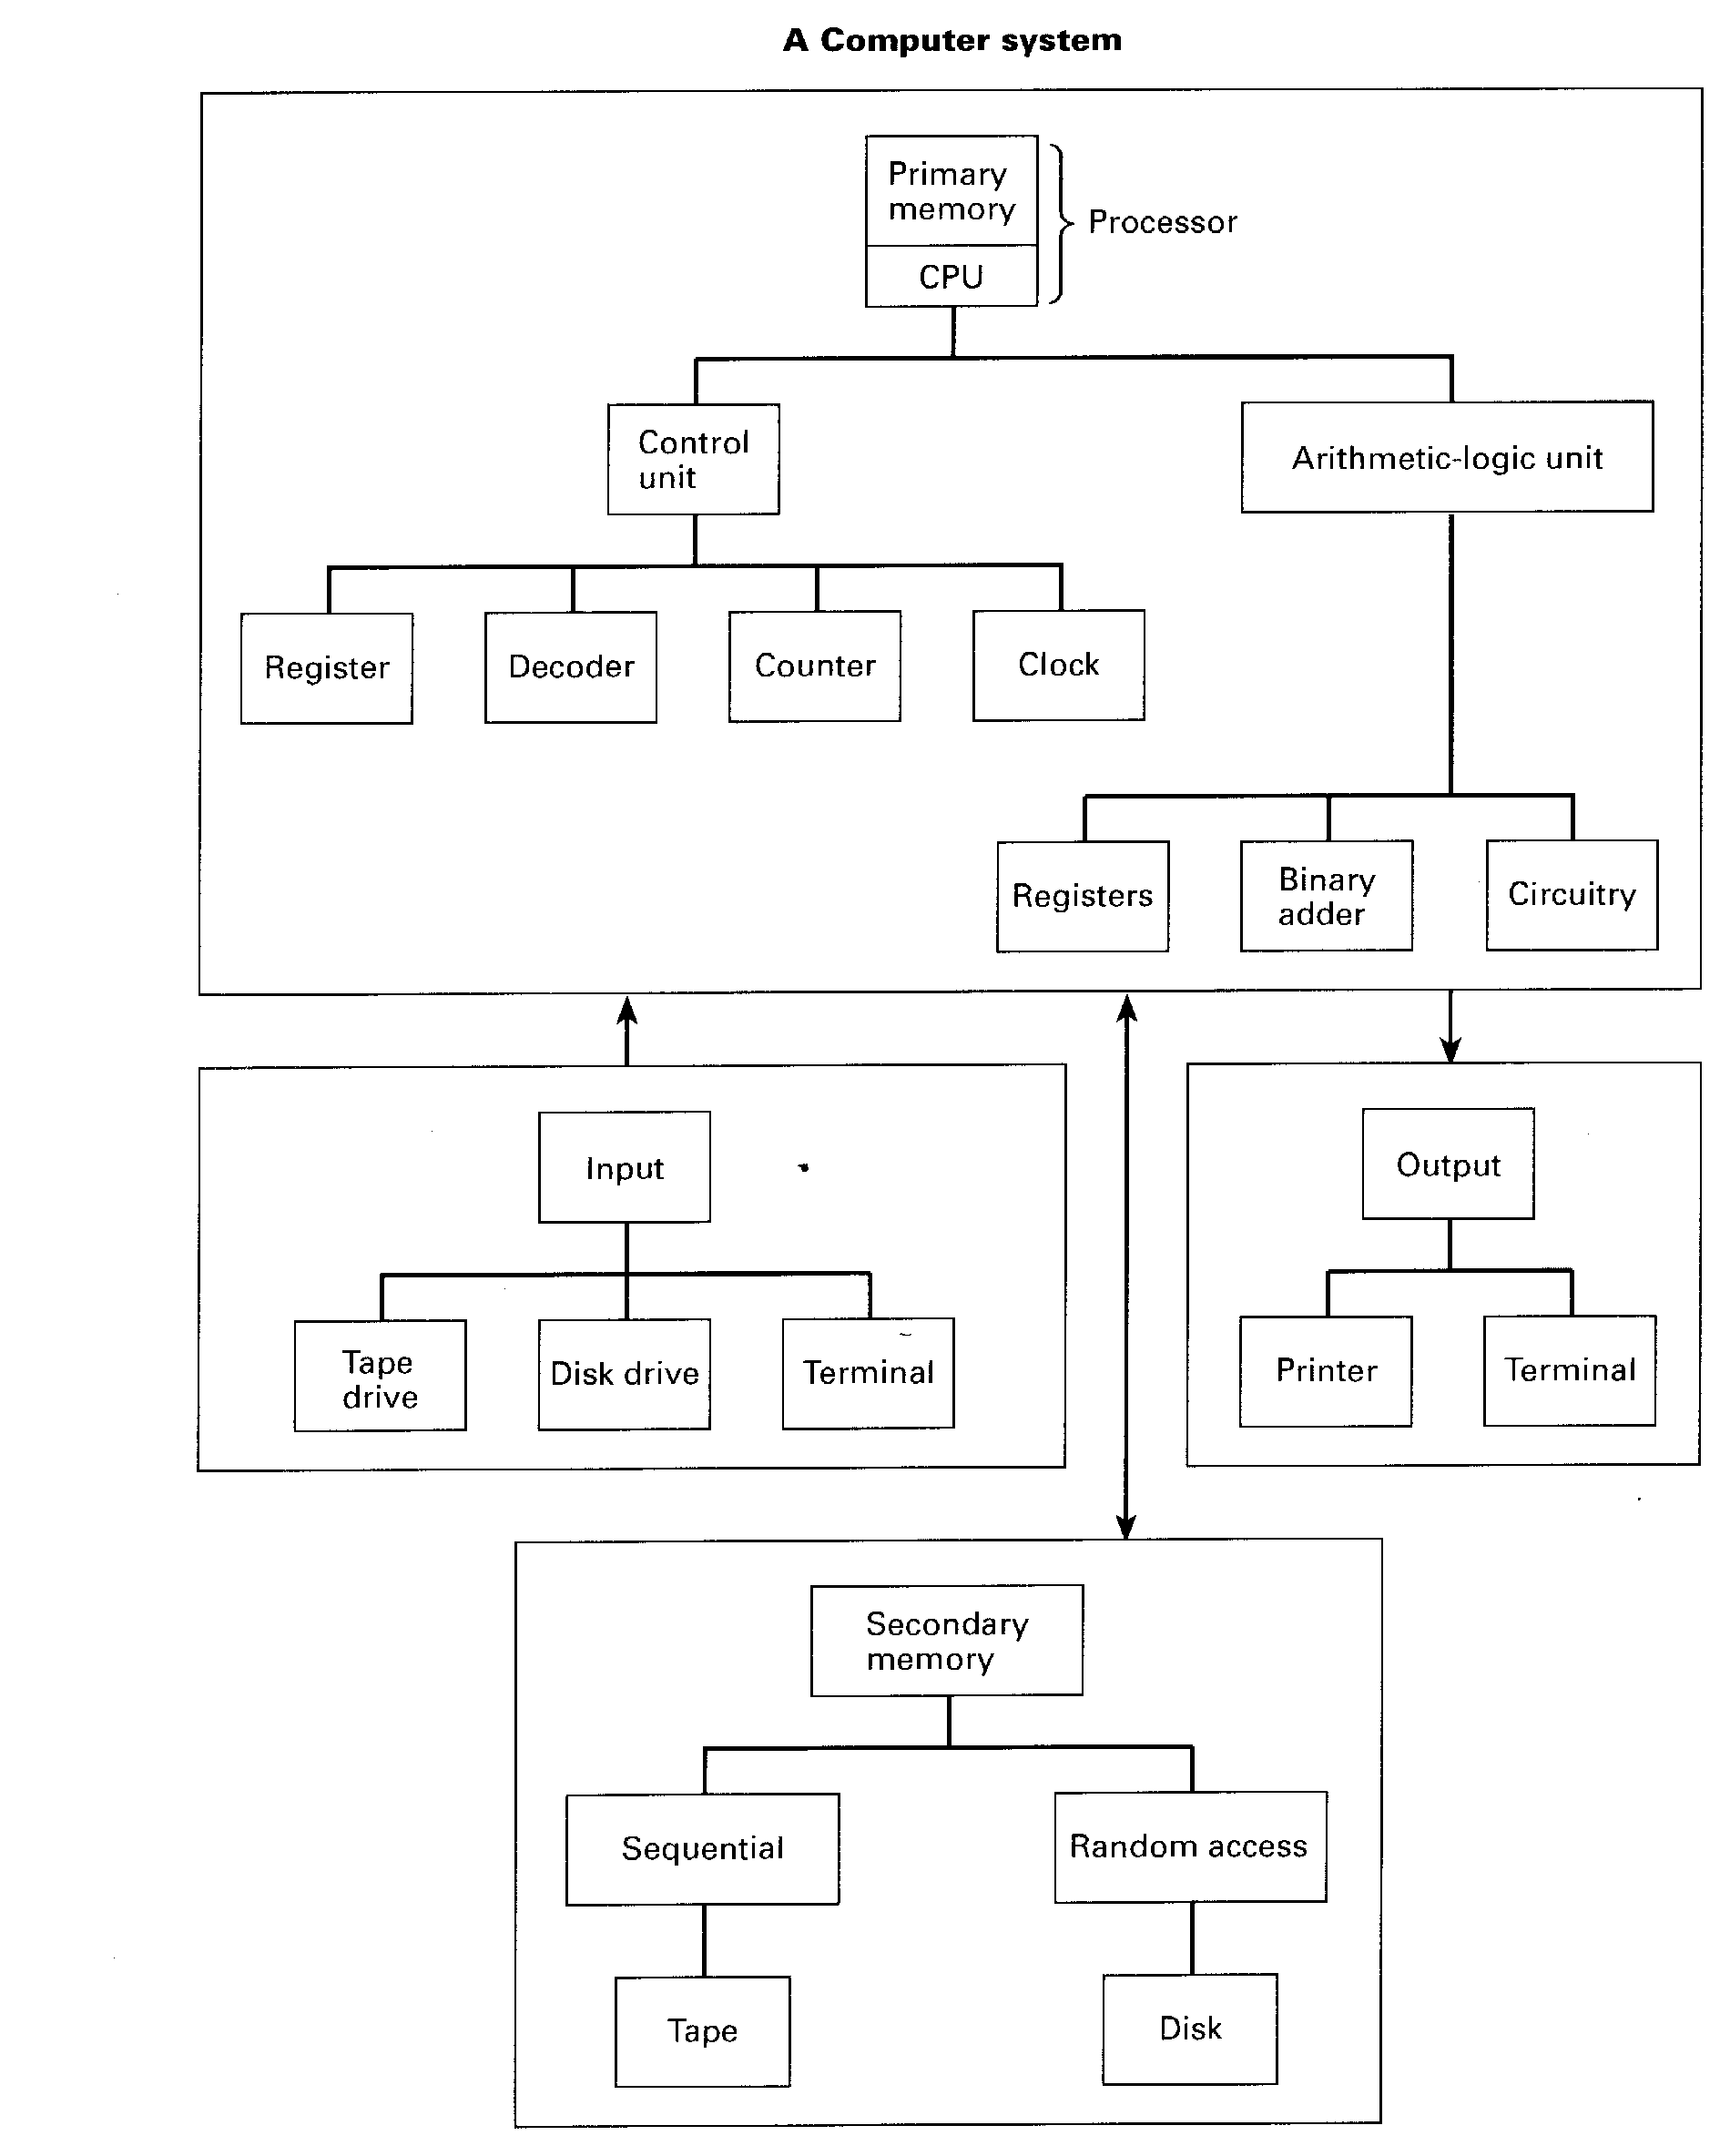
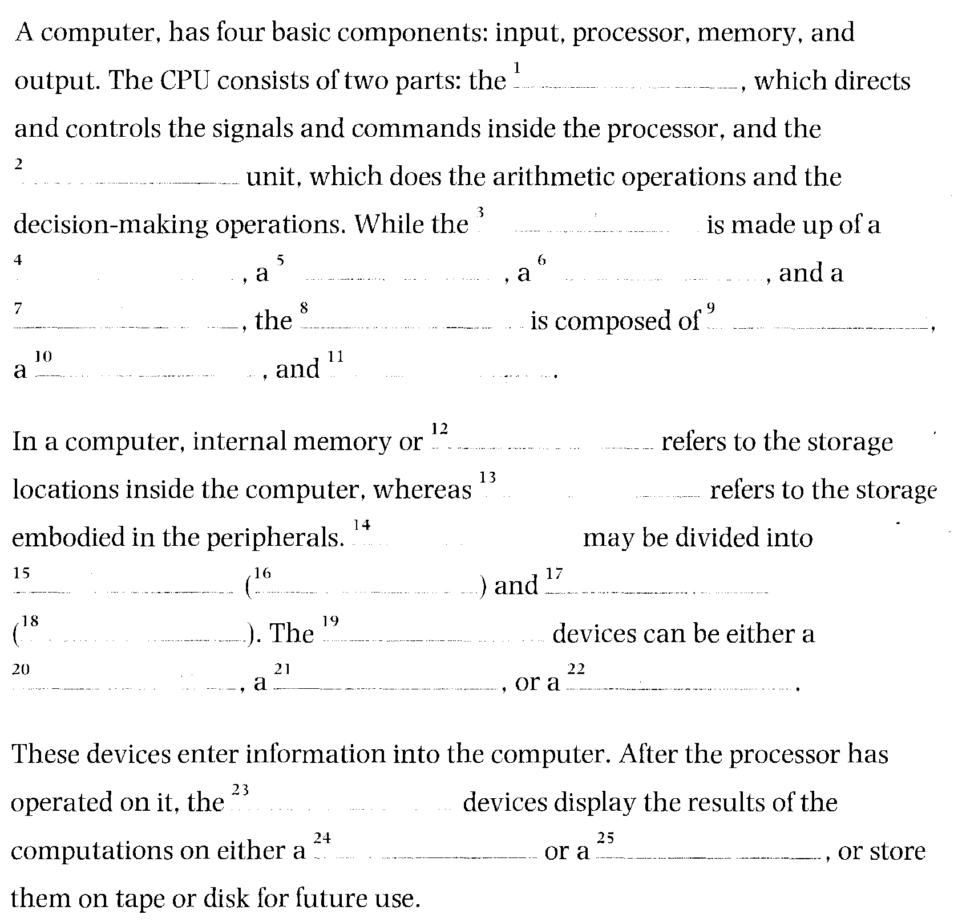

Refer back to the text on C language (Unit 4, page 46) and complete the diagram.
Exercise 2
144
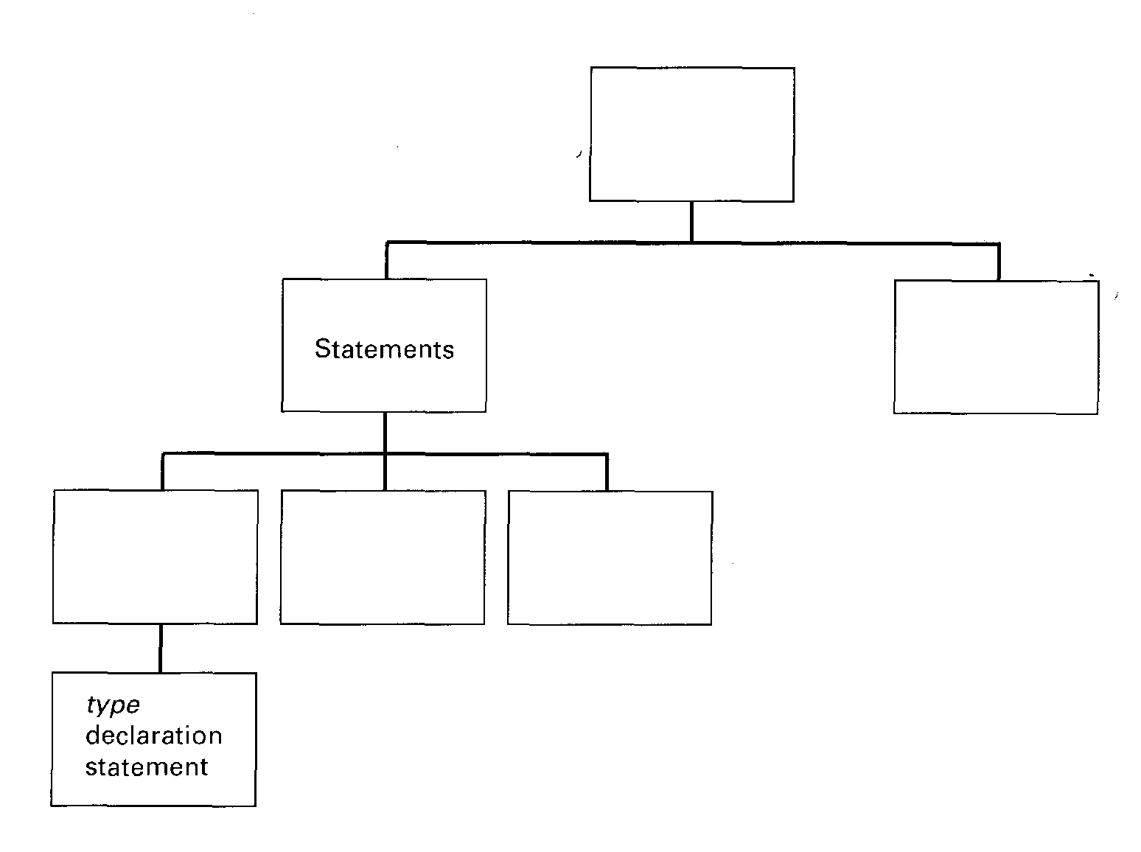

13
Machine translation
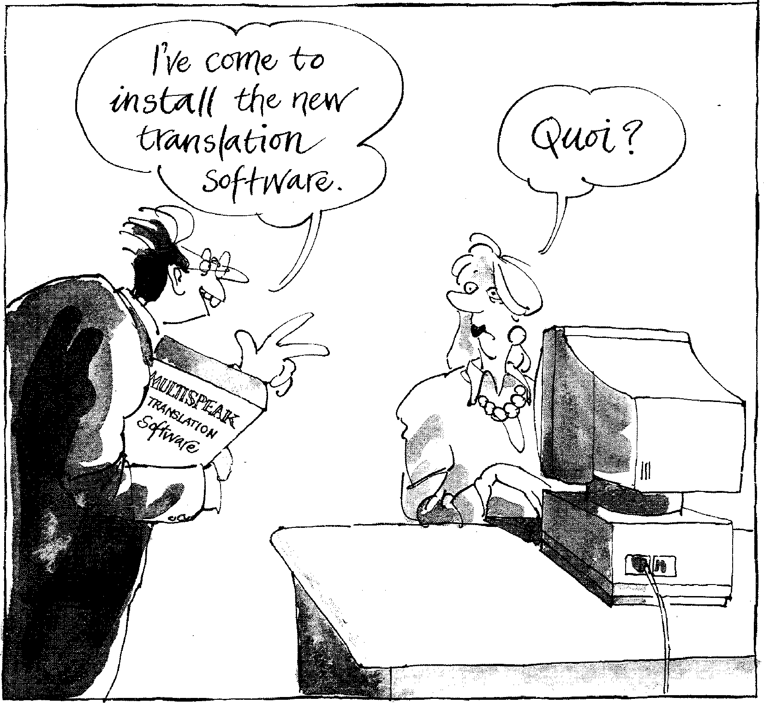
Start-up
Decide whether the following sentences are true (T) or false (F):
Task 1

1 Some machine translation (MT) systems produce good translations.
145
2 It is difficult to compare different MT systems.
3 The easiest way to evaluate any machine translation of a given text is to
compare it to a human translation of the same text.
Reading
Task 2 Read the text on the following page and check your answers to Task 1.

Lost in the machine translation

para
You can go out right now and buy a machine translation system for anything between £100 and £100,000. But how do you know if it's going to be any good? The big problem with MT systems is that they don't actually translate: they merely help translators to translate. Yes, if you get something like Metal (very expensive) or GTS (quite cheap) to work on your latest
brochure, they will churn out something in French or whatever, but it will be pretty laughable stuff.

All machine-translated texts have to be extensively post-edited (and often pre-edited) by experienced translators. To offer a useful saving, the machine must make the time the translator spends significantly less than he or she would have taken by hand.
2
Inevitably, the MT manufacturers' 3
glossies talk blithely of 'a 100 per cent increase in throughput', but scepticism remains. Potential users want to make their own evaluation, and that can tie up key members of the corporate language centre for months.
A few weeks ago, translators,
system developers, academics, and others from Europe, the US,
Canada, China, and Japan met for the first time in a Swiss hotel to mull over MT matters. A surprisingly large number of European governmental and corporate organizations are conducting expensive and elaborate
evaluations of MT, but they may not produce 'buy or don't buy' results.
Good human translators produce 8
good translations; all MT systems
para
It isn't just users who have trouble 6
with evaluation. Elliott Macklovitch,
of Canada, described an evaluation of a large commercial MT system, in which he analysed,the error performance of a series of software updates only to find — as the
system's suspicious development manager had feared — that not only had there been no significant improvement, but the latest release was worse.
And bugs are still common. Using a 7 'test suite' of sentences designed to see linguistic weaknesses,
researches in Stuttgart found that although one large system could cope happily with various complex - verb-translation problems in a relative clause, it fell apart when trying to do exactly the same thing in a main clause. Developers are looking for bigger, better test suites to help to keep such bugs under control.
produce bad translations. But just
what is a good translation? One
4 traditional assessment technique involves a bunch of people scoring translations on various scales for
intelligibility ('Does this translation into English make sense as a piece of English?'); accuracy ('Does this piece of English give the same information as the French
original?'); style, and so on.
However, such assessment is expensive, and designing the scales is something of a black art.

Take error analysis, a fancy name 5
for counting the various types of errors the MT system produces. You might spend five months working out a suitable scoring scheme — is correct gender agreement more important than correct number? —and totting up figures for a suitably large sample of text, but what do those figures mean? If one system produces vastly more errors than another, it is obviously inferior. But suppose they produce different types of error in the same overall numbers: which type of error is worse? Some errors are bound to cost translators more effort to correct, but it requires a lot more work to find out which.
Properly designed and integrated 9
146
MT systems really ought to enhance the translator's life, but few take this on trust. Of course, they do things differently in Japan. While
Europeans are dabbling their toes and most Americans deal only in English, the Japanese have gone in at the deep end. The Tokyo area already sports two or three independent MT training schools where, as the eminent Professor Nagao casually noted in his presentation, activities are
functioning with the efficiency of the Toyota production line. We're lucky they're only doing it
in Japanese.

Each of the sentences below (except one) summarizes an individual paragraph of the text. Order the sentences so that they form a summary of the text. One of the sentences contains information which is not in the text. Which one?
Task 3
The developers of MT systems have also had problems evaluating their systems.

Many European organizations are evaluating MT, but the results may not be conclusive.
Assessing machine translations as good or bad is very difficult because such judgements cannot be made scientifically.
It is time-consuming for potential users to test the MT manufacturers' claims that their products double productivity.
Better tests are needed to monitor linguistic weaknesses in MT systems.
All machine translations need to be edited by a human translator. A reliable MT system is unlikely to be available this century.
The price of MT systems varies greatly and none actually translates.
The Japanese have a few independent MT training schools, which are said to be very efficient.
Analysing the errors made by MT systems is inconclusive because it may only show that different systems produce similar numbers of different error types.

Match each of the following verbs from the text with the expression that has a similar meaning:
Task 4
1 churn out (para. 1) a add up
2 tie up (para. 3) b think carefully about
3 mull over (para. 4) c manage successfully
4 tot up (para. 5) d produce large amounts of
5 cope with (para. 7) e fail
6 fall apart (para. 7) f occupy the time of

147
Task 5 | Using the paragraph reference given, find words or phrases in the text which have a similar meaning to:  1 ridiculous (para. 1)  2 colour brochures (para. 3)  3 casually (para. 3)  4 sure to (para. 5)  5 group (para. 8)  6 mysterious ability (para. 8)  7 experimenting in a small way (para. 9)  8 invested heavily (para. 9)

Speaking

Task 6 | Look at these sentences. Discuss why a machine might find them difficult to translate.  I bought a set of six chairs. The sun set at 9 p.m.  He set a book on the table. We set of ffor London in the morning.  She had her hair set for the party. The VCR is on the television set.  Can you think of other examples where this kind of problem occurs?

Al and expert systems
148
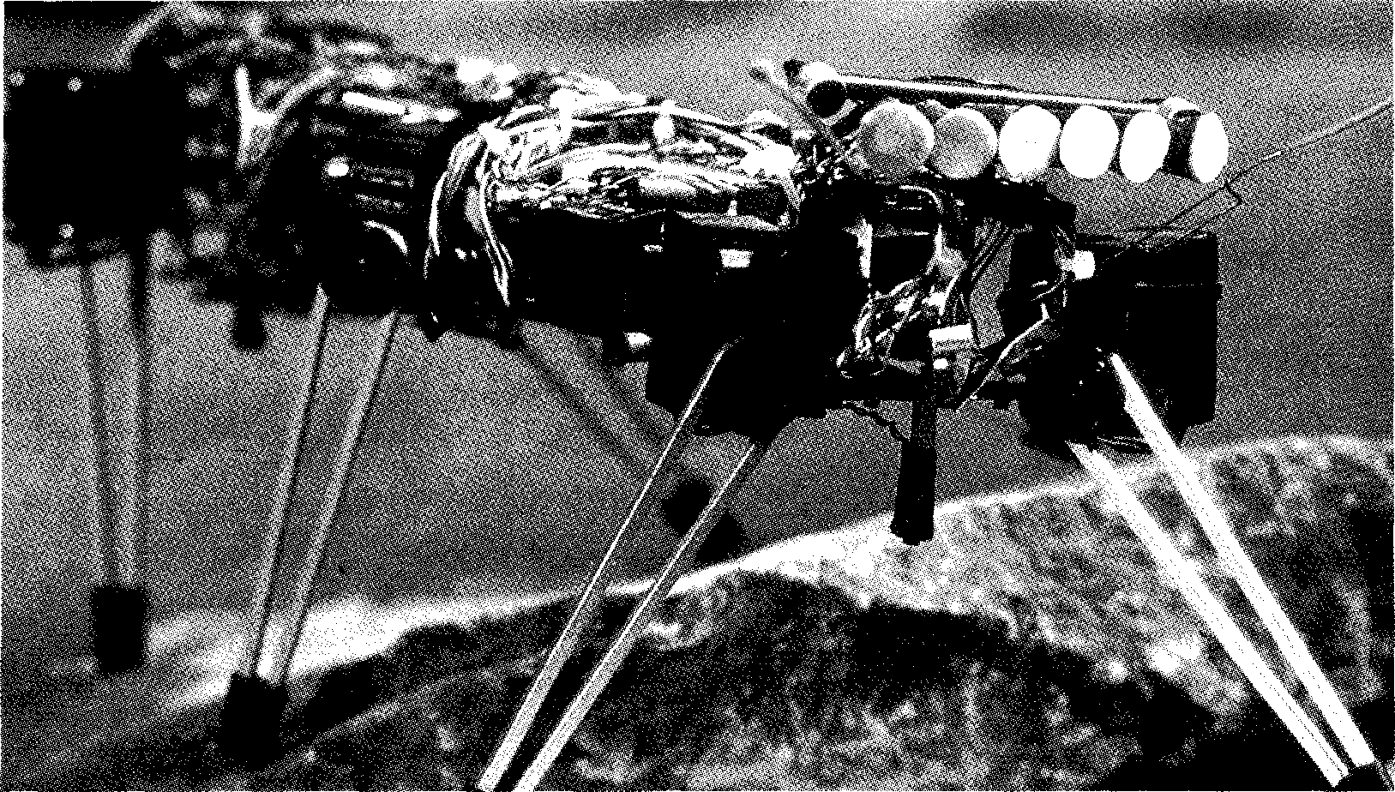
Listening
Task 7 [2] You are going to hear a conversation in which David, a graduate student doing
research in the field of artificial intelligence, explains to a friend, Kevin, what AI and expert systems are. Before you listen, try to write short definitions to explain:
1 artificial intelligence
2 expert systems
Now listen to the conversation and modify your definitions as necessary.
Task 8 n Listen again to the recording and answer these questions:
1 Does visual perception require intelligence when done by humans?
2 What two categories of task are mentioned in relation to AI programs?
3 Which category of task is AI more successful at?
4 What is the relationship between AI and expert systems?
5 What examples of existing expert systems are mentioned?
6 In what way do expert systems imitate human experts?
7 Why does the Japanese system have two parallel inference engines?
8 What is the function of inference trees?
Task 9 ij Read this adapted extract from the tapescript and fill in the gaps with the
missing words.
KEVIN: What are e 1 2 s used for?
DAVID: They're built for commercial a ³. Up to now they've been
used for a variety of tasks — medical d ^{4,} electronic fault finding,
machine translation, and so on. But the point about them is that you can ⁵ them about how they came to a particular c 6
KEVIN: So, in that respect, they imitate human experts.
DAVID: Yes. I read recently about a Japanese system that can be used by 1 ⁷ to draw conclusions about new legal cases. It refers to
_{d} 8
of statutory laws and legal precedents and is able to see similarities in the r processes used to decide each case — exactly
as a s ¹⁰lawyer would.
KEVIN: How can it do that?
DAVID: The system has two reasoning mechanisms, known as i
e ¹², which work in p ¹³. One operates on the written
laws, the other operates on the legal precedents. They draw all the possible
conclusions and then output them in the form of i 14
15
Now listen again to the recording and check your answers.
Reading
Read quickly through the text which follows and note down the answers to the following questions:
What does the expert system ROI do?
How did Scott French 'clone' Jacqueline Susann?
What other applications of AI are mentioned in the text?
Task 10 | 1  2  3

One tough cookie
The software division of Mrs. Fields Cookies, Fields Software Group, has sold a version of its AI-based Retail Operations Intelligence
5 system to fast-food giant Burger King Corp. The expert system, called ROI, assists in the management of franchised or multiple-location retail operations
10 by creating work schedules, recommending marketing tactics, and assisting in personnel hiring. Fields has been successful with this package and has started
15 commercializing it. Now Burger King is developing its own expert system in an attempt to outperform its hamburger competitor McDonald's. Maybe it can clone
20 Ronald McDonald's expertise.
AI waxes poetic
Cloning a well-known figure is no joke. Just This Once is a new novel
making the rounds in the publishing world. It was written
149
25 by Scott French, who claims that 10% of the novel was written by him, 25% was created by an AI program he created to imitate novelist Jacqueline Susann, and
30 the remainder was a
collaborative effort between himself and the computer. Susann, who died in 1974, wrote the definitive trash novel -
35 and one of history's all-time bestsellers — Valley of the Dolls.
French used Nexpert Object and took development lessons from Bechtel AI Institute to
40 program his system with
hundreds of formulas he had developed regarding Susann's essential plots and charactertizations; it created a
45 350-page novel, which some in
the literary community are

⁻II calling 'computerized literary ghost-
writing'. While not all the reviews
on his methodology are positive
50 (some think it is a violation of Susann's intellectual property), French claims, 'I don't think you can copyright the way a person thinks.' If French gets a book deal,
55 this would be the first computer-generated novel ever published. Just this once, indeed.
Hundreds of other places are employing AI; some of the
60 applications may seem mundane
while others are intriguing.
From expert systems that help
you plan your garden to voice
systems that help doctors treat
65 critically injured patients in
emergency rooms to natural language front-ends for multimedia systems that feature models, actors, and actresses, AI
70 is being accepted in arenas outside those traditional realms
of science and engineering. ■

Answer these questions about the text.
Task 11
1 What does the acronym ROI stand for?
2 Why is Burger King developing an expert system?
3 What kind of books did Susann write?
4 What percentage of his novel did French write jointly with his computer?
5 Has French's novel been well-received?
6 How does French justify his action?
7 Has French found a publisher for his book?
8 Where has AI traditionally been accepted?
Choose the definition that best expresses the meaning of the word or phrase.
Task 12

a licensed to sell another company's products
1 franchised (1. 8)
2 hiring (1. 12)
3 outperform (1. 17)
4 clone (1.19)
5 making the rounds (1. 23)
6 trash (1. 34)
7 ghost-writing (1. 47)
8 mundane (1. 60)
150
b individual
c specially selected
a managing
b employing
c training
a do better than
b remove from the top position
c survive longer than
a copy
b use to one's own advantage
c make people laugh at
a circulating
b making no progress
c making a bad impression
a printed on cheap paper
b popular
c of poor quality
a writing under someone else's name
b writing stories intended to frighten
c writing for someone who is dead
a ordinary
b simple
c world-wide

Writing
151
Read this summary of the first paragraph of the text on page 149, then compare it to the original.
Task 13
The software division of Mrs. Field's Cookies has sold a version of its Al-based system for assisting in the management of retail operations to Burger King, who are now developing their own system in an attempt to outperform McDonald's.
1 Note the information that has been omitted from the summary.
2 Look carefully at how the remaining information has been re-ordered and condensed.
3 Now complete the summary of the text, keeping it as concise as possible.
Word-play
The clues below contain anagrams of words from this unit. Enter the words in the grid, then solve the anagram in the bold boxes to find the hidden word.
Task 14
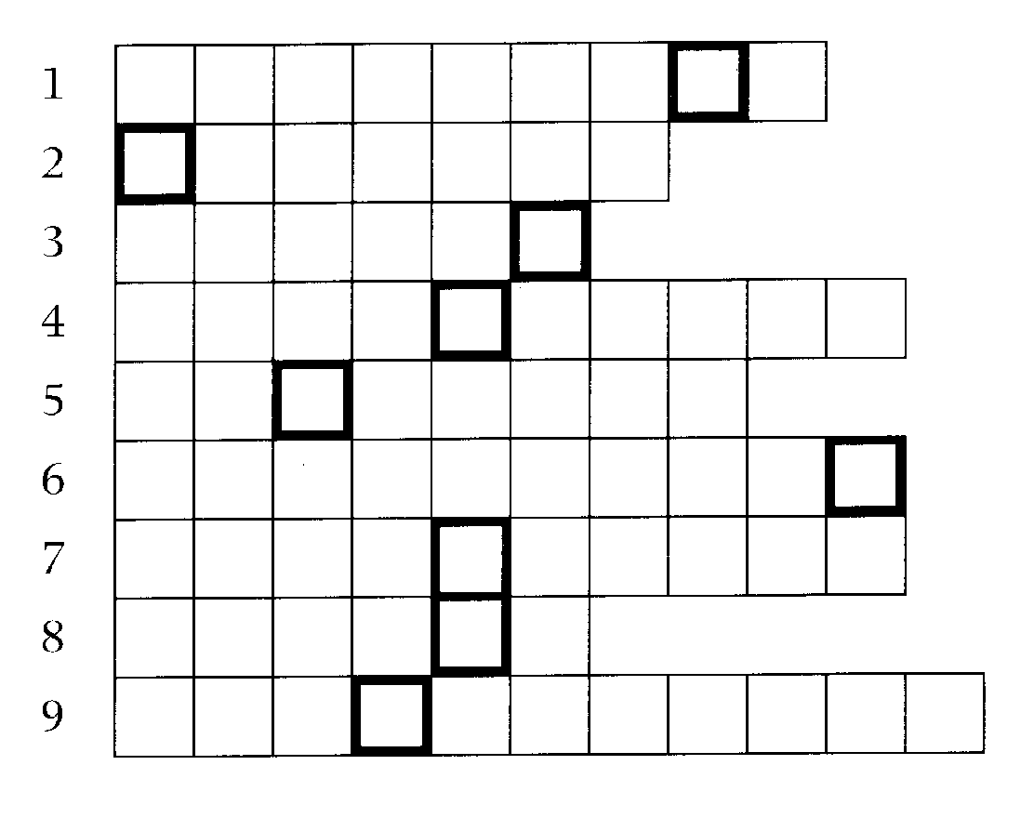
1 Expert systems have been used in medical . (ossadiing)
2 A set of instructions for making something. (lamurof)
3 Modernize. (dapetu)
4 A rival company. (torpetimoc)
5 Used of lines which are the same distance apart at any point. (alerlapl)
6 Assessment. (tualiaveno)
7 Having formal permission to sell another company's goods in a particular geographical area. (danrifcesh)
8 An exact copy. (ecnol)
9 Machines are still not very good at doing this. (nartgslanti)
Hidden word clue
This kind of engine is one of two reasoning mechanisms in an expert system.
Language focus M
152
Cause and effect
Understanding the different ways of expressing the relationship between the causes and the effects of an action is very important when you are reading English. This cause—effect relationship is commonly used in texts about computing.
Before we look at some of the ways of expressing cause and effect, note carefully this important distinction.
We can mention the cause before the effect.
Example:
(cause) (effect)
Dust often causes the recording condition of disks to deteriorate.
We can mention the effect before the cause.
Example:
(effect) (cause)
Deterioration in the recording condition of disks is often due to dust.
There are many different ways of expressing cause and effect. 1 Verbs linking cause and effect:
result cause
produce result in
allow result from
prevent bring about
enable
Examples:
1 The introduction of computer technology brought about significant changes in office routines. (cause —> effect)
2 Computers can create artificial objects in their memories. This allows developers to test product design without actually creating a real prototype.
(cause —> effect)
3 The extensive use of computers in schools is resulting in a new generation of computer-literate students. (cause —> effect)
4 The problems were caused by the volume of network traffic.* (effect 4— cause)
Note: * See Language focus H for an explanation of the passive used in example 4.
2 Connectives introducing cause:
153
due to
as the/a result of since
because
in response to
as
Examples:
1 Early computers developed quickly as a result of their use in military applications. (effect -I- cause)
2 Teachers must rethink their roles as computer technology is creating a revolution in the classroom. (effect 4- cause)
3 Because off-the-shelf programs do not always fit a company's needs, software often has to be specially developed. (effect 4— cause)
3 Connectives introducing result:
with the result that so that
thus
therefore
consequently
hence
for this reason
thereby
Examples:
1 Computers can remove many of the routine and boring tasks, thereby leaving us with more time for interesting, creative work. (cause —* effect)
2 Carpel tunnel syndrome is a serious medical condition. For this reason, computer users should be careful of their posture and take frequent breaks. (cause effect)
3 When using an online database service, you must pay for the time you use. Consequently, you should have a good idea of what you want before you log on. (cause effect)
4 Another way of showing causal relationship is by introducing the cause with if, Both the cause clause and the effect clause verbs are in the present tense.
Examples:
1 If your company has a LAN, you can share the use of a printer with your colleagues. (cause effect)
2 It is easy to transport your data to another location if it is stored on a disk. (effect 4— cause)
Exercise 1 Read the following sentences and underline the part which expresses the cause.
1 Because a modem can be used for inter-computer communication, many people can now do their office work on their computer at home and transfer the files to a computer at the office.
2 Many people do not explore new software because they are comfortable with what they already have.
3 When robots malfunction, it is usually due to mistakes in the programming or the design.
4 Laser printers can be quite expensive and are therefore often shared through networks.
5 Voice-recognition systems are becoming more sophisticated. Thus, keyboards may be unnecessary in the future.
.91.114•■■••

Read the following sentences and underline that part which expresses the
Exercise 2
154
effect/result.
1 Computers can remove many of the routine and boring tasks from our lives, thereby leaving us with more time for interesting and creative work.
2 Because there are many different types of printers, you must analyse your needs before making a purchase.
3 Since anyone can consult your files on a computer, it is a good idea to protect sensitive files with a password.
4 Fax boards are available to plug into your computer, so you do not have to buy a fax machine.
5 Computers have been reduced in both size and cost as a result of advances in design and technology.
The sentences below have appeared in previous units. Read them again and circle the marker showing a cause—effect relationship and underline the part of the sentence that expresses the cause. The first one has been done for you.
Exercise 3
aMIEMEEININ,
1 By 1980, IBM decided there was a market for 250,000 PCs, !soy they set up a special team to develop the first IBM PC. (Unit 1)
2 Because of these and so many other different judgements, there can be no absolute. (Unit 3)
3 Global communication and computer networks will become more and more a part of professional and personal lives as the price of microcomputers and network access drops. (Unit 6)
4 One of the features of a computer virus that separates it from other kinds of computer program is that it replicates itself, so that it can spread to other computers. (Unit 7)
5 ...Lehigh is waiting to infect other unsuspecting computers if you boot from one of those four infected floppies. (Unit 7)
6 As they became more proficient on the computer, some showed gains in their overall self-confidence, as well. (Unit 10)
7 Robots are better at this task, not because they are faster or cheaper than humans, but because they work in a place where humans cannot. (Unit 11)
8 This automatic accuracy is particularly valuable in this kind of industry because locating and fixing mistakes is costly. (Unit 11)
9 Artificial worlds are being built up in a computer memory so that people can walk through at will, look around, and even touch objects. (Unit 12)

14
Multimedia
155
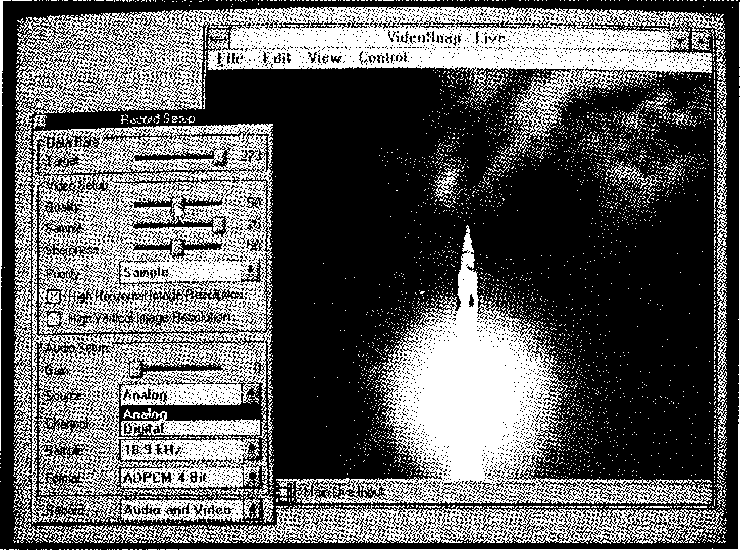
Start-up
Task 1 Discuss these questions.
1 Can you think of any actual or potential applications of multimedia in industry?
2 Do you think multimedia systems will ever become as popular as conventional audio-visual systems?
Listening
Task 2 ij You are going to hear Nathan Ward, a multimedia applications developer,
answering questions on various aspects of multimedia. Before you listen, try to predict the answers to these questions:
1 Why is multimedia similar to graphics?
2 How does Nathan Ward define multimedia?
3 Which types of data are involved?
4 Is it easy to adapt most PCs for multimedia applications?
5 What does the term `full-motion video' refer to?
6 Are there industry standards for multimedia?
7 What is the best platform for multimedia, according to Ward?
8 What is the most popular application of multimedia?
Now listen to the recording and check your guesses.
Task 3 Listen again to the conversation and complete the table below.
Hardware requirements for multimedia
1
2
3
4
5
6
Task 4 Read this extract from the tapescript and try to fill in the gaps. The first letter of
each missing word is given.
NATHAN WARD: Tull-motion video' refers to the impression the v
has that he or she is watching f 2_ ³television. The
idea is to c ⁴ full-motion video in r 't 6
and digitize and c 7 information nformation so that the system can treat
it like any other digital data s ⁸. Some systems do it better than
others.
INTERVIEWER: I see. Getting back to h ⁹requirements, apart from
the e ¹⁰cards that you mentioned, is there anything else that is
needed?
NATHAN WARD: Yes. The machine must have i |  | 11  for a variety of

input and output d 12
INTERVIEWER: Such as?
NATHAN WARD: Such as a CD-ROM d
¹³, VCR, d 14

156
a |  | 15  tape...

INTERVIEWER: Isn't there a problem of c 16
NATHAN WARD: There is, but that situation is changing. Microsoft's b ¹⁷-1 ¹⁸ MPC specification has some support, but it's
only a start. The lack of s | 19 is the main reason that multimedia is

not bigger than it is. Once these are in place, users will have easy p ²⁰-and-p ²¹ compatibility, and developers will be
able to develop a ²² that can run on a variety of p 23.
Now listen again to the cassette and check your answers.

Reading

Task 5 | Read these sentences and decide which one best summarizes the text which follows.  1 Computers cannot yet match the technological achievements of conventional audio-visual systems.  2 Although multimedia computer systems are improving very fast, they do not yet reflect the multimedia world we already live in.  3 Multimedia computer technology will soon be widely used in business, in industry, and in the home.

JET AIRCRAFT technician peers
A into the bowels of a malfunctioning engine searching for the source of the problem.
5 Finally, he spots it. Buried deep within the engine is the troublesome part. He will have to replace it. A complicated procedure, to say the least.
10 The technician goes to his high-
powered workstation attached to a network and calls up the information on the part and the replacement procedure. An image
15 of the part seated in the engine appears. In another window, an instructor demonstrates the repair procedure in full-motion video while the technician listens through
20 the audio channel as the instructor explains the process. Diagrams pop up to further clarify key points. In a text window, he reviews lists of
necessary parts and tools he will
25 need to complete the repair.
Still confused about an irregularity in this situation, the technician presses the help key and a real-time image of a live
30 supervisor pops up in another window. Using the attached microphone, the technician discusses the particular problem with the supervisor, who directs
35 more information onto the technician's screen. The technician points a video camera at the part in question to show the supervisor the specific situation.
40 Welcome to the world of high-
end multimedia. The situation described above is not quite here yet, but most of the pieces already
exist to make this scenario
157
45 become a reality using a
networked RS/6000 or other high-powered workstation.
Or take this example of a
scenario that is more likely
50 today. A manager creates a detailed business presentation involving text, graphics, digitized photographic still images, and tables of spreadsheet data all
55 combined in a single compound document. Before sending the document across the network to a colleague, the manager picks up the microphone and attaches
60 an audio note to one of the tables, reminding the colleague about something unusual or potentially confusing in the accompanying figures.
65 Using a networked RS/6000
equipped with the necessary audio boards and Bolt Baranek & Newman's (Cambridge, Mass.) BBN/Slate, a compound
70 document/office automation application, this scenario is
possible today. High-end multimedia is only in its infancy, but it is here. And over the next
75 few years, industry observers expect multimedia development to accelerate as current barriers are overcome.
Multimedia is not a new
80 phenomenon, although it is new to business computing. We live in a multimedia world. At home, we experience a variety of media through our television: full-
85 motion video, still images,
graphics, sound, and animation. ►

⁴¹¹ At school, we learn through systematic exposure to different media: the instructor's words, text,
90 audio tapes, graphics, and a variety of visuals and video.
Computers, however, have tended to be uni-medium. Traditionally, computers were text-
95 based, and this continues to be the
primary format for business information. A few systems have provided sound or graphics, but until recently, the efforts were
100 rudimentary compared to the
seamlessly integrated, high-quality visuals, video and audio we experience every evening at home. ■

■ Vocabulary
158
peers into the bowels of (1. 1) — looks down into

Task 6 | Decide whether the following statements are true (T) or false (F) in relation to the information in the text. If you think a statement is false, change it to make it true.

1 I 1 The jet aircraft technician first locates the faulty part and makes a mark on it.
2 1⁻1 The technician calls up his supervisor from his workstation to get information about the faulty part and the replacement procedure.
3 The technician can display a computer-generated graphical
II
representation of a supervisor on his screen.
4
5 You can already buy multimedia business presentation applications.
6 Industrial experts expect multimedia development to get faster and faster.
7 I⁻I Multimedia existed long before the invention of the computer.
1⁻1 This kind of repair procedure could well be possible before long.
Il
II
8 I I In terms of quality, multimedia computer systems have only recently become comparable with the media we already use.

Task 7 | Using the line references given, find the words in the text which mean:  1 catches sight of (lines 1-5)  2 order of doing things (lines 5-10)  3 instruments (lines 20-25)  4 appears (lines 30-35)  5 top quality (lines 40-45)  6 made up of two or more parts (lines 55-60)  7 early stages of development (lines 70-75)  8 obstacles (lines 75-80)  9 undeveloped (lines 95-100)  10 smoothly (lines 100-104)

Speaking
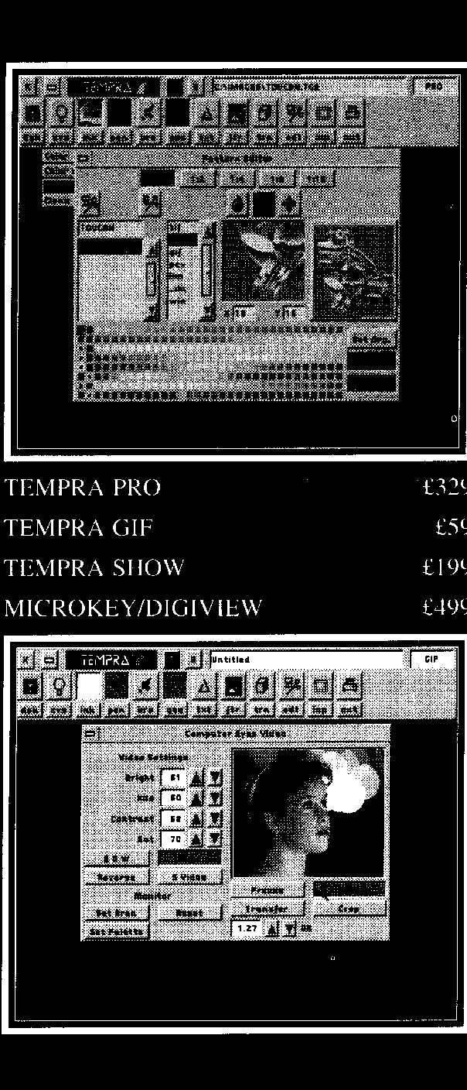
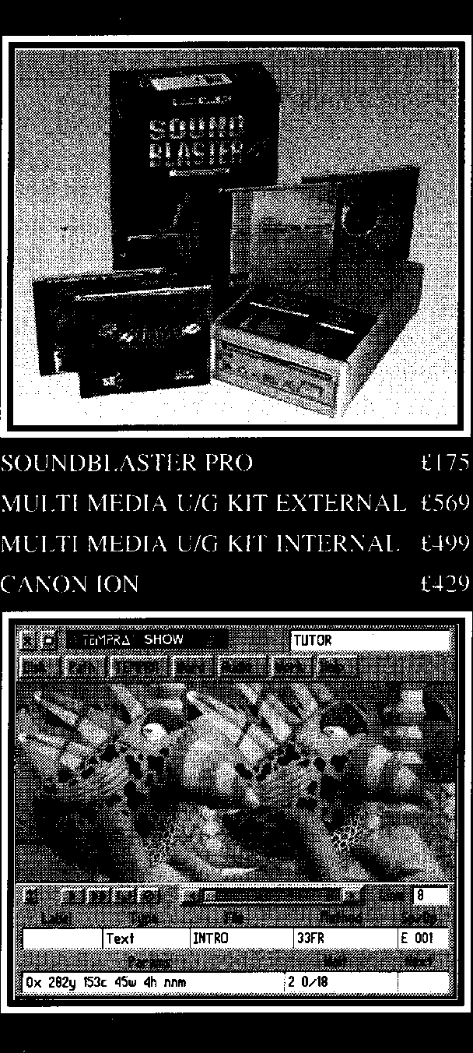
Task 8 Work in pairs using the information in the advertisement below.
Student A: You are interested in upgrading your PC to use multimedia. Describe your machine to the salesperson and ask about the various options available, prices, etc.
PC specifications
386 25MHz
4 MB RAM
105MB hard disk VGA colour monitor 3 expansion slots
Student B: You work for a company that sells hardware and software. Find out what your customer wants and check that his/her PC can be upgraded, by referring back to the list you made in Task 3. Explain the options that are available and try to persuade the customer to buy one of the products advertised.


Low cost hardware and software is now
available to transform your Personal
Computer into a MultiMedia workshop.
159
TEMPRA PRO is a fully functional 24 bit colour image editor which can be used to create, import and edit colour pictures. Images can be scanned from a variety of scanners or captured directly from a video camera.
TEMPRA SHOW is a MultiMedia development system and a menu-driven storyboard editor for presentations. This exiciting new medium has been built to give you the power to express your thoughts in a simple and flexible manner.
CREATIVE LABS MULTI-MEDIA UPGRADE KIT includes the Sound Blaster Pro stereo card, MIDI Kit, a high-perfromance CD-ROM drive, Microsoft Windows® version 3.0 graphical enviroment with Multimedia extensions 1.0, Sound Blaster Pro software and additional CD-ROM titles.
MICROKEY/DIGIVIEW is an AT compatible expansion board that captures near photo quality images from still or motion video sources and displays full-colour motion video in a window on standard VGA monitors.
For more information contact us on
T E L (0923) 240272 F A X (0923) 228796
26 GREENHILL CRESC ENT,WATEORD BUSINESS PARK,
WA TFORD,HER TFORDSHIRE,WD I 8XG

160
Writing
Work in pairs. You manage a company specializing in multimedia hardware and software. Prepare a leaflet to inform companies of the potential benefits of using multimedia. Invite them to contact you for a free consultation.
Task 9

Computer-to-video conversion
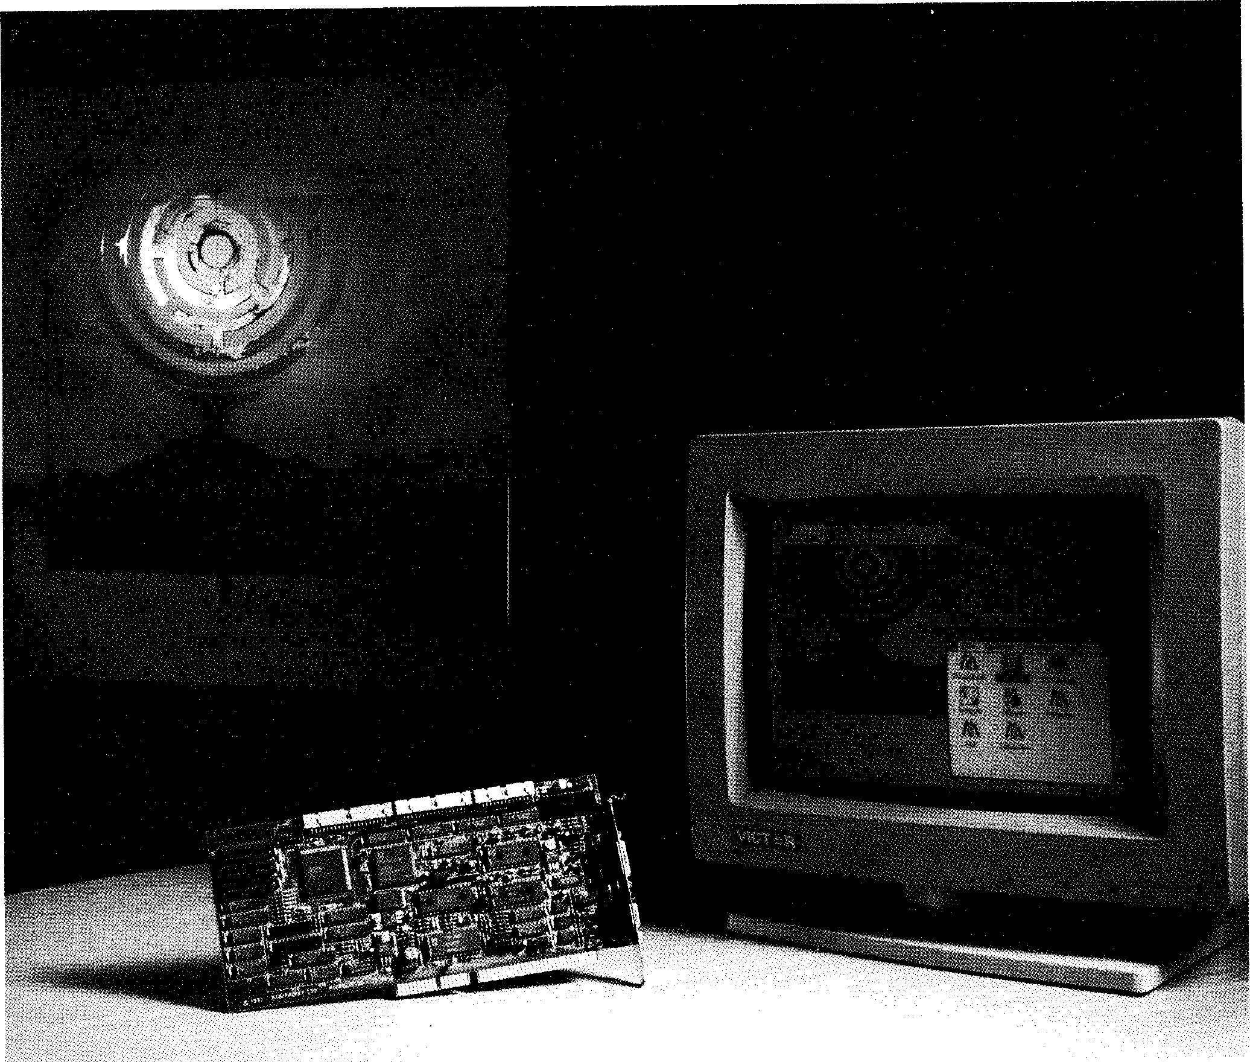
Reading
Task 10 Read the text opposite and answer these questions.
1 What are the main differences in the way images are produced on a TV screen and on a computer screen.
2 Why did the developers of the PAL system invent interlaced video? What are its advantages and disadvantages?
3 Which of the two suggested ways of getting a signal from a computer to record on a VCR do you think is preferable? Why?

How they work
A(though the computer screen has the standard
characteristics of a TV display,
images are produced in a very
5 different way. If you want to record anything from your computer to video for play-back on a TV monitor, you need a print-to-tape device.
In a TV display, a tight beam of
io electrons scans the screen in much
the same way you read a page of
text—from the upper-left corner, it
moves line by line to the lower
right. Usually, one pass writes the
15 entire image once. The number of passes the beam writes per second is called the vertical refresh rate and is measured in kiloHertz. Most computer systems follow the
20 American TV standard and use a vertical refresh rate of 60kHz whereas PAL, the European TV standard, requires 50kHz.
Another difference is with
25 bandwidth. When PAL was defined,
the bandwidth available for a TV
signal was very narrow. While the
TV image had to be refreshed at
least 50 times a second for flicker to
30 remain unnoticeable, there was not enough bandwidth to transmit all 625 lines of one TV image in a fiftieth of a second. The developers of PAL, therefore, employed a
35 clever trick called interlaced video. They split each frame of the image
into two fields of 312.5 lines, the odd lines into field A, the even ones into field B. The fields are
40 transmitted at a rate of 50 per second, leaving us with an effective
frame rate of 25 per second while eliminating most of the flicker.
This is fine for viewing from
45 several yards, but should you move as close to your TV as you would to your computer screen,
you'd end up with a headache after half an hour. Also, if any
50 parts of the displayed image occupy only one horizontal scan
line, that scan line will flicker quite noticeably at 25kHz.
All video equipment works
55 with PAL-standard, 50kHz
interlaced video. Computers tend to use 60kHz (or more), non-interlaced video and look more stable. To get a signal from your
60 computer to record on a VCR,
there are two possibilities:
1 Use a display adaptor that can produce PAL-standard video. You would not be able to
65 connect such a card to a
standard computer monitor, however. A video monitor or a multi-sync monitor is needed. You wouldn't want to look at
70 such a screen for hours on end
— interlaced video is not
suitable for word processing.
2 Put up with the standard
display signal from your
75 computer (probably 60kHz)
and use a scan converter. It can take a video signal with one refresh or scan rate, and convert it to the other. A scan
80 converter is actually a small
digital frame-grabber with asynchronous video output.

Vocabulary
yard (1. 45) — measure of length (1 yard = 0.914m) Match the sentence halves to form complete sentences.
Task 11

it will have a vertical refresh rate of 60kHz.
you must use a scan converter. you need a print-to-tape device.
you cannot use a standard computer monitor, but must use a video or multi-sync monitor instead.
you will get a headache!
161
1  2 | If you want to play back anything from your computer on a TV monitor,  If your computer system follows the | a  b
3  4  5 | American TV standard,  If you use a monitor with interlaced video for word processing,  If you use a display adaptor that can produce PAL-standard video,  If you want to use the standard display signal from your computer, | c  d  e

Task 12 Which of the two configurations for computer-to-video conversion suggested
162
in the text does this diagram show?
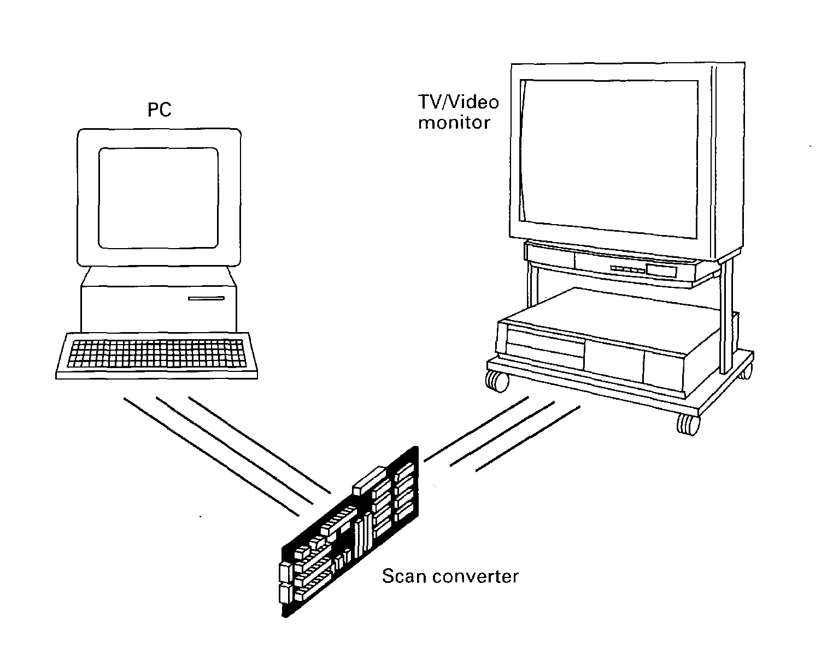
Word-play
Task 13 Find the hidden words in this square. Some appear vertically, some
horizontally, and some diagonally. They may be upside-down or back to front. Use the clues on the opposite page to help you. The number of letters in each word and the first letter of the word appear in brackets after the clue.

Find words which mean:
163
1 A strange thing or event. (10, P)
2 An instrument that changes soundwaves into electrical current. (10, M)
3 A display is one device used in computer-to-video conversion. (7, A)
4 Mend. (6, R)
5 A person who monitors the way people work to check that things are done properly. (10, S)
6 An opening on a computer into which fits an expansion board. (4, S)
7 To shine unsteadily. (7, F)
8 A document is made up of two or more documents combined together.
(8, C)
9 A converter is another device used in computer-to-video conversion.
(4, S)
10 The technique whereby still drawings are given the appearance of movement.
(9, A)
Language focus N
164
Making predictions
A prediction is a statement about a particular subject in which we say what we think will happen in the future. Predictions are not always absolute, but can be expressed with different levels of certainty, according to the context in which they are made.
1 Certainty can be expressed by:
will (definitely, certainly)
certain, sure
without a doubt, without question
2 Probability can be expressed by:
probable, probably, likely
most/highly probable, most probably most/highly likely
3 Possibility can be expressed by:
may (not), might (not), can, could possible, possibly, perhaps
4 Improbability can be expressed by:
improbable, unlikely
doubtful, questionable
probably not
most/highly improbable/unlikely most/highly doubtful/questionable most probably not
5 Impossibility can be expressed by:
present or future past
cannot, could not could not
not possible, impossible not possible, impossible
These expressions are used in sentences in different ways: Examples:
165
1 Notebook computers will definitely be cheaper next year.
2 It is (highly) probable/likely that notebook computers will be cheaper next year.
3 Notebook computers may/might be cheaper next year.
4 Perhaps notebook computers will be cheaper next year.
5 It is unlikely/doubtful that notebook computers will be cheaper next year.
6 Notebook computers will most probably not be cheaper next year.
7 Notebook computers will definitely not be cheaper next year.
8 It is impossible that notebook computers will be cheaper next year.
Sometimes, predictions are made subject to certain conditions. In such cases, sentences typically have two parts: the if-clause and the main clause.
Examples:
1 If the price of notebooks fall next year, I will buy one.
2 If the system crashes, we will lose all our latest data.
When the if-clause comes second, there is no comma between the two clauses. Examples:
1 I will buy a notebook if the price of notebooks fall next year.
2 We will lose all our latest data if the system crashes.
As with the simple predictions listed above, it is possible to express different levels of certainty about the likelihood of the condition (in the if-clause) by changing the tense of the verbs from the future and present forms to the more `remote' past and conditional forms.
Examples:
1 If the price of notebooks falls next year, I will buy one. (The speaker thinks it is possible that the price of notebooks will fall next year and, if it does, he will buy one.)
2 If the price of notebooks fell next year, I would buy one. (The speaker thinks it is unlikely that the price of notebooks will fall next year but, if it does, he will buy one.)
3 If the system crashes, we will lose all our latest data. (The speaker thinks it is possible that the system will crash and, if it does, we will lose all our data.)
4 If the system crashed, we would lose all our latest data. (The speaker thinks it is unlikely that the system will crash but, if it did, we would lose all our data.)
The first form, as in sentences 1 and 3 — [(If + present) + will] — is known as the first conditional. The second form, as in sentences 2 and 4 — [(If + past) + would] — is known as the second conditional.
166
Exercise 1 |  | Match the if-clauses (1 to 6) to the main clauses (a to I) to make complete sentences.
 | 1 | If you never read computer a ...you would be able to access our  magazines... bulletin board.
 | 2 | If you never back up your hard b ...it is unlikely that you will have a  disk... problem with computer viruses.
 | 3 | If you had a modem... c ...we would have a bigger range of  typefaces and fonts to choose from.
 | 4 | If you don't copy pirated software... d ...you will miss important new  products.
 | 5 | If I knew more programming e ...I would get a better job.  languages...
 | 6 | If we bought a better printer... f ...you will probably lose some  important files.
Exercise 2 |  | Complete the sentences with the words below. Are the sentences first (F) or second (S) conditionals?
1
1⁻1 If you your VDU in direct sunlight, it
damaged.
 | 2 | - If you your screen for too long, you  headache.
 | 3 | - If you to link your PCs with a mainframe, you  to install a network.
 | 4 | 1⁻1 If the market for portable computers , prices  even more next year.
 |  | 5  1⁻1 If we a fax machine and e-mail facility, we | SO
many letters each day.
would not post leave
grows will get
will be would need
wanted will be reduced
look at installed
Now make up three first conditional and three second conditional sentences of your own.

Computer graphics
167
Start-up
Task 1 Work in pairs. Look at the photograph below and discuss these questions.
1 What do you think the photograph was used for?
2 How was the image achieved?

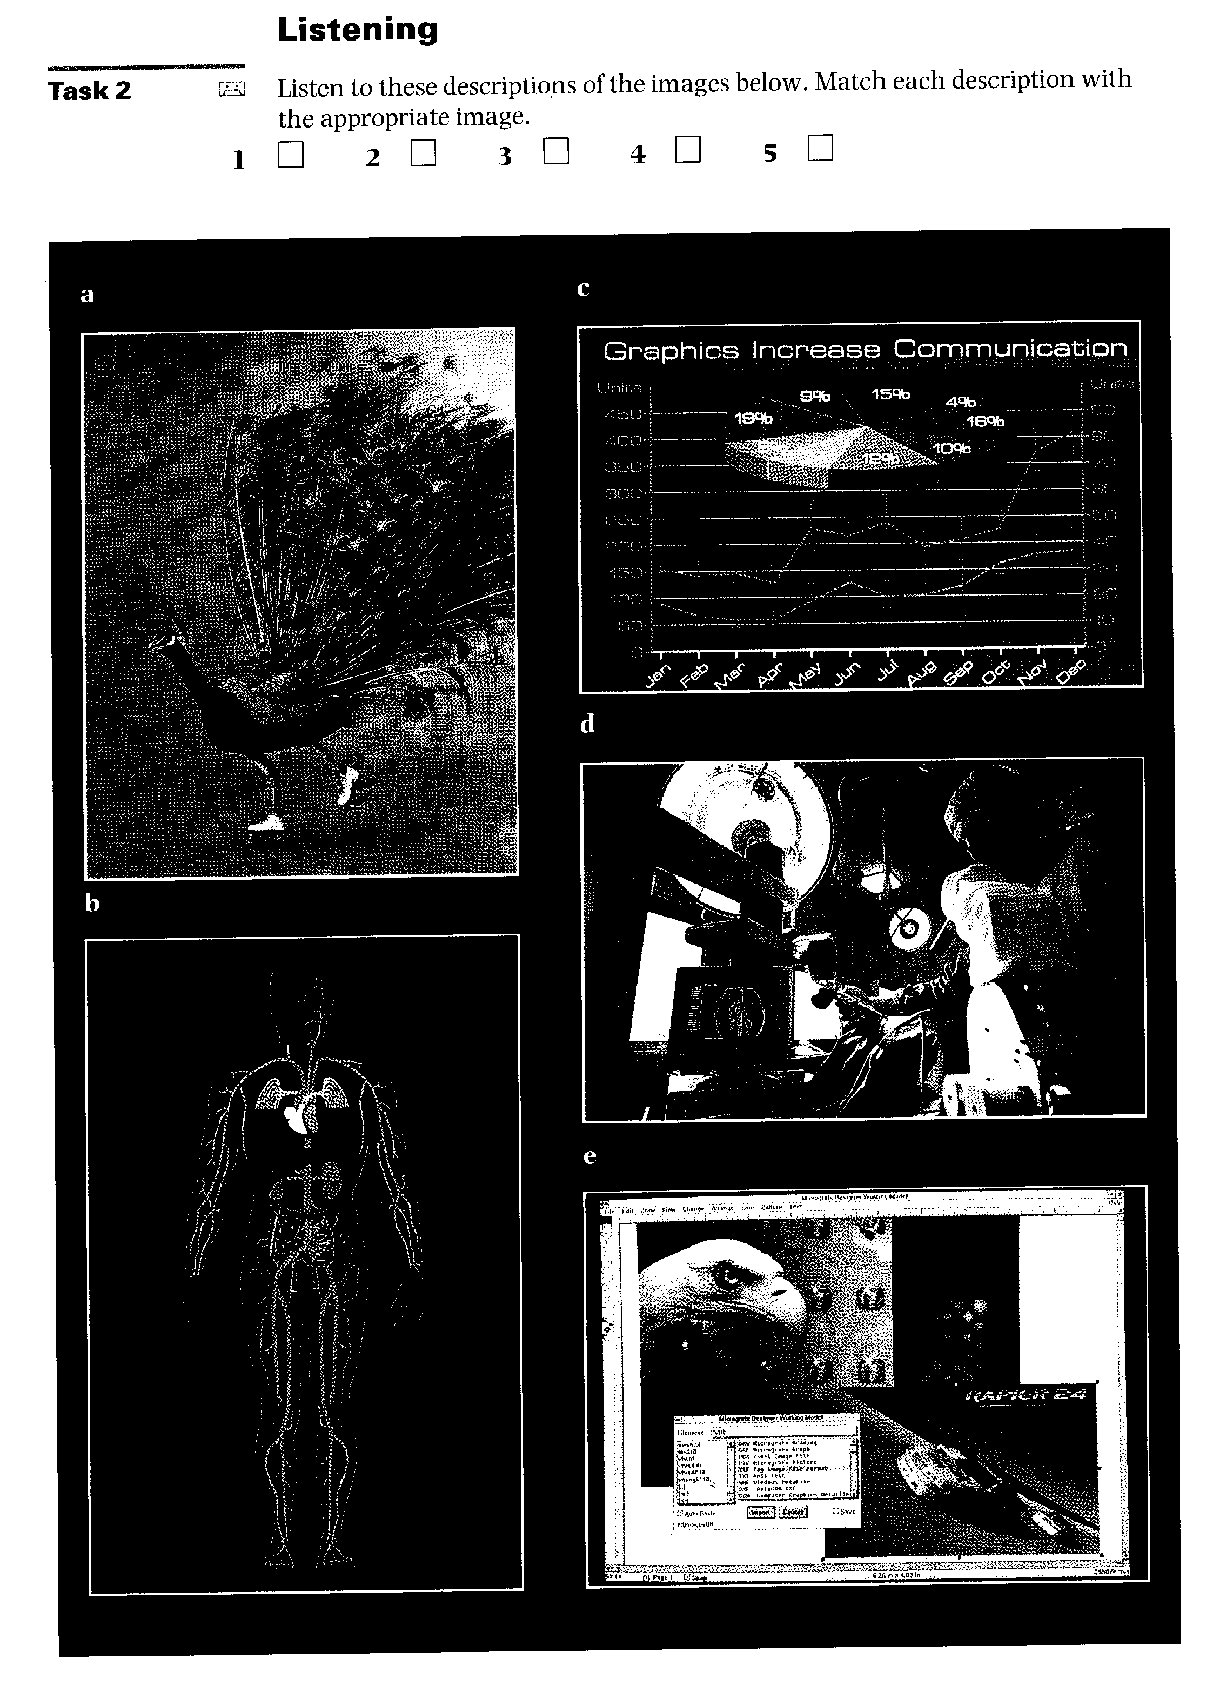
168
Reading
Task 3 Match each of the following words with the appropriate definition:

1 capture
2 poster
3 retouch
4 airbrush
5 emulsion
a light-sensitive substance on the surface of film
b device that uses compressed air to spray paint
c succeed in representing on film
d alter by making minor changes
e large printed picture used for advertising purposes

169
Task 4 | Compare the two photographs below.  1 How many differences can you find?  2 Why do you think the changes were made?


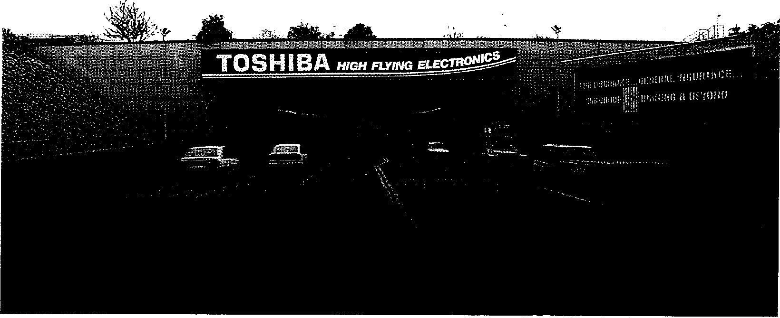

Now read the text and compare your answers.

Tunnel vision
You're at Heathrow but your plane is at Gatwick. This was just one of the problems facing the agency producing this ad.
5 Capturing this image was never going to be easy, not least because Virgin Atlantic wasn't flying out of Heathrow when this poster and press campaign was being put together
10 during May and June. Also, while the
road tunnel does indeed pass under
one of the Heathrow runways, a
plane would never appear this big
from the photographer's standpoint
15 (or if it did, it would be taxiing along the A4 Bath Road, which in real life runs just above the tunnel mouth). Another inherent difficulty was that you can't really see any light at the
20 end of the tunnel because the road dips in the middle.
From the outset, therefore, Moira Gaskin O'Malley of London ad agency Woollams knew some kind of
25 electronic jiggery pokery would be necessary, and for this art director John Jessup turned to 'conventional retouching house Acorn Studios, which offers use of Apex Graphics'
30 electronic Dalim Litho colour design system as part of its service.
The ad, which launches the new Virgin Atlantic flights from
Heathrow, is made up of two shots
35 taken by photographer Max Forsythe: one of the jumbo taken at Gatwick, and another of the Heathrow tunnel taken on a typical day (which must rank as every photographer's most
40 unfavourable location).
Considerable retouching took place to create just the right scene. The vehicles coming out of the tunnel were removed, and on the opposite
45 side the white cars and the traffic in the tunnel were extracted, while
the taxi cab and the estate car were added.
The Toshiba ad was replaced
50 with a Welcome to Heathrow poster, and the ad on the right and the neighbouring steps were conveniently taken out. The bush
on the left, which seems out of
55 character with the rest of the
resident shrubbery, was
considered too spiky and was therefore redrawn.
With the airliner in position, the
60 streetlights needed to be extended, and highlights were also added to
them. Given the presence of the light on the right, a shadow had to be appropriately positioned on the
65 jumbo.
To create that elusive patch of light at the end of the tunnel (which was crucial to copywriter Paul Quarry's words), Acorn used
70 the Dalim's electronic airbrush facilities.
The lorry disappearing into the patch of light was painted conventionally onto the final
75 output transparency by retoucher John Stammers, who is also managing director of Acorn. Stammers put this addition on to the base side of the film so it could
80 be easily washed away if the art director didn't like it (conventional
retouching is normally done on the emulsion side). It also meant that no time or money was wasted
85 going back to the system.

► Vocabulary
170
Heathrow (1. 1)/Gatwick (1. 2) — London's main airports
taxiing (1. 15) — moving slowly along the runway before take-off or after landing
jiggery pokery (1. 25) — trickery
bush (1. 53) — thickly-growing plant
shrubbery (1. 56) — area planted with bushes

Task 5 Use the table below to note down the steps taken to produce the final poster
171
and the reason for each alteration.
Alteration Reason
Task 6 These are answers to questions about the text. Write the questions.
1 During May and June.
2 Woollams' Moira Gaskin O'Malley.
3 Apex Graphics.
4 To launch the new Virgin Atlantic flights from Heathrow.
5 No, the shot of the tunnel was taken at Heathrow, but the shot of the jumbo was taken at Gatwick.
6 To create just the right scene.
7 A Welcome to Heathrow poster.
8 Because it fitted in with the chosen slogan: 'Now there's light at the end of the tunnel'.

Task 7 | Using the line references given, look back in the text and find words that have a similar meaning to:  1 built-in (lines 15-20)  2 goes down and then up again (lines 20-25)  3 traditional (lines 25-30)  4 be rated (lines 35-40)  5 nearby (lines 50-55)  6 dark patch (lines 60-65)  7 difficult to represent (lines 65-70)  8 used unnecessarily (lines 80-85)

24-bit colour

Reading
Task 8 Before you read the text, try to answer these questions.
1 How many distinct shades of colour can the human eye see?
2 What is:
a a pixel?
b a bit?
c a byte?
d a greyscale display?
3 Roughly how many different colour shades can be generated from 24-bit colour?
4 If your machine has 24-bit colour and a one million-pixel display, how much memory will you need to drive the screen?
Now read the text and check your answers.
Baffled by computer-speak? Take Buzz, the instant remedy to jargon


24-bit colour
Short explanation:
If your computer has 24-bit colour, then it can display photographic images in colour
5 on its screen that have natural-looking tones.
Long, long explanation: In principle, there is an infinite number of shades available
io between a solid colour and pure white. In practice, the human eye can detect somewhere between 150-200 distinct shades, so as long as
15 you've got more than this, you can produce an undetectably smooth progression of shades (there are exceptions, but
they're not worth going into 20 here).
Cheapo computer monitors can't display shades — you get solid black or white and nothing else (in many cases
25 you get black or green). It is possible to fake shades on one of these monitors by a sort of poor man's halftone process called dithering, but this is
30 useless for serious image viewing and retouching.
What you need is a computer that can show true shades on its screen.
35 A computer builds up a
picture from a series of building blocks called pixels. Each pixel is a square (normally) of a single colour.
40 The more pixels you can divide the picture into, the higher the resolution of the complete image. The computer
172
organizes itself by describing
45 each pixel that it wants to display as a code in the binary mathematical set (numbers built up from a series of Os or 1s). Each 0 or 1 is called a bit.
50 Computers are generally
structured to work in groups of eight bits (called a byte). These eight numbers can be used to count up to 256, and so can
55 describe 256 shades of grey from black to white, which is more than enough to satisfy the eye.
A computer which can
60 assign eight bits to describe •

⁴4 each pixel will produce perfect black and white photographs on its monitor. A monitor that can show all these shades is
65 called a greyscale display.
Now your eye can detect those 150-200 shades in all three of the colours it can see: red, green, and blue. If you use
70 eight bits to describe colour, you only get 256 colours, which isn't enough — you get a mildly posterized effect, although the dithering process
75 can simulate more colours at the expense of quality.
To get the full colour photographic effect on a computer monitor, you need
80 to be able to generate 256 shades for each colour. This takes eight bits of information per colour, giving a total of 24 bits. This is the 24-bit colour
85 that you keep reading about in
computer magazines. If you
take all the possible variations of 256 shades of three colours, you end up with a possible
90 16.7 million colour shades.
Some computers, such as the Macintosh, offer 32-bit colour: the spare eight bits can be used to control transparent
95 overlays of colour — you get 256 levels of transparency.
You only really need 24-bit colour if you are going to do colour photographic
100 retouching on-screen or similar 'painting' on-screen.
For linework and picture placing, an 8-bit colour monitor is perfectly adequate,
105 as you can still define colours
for print even if you can't
show them on the screen.
Naturally, there's a bottom
line in all this, or everyone
110 would be using 24-bit colour. To start with, you need special circuit boards which plug into
your computer and drive the
monitor. An 8-bit board is
115 cheaper than a 32-bit one.
You also need plenty of memory. A typical high resolution colour monitor can display about a million pixels.
120 The 24 bits that your
computer uses to describe each pixel can also be described as
three bytes. To describe a million pixels takes three
125 million bytes. In other words, a hefty three megabytes of your computer's memory is assigned to driving the screen. With 8-bit colour, you only
130 need one Mb.
Generally, 24-bit colour boards include extra memory and processors to speed up the display performance.
Your opinion:
135 It's cheaper to be colour-blind. ■

0- Vocabulary
5 32-bit colour offers 256 times as many shades of colour as 24-bit colour.
detect (1. 12) — recognize
dithering (1. 29) — a process which makes the transition between shades seem smoother
retouching (1. 31) — making minor changes in a photograph
a mildly posterized effect (1. 73) — a slightly crude image
there's a bottom line (1. 108) — it is expensive
hefty (1. 126) — large

Task 9 | Decide whether the following statements are true (T) or false (F) in relation to the information in the text. If you think a statement is false, change it to make it true.  1 ❑ If a computer can generate more than 200 distinct shades of colour, the  human eye will see a perfectly smooth progression of shades.

2 Everybody should have a computer that can show true shades on its screen.
3 ❑ A group of eight binary numbers is called a byte.
4 ❑ Under certain circumstances, 8-bit colour can provide more than 256 colours.

Use the information in the text to complete the dialogue in your own words.
Task 10
A
B Yes, I'd like to find out a little about 24-bit colour.
A
B Well, first of all, I'd like to know what sort of quality it will give me on my
monitor.
A
B As many as that? What add-ons do I need?
A
B How much memory will I need to drive the screen?
A
B It's a high-resolution screen.
A
B That's a lot! I use colour mainly for linework and picture-placing. Do you
think it's worth buying 24-bit colour?
A
Writing
Write a summary of the text. You should aim to limit your summary to about 150 words. Start by underlining the important ideas in the text. Try, where possible, to combine more than one idea in each sentence.
Task 11
Word-play
Solve the crossword puzzle using the clues below. The words are taken from all fifteen units.
Task 12

Across
174
2 A device for converting digital data into a sound signal that can be transmitted by a telephone network. (8,7)
4 One kind of printer. (6)
5 and 6 An is a smoothly varying electrical pulse that was the
basis for all telephone communication until recently. (6,6)
6 See 5 across.
7 Someone who is extremely knowledgeable about a particular subject. (6)
8 The lack of an industry for operating systems means that programs have
to be specifically written for each existing system. (8)
9 A million floating point instructions per second. (8)
11 A robot with some physiological structures similar to those of humans. (6)
12 To transmit a virus to a computer. (6)
13 To go into a computer file. (6)
14 Erase or omit. (6)
15 An operation performed by the control unit. (7,8)

Down
175
1 To jumble up a string of characters so that it can be read only after decoding. (8)
2 This unit forms part of the CPU. (10-5)
3 A device fitted over a computer screen to stop dangerous emissions. (9,6) 10 Another way of saying 'logs off . (5,3)

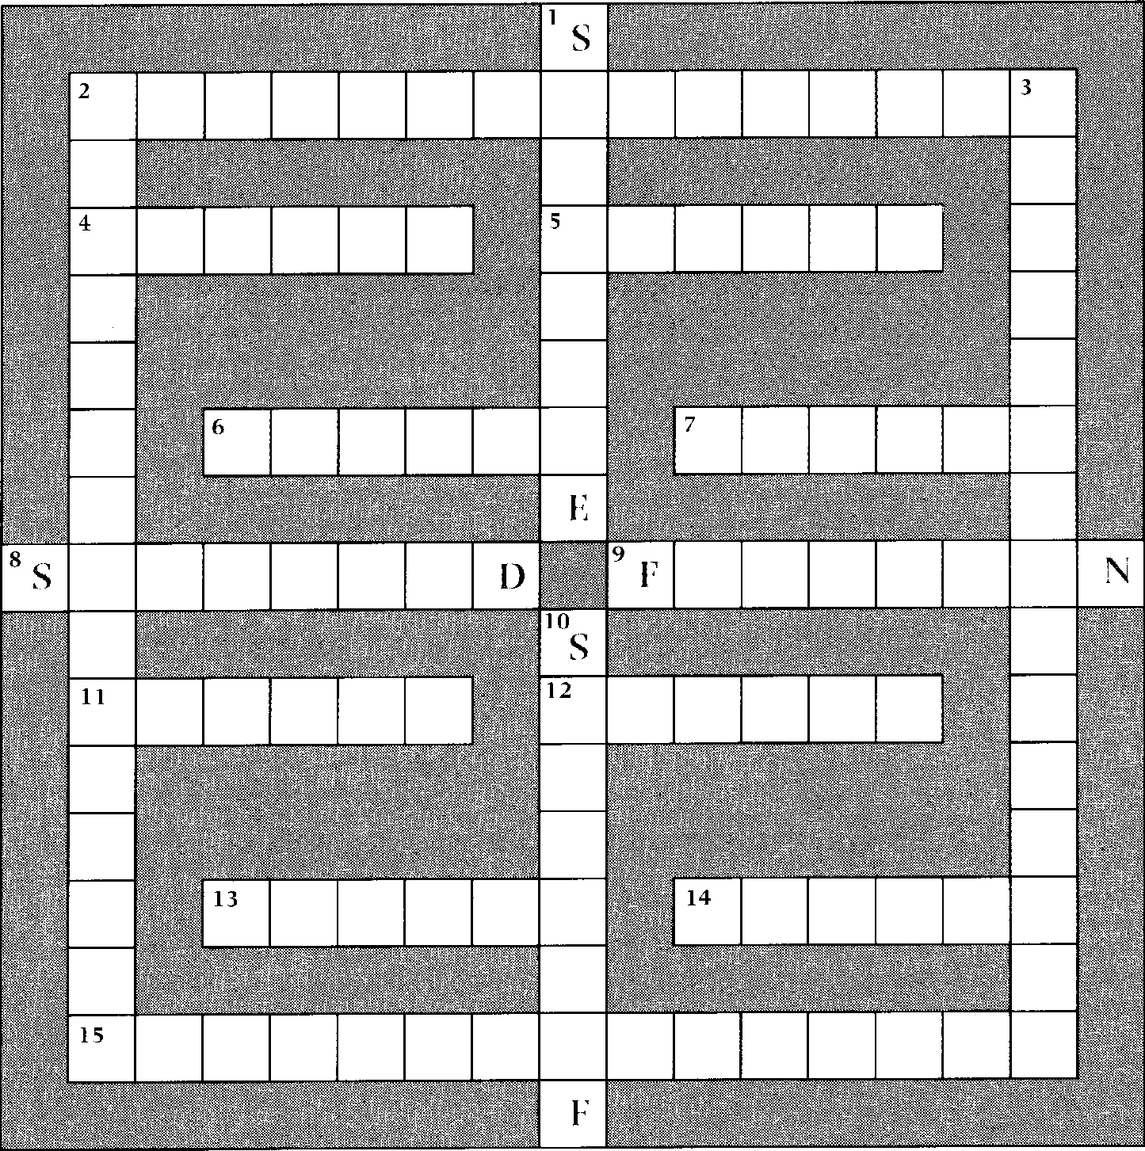
S
1 4
IN
Appendix 1
176
Letter writing
1 | Presentation and structure | p. 176
2 | Enquiries and replies | p. 178
3 | Quotations and orders | p. 182
4 | Letters of complaint and replies | p. 188
5 | Employment | p. 192

The aim of this section is to help students of computer science and those already working in computing-related jobs to improve their letter-writing skills. All the most common types of work-related letters are covered, and special attention is given to presentation and structure.
1 Presentation and structure
The layout of business letters often varies slightly from company to company. All the letters in this appendix follow a style which is acceptable for all kinds of business letter and may safely be used as models for your future
correspondence.
Task Decide whether the following statements are true (T) or false (F). Then read the
text which follows to check your answers.
1 On unheaded notepaper, you should always write your name above your address.
2 On unheaded notepaper, the address of the sender is on the right.
3 ❑ Our ref. refers to the writer's filing system.
4 In the UK, the date 2/4/93 means February 4th, 1993.
5 ❑ You should always write the name and position of the person you are writing to above his/her company address.
6 You use the salutation Dear Sir or Dear Madam when you know that the person you are writing to is older or more senior than you.
7 If you begin with Dear Sir, you end with Yours faithfully.
8 The initials p.p. indicate that the person signing the letter is doing so on behalf of someone else.
9 It is unusual for the writer to put his/her company position at the end of the letter.
10 In business letters, dates should appear as numbers separated by full points (.) or obliques (/).
The abbreviation Ms can refer to both married and unmarried women. lf you are writing to Mrs Anne Swanson, you open with Dear Anne
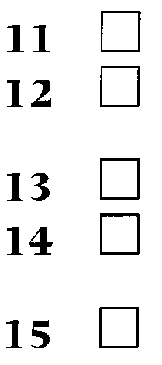
177
Swanson.
Short business letters are regarded as impolite.
Americans may begin a business letter with the salutation Gentlemen, followed by a colon.
The letters Enc. mean that something else has been sent with the letter.
Points to note
- Most company notepaper is headed. However, if you are writing on unheaded paper, put your address (but not your name) in the top right-hand corner. The address of the company you are writing to should appear on the left so that it can be seen through an envelope with a window. If you are writing to a specific individual in the company, his/ her name and position goes above the address.
- Dates can cause some confusion. 2/3/9_ means 'the second of March'
in English letters, but `February third' in American ones. Confusion can be avoided by writing dates as follows: .2 March (or March 2 in the USA) 199_. The names of the months should not he abbreviated in formal letters.
a When you receive a business letter, there is usually a reference number at the top following the words Our ref. This is designed to help the sender to file related correspondence, and you should quote this reference when you reply.
a. If you do not know the name of the person you are writing to, or you are not sure if you are writing to a man or woman, you should begin Dear Sir or Madam (Gentlemen: in the USA) and end Yours faithfully (Yours truly in the USA). If you know the person's surname, begin (for example) Dear Mrs Jones and end Yours sincerely. If the person is more of a friend, begin (for example) Dear Peter, and end Best wishes. In opening and closing salutations and in addresses, it is common not to use full stops and commas.
a Refer to men as Mr. Refer to women as Ms, unless in previous correspondence from them they have indicated that they use the title Mrs (for married women) or Miss (for unmarried women). Women will often indicate their preferred title by writing it in brackets after their signature, for example: Catherine Honey (Mrs). Most correspondents will assume you are a man unless told otherwise, so if you sign a letter H Jones, most people will reply beginning Dear Mr Jones.
■ When you sign your name, it is common practice to type it out as well and to put your position in the company below it. If someone in a company signs a letter on behalf of someone else, the initials p.p. (per pro) should be used before the name to indicate this,
■ If something is being sent with a letter, Enc, or Encl.(enclosure) should appear in the bottom left-hand corner of the page,
a State your message clearly, concisely, and politely.
2 Enquiries and replies
178
The content of a letter of enquiry will depend on how well you know the person or company you are writing to. If you are writing to a company for the first time — whether asking for a catalogue or requesting details about a particular product or service — you should start your letter by giving information about your own company. Then state your reason for writing and make your request.
Task 1, when completed, provides a model for a letter of enquiry. Task 2, when completed, provides a model for a reply to an enquiry.
Task 1 | Read the following letter. Fill in each gap with the letter corresponding to the appropriate word.

a send d Project g attention j graphics
b together e Madam h pRamonièresk faithfully
c forward f based sell
Physiologica | 17 Princes Street London  EC1 7DQ | Telephone 071 982 7111 Telex 988153  Fax 071 982 7712

Our refAN/JS Your ref:
1 July 19___
Discpro SA
251, rue des Ramonieres F-86256 POITIERS CEDEX France
For the ¹ of the Sales Manager
Dear Sir or ²
We are a software company ³ in London and are
currently developing a Windows-based scientific ⁴ package for use in universities and research laboratories. We are interested in ⁵ the programs we ⁶ from
unauthorized copying and duplication.
Could you please ⁷ us more technical information about
your RSP-11 software protection system ºgcath your
current brochure and price list?
We look ⁹ to hearing from you.
Yours ¹⁰

Complete this reply to the letter of enquiry in Task 1 using the prepositions given. You will have to use some prepositions more than once.
for from in to
on of with
251, rue des Ramonières F-86256 POITIERS CEDEX
Discpro SA | Tel ₍₃₃₎ 99681031 Telecopie (33) 102163

Ref PV/KH
179
5 July 19___
Ms Anne Newson Project Director Physiologica
17 Princes Street London EC1 7D0
UK
Dear Ms Newson
Thank you ¹ your letter ² 1 July ³ which you
expressed an interest ⁴ the RSP 11 software protection system. Please find enclosed our latest brochure and price list.
5 the information in your letter, I can confirm that
the range of products we supply would be ideal ⁶ your
needs.In particular, I would like to draw your attention
7 the RSP 11W ⁸ page 3 which is designed for
software protection in both Windows and 0/S 2 environments.
As you will see, our protection systems are tailored ⁹ individual programs. Please let me know whether you would like to arrange a meeting ¹⁰ our Technical Director, Mr
Michel Gerard, to prepare a more detailed report ¹¹ your program and particular requirements. He will be in London during the week beginning 15 July.
I look forward to hearing 12 youTélécopie
Yours sincerely


In each of the following sentences, choose the correct word to fill the gap.
Task 3
1
2
3
4
5
6
I would be if you could send me details of your PS/2 range.
a thankful b please c content d grateful
You were to us by our associates.
a advised b suggest c recommended d informed
We were given your by The Chamber of Commerce.
a identity b company c name d placing
Thank you for your letter 19 June.
a in b on c of d from
Please enclosed our current catalogue and price list.
a find b look c receive d examine
We would appreciate you could send us further information on
your range of non-impact printers.
a it that b this c when d it if

7 I would be grateful if you could arrange for your Technical Director
on me.
180
a will call b is calling c to call d calls
8 We look forward from you.
a hear b to hear c hearing d to hearing
9 We would be grateful an early reply.
a to b of c for d with
10 Should you require anything further at this time, please do not contact me.
a void b hesitate c delay d prevent
Task 4 Match each section of the letter of enquiry on the following page with the
appropriate gap on the blank below.
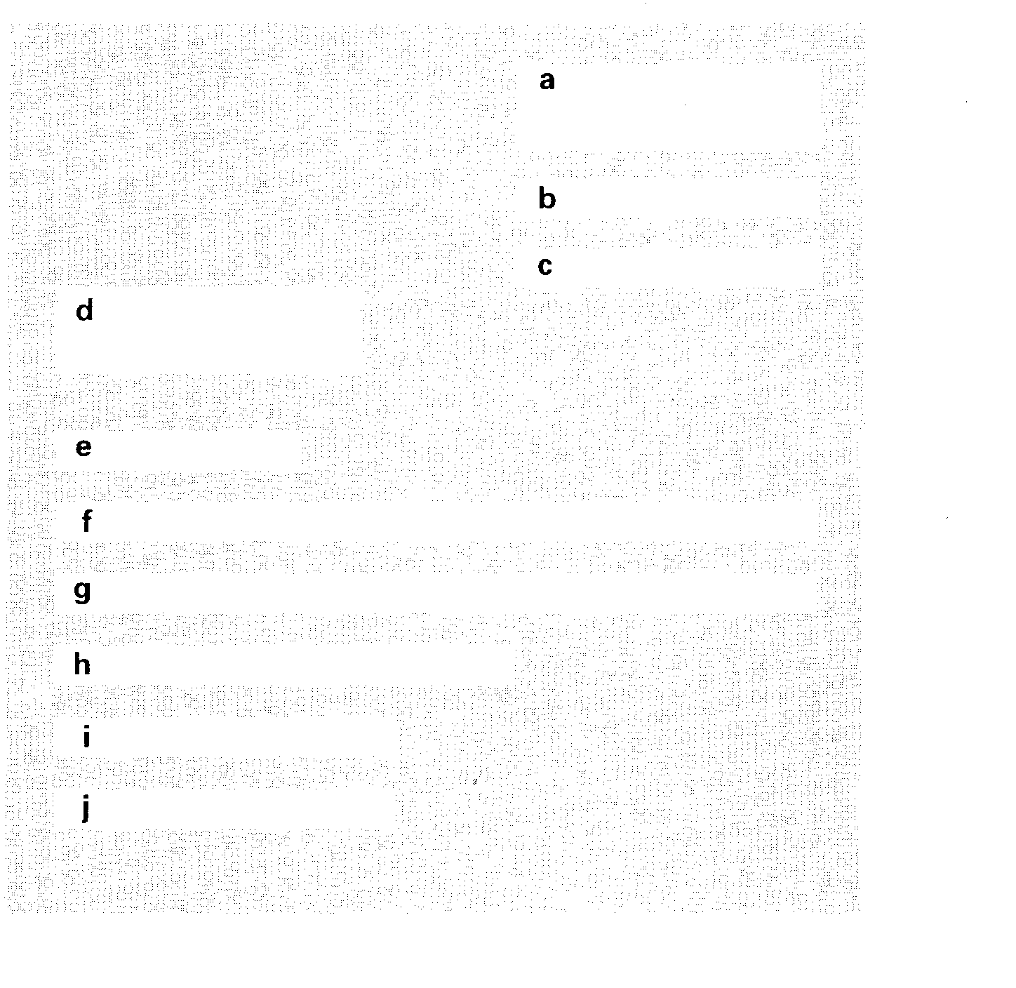

1 We are currently using 15 Procom 211 Premier PCs in our mail-order department. We have been pleased with their performance, but now
require machines that will run faster.
2 M H Jansen Publicity Manager
3 I look forward to hearing from you.
4 Could you please let me know whether it is possible to upgrade the PCs to 486s and what the likely cost would be?
5 Dear Mr Barnard
6 Mr J Barnard
Corporate Sales Department Procom Ltd
58 Edison Street
Robin's Lane Industrial Estate Canterbury
Kent CT19 3TE
7 Yours sincerely
8 12 May 19
9 The Red Box
54 Streamside Road Cardiff CF1 1JW
10 Our ref: CUG/PL

Task 5 | You are Mr Barnard. Reply to the letter of enquiry in Task 4.  Paragraph 1: Refer to the customer's letter. Say you are happy that the PCs have given satisfaction.  Paragraph 2: Explain that the Procom 211 Premiers cannot be upgraded because that particular model has been discontinued. Say that you are enclosing the latest catalogue and draw attention to the Procom 400 PC, which would be ideal for the customer's needs. Suggest that you call soon to arrange a time and date when a representative can visit to give a demonstration of the PC.  Paragraph 3: Conclude the letter appropriately.

Follow the instructions on the memo below. Write out the letter of enquiry in full, including names, addresses, etc.
Task 6
181
Mark Walton is the Senior Programmer of Inlogic, Morley House, 18-22 Wolves Road, London SW1 7ND.
Memorandum
To Laura Hayward Date 27 March 19
From Mark Walton Ref
Please send a letter to ASD Computer Products who advertised in the March 23 edition of 'Info Globe'.
Say where you saw the advertisement and ask them for their catalogue.

3 Quotations and orders

In reply to an enquiry you may want to provide a potential customer with a quotation. This will, of course, quote the price for the requested goods or services, but it will also give some or all of the following information:
182
1 details of any applicable discounts (a trade discount may be offered to companies in the same line of business while a quantity discount may apply to orders over a certain amount).
2 details of what costs (if any) are included in the price, such as transport and insurance*.
3 the preferred method and terms of payment (for example, a letter of credit payable within 30 days*).
Note: a glossary of terms covering the most common costs included in quotations and the most common methods of payment can be found on page 1R7
4 some indication of how long it will take for the goods to reach the customer.
Task 1, when completed, provides a model for this type of letter.
The order itself is likely to be written on an official order form, but it will normally be accompanied by a covering letter confirming the terms that have been agreed. The letter in Task 2, when corrected, provides a model for a covering letter to an order.
The following letter gives a quotation. Read it and choose the best word from the options in brackets.
Task 1
Dear Mr Gianelli
Thank you for your fax of 18 May in which you request a quotation for 5 EMC18O flat-bed scanners.
We can offer a gross price of £3,425.00 — unit price: £685.00 — c.i.f. Genoa. This includes a ( batch, quantity, multiple) discount of 10%.
Payment may be (done, made, spent) by irrevocable letter of credit or by banker's draft. On all ( starting,
initial, prime) orders we usually require payment ( on
by, of) delivery, and for all subsequent orders we ( make, let, allow) a 30-day credit period. Please let us know how you would like to arrange payment.
We have the items in stock and can ( persuade, assure, console) you that your order will be dealt with promptly. Please allow six weeks for delivery.
We look forward to hearing from you again soon. Yours sincerely


Task 2 | The following letter was written to accompany an order. There are 8 mistakes  (grammar, style, EMC18Order, vocabulary, spelling, etc.). Can you find and correct them?

Dear Mr P J Wilson
Thank you for you fax of 19 May Please found enclosed our 3O-dayno 88694 for five EMC180 Scanners.
We would like confirming that payment for this initial order will make by banker's draft on delivery. We will take advantage of the 30-day credit, period for any subsequent orders.
We would appreciate if, you could arrange for the scanners to be shipped as soon as possible.
I look forward to hear from you in short. Yours faithfully
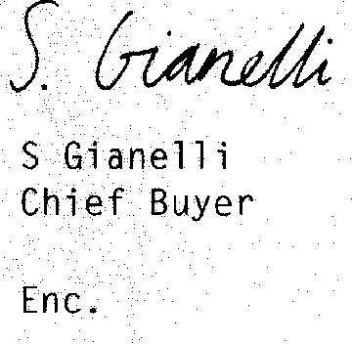

Task 3 | Match the beginnings and ends of these sentences.

I | Please find enclosed our current price | a
2 | Please fill in the order | b
3 | The prices quoted are subject to | c
4 | Payment can be made by | d
5 | We offer free overnight delivery on | e
6 | We would like to place an order | f
7 | Please could you let us know what trade | g
8 | If the product sells well, we will | h
9 | Please find enclosed a cheque | i
10 | Please let us know when | i
cheque or credit card.
with you for 2,000 units. we can expect delivery. discounts you can offer.
183
for f395.95.
place further orders with you. list and order form.
form on Page 26.
orders of over f50.00.
VAT at 17.5%.

184
Task 4 | Due to a malfunctioning word processor, the following two letters have been mixed up. One is from Discpro SA providing a quotation for a further order of software plugs. The other is from Physiologica to confirm the order. Match each missing section with the appropriate gap on the blank letters.

1 We would like to place an initial order with you for 500 RSP 11W plugs and enclose your official order form. We normally make payments by banker's draft. Could you please confirm that this is acceptable to you?
2 Further to your letter of 1 July and your meeting with Mr Gerard in London on 18 July, I am pleased to be able to give you a quotation for the software protection plugs you discussed.
3 P Varenne Sales Manager
4 Thank you for your letter of 23 July.
5 We hope that this highly competitive price will meet with your approval, and I look forward to receiving your order.
6 Dear Mr Varenne
7 Anne Newson Project Director
Enc.
8 Mr P Varenne
Discpro SA
251, rue des Ramonieres F-86256 POITIERS CEDEX France
9 I would like to point out that delivery before the end of November, as agreed with Mr Gerard, is a firm condition of this order as we hope to have the program ready for sale by then.
10 Dear Ms Newson
11 Ms Anne Newson Project Director Physiologica
17 Princes Street London EC1 7D0 UK
12 We would be able to supply 500 RSP 11W plugs at a unit cost of E17.86, including transportation costs. On any additional orders, we would be able to offer a 20% discount on the unit price.
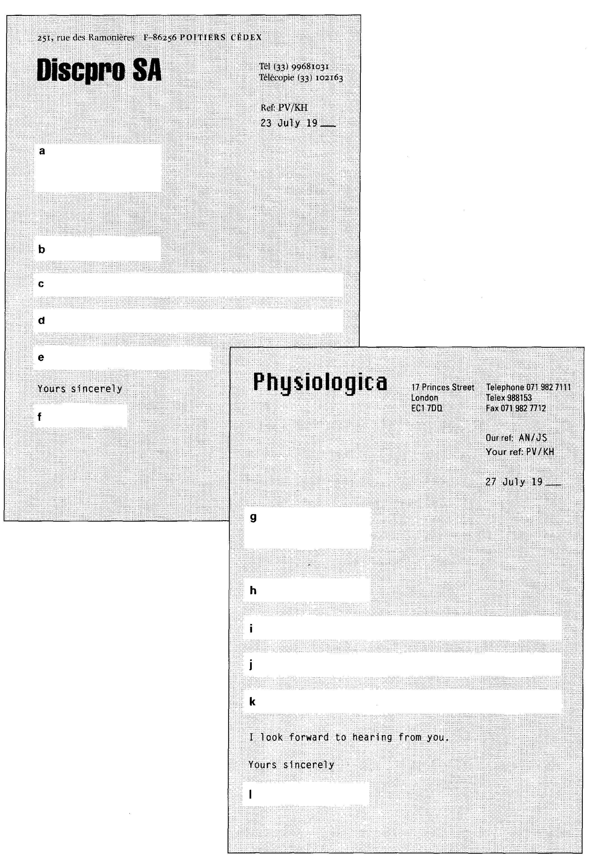
185
186
Task 5 | When writing formal letters, we often precede questions which ask for information with phrases like Could you please let us know... and Kindly inform us...

Look at the examples below and note how the original questions change when they become part of a longer question or statement. Then change the questions which follow in the same way.
1 When/Where/How will the consignment arrive?
Could you please let us know when/where/how the consignment will arrive%
2 Do you offer discounts on large orders?
Could you tell us whether you offer discounts on large orders?
3 Are you interested in this offer?
Please let us know whether you are interested in this offer.
1 How would you like us to pay?
Could you please let us know -
2 How many items would you like to order?
Please let us know
3 Do you have the items in stock?
Could you please tell us
4 Are these terms acceptable to you?
Please let us know
5 Do you anticipate any delays with delivery?
Please let us know
6 When would you be able to ship the order?
Kindly inform us
7 Where would you like us to send the order?
Please let us know
8 Would you be prepared to offer us a quantity discount?
Could you please tell us
9 When would you like to receive payment?
Please let us know
10 Would you like us to arrange a maintenance contract?
Kindly inform us
Task 6 | Follow the instructions from George Ramsden, Senior Project Engineer at Bespoke Assemblers, 22 Clarendon Street, Cambridge CB4 8RP.

Memorandum
To Sally Parker Date 24 July 19_
From George Ramsden
Please write a letter to Frith Components, 139 Giles Kemp Road, London N1 2RR.
1 Say we saw the advertisement for their company in
the latest issue of Electronic Engineer.
2 Ask if they are able to supply the following: 2O 486DX-33 motherboards
12 4Mb SIMM 60NS
8 Intel Ether Express 8/16-bit switchablecards.
3 Find out what discounts they give and what their terms of payment are.

Methods of payment
Common methods of payment include:
bank transfer: payment can be made by ordering a home bank to transfer money to an overseas account. If telegraphed, the transfer is known as a telegraphic transfer (TT), and if mailed, a mail transfer (MT). The Society for Worldwide Interbank Financial Communications (SWIFT) offers facilities for a 24-hour transfer of money to a beneficiary on its computer systems.
international banker's draft: a banker's cheque which the bank draws on itself and sells to the customer, who then sends it to his supplier as he would an ordinary inland cheque. So if you have to pay your supplier £2,000, you purchase the cheque for that amount, plus charges. Usually the receiver's bank should either have an account with the sender's hank, or an agreement.
bill of exchange: the seller prepares a bill of exchange in the name of the buyer. The bill states that the buyer will pay the seller an amount within a stated time, e.g. 30
days. The bill is sent to the buyer either by post, or through a bank, and the buyer signs (accepts) the bill before the goods are sent. Shipping documents usually accompany bills when the hank acts as an intermediary in overseas transactions.
letter of credit (L/C): letters of credit (or documentary credits, as banks refer to them) have to be applied for from the buyer's
bank, by filling out a form giving details of the type of credit (i.e. revocable, which can be cancelled, or irrevocable, which cannot be cancelled), the beneficiary (the person
187
receiving the money), the amount, how long the credit will be available for (i.e. valid until...), the documents involved (bill of lading, insurance, invoice, etc.), and a description of the goods. The money will be credited to the supplier's account as soon as confirmation of shipment is made. This is done when the documents are lodged with the customer's bank.
Transport and insurance costs
There are a number of abbreviations that explain the price quoted to the customer. These include:
ex-works: the buyer pays all costs once
the goods leave the factory/warehouse.
f.o.r. (free on rail): includes cost of delivery
to the nearest railway station.
f.a.s. (free alongside ship): includes cost of taking goods to the side of the ship, but not loading.
f.o.b. (free on hoard): as for f.a.s., but includes cost of loading goods.
c.& f. (cost and freight): includes cost of shipping goods to the named destination, hut not insurance.
c.i.f. (cost, insurance, and freight): includes all costs to the named destination.

a
188
Letters of complaint and replies
The purpose of a letter of complaint is to get a problem solved so avoid emotional language (e.g. I am absolutely furious...). In any case, the person reading your letter is probably not the person who caused the problem. When replying to letters of complaint, avoid blaming a member of staff by name. Instead use a passive structure. Compare the following examples:
1 Mrs Smith, in our accounts department, sent the wrong invoice.
2 The wrong invoice was sent due to an error in the accounts department.
A letter of complaint should be structured as follows:
1 Begin with a clear reference.
2 State clearly what the nature of the complaint is.
3 Suggest a course of action that should be followed.
4 End the letter politely.
Task 1 shows a typical letter of complaint.
A reply to a letter of complaint should be structured as follows:
1 Begin with a reference to the letter.
2 If appropriate, apologize for the error and explain what happened.
3 Say what action you will take.
4 Apologize again and end the letter politely.
Task 2, when completed, provides a model for a reply to a letter of complaint.
Read this letter of complaint and answer the questions at the top of the following page.
Task 1

I am (complaining, writing, referring) regarding the consignment of 14
Olivetti 486 PCs, Order no. 3982/JKS which was delivered on 12 May.
It was clearly stated on the order form that these machines should be pre-loaded with the latest version of DOS. Unfortunately, they have all been loaded with DOS version 3.1, and we are therefore unable to run a number of programs. In addition, you agreed to supply all the necessary cables, but three of these are missing.
Could you please send one of your representatives to load the machines with the correct version of DOS as soon as possible. In addition, please send the three cables (part number CN-H97/k) as soon as possible.

1 Does the letter begin with a clear reference to the particular consignment?
189
2 What is Mr Panting's complaint?
3 What does he want the supplier to do?
4 Do you think the letter is polite enough?
Task 2 Here is the reply to Mr Panting's letter. Fill in the missing prepositions.
Reg. England 1831713  VAT 24HB 62114 | Wildman  Office  Equipment
18 Station Lane
London N8 4HE
Telephone 071 996 6431/2/3 Telex 485881
Fax 071 996 6444
Your Ref Our Ref
17 May 19_
Mr G 0 Panting
Operations Manager Princes Marketing Nessonyou___se
Newell Street
Birmingham B3 3EL
Dear Mr Panting
Thank youl your letter 2 14 May regarding problems
3 a consignment that was recently sent ⁴ you.
The difficulty appears to have arisen ⁵ a
misunderstanding ⁶ our ordering department, and the
matter has now been put right.
I have asked our Corporate Computing Consultant,
Mr R Marley, to call 7 you ⁸ Friday 21 May
9 9 a.m. to ensure that the PCs are correctly loaded and
to supply the three cables that were left 10 of the
order.
I will telephone you to check that this meeting is convenient, and in the meantime, I would like to apologize 11 the inconvenience that has been caused.
Yours sincerely

1 You have sent us the wrong items again. The wrong
Task 3
Rewrite these sentences using the passive, beginning with the words indicated.
2 You should have delivered this consignment last week. This consignment
3 Someone broke two of the VDUs during transportation. Two
4 Someone sent the order by sea mail instead of air mail. The order
5 Please let me know when you think you can sort this matter out. Please let me know when you think this matter
6 You should have sent the documents by registered post. The documents
7 A faulty connection could have caused the problems with the hard disk. The problems with the hard disk
8 You omitted the manuals from the order.
The manuals
9 You delivered the printers over three weeks late. The printers
10 We will not pay the invoice until this problem is rectified. The invoice
Task 4 Match the beginnings and ends of these sentences.

1 I am writing to complain about the late
2 I am writing with reference
3 We are returning the goods to you because
4 Please arrange for the goods to be
5 Please send us a refund for
6 Please accept my apologies
7 The problem arose due to
8 We would like to apologize for the error
a collected from the factory.
b on the invoice.
190
c a fault in the manufacturing process.
- we are not satisfied with them.
e delivery of items I ordered last week.
f to order UH-879/94.
- the full amount.
- for the inconvenience.

Task 5 Look at the following letter of complaint from Physiologica to their suppliers.

Yours sincerely
191
1 In pairs or small groups, decide:
a how effective the letter is.
b how it could be improved.
2 Rewrite the letter in a more concise and appropriate manner (in about 80 words). Use the spaces provided.
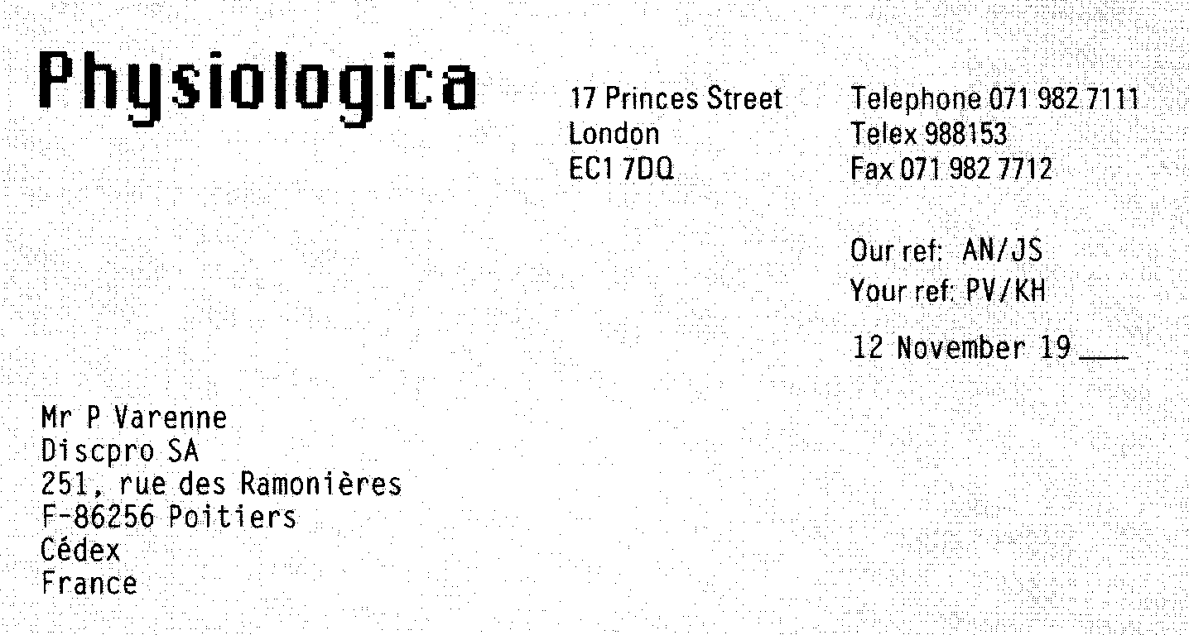
Dear Mr Varenne
When we began this association, I had great hopes that everything would run smoothly, and there was little reason to suppose that your organization was in fact a TOTAL SHAMBLES; and to be quite frank with you, it astonishes me that you have managed to stay in business for as long as you have You've made a complete mess of our order.
We made it clear that we wanted the software protection plugs by the
end of NOVEMBER because we were going to start selling our program. Time and time again, you said that there was no problem, and yet here we
are, two weeks from the launch of the program, and there isn't a plug in sight. I am absolutely furious, and so is everyone else here.
Now listen: this is your very last chance. Get those plugs here within five days or the deal is off, and we'll go to someone else. OK? And if that means that you lose your development costs, that's your problem.
I advise you to contact me immediately because I'm finding this situation an incredible strain, and I= can't take much more of this.
Task 6 You are Mr Varenne. Write a reply to the letter from Ms Newson.
192
I Thank her for her letter.
2 Apologize for the difficulties the late delivery is causing. Explain that a small number of the plugs had a technical fault caused by a problem in the manufacturing process. You have now sorted the problem out.
3 Say you have now sent the full consignment of plugs and they will arrive within the next few days.
4 Apologize for the delay and end your letter politely.
5 Employment
When you apply for a job, you may need to fill in a company application form which asks for personal details, your qualifications, and your work history. Alternatively, you may be asked to supply a curriculum vitae, which gives similar information, but which you write yourself.
In either case, you will need to write a covering letter to go with the application form or CV. Most jobs will have been advertised in the papers or specialist publications, and before you write your covering letter you should study the wording of the advertisement carefully. Find out exactly what the employer is looking for (for example, a certain amount of experience, familiarity with particular languages, etc.). Then, in your covering letter, try to show that you have all the qualities, qualifications, and experience that the employer is looking for. You should not simply repeat all the information in the CV, you should highlight the most important parts.
Task 1 Read this advertisement and answer the questions that follow.
Systems Programmers to £20,000 - London
Our client is a major UK clearing bank whose range of activities is as impressive as the growth of its profits. A bank that is dedicated to a long-term programme of systems development.
With IBM RS/6000, System 38, and VAX hardware driving user-interface PC networks using C, UNIX, FOXPRO, and SYBASE, there's no doubting our client's commitment to systems innovation and investment.
We are looking for SYSTEMS PROGRAMMERS with C and UNIX skills, who can show us 2 years' experience of delivering advanced banking and online information systems. Above all, we need flexible thinkers who appreciate the commercial realities and priorities of the banking industry.
Show us these qualities, and our client can offer you a competitive salary plus many banking benefits. If your talents and ambitions are ready for such a move, please send your CV, quoting Ref. 349, to:
Harriet Bradman at Compro Recruitment Services, 318 Leadhill Street, London EC1 1DR.

1 Who placed the advertisement?
2 What software does the current system use?
3 What specific characteristics or qualities are required?
4 What benefits come with the job?
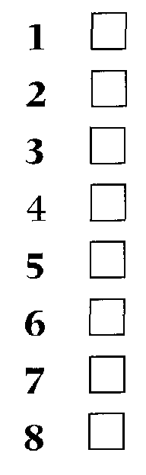
begin with a reference to where he saw the job advertised? give details of the subjects he studied at school?
Task 2
David Manning has applied for the job advertised in Task 1. Before reading his letter, tick the items you think he should mention in replying to the advertisement.
Do you think he should:
193
list briefly all previous jobs?
be honest and admit that he lacks exactly the required experience? indicate his current level of responsibility?
explain why the company would benefit if they employed him? say when he will be available for interview?
request that they reply as soon as is reasonably possible?
Now read the letter and compare your predictions. Do you think it is a good letter? Discuss the reasons for your opinion.
22 Carlyle Crescent London WC1H 9BH
18 June 19___ Yr Ref: 349
Ms H Bradman
Compro Recruitment Services 318 Leadhill Street
London EC1 1DR
Dear Miss Bradman
I wish to apply for the post of Systems Programmer, which was advertised in this month's edition of IT World.
I am currently a Systems Programmer at GCG Merchant Bank where I have two years' experience of specialized programming for the financial sector. I am familiar with C/UNIX, LAN/WAN technology, and relational databases.
Prior to taking over my current post, I worked for Data International as a Trainee Systems Programmer, where I was
involved in the development of a new online information system for a financial services company.
My experience in the fields of both banking and online information services has given me the necessary commercial and technical awareness to be able to make a valuable contribution to the systems development programme of your client.
Please let me know if there is any further information you require.
I look forward to hearing from you. Yours sincerely

194
Task 3 |  | The advertisement mentioned three specific requirements for the job. Write down the phrases that David Manning used when referring to those requirements.
1
2
3
Task 4 Using the information from the letter, complete the following CV that David
Manning sent with the covering letter.
CURRICUUM VITAE
Personal details  Position applied  Education 19_ to 19  19 19_  Work experience 19_ to present  19 19_  Other information | for: | Name: David William MANNING Age: 21  Date of Birth: 29 May 19 —Marital StaLus: Single  Address:¹
 | for: | Tel: Status 6925
 | for: | St Godric's School, Buckingham  General Certificate of EducatiHr.  MathematiCertifB  Physics A  English B  German D  Aston Technical Co__ e Birmingla:r.  OND in Computing  Company: GCG Merchant Bert Post
 | for: | Responsibilities:
 | for: | Company:⁵
 | for: | Post: ⁶
 | for: | Responsibilities: assisting in the  development of a new online information system for a financial services company.  Clean driving licence

Referees  Mr Joseph Morse Systems Manager GCG Merchant Bank  Threadneedle Street London EC1 7GH | Mr J H Holloway  Data Processing Manager  Data International 106 Sidmouth Street London WC1H 4GJ

Current Salary £16,500 p.a.
195
Task 5 | In each of the following sentences, choose the most appropriate word from the options in brackets.  1 I am writing to (apply, request, ask) for the post of Sales Consultant advertised in today's edition of The Independent'.  2 I enclose my curriculum vitae for the (job, position, work) of Program Manager.  3 As you will see from the enclosed (CV, covering letter, application), I have had several years' experience of Export Sales.  4 1 (qualified, left, graduated) from Manchester Technical College with an HND in Electronic Engineering.  5 At present, I am (worked, employed, taken) by Unisys, where I work in the Customer Services Department.  6 I would be grateful if you could send me an application (form, formula, card).  7 While I was at Dell, 1 was (liable, responsible, charged) for the day-to-day running of the Technical Services Department.  8 At ICL my duties (included, added, completed) installing and testing new computer systems.  9 I look (forward, ahead, on) to hearing from you.

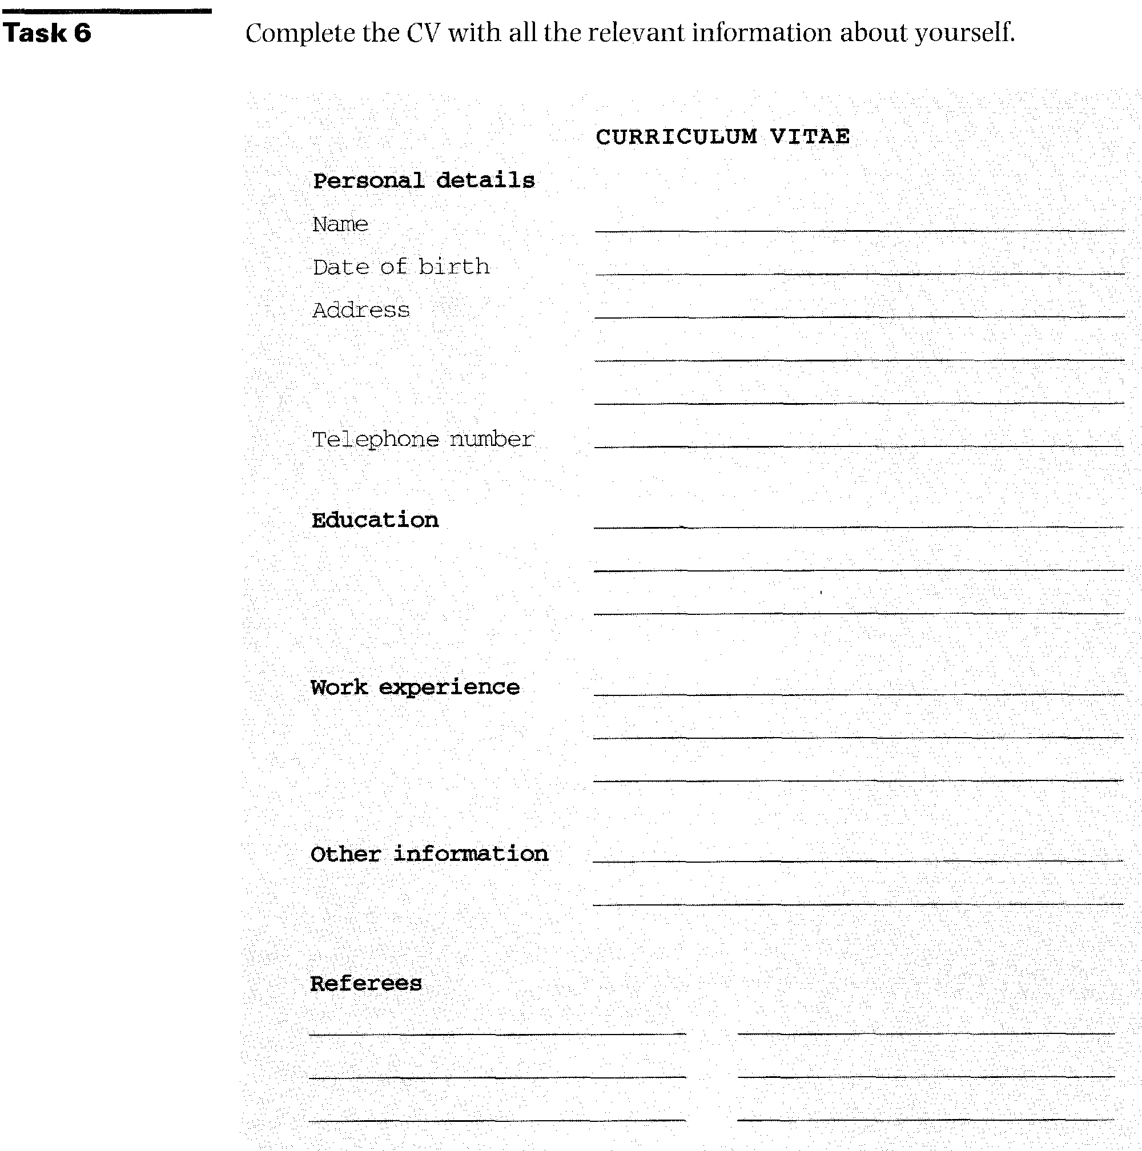

Task 7 | Compro Recruitment Services are advertising a number of jobs. Choose a job and write a covering letter to send with your completed CV.  Begin by saying which post in particular you are applying for.  Give relevant details about yourself and your experience/qualifications. Say why you would be useful to the company.  Close your letter politely.

Sales and support £12,000 to £15,000
A growing company requires an experienced PC Consultant to provide technical support for both specialist systems and general packages including word processors, spreadsheets, and databases. Additional responsibilities will include dealing with sales enquiries, both at exhibitions and on the telephone. Full training in this area will be provided.
Ref. S/167
Programmers/Analyst programmers
To £20,000
A London-based financial organization requires an experienced person with a thorough knowledge of UNIX and 'C'. You will need excellent communication skills and be able to work effectively as a member of a team. This company offers excellent benefits and prospects to its employees.
Ref. P/256
Network manager £16,000 to £20,000
Well-known manufacturers seek ambitious candidate with one to two years' experience of using Lotus, Paradox, WordPerfect, and Harvard Graphics. A knowledge of Windows will be a definite advantage. Working within a small team, you will be solely responsible for the support and management of forty to fifty PCs running on a network.
Ref. N/80
Junior support £15,000 + benefits
196
A specific requirement has arisen in an international bank. A vacancy exists for a PC support professional to work within a small team. You will be the first point of contact for dealing with problems relating to software, hardware, and networks. Candidates should have a minimum of 18 months experience. Further training will be given on the job. Knowledge of mainstream PC software is essential, i.e. Windows, Excel, Lotus, WordPerfect. You should be well presented with excellent interpersonal skills. Very attractive position with much scope for career progression.
Ref. S/168
Analyst programmers £ negotiable
Analyst programmers with at least two years' C' or OS/2 experience looking to move into a truly dynamic development environment should call us NOW! The package is negotiable and promotion prospects are excellent for those prepared to work hard.
Ref. P/257
If you are interested in any of the above vacancies, contact Valerie Stevenson at:
FASTRECRUIT
18 Wolvercote Avenue Bolton
BCl2 6CT
Telephone
0204-112340

Appendix 2

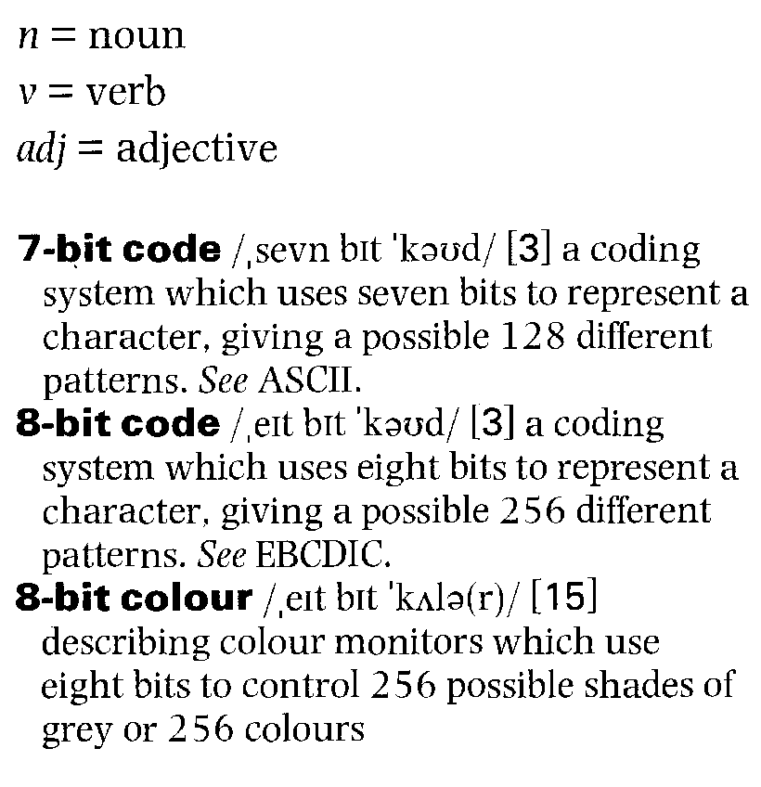
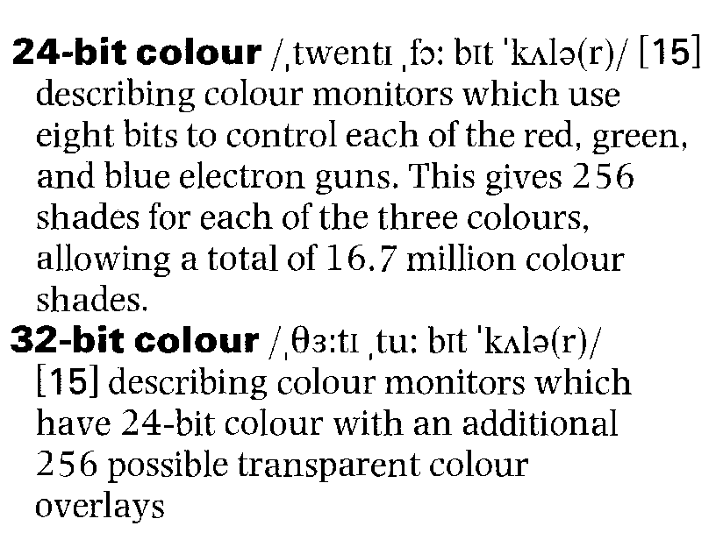
197
Glossary of technical terms
and abbreviations
The definitions in this glossary refer to words only as they are used in this book. The meanings of certain words will vary according to context. As the texts in this book are authentic and come from a variety of sources, some inconsistency in hyphenation and spelling is inevitable.
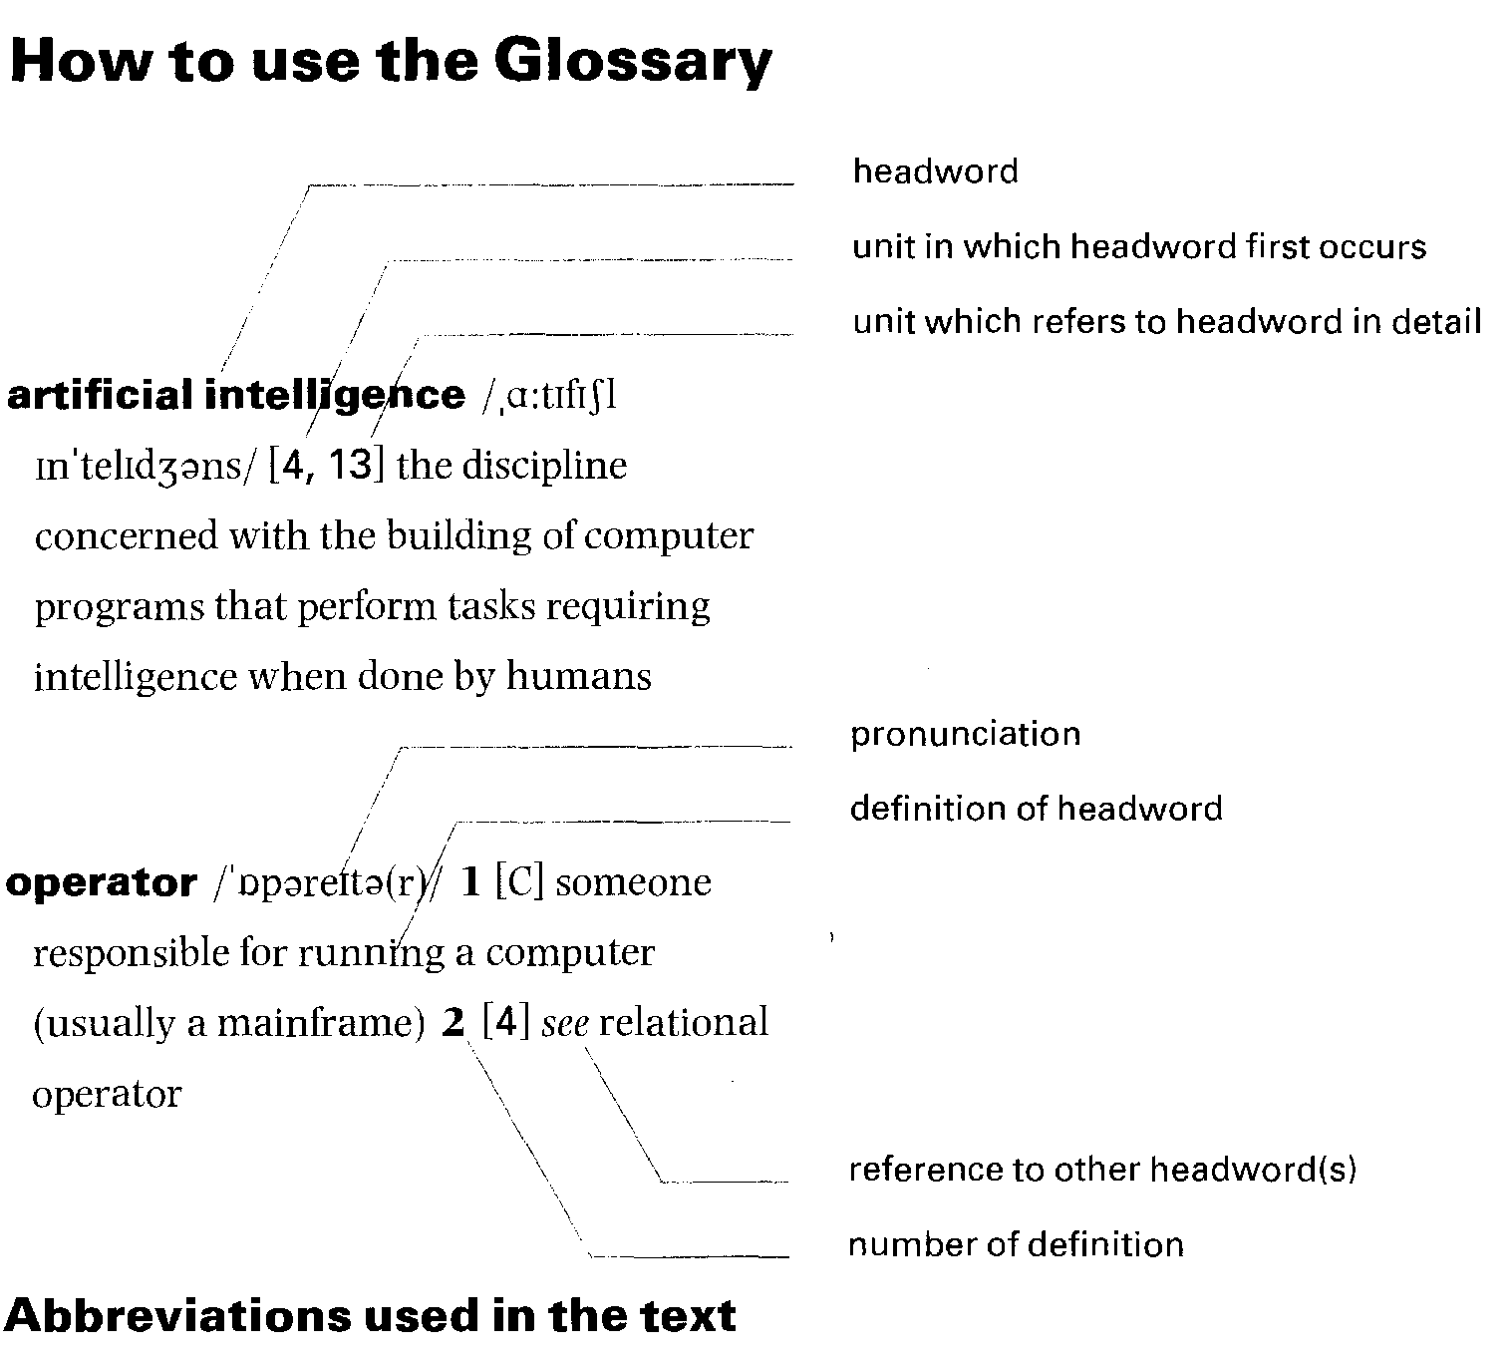
access f wkises/ v [10] connect to, or get (information) from, a system or a database
access control / wkses kan,troul/ [7] a feature of a computer security system which prevents unauthorized users from accessing a system
access request iwkses ri.kwest/ [101 a user request for data from a database accumulator 4kju:mju,leita(r)/ [1]
a register that holds the results of operations performed by the arithmetic portion of the CPU
acoustic coupler /a,ku:stik 'kApla(r)/ [3] a device that converts the digital data of the computer into a sound signal that can be understood and transmitted by a telephone network. The connection is usually made by placing the handset of a telephone into rubber cups containing a microphone and a loudspeaker.
adaptor board /o'dwpto ,b3:d/ [1]
a circuit board put in a spare slot in a microcomputer to control an external device
A/D converter /,ei 'di: kan,v3:to(r)/ [81 analog-to-digital converter: an electronic circuit that changes analog signals to digital signals
address /3'dres/ [11 a location within the memory of a computer
address bus /3'dres ,bAs/ [1] a signal route within a computer dedicated to sending address information. This may be a subset of the system bus.
address register /a'dres ,red3ista(r)/ [1] a register which stores an address in memory
Al /,ei 'al/ [13] artificial intelligence ALGOL it✓lgul/ [4] algorithmic language:
a language developed for mathematical
and scientific purposes
algorithm Lulgoriom/ a prescribed set of well-defined rules or instructions for the solution to a problem
alphanumeric /,w1fonju:'merik/ adj used to describe data that contains numbers and letters
analog /'analog/ adj [3] describing a smoothly varying signal that has no discontinuities
analogue iwnolog/ see analog
analyst annalist/ [4] someone responsible for understanding a problem in a business environment and designing a computer system to solve it
android amdmicl/ [11] a mobile robot whose structure approximately resembles that of a human
ANSI it✓nzi/ American National Standards Institute: an industry-supported standards organization founded in 1918 that
establishes US industrial standards and their correspondence to those established by the International Standards Organization (ISO)
198
anti-glare shield /,),enti 'glea ,Sidc1/ [B] a protective screen over the front of a computer screen to reduce the amount of reflected light
APL /,ei pi: 'el/ [4] a programming language: originally devised as a mathematical notation and later turned into a language
application(s) program /,),uplfkeiln(z) ,praugracm/ [2,4] a program written in a high-level language, designed to perform a specific function such as calculate a company's payroll
application software /,a2p1I'kelf n ,softweo(r)/ applications programs (i.e. programs that directly meet the needs of the computer user). In contrast, systems software (part of the operating system), although essential, does not directly meet any specific user needs.
arithmetic-logic unit /a,n0motik '1Dd311( ,ju:nit/ [1] the component of the CPU which performs the actual arithmetic and logic functions asked for by a program
arithmetic unit /aerielmatik ,ju:mt/ [1] see arithmetic-logic unit
artificial intelligence /,a:tififl in'telicl3ms/ [4,13] the discipline concerned with the building of computer programs that perform tasks requiring intelligence when done by humans
ASCII f Leski:/ [3] American standard code for information interchange: a standard character encoding scheme introduced in 1963. It is a 7-bit code allowing 128 different bit patterns or characters.
Assembler /o'sembla(r)/ [4] a program that takes as input a program written in assembly language and translates it into machine code
assembly language /a'sembh laqgwic13/ [4] a human-readable representation of machine-code programs
assignment statement /a'sammant ,steltmant/ [4] a fundamental statement of most programming languages that assigns a new value to variables
asynchronous /ei'smkranas/ [14] describing a form of computer control timing in which a specific operation is begun as soon as a signal is received to indicate that the preceding operation has been completed
AT-compatible /,ei ,ti: kam'pwtabl/ [14] describing a computer which can run the same software as the IBM PC model AT
audio board 3:chou ,bo:d/ [14] a computer expansion hoard that allows sound to be recorded and played back by the computer
audio note /' 3:thou ,nout/ [14]
in multimedia, a digitized audio message that can be attached to text or graphics auto-kerning /'::):tau,k3:nio/ [5] a wordprocessing feature that automatically adjusts the space between the characters of a typeface to give the best-looking lit
automate /' 3:tameit/ v [11] use automatic equipment and machines to perform an activity previously done by people
automaton /3Aumation/ 111] a machine capable of operating independently, such as a clothes drier
auto numbering /,D:tau 'nAmbarn3/ [5] a feature that automatically numbers
diagrams, paragraphs, etc., in a document
B /bi:/ [4] a programming language derived from BCPL
background /' kekgraund/ [2J describing processing which does not involve computer—user interaction. Such processes use spare computer resources to perform low-priority tasks.
backing storage /k✓li] ,sto:rid3/ [1] see secondary memory
backup /' bwkAp/ It a copy of a piece of data or a program taken in case something happens to the data or to the disk on which the original data is stored
back up /,bark 'Ap/ v [2] take a backup bandwidth /' bLendwit0/ [14] the difference between the lowest and highest frequency in a group of frequencies
bar code ibcrkoud/ [K] a machine-readable printed code that consists of parallel bars of varied width and spacing, usually used to code goods
bar code scanner ibu:kaud ,sk✓n3(r)/ 1K] a scanning device that can read bar codes as input
BASIC /' beisik/ [4] beginners' all-purpose symbolic instruction code: a programming language developed in the mid-1960s to exploit the capability (new at that time) of the interactive use of a computer from a terminal
batch program ibwtS ,prougnem/121
a program that runs without any terminal or user interaction. Typically such programs perform large scale updates, produce reports, or handle housekeeping functions. A high priority batch job may be run in foreground.
BCPL /,bi: si: pi: 'el/ [4] a programming language used for systems programming
binary adder /bainari ,do(r)/ [L] the portion of the arithmetic-logic unit which performs binary addition and subtraction
binary arithmetic /,bamari o'nematik/ [4] arithmetic done to the base 2 using only 0 and 1 as its basic digits
binary number /minor' ,nAmba(r)/ [15] a number (0 or 1) used in binary arithmetic
199
bistable /,batsteibl/ [1] an electronic circuit whose output can have one of two stable states, i.e. on or off
bit /bit/ binary digit holding the value () or 1: the smallest unit of information in a computer system
bit-mapped ibitmwpt/ [6] describing the image displayed on a computer screen
whereby each pixel corresponds to one or more bits in memory
BIX /biks/ [3] Byte Information Exchange: an online service
block /bluk/ a physical group of records on a tape or disk. A number of blocks form a file. Records are blocked together to improve 1/0 throughput.
Boolean algebra /,bu:lian 'ald3abra/
an algebra closely related to logic in which the symbols do not represent arithmetic quantities
boot /bu:t/ v [2,7] reload the operating system of a computer
broadcast ibro:dku:st/ [61 a message-routing algorithm in which a message is transmitted to all nodes in a network
bug /bAg/ n an error in a program bulletin board fbulotin ,bD:d/ [31
a teleconferencing system that allows users to read messages left by previous users on a variety of topics. All users can see all messages, unlike e-mail where the message is private.
bus /bAs/ [1] a signal route within a computer to which several items may be connected so that signals may be passed between them
bus network chAs ,netw3:k/ 161
a network topology which is non-cyclic, with all nodes connected. Traffic travels in both directions and some kind of arbitration is needed to determine which terminal can use the network at any one time.
byte /bait/ [2] a character consisting of 8 binary digits or bits
C /si:/ [4] a highly portable programming language originally developed for the UNIX operating system, derived from BCPL via a short-lived predecessor B
C++ /,si: plAs 'plAs/ 141 a programming language combining the power of object-oriented programming with the efficiency and notational convenience of C
cabling fkeibln3/ [6] the wiring used to carry the signals for a network
CAL /k✓1/ Computer Assisted Learning: one of several terms used to describe the use of computers in training and education
CALL /kwl, ko:1/ [91 Computer Assisted Language Learning: the use of computers in the teaching of languages
capacity /ka'pwsati/ [2] the amount of free unused space left on a disk
CBT /,si: bi: 'ti:/ [9] computer-based training: see CAL
CD-ROM /,si: di: 'rnm/ [8] the predominant form of ROM optical disk. Both disk and drive are based on the product used for commercial music systems. The disk is 120mm in diameter, single-sided, and holds up to 600Mb of data.
cell /sel/ [A] a location in a spreadsheet capable of holding text, numeric data, or a formula
central processing unit /,sentral 'pratisesn3 , ju:nit/ [1] the principal operating part of a computer, consisting of the arithmetic unit and the control unit
channel itf xnal/ [1] a specialized processor that consists of an information route and associated circuitry to control input/output operations. More than one I/O device may be attached to a channel for fast accessing and updating of information.
check point itf &point/ [2] a point in a series of programs at which a backup is taken, and the point at which the series of programs will be restarted
chip /tfip/ [F ] see microchip
circuit is3:1cit/ [11 a combination of electrical devices and conductors that form a conducting path
circuit board is3:lot ,113:d/ [1] a board containing integrated circuits which make up the processor, memory, and electronic controls for the peripheral equipment of microcomputers
click /kik/ v [1] press the button on a mouse to initiate some action or mark a point on the screen
clipboard ficlipbp:d/ [2] see portable computer
clock /klnk/ [1] an electronic device that generates a repetitive series of pulses, used to control and synchronize the internal workings of a computer
cluster controller /11Asta kan,traula(r)/ [31 a device that controls a number of similar peripheral devices such as
terminals and links them up to the main computer
coaxial cable /1cou'wksial ,kethl/ [6]
a type of network cable consisting of two wires, one of which is contained totally within the other
COBOL joubol/ [4] common business-oriented language: a high-level language designed for commercial business use
code /kaud/ n [7] the representation of information data in symbolic language or in a secret fashion
code /kaltd/ v write a computer program cold-boot /kauld bu:t/ v [71 load the operating system of a computer from `cold' (i.e. when the computer has to be switched on first)
200
command-based /ka'ma:nd ,bust/ [11 a computer system which interacts with
the user by commands entered at a prompt on the screen. See command line interface. COMMAND.COM /ka,ma:nd 'knm/ [7] the main part of DOS
command line interface /ka,ma:nd lain 'intafeis/ a method of interaction with a computer whereby the user types specific commands in order to achieve his requirements. This is generally regarded as not very user-friendly, although it is often the most efficient way of communicating with the computer.
comment /Inment/ [4] part of a program text included for the benefit of the human reader and ignored by the compiler compile /kam'pail/ v [4] interpret a source program or a list of instructions in
symbolic language
compiler /kam'paila(r)/ n [41 a program which converts source programs into machine code. Each high-level language has its own compiler.
compound document /,knmpaund 'dokjitment/ [141 an electronic document which may contain text, photographs, spreadsheets, audio, or graphics compress /kam'pres/ v [141 in
multimedia, to force digitized data into a smaller space for handling by the system CompuServe /1nmpju:s3:v/ [3]
an online service
computational psychology /,knmpju:,teif and sailnlad31/ [131
a discipline lying across the border of artificial intelligence and psychology concerned with building computer models of human cognitive processes. It is based on an analogy between the human mind and computer programs.
computer /kam'pju:ta(r)/ [1] put simply, a system that is capable of carrying out a sequence of operations in a distinctly and explicitly defined manner
computer centre /kam'pju:ta ,senta/ [7] a place where there is a central computer facility usually containing mainframes
computer game /kam'pju:ta germ/ [1] an interactive game played against a computer
computerize /kam'pju:taraiz/ v [1]
provide a computer to do the work of/for something
computer language /kam'pju:ta Jwngwid3/ [5] see programming language conceptual schema /kan,septS ual 'ski:ma/ [10] the logical design of a database
conference ikonfrans/ [3] a computer-based system enabling users to participate in a joint activity despite being separated in space or time
configuration /kan,figu'reqn/ [6]
the particular hardware elements and how they are interconnected in a computer system or network
consultant /kan'sAltant/ [6] a (computer) expert brought in to give advice
control bus /kan'traul ,bAs/ [1] a signal route within a computer dedicated to the sending of control signals
control flow construct /kan,traul flu 'konstrAkt/ [4] a syntactic form in a programming language to express the flow of control. Common structures are 'if... then... else...', 'while... do...', 'repeat... until...', and 'case'.
control function /kan'traul ,fADkIn/
a function performed by the control unit of a computer co-ordinating the internal functions and passing commands to the processor
control signal /kan'traul ,signal/ [2,12] an electronic signal sending a control message to another part of the computer or to a robot
control unit /kan'traul ,ju:nit/ [1] one of the two main components of the CPU. It transmits co-ordinating control signals and commands to the computer.
counter ikaunte(r)/ [L] a component of the control unit which selects instructions one at a time from memory
CPU /,si: pi: 'ju:/ [1] central processing unit crash /krwls/ n [6] a severe failure of a computer system that causes the hardware or software to be restarted
cursor /13:sa(r)/ a symbol on a computer screen that indicates the active position, e.g. the position at which the next character to be entered will be displayed cut and paste /.kAt and 'peist/ [B]
a word-processing or desktop publishing software feature which allows the user to mark a piece of text and then move it to a different location, not necessarily in the same document
cyborg isatbD:g/ [11] an android with organic structures. Cyborgs have some physiological structures similar to human beings.
data /delta/ [1] information that has been prepared, often in a particular format, for a specific purpose. The term is used in computing to distinguish information from program instructions.
databank Tdeitabwijk/ [7] see database database ideitabeis/ [1,10] a file or group of files structured in such a way as to
satisfy the needs of various users and accessed using the facilities of a database management system
201
database management system /,deltabeis 'mwnid3mant ,sistam/ [9,10] a software system designed to handle multiple requests for data access while at
the same time maintaining the integrity of the data
data bus /delta ,bAs/ [1] a bus dedicated to sending data between different parts of a computer
data frame /delta freim/ [3] one of a number of predefined slices into which data may be broken for transmission
data-manipulation language /,delta ma,mpju'leifn ,lwngwid3/ [10] a sublanguage of a database language providing facilities for storing, retrieving, updating, and deleting data records
data processing /delta ,prousesnj/ [4] the handling or manipulating of information called data which is specially prepared to be understood by the computer
DBMS /,di: bi: em 'es/ [9,10] database management system
debug /,di: 'bAg/ v remove bugs from a program
DEC /dek/ [4] Digital Equipment Corporation
decision support system /th,si3n sa'po:t ,sIstam/ [8] (computerized) system designed to aid managers in day-to-day operational decisions
declaration statement /,dekla'reif n ,steitmant/ [4] in C, the element of the program that introduces an entity, giving it a name and establishing its properties
dedicated idedikeitid/ [1] used exclusively for something
delete key ,ki:/ [2] the key on a
keyboard which, when the cursor is placed over a character, deletes it
desktop publishing /,desktop tij/
[5] the use of a computer system to perform many of the functions of a printing shop, including page layout and design, choice of fonts, and the inclusion of illustrations. The output may be sent to a printer or to a high quality typesetter.
detonator Tdetaneita(r)/ [7] a device used to set off another process or event
device /di'vais/ [1] a piece of hardware that is attached to a computer and is not part of the main central processor (CPU)
device control /dtvais kantraul/ [3] the use of control characters to control external devices
dialling up /,daialnj 'Ap/ [8] using a modem to connect a terminal or PC to a remote computer
digit fdid3it/ a number which has only one character: 0, 1, 2, 3, 4, 5, 6, 7, 8, or 9
digital iclid3ital/ [3] the use of discrete digits to represent arithmetic numbers digital signal /,c1K13101'signol/ [3]
a wave form or signal whose voltage at any particular time will be at any one of a group of discrete values (generally a two-level signal)
digital transmission /,clid3itol trwnz'alif n/ [3] the sending of digital signals along a communications link
digitize idid3itaiz/ v [14] convert analog signals to digital representation
digitized sound /,did3itaizd 'saund/ [8] sound waves that have been converted into a series of bit strings for digital representation
DIP /dip/ [8] document image-processing directory /,dai-, ,dfrektori/ [2] see disk directory
disk /disk/ [2] a storage device in the form of a circular magnetic plate in which the information is stored via magnetic encoding
disk directory /disk di,rektori/ [2]
an index to the contents of a disk
disk drive /disk draiv/ [2] a device which is capable of transmitting magnetic impulses representing data from the disk to the computer memory and vice versa
disk error /disk ,ero(r)/ [2] a detected (or otherwise) error in the way that data is stored on the surface of a magnetic disk. Such errors are usually detected when reading from or writing to the disk. diskette /di' sket/ see floppy disk
display /dis'plei/ [8] see VDU
distributed (computer) system /th,stribjuad (kom'pju:to) 'sistom/ [6] the organization of processing whereby each process is free to process local data.
The processes exchange information with each other over a network.
document Alokjumont/ v [4] produce the material that serves to describe a program and make it more readily understandable
document image-processing /,dokjamont ,prousesi1J/ [8]
a system which takes scanned images of documents and stores them on computer for access, rather than filing the paper copies of the document
document processing idokjumont ,prousesig/ [14] the machine-processing, reading, sorting, etc., of documents that are generally readable both by humans and computers, e.g. bank cheques
DOS /dos/ [2] disk operating system: the
generic term for the operating system
developed for IBM PCs and their clones download iclaunloud/ v [3] send
programs or data from a central computer to a remote terminal or PC
DR/DOS /,di: a: 'dos/ [1] Digital Research disk operating system
DTP /,di: ti: 'pi:/ [5] desktop publishing dump /dump/ v [2] in a system handling large numbers of users' files stored on magnetic disk, to take a periodic record of the state of the disks that are made on magnetic tape, in order to protect against accidental overwriting or mechanical failure of the disks
202
0
EBCDIC /' ebsidik/ [3] extended binary coded decimal interchange code: a proprietary IBM character encoding scheme based on eight bits allowing 256 characters
electronic circuit /,elektronik 'sa:lut/ [1] a combination of electrical devices and semiconductors that form a conducting path
electronic mail /,elektronik 'meal/ [3,8] messages sent between users of computer systems, where the system is used to hold and transport messages. Sender and
receiver need not be online at the same time.
electronic publishing /,elektronik 'pAblif iq/ [E] the publishing of text in an electronic format
e-mail [3,8] electronic mail
ergonomic /,3:go'nomik/ adj [8] describing something which is designed to take into account the human who is to use it
execute /' eksikju:t/ v [2] run a program in a computer
expansion /ik'spwnfn/ [6] the addition of extra facilities or features
expansion board /ik'spwri.j.n ,ba:d/ [6] a printed circuit board that may be
inserted into a computer to give it extra functionality
expansion slot /ik'spwnfn ,slot/ [2] a spare space on the system board of a
computer to which expansion boards can be fitted
expert system /' ekspa:t ,sistom/ [13]
a system built for problem solving which tries to emulate the skills of a human expert. The result of study in the field of artificial intelligence.
external schema /ik,sta:nol 'ski:mo/ [10] a user's permitted view of data in a database
facsimile machine /fwk'simoli mo,fi:n/ a machine which will provide electronic transmission of documents over telephone lines
fault-tolerant ifo:It ,toloront/ [6] of a computer system, having the ability to recover from an error without crashing
fax /forks/ n 1 [8] facsimile machine 2 the output from a facsimile machine
fax board ifEeksbo:d/ 1E] an adaptor board which can be put into a computer and linked to a telephone line to replicate the functions of a facsimile machine directly from the computer
FDD /,ef di: 'di:/ 12] floppy disk drive feature ifi:tf o(r)/ [1] facility provided by an application
fibre optics ifalbar ,optiks/ [6] data transmission using cable made of optical fibres instead of copper wire
field /fi:Id/ [10] an item of data consisting of a number of characters or bytes to form a number, a name, or an address
firmware /13:mwea(r)/ [1] system software (part of the operating system) that is held in ROM
file /falai/ [2] information held on disk or tape in order for it to exist beyond the time of execution of a program. Files may hold data, programs, text, or any other information.
file encryption Jam] en,kripfn/ [7]
a security method whereby an algorithm is used to scramble the data before it is written to disk to prevent unauthorized users reading the data directly from the disk
fixed-format record /fikst 'fb:mwt ,reko:d/ [10] a record whose data items are fixed in nature, in contrast to records whose layout may change according to the data being held
flicker ifliko(r)/ [14] on a screen, the rapid increase and decrease of brightness floppy (disk) /,flopi ('disk)/ [2] a flexible magnetic disk which can be removed from the computer. The two most common sizes are 3-inch and 5-inch.
flowchart iflautfa:t/110] a diagram or a sequence of steps which represent the solution to a problem. Arrows are used to show the sequence of events.
footprint ifutprint/ [8] the amount of desk or floor space taken up by a computer foreground /13:graund/ [2] describing high-priority processing involving interaction with the user, in an environment that allows background tasks
format ifo:mwt/ v [2] prepare a disk for use by a computer whereby the structure of the pattern of information to be held on the disk is written to the disk surface
FORTRAN (77) fib:tn.:en (sevann ,sevn)/ [4] formula translation: a programming language widely used for scientific computation. The '77' defines the year in which the official standard (to which the language conforms) was issued.
frame-grabber /'freim ,grwba(r)/ [14] a device for capturing a still video image and converting it into a digital form that
can be viewed on a computer screen. By capturing a sequence of still images, it can effectively create a moving picture
203
free-format /' fri: ,f3:mwt/ [10] describing data whose structure is not pre-defined full-motion video /,ful ,maufn
[14] captured and digitized video images displayed on a computer screen giving the viewer the impression of watching a television picture.
functional language ifnukSnal Jwiggwid3/ [4] a programming language whose programs consist typically of sets of unordered equations that characterize functions and values. The values that are characterized by the equations include the desired results, and these values are calculated by executing the program.
function register ifAi3kfn ,red3isto(r)/ [1] a register used to control the processing of a function
gateway igeitwei/ [3] a device that links two networks in a way that is usually visible to the network users (as opposed to a bridge which is not visible). Gateways may deal with differences of protocol and naming convention when converting between the two networks.
grammar check ignema tfek/ [5] software that attempts to correct the grammar of a piece of text, or offer advice on its structure
graphical (user) interface /,gnefikal (,ju:zor) 'intafels/ [1] a style of interaction between the user and the computer involving a graphics screen, icons, and some form of pointing device such as a mouse. See command line interface and window.
graphics igrwfiks/ [3,15] a non-character based method of displaying information on a screen, usually used for displaying pictures. The basic unit from which the display is built up is the pixel.
grid /grid/ [2] used for touch-screen and pen-based computers. Voltage is sent across the glass in horizontal and vertical lines forming a grid.
GUI /.(131: ju: [1] graphical user
interface
hacker ihwka(r)/ [7] a person who attempts to breach the security of a computer system by access from a remote point. This may be for amusement or for a more sinister purpose.
hard disk /,ha:d 'disk/ [2] a fixed disk inside a computer which may not be removed
hardware iha:dwea(r)/ [1] the computer equipment and its peripherals
hardware interrupt /,ha:dwear Into'rApt/ [2] see interrupt
HDD Lettf di: 'di:/ [2] hard disk drive hexadecimal Lhekso'destmal/ [B] arithmetic to the base 16
high-level language /ha' Jevl 'hew⁻1/.7_03/ [4] a language in which each instruction represents several machine code instructions, making the notation more easily readable by the programmer
home-shopping service /houm ,s3:vis/ [3] an online service that allows one to purchase items by placing an order over the network, usually by credit card
IAL /,ai ei 'el/ [4] international algebraic language: former name for ALGOL
IBM /,ai bi: 'em/ [1] International Business Machines
IBM-compatibility /,ai bi: ,em kom,pwta'bilatt/ [1] describing computers that conform to the hardware specification of the IBM PC and will run all the
hardware that an IBM PC will run
icon adcnn/ [1] a visual symbol or picture
used in a menu to represent a program
or a file. The program is usually
initiated by using a mouse and clicking the mouse's button when the cursor is over the icon.
image compression /Irntd3 kom,pref n/ [10] a technique for reducing the amount of space that a graphics image will take to store in computer storage
index /' Indeks/ n [8] a set of links that can be used to locate records in a data file index generation /' mdeks d3eno,reqn/ [5] the facility to automatically generate a sorted alphabetical index for a document
'infected /In'fekticl/ [7] of a computer, being inhabited by a computer virus infector /In'fekta(r)/ [7] something that transmits a computer virus
inference engine /Informs ,end3m/ [13] within the context of expert systems, the part of the expert system that operates on the knowledge base and produces inferences
information technology Linfo.meif n tek'nulac131/ [9] any form of technology, incorporating computing, telecommunications, electronics, and broadcasting, used by people to handle information
inference tree /Informs ,tri:/ [13]
the structure of a set of inferences which show how a conclusion was reached
information separators /,Infa'metSn ,separettaz/ [3] control characters used to
delimit the boundaries of pieces of information
204
Information Services Manager /,Info,meif n ,s 3 :VISIZ mamd3o(r)/ [8] the head of the computer department
information system /,Infa'meif n sistann/ [8] a computer-based system with the defining characteristic that it provides information to users in one or more organizations
ink jet printer /113k d3et ,printa(r)/ [1] a printer that produces an image by squirting a fine jet of ink onto specially absorbent paper
input /'input/ n [1] the information which is presented to the computer
input /Input/ v put information to a computer for storage or processing input device /Input duals/ [1] any device that allows data to be passed into the computer
input-output /,Input 'autput / [12] the part of a computer system or the
activity that is primarily dedicated to the passing of data into or out of the central processing unit
input port /Input ,p3:t/ [1] the socket into which an input device may be plugged on a computer
input tagging /'input ,twgn3/ [5]
a feature of word-processing software that allows text to be pre-coded with tags so that the correct format can be applied automatically
instruction An'strAkfn/ [2] part of a computer program which tells the computer what to do at that stage
integrated circuit /nntagrettid 's3:krt/ an implementation of a particular electronic-circuit function in which all the individual devices required to realize the function are fabricated on a single chip of semiconductor
interactive nnta'rwktw/ [D] describing a system or a mode of working in which there is a direct response to the user's instructions as they are input
interactive video /,Intar;,ektiv 'Inc:113u/ [9] a computerized video system used for learning or play, in which the user interacts with the video.
interface fintafets/ [B] a common boundary between two systems, devices, or programs
interface cable fin⁻tale's [B]
the logic cable between the computer and a device. Signals and data are passed over this link.
interlaced video /,Intaleist 'vichau/ [14] in narrow-band PAL systems, a method of transmitting all 625 lines of a single TV image in a fiftieth of a second, whereby each frame of the image is split into two fields of 312.5 lines
internal memory /rn,t3:nl'memarr/ [1] memory held within the CPU. The main storage or primary memory of the computer.
internal modem /rn,t3:nl'maudem/ [8] a modem which can be fitted inside a computer rather than a separate piece of equipment
internal schema /m,t3:n1 'ski:ma/ [10] the way that the data is physically held in a database
internal storage /m,t3:nl'sto:ric13/ see internal memory
Internet /' mtanet/ [8] an informal shared public network linking UNIX and other computers world-wide using the Internet protocol (IP)
interrupt fintarApt/ n [2] a signal to the processor that a higher priority event has occurred and must be serviced, causing the current sequence of events to be temporarily suspended
I/O /.ai 'au/ input/output
I/O device /,ar 'au di,vars/ any device that allows input or output to a computer
IP /,ar 'pi:/ [8] Internet protocol
ISDN Lar es di: 'en/ [3] Integrated Services Digital Network: a concept developed by PTTs providing one network to transmit all forms of signal traffic, e.g. voice and data over the same lines
ISO /,ar es 'art/ International Standards Organisation
IT /,ar 'ti:/ [9] information technology
joy stick fdpistik/ [1] an input device used in computer games for controlling the cursor or some other symbol in its movement around a screen
junction box /' cl3A13kS n ,bilks/ [6] a box attached to a network which attaches a device to the network
K /ker/ [1] kilobyte: unit of measure of memory or disk space in thousands of bytes. 1 kilobyte is 1024 bytes.
keyboard Tki:b:d/ [1] an input device like a typewriter for entering characters. The depression of a key causes a signal to be transmitted to the computer.
keyboard lock / ki:bo:d lok/ [7]
a security method whereby the screen is cleared and the keyboard is locked after a pre-set period of inactivity to prevent unauthorized use
key number /' ki: ,nAmba(r)/ [8] a unique number generated to identify a record knowledge base /' nohd3 ,bens/ within the context of expert systems, a collection of knowledge that has been formalized into
the appropriate representation with which to perform reasoning, usually a set of rules about the subject
205
LAN /hen/ [5] local area network
laptop ilwptop/ [2] see portable computer laser printer /lerza ,printa(r)/ [1] a nonimpact printer in which the paper is charged electrostatically with an image of the whole page to be printed. This attracts dry ink powder which is then baked on to the paper.
LaserWriter flerza,rarta(r)/ [5] a laser printer manufactured by Apple Corporation
LCD /,elsi: 'di:/ [2] liquid crystal display linkage editor flmluct3 ,edrta(r)/ [4]
a systems program which fetches
required systems routines and links them to the application program object
module
liquid crystal display /jrkwid ,krtstal dis'pler/ [2] one type of technology that is used to produce flat monochrome computer screens. Such screens do not have their own internal illumination.
LISP /lisp/ [4] list processing: a programming language designed for the manipulation of non-numeric data. It is commonly used in artificial intelligence research.
load module /laud ,modjual/ [4]
the program which is directly executable by the computer
local area network /1aukal ,earn 'netw3:k/ [5,6] a network linking a number of nodes in the same area, limited usually to a building or sites up to a kilometre apart
logical operation /Jodykal opa'rerf n/ [1] an operation on logical values producing a Boolean result of true or false
logical record Rodykal 'reko:d/ [10] the collection of data in a database relating to one subject
logical unit /Jodykal 'ju:rut/ [1] see arithmetic logic unit
LOGO flaugau/ [4] a programming language developed for use in teaching young children
log on /,log 'on/ [2] identify oneself to a computer system in order to gain access to it
loop /lu:p/ n [4] a sequence of instructions that is repeated until a certain condition is reached
low-level language /Jou Jevl '1wwwx13/ a language such as assembly language in which each instruction has one corresponding instruction in machine code
Mac /mwk/ [5] Apple Macintosh computer machine code /ma'Si:n ,kottd/ [4] the code actually executed by the computer, not easily readable by the programmer machine translation /ma,fi:n trwnileif n/ [13] the use of computers to translate natural languages
magnetic card reader /mwg,nettk 'ku:d ,ri:da(r)/ [1] a device for reading the data held on the magnetic strip on a card such as a credit card
magnetic tape /mxg,nettk 'tell)/ [4] a strip of plastic coated with magnetic oxide used to store information
sequentially. Tapes may be hundreds of feet long.
mail analyst /melt ,wrialist/ [8] someone who is responsible for directing mail, which has been scanned using a DIP system, to the correct recipient
mail merge /melt m3:d3/ [5] a software feature which allows the user to read in a file of names and addresses and create personalized' letters for mail shots
mainframe (computer) imeinfreim (kom,pju:ta(r))/ [1] a large computer which requires a special environment for temperature and humidity in order to run it. This is in contrast to minicomputer or microcomputer.
main storage /,mein 'stoxic⁻13/ [1] see internal memory
management information system /,mxmd3mant ,mfo'meif n ,sistam/ [8] a (computerized) system for providing information to management
maths function itriOs ,fAt3kf n/ [5] a software feature which allows simple
mathematical functions to be carried out (such as totalling columns)
Mb /megabatt/ [1] megabyte
megabyte /' megabatt/ [1]one million bytes: unit of measure for the amount of memory or disk storage on a computer
megaflop imegaflnp/ [12] a million floating point instructions per second. Floating point notation is a representation of real numbers that allows both very large and small numbers to be conveniently represented. A floating point instruction is an arithmetic operation on two floating point numbers.
memory /memon/ [1] a device or medium that can retain information for later retrieval. It is usually used to refer to the internal storage of a computer that can be directly addressed by operating instructions.
memory board imemart ,b3:d/ a circuit board which contains additional memory for a computer
menu-driven imenju:,drivon/ [14] describing a program that obtains input by displaying a list of options (the menu) from which the user indicates his choice
206
message-base posting imestd3 ,bets ,poustiti/ [3] another form of e-mail MHz imegah3:ts/ [1]MegaHertz: a
measure of the speed of a computer's CPU. In millions it measures the number of processing cycles performed by the CPU.
micro /maikrau/ [4] see microcomputer microchip /Thaikrautf ip/ [1]
a semiconductor device used to build the hardware of a computer
microcomputer /,maikraukam'pju:ta(r)/ [2] a computer whose CPU is a microprocessor semiconductor chip
microprocessor /,maikratf prousesa(r)/ [1] a semiconductor chip that forms the central processor of a computer
Microsoft imatkrousoft/ [4] a computer software company
minicomputer /rninikam,pju:13(r)/ [B] originally a computer contained within a single equipment cabinet. Compared with mainframes they are usually smaller and slower. The word is no longer used very
specifically since the advent of microcomputers.
Minitel iminite1/131 a French online system originally provided by the PTT to provide access to French telephone directories. The service has been expanded since its original introduction.
modem imaudem/ [3] modulator and demodulator: a device that converts the digital bit stream used by the computer into an analog signal suitable for transmission over a telephone line (modulation), and then converts it back to digital (demodulation)
monitor imnnita(r)/ [8] see VDU monochrome imnnaukraum/ FBI describing a screen with a single-colour display
mouse /maus/ [1] a device used to point at a location on a computer screen. It is moved around by hand on a flat surface. The movements on the surface correspond to movements on the screen. The mouse has one or more buttons to initiate an action on the screen.
MPC /,em pi: 'si:/ [14] multimedia personal computer: Microsoft's minimum specifications for hardware to be used for multimedia purposes
MS/DOS /,em es 'dos/ [1] Microsoft disk operating system
MT /,em 'ti:/ [13] machine translation multimedia /,mAltfmi:dia/ [5,14]
an application of computer technology that allows the capture, manipulation, and presentation of different types of data, e.g. text, graphics, video, animation, sound, etc.
multiple rulers /,mAltipl 'ru:loz/ [5] rulers to define margins and tab settings multiplexor imAlti,plekso(r)/ [3] a device that merges information from several communications channels into one channel. It is a two-way device and is also used to separate out the combined signal into the individual channels.
multiprogramming /,inAlti'prougrwmu3/ [2] see multi-tasking
multi-sync monitor /,mAltt 'sink
,monfio(r)/ [14] a video monitor that can synchronize a range of video devices to a common time-base
multi-tasking /Junin 'ta:slag/ [2] used of computers capable of running more than one program at the same time, although on most only one program has control and is executing at any given moment
multi-user imAlti,ju:za(r)/ [1,10] describing computer systems which allow access by more than one user simultaneously
0
NCR /,en si: 'a:/ [2] National Cash Register, now a computer company
network inetw3±/ [1,6] a system which connects up a number of computers and communications devices to enable messages and data to be passed between those devices
network-compatible /,netw3:k kom'pwtobl/ [5] describing software that can be run on a network with shared files rather than as a stand alone piece of PC software
network traffic /'netw3:k ,trwfik/ [6] the data transmitted around a network node /noud/ either a point in a network where communications lines are
interconnected, or where a workstation or a mainframe computer is attached notation /nou'tegn/ a system of symbols notebook /'noutbuk/ [2] see portable computer
numeric /,nju:'mertk/ adj [1] describing data which only contains numbers
object module rad3ekt ,mudjuol/ [4] see object program
object-oriented /,obd3ekt '3:rientid/ [4] describing a computer architecture in which all processes, files, I/O operations, etc., are represented as objects (i.e. data structures in memory that may be manipulated by hardware and software). The IBM System 38 is an example of an object-oriented architecture system.
object program /' obd3ekt ,prougrwm/
[4] the result of converting source code
into machine code using a compiler OCR /,au si: 'a:/ [8] optical character
207
recognition: a process in which a machine scans, recognizes, and encodes
information printed or typed in alphanumeric characters
octal /' uktol/ [B] arithmetic to the base 8 off-line /,uflam/ describing any part of a computer system which operates independently of the central processing unit
online, on-line /,Dn'lain/ [3] used of computer services that are accessed from a terminal interactively
online service Lonlatn 'S3: ViS/ [3]
a public database or bulletin board which can be accessed over a computer or telephone network
operating environment /' uporeMD in,vatoronmant/ [5] the hardware and operating system being used
operating system ropore►tio ,sistom/ [1,2] the set of programs that jointly control the system resources and the processes using those resources on a computer
operator / oporetto(r)/ 1 [C] someone responsible for running a computer (usually a mainframe) 2 [4] see relational operator
optical character reader roptikol 'kEerokto(r) ,ri:do(r)/ [K] a device which scans, recognizes, and encodes
information printed or typed in alphanumeric characters
OS /,ou 'es/ [2] operating system
OS/2 /,au es 'tu:/ [4] an operating system for IBM PCs
outliner fautlaino(r)/ [5] a writing aid to enable the structure of a document to be worked out in advance and used as a guide when writing the detailed document
output /output/ J⁻1 [1] the result of performing arithmetic and logical operations on data. It can be displayed on screen or transmitted by the computer.
output /,aut'put/ v transmit processed data to a physical medium such as a printer or disk drive
output device /' autput di,vais/ [1] a device which transmits or displays
processed data, e.g. a printer, disk drive, or VDU screen
output port /' autput ,po:t/ [1] the socket into which an output device may be plugged
package frowlod3/ [4] see software package
paint software ipeint ,suftweo(r)/ [5] software that allows the user to create graphics images using techniques that emulate painting and drawing
PAL /px1/ [1 4] the European standard for television and video systems requiring a vertical refresh rate of 50kHz
palmtop /pa:mtnp/ [8] see portable computer
parallel fpwrolel/ 1 [1] describing the transfer of data across the interface by having one connection per bit of a data word, e.g. for 8 bits there would be 8 connections in parallel. The control signals are also carried on individual connections in parallel. See serial and bit. 2 [12] describing computers with more than one central processing unit which work in parallel to solve a problem simultaneously parameter /po'rwmffo(r)/ [4] information which is passed to a program subroutine parse /pa:z/ v [6] analyse the syntax of an input string
PASCAL /pws'kw1/ [4] a programming language designed as a tool to assist the teaching of programming as a systematic discipline
password /pa:sw3:d/ [7] a method of security in which the user has to enter a unique character string before gaining access to a computer system
PC /,pi: 'si:/ personal computer
PDP II /,pi: di: pi: 'tu:/ a DEC minicomputer pen-based computer /,pen beast kom'pjuffo(r)/ [2,8] a computer which uses a pointing device like a pen as an input device
performance /po'fo:mons/ [10] the speed of a computer or computer system peripheral /po'nforol/ [1] an input or output device attached to a computer peripheral bus /po'nforal ,bAs/ [1]
the communications link to which peripherals are attached
physical record /fizikol 'reko:d/ [10]
the collection of data transferred as a unit
pirate /patorat/ v [7] use software that has
been copied in breach of copyright
pixel ipilcsal/ [2] an individual dot on a computer screen. The computer controls the colour and brightness of each pixel.
PL/I /,pi: el 'wnn/ [4] programming language I. A programming language developed by the US IBM users' group, implementing the best features of COBOL, FORTRAN, and ALGOL.
platform /pIxtfo:m/ [1 4] a generic term for different types of computer system (e.g. PC, Mac, workstation, etc.)
plotter /pluto(r)/ [K] an output device for translating information from a computer into pictorial or graphical form on paper or a similar medium
plug-(and-play) compatibility /,plug and kompueto,bilatt/ [1 4] the ability to
connect one manufacturer's hardware directly to another manufacturer's hardware
port /po:t/ [1] a connection point that allows I/O devices to be connected to the internal bus of a microprocessor
208
portable /po:tobl/ [4] describing programs which can run on a variety of hardware or under a variety of operating systems
portable (computer) /,po:tobl kom'pjuffo(r)/ 1 [2] the generic term for any microcomputer that is designed to be carried around 2 [2] the largest type of computer designed to be carried around. It must be connected to the mains electricity supply. Other smaller types include laptops, notebooks, clipboards, and palmtops (or personal organizers). These have an internal power source.
primary memory /,praimori 'memori/ [1] see internal memory
printer /iInnta(r)/ [1] an output device which changes output data into printed form
printout /'printaut/ the printed pages which are output from a computer print-to-tape device /,print to 'teip di,vais/ [1 4] a device which allows computer-generated images to be
recorded to video for play-back on a TV monitor
processing fprousesiD/ [1] the
performing of arithmetic or logical operations on information which has been input to a computer
processor /prouseso(r)/ [1] see CPU program /prougrm/ [1] a list of instructions which are used by the computer to perform the user's requirements
programmer /prougrwma(r)/ [4] someone who writers computer programs programming /prougrwm.u3/ [4] the act of writing a computer program programming language /prougr✓m113 J✓i3gwid3/ [4] a notation for the precise description of computer programs proprietary /pra'praiotri/ [8] describing a protocol or standard developed and owned by a particular manufacturer
protocol /proutoknl/ [3] an agreement that covers the procedures used to
exchange information between cooperating entities
PTT /,pi: ti: 'ti:/ [3] Postal, Telegraph, and Telephone Administration, the national government communications organization of many countries
public database /,pAblik 'dettobets/ [1] a database which is accessible over a public network
query /'kwiari/ [6] a request for
information from a database
radiation screen /reidi' elf n ,skri:n/ [8]
a screen placed in front of a VDU to protect a user from possibly harmful radiation from the screen
RAM /rwm/ [1] random-access memory: this is memory which can be read and written to. The basic element is a single cell capable of storing one bit of information. Each cell has a unique address in memory and so can be accessed in random order.
raw data /,ro: 'delta/ [2] data which has not been interpreted
real-time program /'real taim ,praugrwm/ [2] a program that interacts with the users in such a way that the timing of the interaction is significant. This is usually because the input corresponds to some movement in the physical world and the output has to relate to the same movement.
record /' reko:d/ [10] a collection of data handled together in movements to and from storage. Files held in storage are frequently treated as sequences of records.
refresh rate /raref ,rest/ [14] see vertical refresh rate
register /' red3ista(r)/ [1] a group of devices that are used to store information within a computer for high-speed access. Some registers may be used as counters.
relational operator /ri,leilanl 'apareita(r)/ [4] a symbol representing an operation that compares two values and returns a truth value. Operators include `greater than...', 'equal to...', and 'less than...'.
remote device /ri'maut di,vais/ [6] a device connected over a WAN repetitive-strain injury in,petitiv
'street ,Indjuri/ [8] a medical condition apparently caused by using a keyboard in an inappropriate position. The symptoms are that the muscles in the lower arm and fingers may seize up.
response /ri'spons/ [61 the elapsed time between an action by a computer system and the receipt of some form of response from the system
ring network /rip ,netw3:k/ [6]
a network constructed as a loop of unidirectional links between nodes robot /' raubot/ [10] a programmable device consisting of mechanical manipulators and sensory organs. The
main goal of robotics research is to provide the robot with an artificial eye and to use visual perception to guide a mechanical arm in a flexible manner.
robotics /rau'botiks/ [11] a discipline (lying across the border between artificial
intelligence and mechanical engineering) which is concerned with building robots ROM /rum/ [1] read-only memory: this is memory used for storage of data that cannot ever be modified. The memory contents are permanently built into the device when it is manufactured.
209
RS/6000 /,a:r es siks 'Oauzand/ [14]
a model of IBM computer which is UNIX based
RSI /,a:r es 'ai/ repetitive-strain injury
tifiCr
satellite i'swtalait/ [9] in communications technology, a man-made device in orbit round the Earth used to relay back telephone messages or radio and TV signals from another part of the Earth
scan /skwn/ n [8] a scanned image scan /skwn/ v [8] process a document through a scanner
scan converter /skwn kan,v3:ta(r)/ [14] a device for converting the vertical refresh rate of video signals (50 kHz) to the vertical refresh rate of 60kHz or more used by computer systems
scanner / skwna(r)/ n [8] an input device which reads images on paper using a photoelectric cell and produces a computer graphic file as output. The image scanned may be a bar code, a picture, or a piece of text.
scan rate fskwn reit/ [14] see vertical refresh rate
scramble / skraembl/ v jumble up a string so that it can only be read after decoding screen /skri:n/ [10] the part of a visual display unit on which the program, data, and graphics may be seen
secondary memory Lsekandri 'memaril [L] storage space which is outside the main memory of the computer. It can be in the form of either sequential tapes or random-access disks.
security reporting /sajaarati ri,po:tig/ [7] feature of a security system which reports, to an administrator, attempted breaches to the security of a system
security system /si'kjuarati ,sistam/ [7] a system which controls access to a computer and maintains the security of that computer
semiconductor /semikan'dAkta(r)/ [J] a material whose electrical conductivity increases with temperature and is intermediate between metals and
insulators
sensor csensa(r)/ n [12] an electronic device to detect movement
sequence control register Lsi:kwans kan'traul ,redysta(r)/ [1] a register which controls the sequence in which operations are performed by the computer
sequential device /st,kwenSI devals/ a device such as a magnetic tape drive which permits information to be written to or read from in a fixed sequence
only
serial isfariall describing the transfer of data one bit at a time. Control signals are
also passed in sequence with the data. service technician /s3:vis tek,nifn/ [8] an engineer who repairs computers session /sefn/ [6] a period during which two computers are linked
shared-line /lead 'lain/ [3] describing the use of a telephone line to transmit more than one set of data at a time
shield /JIM/ n [7] see virus shield
shield /find/ v [10] protect
signal lines /'signal janiz/ [1] cables over which a computer control signal and data may be passed
signature /sIgnatf o(r)/ [7] see virus signature
sign off /,sain 'of/ log off a computer system
sign up /,sain 'Ap/ [8] log on to a computer system
silicon /silikan; [J] a non-metallic element with semiconductor characteristics
Silicon Valley /,silikan 'veeli/ [E] area of California where there are many computer technology companies
slot /slot/ [14] see expansion slot Smalltalk ismo:Ito:k/ [4] an object-oriented language, an object-oriented environment, and a library of objects first developed at the Xerox Palo Alto Research Centre
smart card /sma:tka:d/ [3] a card containing a microchip which can be used to store large amounts of information
software /snftwea(r)/ [4] a general term for any computer programis)
software base /softwea ,beis/ [2]
the collection of applications written for a particular hardware and software environment
software developer isfiftwea di,velopa(r)/ [5] someone who writes software
software house /spftwea ,haws/ [2] a company that specializes in writing application software
software package /snftwea ,pwkid3/ [5] a series of programs written for a generic application, e.g. a payroll package, which can be adapted by the user to meet individual needs
source file /so:s fatal/ [4] see source program
source program /so:s ,proogrwm/ [4] the original high-level language program which has to be converted to machine code before it may be executed
spell check dictionary /spel tf ek
210
,dikf anri/ [5] a list of correctly spelt words used by word-processing software to validate the spelling in a document
spooling /spu:lni/ [C] the process of storing output temporarily on disk or tape until it is ready to be printed
spreadsheet /spredf i:t/ [2] a program that manipulates tables consisting of rows and columns of cells and displays them on a screen. The value in a numerical cell is either typed in or is calculated from values in other cells. Each time the value of a cell is changed the values of dependent cells are recalculated.
SQL /es kju: 'el/ [6] structured query language
standard /stwndod/ [5] a publicly available definition of a hardware or software component resulting from national, international, or industry agreement
star network /sta: ,netw3:k/ [6] a simple network topology with all links connected directly to a single central node
statement terminator /stearnant ,t3:minefta(r)/ [4] a special character which indicates the end of a statement in a programming language
string /strin/ [2] a sequence of bytes structured programming /,strAktf ad 'prougnemin/ [4] a method of programming development that makes extensive use of abstraction in order to factorize the problem and give increased confidence that the resulting program is correct
structured query language /,strAktf ad
,lwngwid3/ [6] a high-level language for writing routines to query relational databases. Originally developed by IBM in 19 7 3 , it is now an ANSI
standard.
style sheet istatal f i:t/ [5] a wordprocessing software feature that ensures a uniform style within a document
stylus /stafalas/ [1] an electronic I/O device that is used to draw or write on the screen
subprogram /sAb,prougrwm/ [4] a small program called by another program to perform a specific function
support group /sa'po:t ,gru:p/ [8]
a group of staff who are specialists in a particular piece of software
switched network /,switf t 'netw3:k/ [6] a network topology in which a central switching device is used to connect devices directly
synchronous istokranas/ 1 [6] taking place at precisely the same time 2
involving a type of computer control whereby sequential events take place at fixed times
synchronous orbit satellite
/,siokronas 'D:bit ,sEetalait/ [6] a satellite that orbits the Earth at a controlled speed so that it maintains its position in relation to the Earth
system board /' sistom bo:d/ [2] the main circuit board of a computer containing the microprocessor chip. Other devices will be attached to this board.
systems analysis isistamz a,ru✓las►s/
[K] the activity performed by an analyst systems analyst is►stomz ,Lenalist/ see
analyst
systems manager is►stomz
,rrnenid3o(r)/ [7] a person responsible for the management and administration of a computer system
systems program isistomz ,prougrwm/
- a program written for a particular type of hardware. Examples are operating systems and compilers. They are usually provided by the manufacturer.
systems routine isistamz ru:,ti:n/ [4] utility programs provided by the computer operating system. These might be used for converting numerical data into different formats, or performing operations on dates.
systems software /' sistomz ,suftwea(r)/ [J] see systems program
table itelb1/ [10] used to refer to data held
in a database in a conceptual schema
which is a flat two-dimensional table
table of contents Lte►bl ov 'kuntents/
- a word-processing software feature which can automatically generate a table of contents for a document
tag /tLeg/ [5] a code used in word
processing or DTP to denote a feature of a document, such as bold type, the start of a paragraph, or an index word
tape drive / teip dra►/ [L] a device on which a magnetic tape is mounted in order that information may be transmitted from the tape to the memory of the computer or vice versa
template itemple►t/ [2] a pre-shaped pattern used as a guide
terminal it3:minal/ [2] a VDU screen and keyboard used to interact with a
computer, usually with no computing capacity of its own
test suite /test swi:t/ [13] a set of sentences or phrases in a given language designed to test the effectiveness of a machine translation system
token /' toukn/ [6] a unique sequence of bits granting permission to a user to send on a network
trackball itnekb3:11 [I] an upside down mouse. It consists of a ball supported on
bearings so that it is free to rotate in any direction. The ball is rotated by the operator to control the cursor and, as with a mouse, there are buttons to click to initiate an action.
211
transaction /trEen'zwkfn/ [10] a logical unit of work for a database
transaction processing system
/tnenz,ikkfn 'prousesin ,sistom/ [8]
a system which processes the operational transactions of an organization transistor /trEen'z►sto(r)/ [F]
a semiconductor device having three terminals that are attached to electrode regions within the device
transmission /tnenz'mqn/ [6]
the sending of a message
transmitter /traenz'mito(r)/ [10] a device for sending a radio message
trigger itr►ga(r)/ v [7] set a process in motion
turnkey /'t3:nki:/ [J] describing a system in which hardware and software have been delivered by the supplier so that the whole system can be put to immediate use
type declaration statement /Amp dekla'reiSn ,steitmont/ [4] see declaration statement
El
UNIX /'ju:niks/ [4] an operating system originally developed by Bell laboratories in 1971 for DEC PDP I I minicomputers. UNIX has become very popular and is now implemented on a wide range of hardware.
update /Ap'dert/ v [2] modify data held by a computer system
upgrade [Apgre►d/ n [5] a later version of software
upgrade /Ap'gre►d/ v [1] replace or modernize software with a later version of the same software
user fju:zo(r)/ [6] an individual or group making use of the output of a computer system
user-friendly /ju:zo 'frendli/ [E]
describing interactive systems that are designed to make the user's task as easy as possible by providing feedback
user interface /ju:zar 'intofeis/ [6]
the means of communicating between a human being and a computer
utility program nu:'tiloti ,prougrEem/ the collection of programs that form part of every computer system and provide a variety of generally useful functions
variable /' veonobl/ a [4] a string of characters used to denote a value stored within a computer which may be changed during execution
VDU /,vi: di: 'ju:/ [1] visual display unit: the screen of a computer terminal or PC vertical refresh rate /,v3:tildn'fref reit/ [14] the number of times per second that an image is written on a TV or computer screen, measured in kiloHerz
VGA /,vi: d3i: 'et/ [14] video graphics array: a standard for colour monitors developed by IBM for their PS/2 range of PCs
virtual reality /,v3:tjual rewlatt/ [10,12] an attempt to create an artificial world within a computer in which the user can (apparently) move about. This is usually achieved by the user wearing a helmet which covers the eyes and ears and sends visual and oral signals to the user. Special gloves allow the user to manipulate computer-generated items.
virtual storage /,v3:tjual 'sto:nd3/ when disks are connected to a computer and used as an extension of internal memory in order to increase the capacity of primary storage
virus /vataras/ [7] a self-replicating program, usually designed to damage the system on which it lands
virus checking program ivataras
,tf ekiri ,praugrEem/ [7] a program that is used to detect the presence of a virus in memory or on disk
virus scanner /' vaiaras ,skwna(r)/ [7]
a program that detects viruses which have already infected a computer
virus shield ivataras fild/ [7] a program that detects viruses as they attempt to infect the computer
virus signature ivataras ,signatla(r)/ [7] the particular features of each computer virus that enable it to be recognized
voice recognition /' \Tots rekag,m1n/ [8] the technology that allows a computer to interpret human speech. This is a part of artificial intelligence studies.
!12
voltmeter i'valtmi:ta(r)/ [2] a meter for measuring voltage
VR /,vi: 'a:/ [12] virtual reality
WAN /waen/ [6] wide area network
war game /'wo: gem/ [12] a computer game which emulates warfare
wide area network /,waid earta 'netw3:k/ [6] a network linking nodes over long distances
window iwindau/ [1] a type of graphical user interface. Separate tasks are represented by a rectangular portion of the screen called a window. A window may display a menu, and an option on the menu is selected by use of a mouse.
word processing /' w3:d prausesm/ [5] the use of a computer to compose documents with facilities to edit, re-format, store, and print documents with
maximum flexibility
work scheduling /w3:k Jedjualm/ [2] the process of allocating computer
resources between different programs running on a multi-tasking computer workstation / w3:ksteif n/ [14]
a powerful single-user computer, usually attached to a network
worm /w3:m/ [7] an entirely self-
replicating virus which is not hardware dependent
write-protect tab /,raft pra'tekt twb/ [7] a notch on a floppy disk which may be covered to prevent the disk being written to

